FMUSER IPTV HD STB Android 7.1 OS Dual-band Wi-Fi 10/100M Ethernet Input HDMI 2.0 Output 4K H.265 Decoding IPTV Set-Top Box for Hotel Hospital IPTV Systems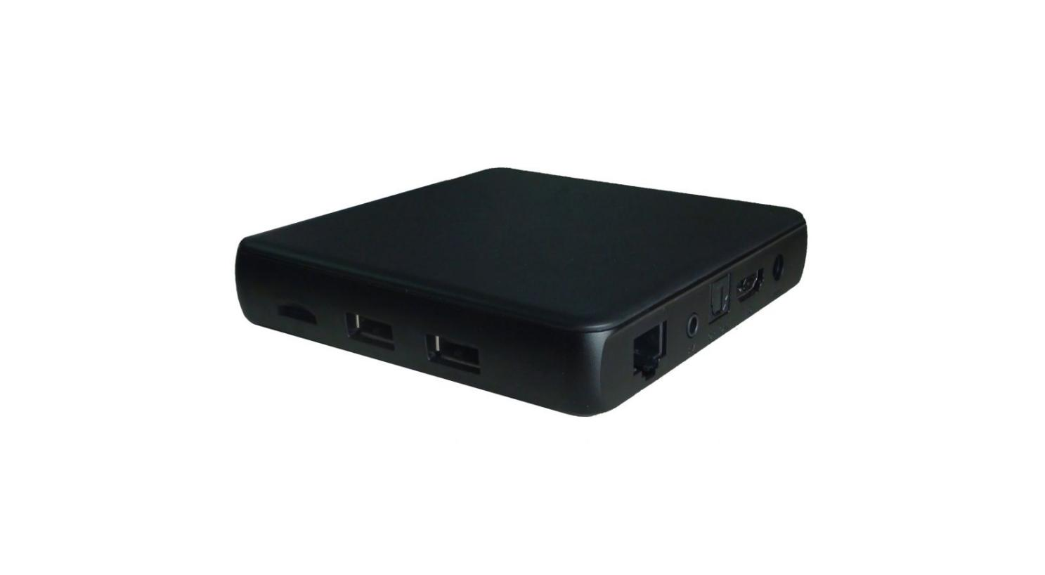

△ Android 7.1.2
△ HDMI 2.0
△ Low Cost
△ Personalized User Interface (Hotel/Hospital/Community…)
△ Advertisement System (ADS) Imbedded
Product overview
The FMUSER IPTV HD STB is an Android 7.1-based set-top box with 4K H.265/HEVC decoding and HDMI 2.0 output. It processes IPTV streams via 10/100M Ethernet or dual-band Wi-Fi, supporting Widevine L1 DRM and custom EPG interfaces. The compact device integrates ad systems and runs commercial apps, ideal for hospitality TV systems and community IPTV deployments.
Key feature
Android 7.1 flexibility: Supports Netflix, Skype, and third-party apps via Google Play
Specifications
Hardware | CPU | RK3229, 28nm Quad core Cortex A7, High cost performance 4K OTT Box solution
Hardware | GPU | ARM Mali-400 GPU
Hardware | HDMI | Including an HDMI 2.0 for HDMI 2.0 for 4K YUV420@60Hz with HDCP 1.4/2.2
Hardware | HDMI | Support 4K 10-bit H.265/H.264/VP9 video playback and display
Hardware | Memory | 1GB DDRIII
Hardware | Flash | 8GB Nand Flash
Hardware | WiFi | 2.4G，802.11 b/g/n,
Hardware | Wired network | Ethernet GMAC 10/100/100M Ethernet controller
Hardware | Wired network | Support 10/100/1000 data transfer rate and RGMII interface
Hardware | Wired network | Support 10/100Mbps data transfer rate and RGMII interface
Hardware | IR | Infra Remote control
Hardware | Power Supply | DC input 5V/2A
Software | OS | Android 7.1
Software | 3D | Hardward 3D graphics acceleration
Software | Video decoding | 4K VP9 Video decoder, 4K 10-bits H.265/H.264 video decoder
Software | Video decoding | 1080P other video decoders (VC-1, MPEG-1/2/4, VP6/8)
Software | Video decoding | Support conversion from BT.2020 to Rec.709/Rec.601
Software | Video decoding | Video post processor: de-interlace
Software | Video decoding | H.263/H.264 2160P@ 24fps  VC-1 ,MPEG - 1 1080p @ 60fps  MPEG- 2 2160P @ 24fps  MPEG-4 1080P @ 60fps  AVS 1080p @ 60fps  MVC 2160P @ 24fps  WMV,3GP,MKV,ASF,3G2M4V,MJPEG,RV8,RV9,RV10 1080P@60fps
Software | Video decoding | Support HEVC decoder
Software | Video decoding | Support Main/Main10 HEVC/H.265 decoder, 4K @ 60FPS
Software | Video decoding | Support 4096x2304 resolution
Software | Video decoding | Support HDMI 720P-2160P FUII 3D HD( 2160P, 3840 * 2160 ), 4K+2 K
Software | Video decoding | Support flash11.1
Software | Video Decoder format | H.264,H.265,VP8,MVC(1080P)
Software | Video format | Supports DIVD/DIVX/REAL8 / 9 / 10, RV, RM, RMVB, PMP, FLV, MP4, M4V, VOB, VP6, VP8 2160P @ 24fps
Software | Audio format | Supports MP1, MP2, MP3, WMA, OGG, AAC, M4A , FLAC, APE, AMR, RA, WAV, etc
Software | Picture format | Supports JPG, JPEG, BMP, GIF, PNG, JFIF etc Resolution 8192x8192
Software | HDD file system | FAT16 / FAT32 / NTFS
Software | Support Subtitle | SRT, SMI, SUB, SSA, IDX+USB
Software | XBMC/KODI | Support
Software | DRM | Widewine Level1, DRM PlayReady ,Verimatrix, built in Trustzone,  HDCP 2.2/1.4
Software | Support language | Chinese, English, Germany, Japanese, Korea etc. multilateral languages
Stream In/Out | 1*HDMI 2.0 | Built-in HDMI 2.0 transmitter including both controller and PHY with CEC and HDCP, 4K @ 60FPS max resolution output
Stream In/Out | 1* SD Card | to 64GB
Stream In/Out | 4*USB HOST | 2High speed USB 2.0,support USB DISK and USB HDD
Stream In/Out | 1*SPDIF | SPDIF output
Stream In/Out | 1*RJ45 | Ethernet:10/100M, standard RJ-45
Stream In/Out | 1*Power input | 5V/2A
Stream In/Out | Accessories | Gift box  Power charger adapter  HDMI cable (optional)  IR remote control (optional)  User's Manual
Applications | Online | Browse all video websites, support Netflix, Hulu, Flixster, youtube etc
Applications | Apps | Apps download freely form android market, amazon appstore etc
Applications | Medium | Local Media playback, support HDD, U disck ,SD card
Applications | Talk online | Support SKYPE video call, MSN, facebook, twitter, QQ etc
Applications | Others | Support WiFi hotpiont, could be as a wireless router  Support DLNA, Google TV Remote, LAN, 3D Moive, Email, office suit etc
Packing | Dimension | 118*118*25 mm
Packing | Approx weight | 400g

System Construction
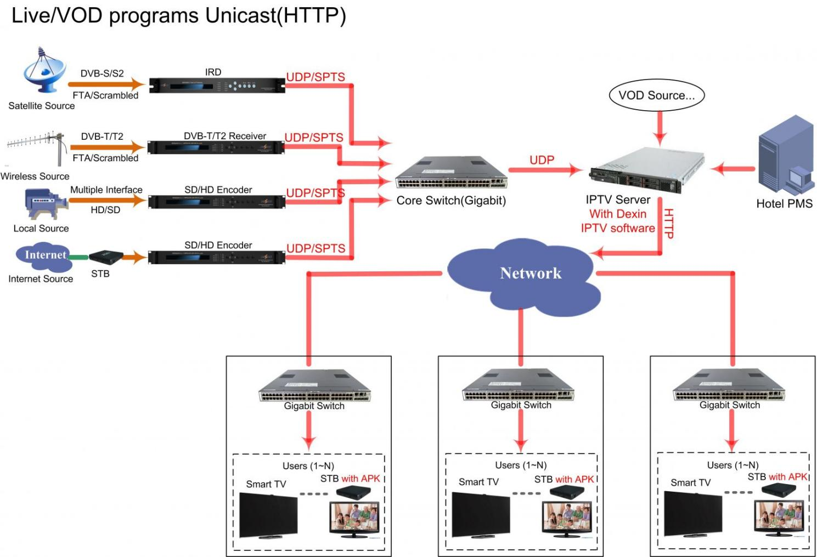
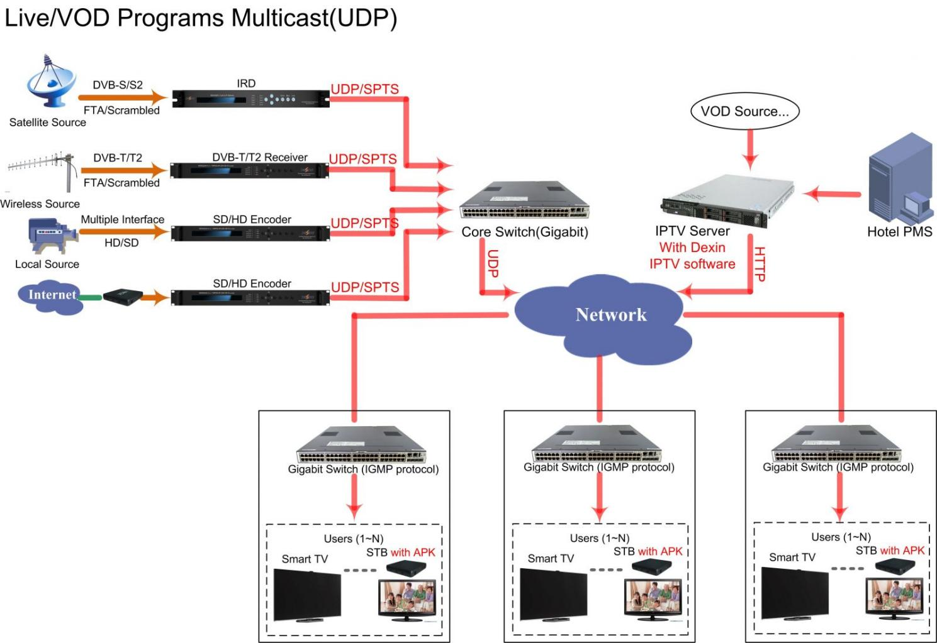
Advantages
Personalized EPG Interface
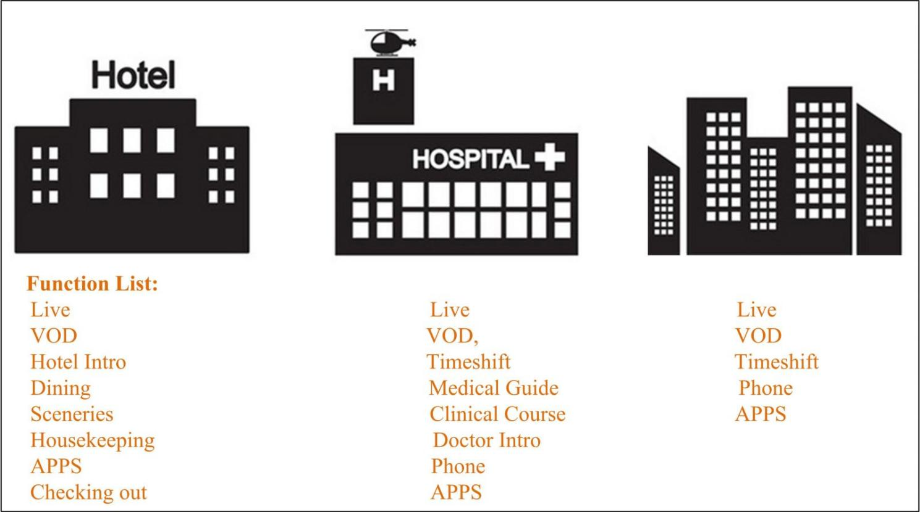

* Personalized EPG interface for hotel, hospital, Community and other industries.
* System wallpaper is changeable and EPG content is editable.
* Various business modes blend in IPTV system
* Support modular interface and convenient to docking with third part manage software

Advertisement System—Value added Services
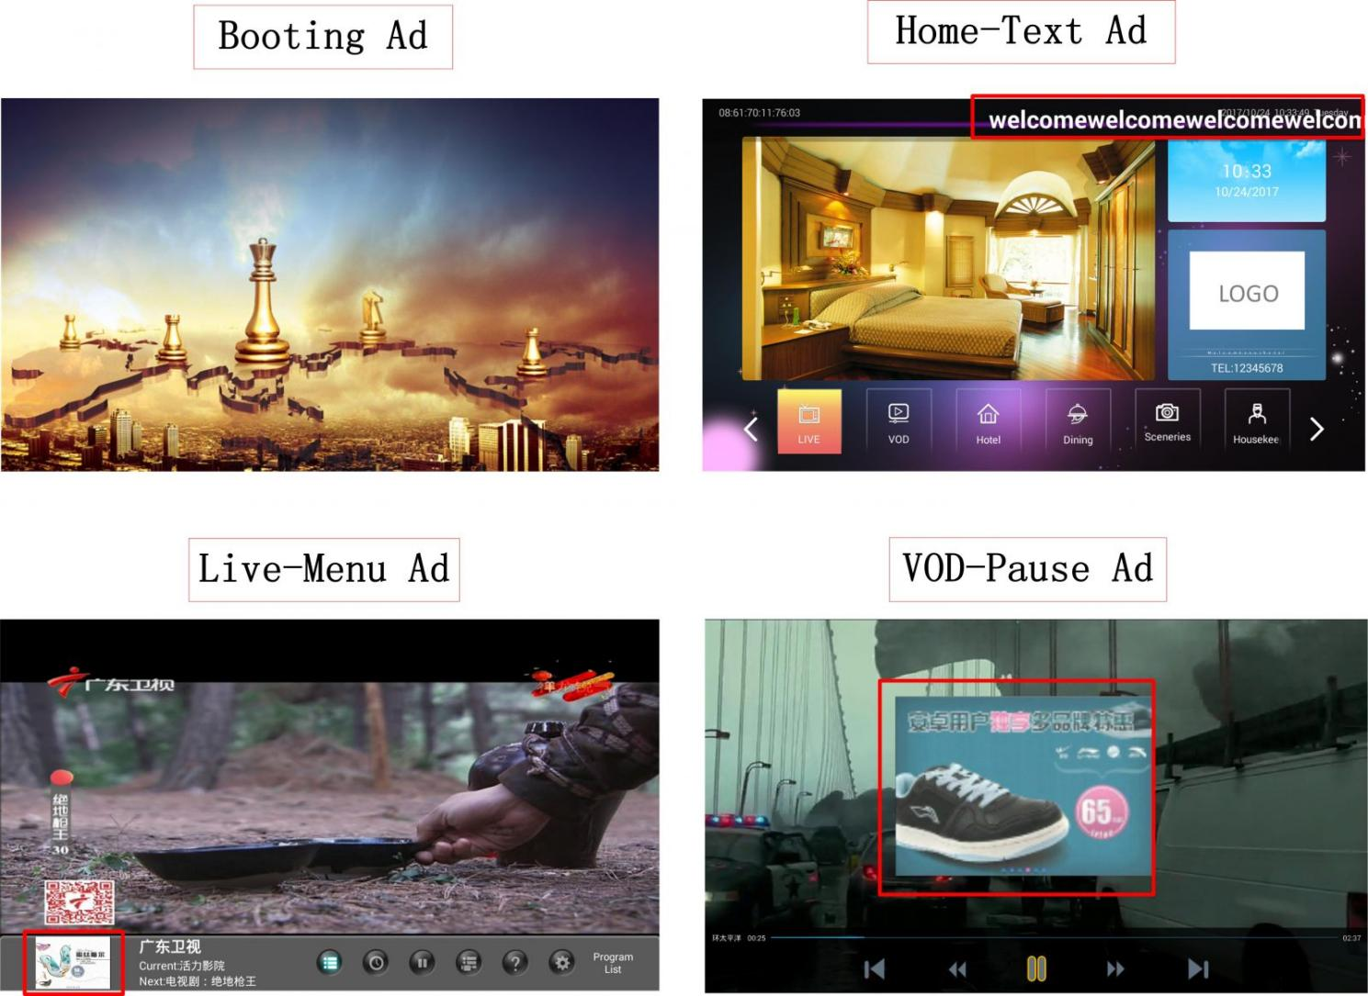

* Hotel, hospital and community version can support set up advertisement business to increase revenues.
* Ad modes include booting ad, Menu ad (only for hospital and community version), VOD ad, pictures and text ad etc.
Mass HD Programs
* 1080P/60Hz full HD video
* Mass resource of Video on Demand including movies, entertainments, factual shows and etc
* Live programs synchronized broadcast

Strength and After-sale Services
* FMUSER IPTV system is with solid quality based on FMUSER’s own DTV head-end equipment
* The whole system is self research and developed, which makes it easy for the after-sale maintenances
* Skilled after-sale supporting team

About Us
FMUSER is a company specializing in broadcasting and television transmission systems and integrating hotel IPTV systems. The company was established in 2009 and has served over 180 countries worldwide. More than 20,000 television stations, radio stations, and hotel clients from different.

Contact:Tomleequan Email：sales@fmuser.com whatsapp: +8613922702227

