FMUSER Encoder Modulator 1 IN-1 OUT DVB-S2-DVB-T Signal Type IP Gateway Protocol Broadcasting & Hotel IPTV System Integration 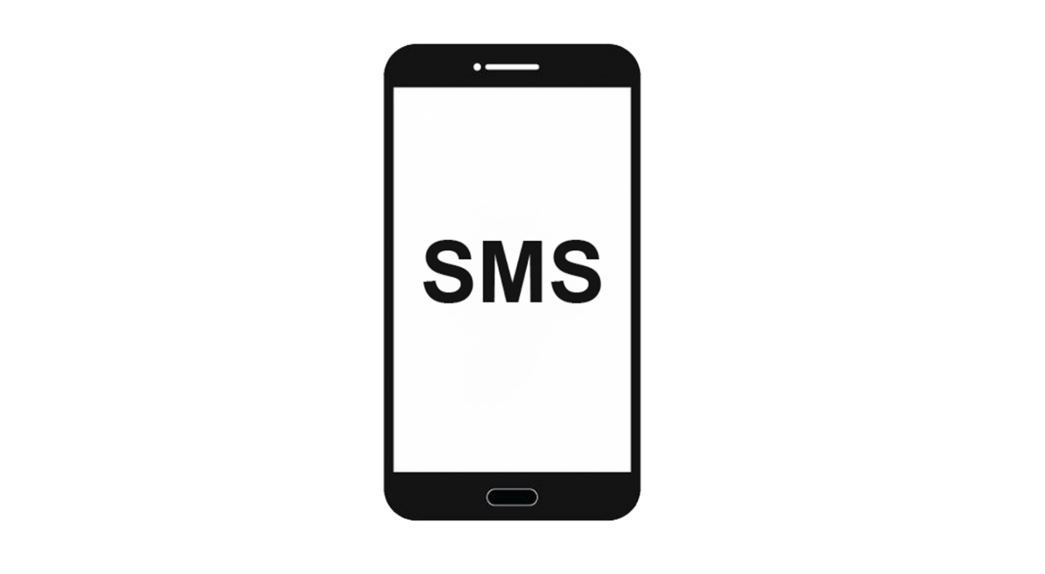
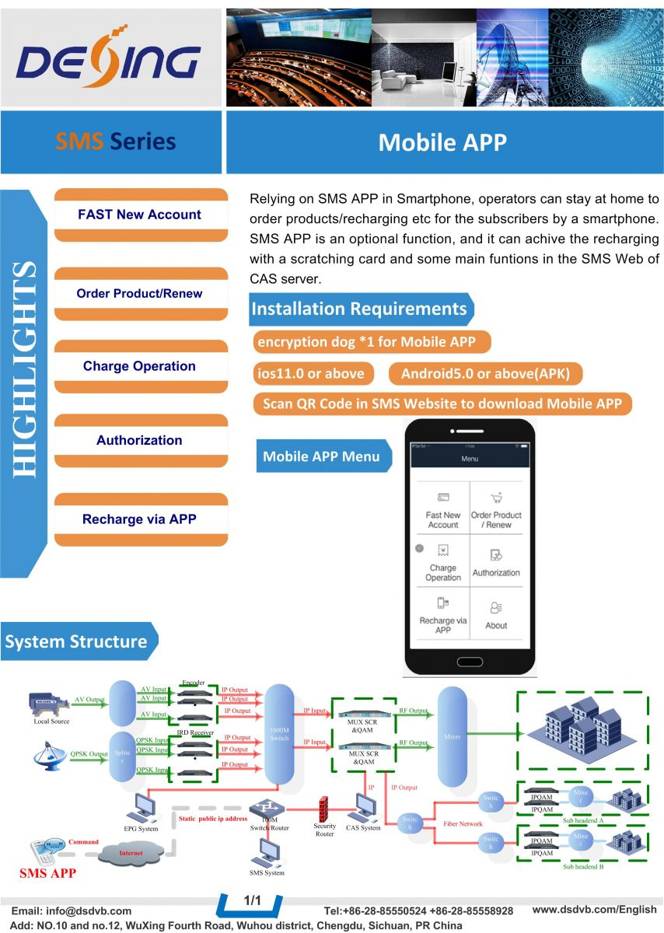
Product overview
The FMUSER Mobile SMS Solution enables broadcast content delivery and hotel IPTV management via SMS technology. It supports real-time messaging integration with television/radio transmission systems and hospitality networks. The solution operates via web-based control panels and is compatible with global telecom infrastructures. Ideal for broadcasters requiring audience engagement tools and hotels deploying IPTV guest services.
Key feature
Trusted by 20,000+ clients since 2009
About Us
FMUSER is a company specializing in broadcasting and television transmission systems and integrating hotel IPTV systems. The company was established in 2009 and has served over 180 countries worldwide. More than 20,000 television stations, radio stations, and hotel clients from different.

Contact:Tomleequan Email：sales@fmuser.com whatsapp: +8613922702227

