FMUSER FUQ-1.0 Conditional Access System SMS Integrated Digital TV Content Protection IP Gateway Support DVB-C DVB-S Core Encryption Technology Interactive Television Solutions Product overview
2020 April News: SMS APP based on Smart Phone is issued.
FMUSER Ensurity CAS provides secure content protection for digital TV systems. It features SMS APP subscriber management via smartphones and supports DVB standards. The system enables remote authorization and scalable business operations. Ideal for broadcast operators and interactive TV service providers requiring robust content security.
Key feature
Delivers remote authorization for operational flexibility
Solution Guide
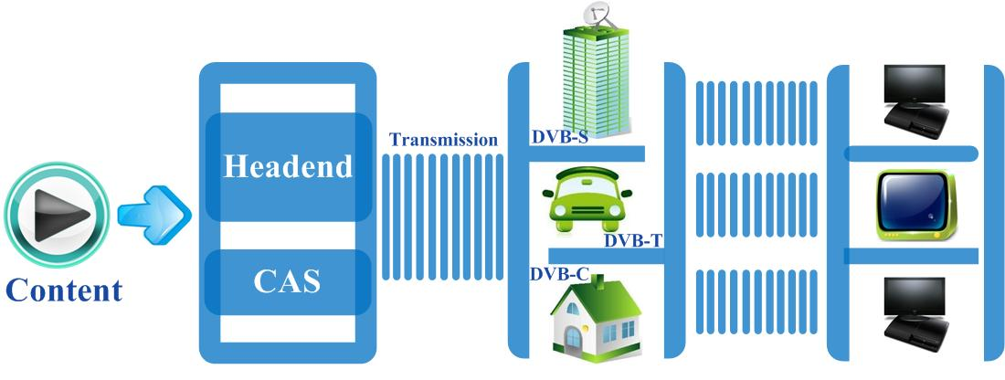

Why choose Ensurity

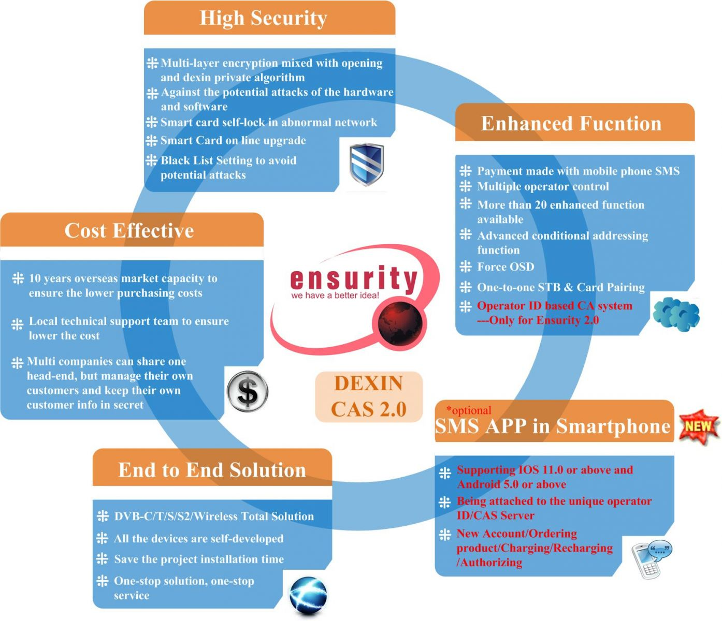

Total Solution

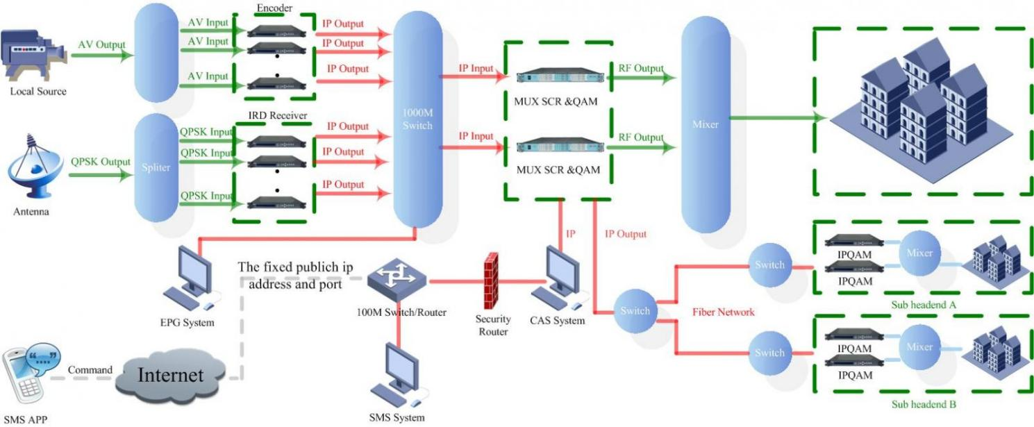

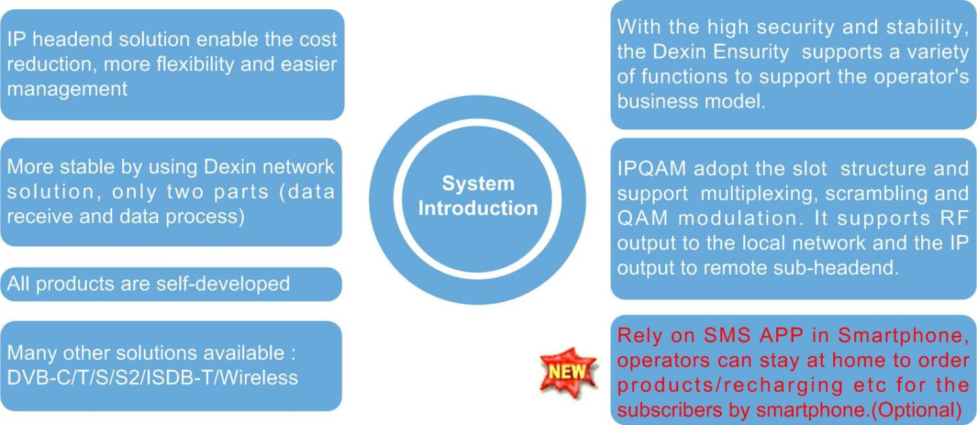

Specification

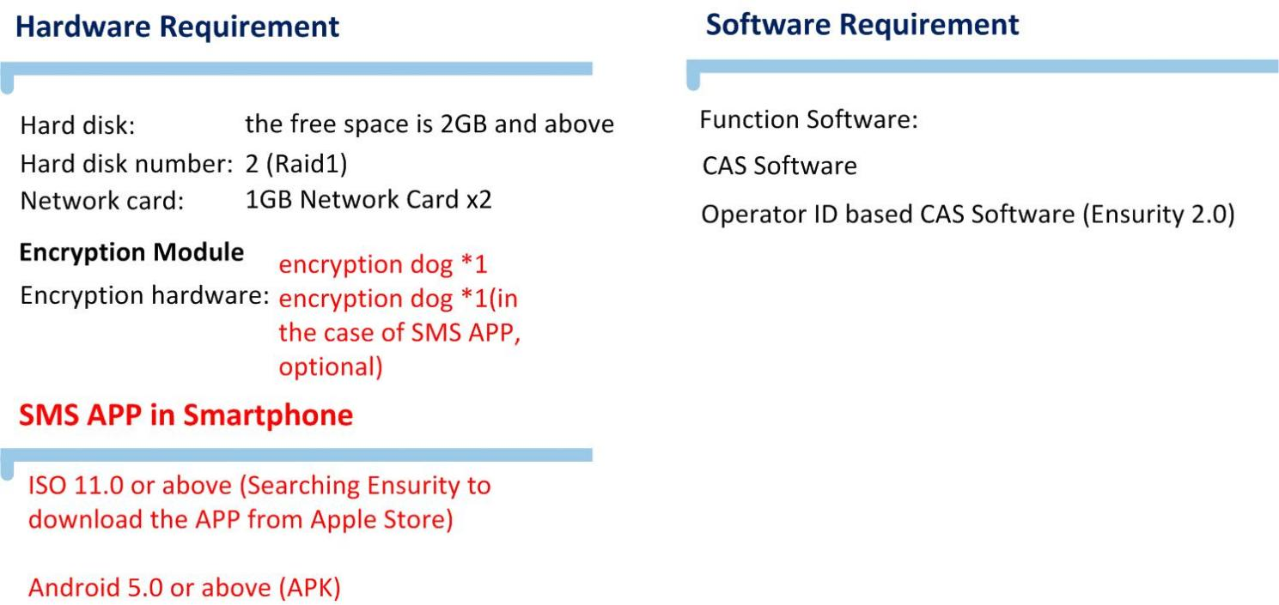

Main Functions Overview

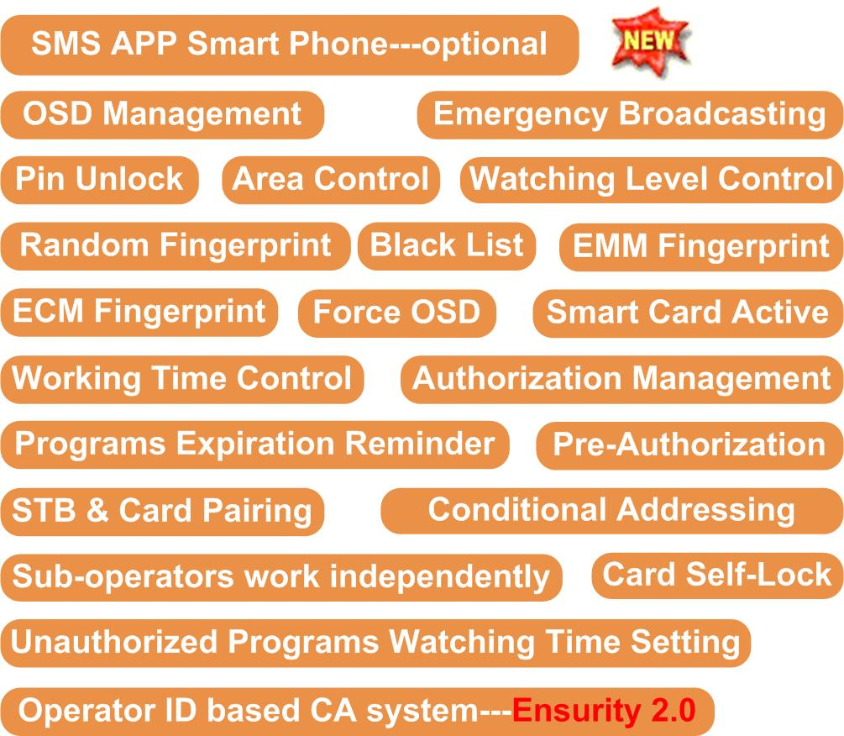

SMS Integrated

ITP Software India PVT Ltd
Reliablesoft Technologies Pvt. Ltd
Aplomb Tecnology
Paycab Solution Pvt. Ltd

About Us
FMUSER is a company specializing in broadcasting and television transmission systems and integrating hotel IPTV systems. The company was established in 2009 and has served over 180 countries worldwide. More than 20,000 television stations, radio stations, and hotel clients from different.

Contact:Tomleequan Email：sales@fmuser.com whatsapp: +8613922702227

