FMUSER FUQ-10 IP Gateway 8-12 HD SD Program IP Input SRT HTTP UDP RTP RTSP HLS RTMP Output Protocol Conversion IP Anti-Jitter Broadcast IPTV Distribution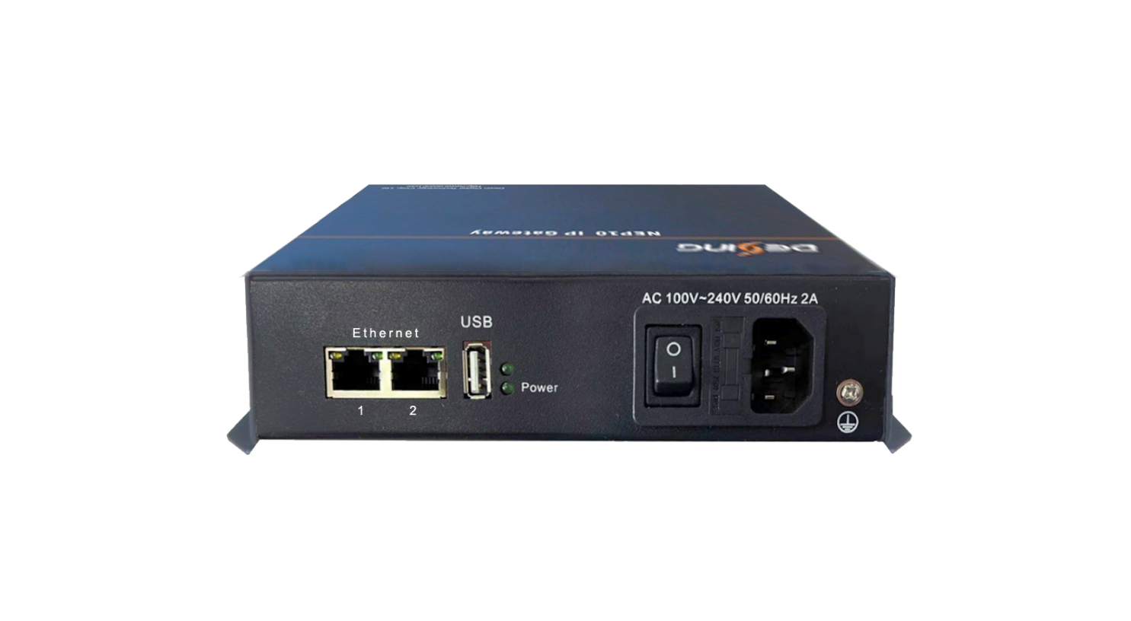
Product overview
The FMUSER FUQ-10 IP Gateway performs multi-protocol conversion between SRT, HTTP, UDP, RTP/RTSP, HLS, and RTMP with 8-12 HD/SD program (8Mbps each) capacity. It processes IP streams with anti-jitter technology via dual Ethernet ports (1×I/O, 1×low-bitrate input). This 180×110×40mm industrial device features web-based NMS control and operates in 0-45°C environments. Ideal for broadcast contribution networks and multi-platform IPTV distribution.
Key feature
Compact 180×110×40mm chassis with 0-45°C operating range
IP Protocol Conversion
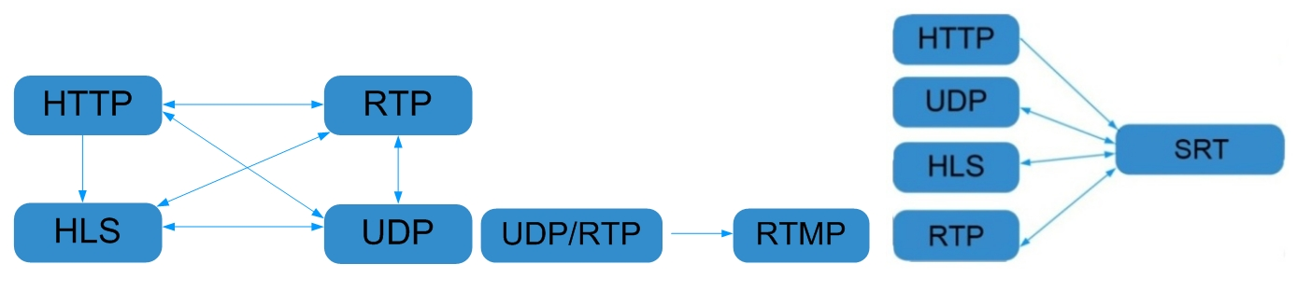

General Principle Chart
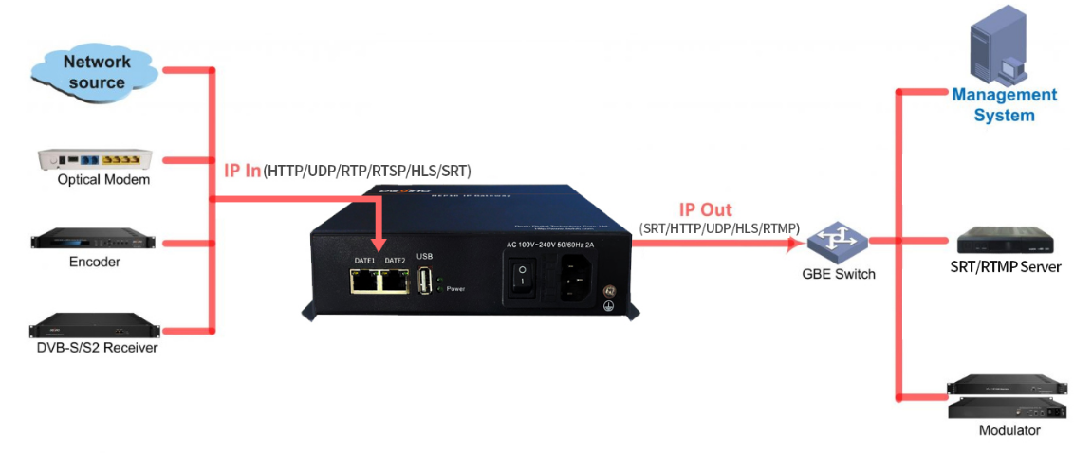

Specifications
IP Input | IP input through Ethernet1/ Ethernet2 over SRT, HTTP, UDP, RTP/RTSP and HLS.
IP output | IP output through Ethernet1 over SRT, HTTP, UDP, HLS, RTMP and RTP/RTSP.
System | Support about 8-12 HD/SD programs (Bitrate:8Mbps) conversion
System | Web-based NMS management through Ethernet port
General | Demission | 180mm×110mm×40mm (WxLxH)
General | Temperature | 0~45℃(operation), -20~80℃(storage)
General | Power Supply | AC100V±10%, 50/60Hz or AC 220V±10%, 50/60Hz

Test data for reference:
Protocol conversion | Bit-Rate | Programs
UDP to SRT/HTTP/RTP/RTSP/HLS/RTMP | 3Mbps | 20
UDP to SRT | 8Mbps | 10
UDP to HTTP | 8Mbps | 12
UDP to RTP/RTSP | 8Mbps | 12
UDP to RTMP | 8Mbps | 12
UDP to HLS | 8Mbps | 12

Protocol conversion | Bit-Rate | Programs
SRT to UDP/RTP/RTSP/HLS | 3Mbps | 20
SRT to UDP | 8Mbps | 12
SRT to RTP/RTSP | 8Mbps | 12
SRT to HLS | 8Mbps | 12

About Us
FMUSER is a company specializing in broadcasting and television transmission systems and integrating hotel IPTV systems. The company was established in 2009 and has served over 180 countries worldwide. More than 20,000 television stations, radio stations, and hotel clients from different.

Contact:Tomleequan Email：sales@fmuser.com whatsapp: +8613922702227

