FMUSER FUQ-10 IP Gateway 8 ASI Inputs 512 IP Inputs UDP ISO13818 EN300 468 TS Re-Multiplexing PID Re-Mapping Web-Based NMS for CATV Broadcasting 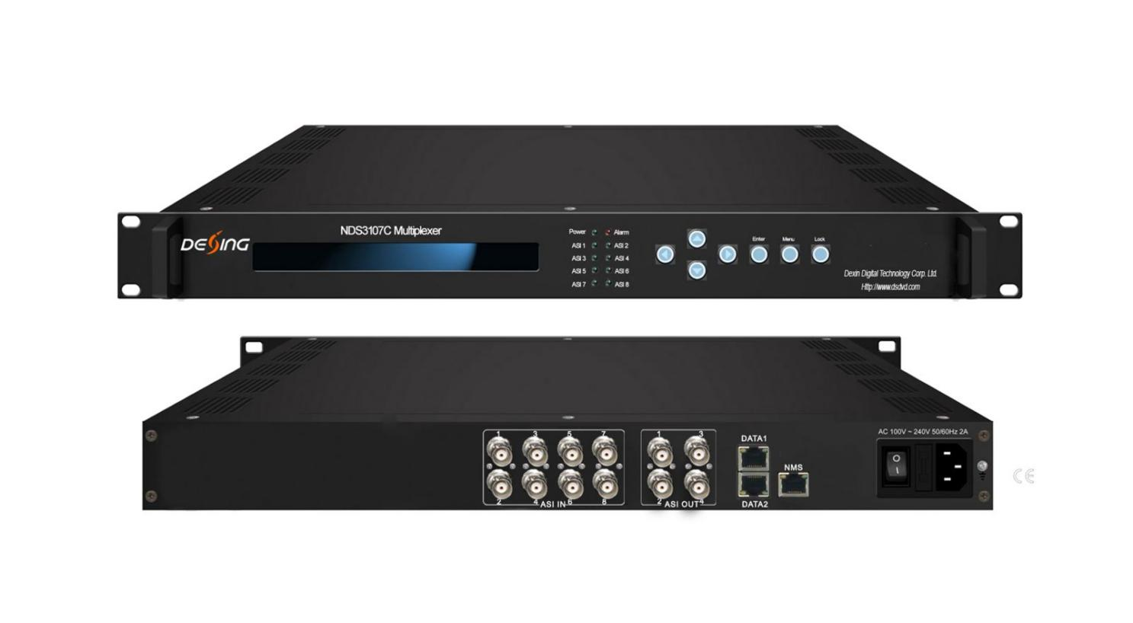Product overview
The FMUSER FUQ-10 IP Gateway supports 8 ASI inputs and 512 IP inputs via DATA ports. It performs TS re-multiplexing, PID re-mapping, and EPG insertion for efficient stream handling. With web-based NMS, it enables remote control over Ethernet. Ideal for digital TV head-end systems in CATV broadcasting applications.
Key feature
Supports ISO13818 and EN300 468 standards for reliable operations.,
Handles up to 8 ASI inputs and 512 IP inputs via UDP protocol.,
Features PCR adjusting, PID re-mapping, and PSI/SI editing.,
Provides ASI and IP outputs with UDP, RTP, and RTSP support.,
Includes web-based NMS for monitoring and control.

Principle Chart

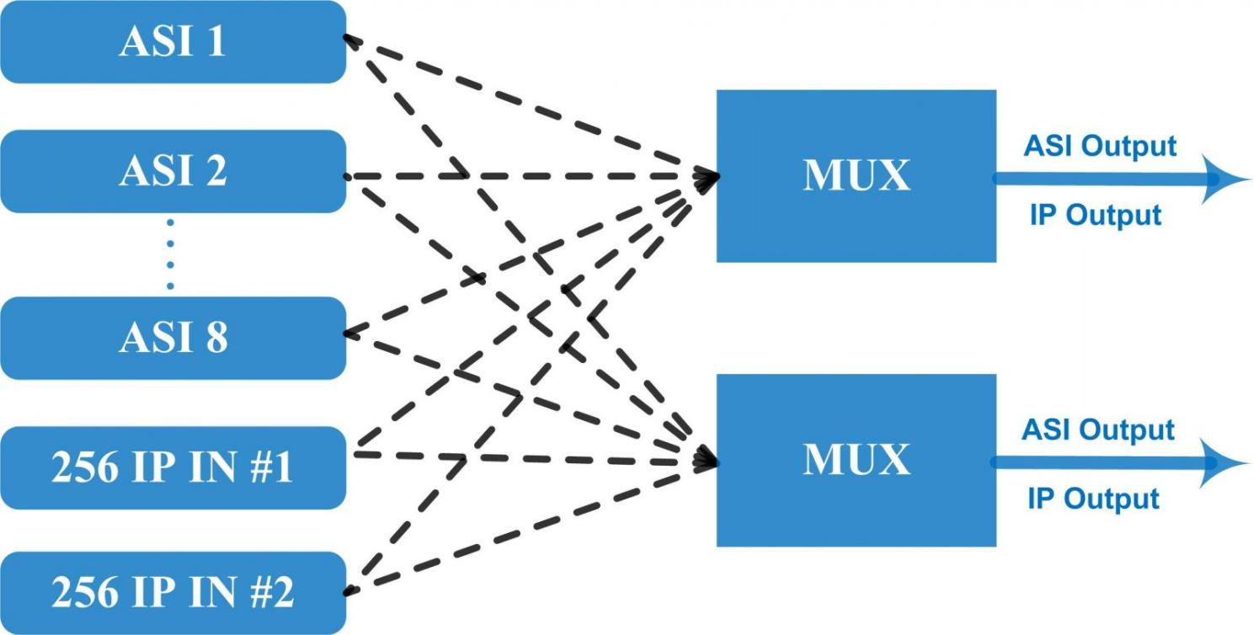

Specifications

Input | 8 ASI input+512 IP input DATA 1 and DATA 2 over UDP protocol
Re-multiplex | PID re-mapping
Re-multiplex | PCR accurate adjusting
Re-multiplex | PSI/SI (PAT, PMT) tables auto generation and edition
Output port | ASI | 2 groups separate outputs (each group has 2 channels)
Output port | IP | MPTS over UDP, RTP/RTSP output (RJ45), 1000Mbps Ethernet, DATA 1 and DATA 2
PID | Output range | 0x0000—0x1FFF
PID | PID transparent | Any PID transparent and mapping achievable
PID | Amount of output PID | 180
NMS port | Ethernet port | 10/100M/1000M self adaption
General | Dimensions | 482mm×300mm×44mm (WxLxH)
General | Weight | 3.5kg
General | Temperature | 0~45℃(operation), -20~80℃(storage)
General | Power supply | AC 110V±10%, 50/60Hz Or AC 220V±10%, 50/60Hz

About Us
FMUSER is a company specializing in broadcasting and television transmission systems and integrating hotel IPTV systems. The company was established in 2009 and has served over 180 countries worldwide. More than 20,000 television stations, radio stations, and hotel clients from different.

Contact:Tomleequan Email：sales@fmuser.com whatsapp: +8613922702227

