FUQ-72XX Series FM Stereo Broadcast Transmitter 10W-10kW Adjustable Output FPGA Processed LDMOS Amplification GB-T4311-2000 GY-T169-2001 Compliant Dual-Transmitter Redundancy Coaxial Switching 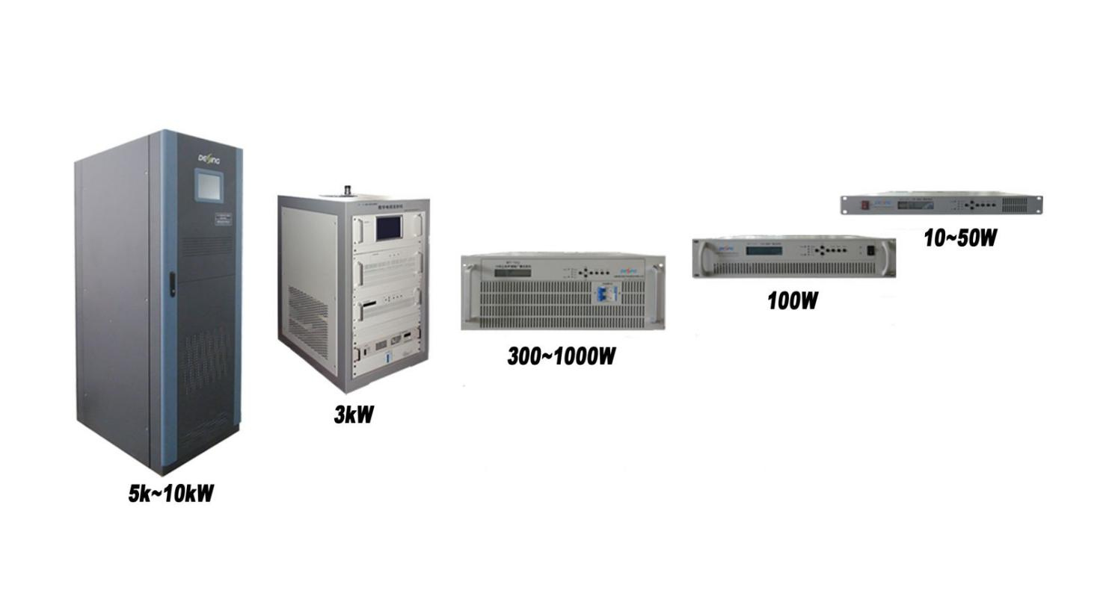
Product overview
The FUQ-72XX series delivers FPGA-processed FM stereo signals with LDMOS amplification, featuring adjustable 10W–10kW RF output and AGC stability (±0.1dB). Its dual-transmitter redundancy with coaxial switching ensures 24/7 operation, compliant with GB/T4311-2000/GY/T169-2001 standards. The 4U rack-mount design supports NMS control for broadcast centers and emergency alert systems.
Key feature
Integrated lightning protection (10kV surge resistance)
Technical Specifications
S/No. | Item |  | Unit | Technical Index |  | Remark
1 | Output Power |  | W | 500
2 | Frequency |  | MHz | 1kW≤ | 65.5~87; 87~108
2 |  |  | MHz | 1kW＞ | 87～108
3 | Frequency deviation |  | Hz | ≤500
4 | Sparious Radiation |  | dB | ≤-70
5 | parasitic amplitude modulation noise |  | dB | -60
6 | Pilot frequency deviation |  | Hz | ±1
7 | S signal 38kHz Residual component |  | dB | ＜-40
8 | Deviation (100% modulation) |  | kHz | ±75
9 | pre-emphasis |  | µs | 50
10 | Distortion (100% modulation) | L | ％ | ＜0.2
10 | Distortion (100% modulation) | R | ％
11 | Frequency response (without emphasis, de-emphasis) | L | dB | ±0.2
11 | Frequency response (without emphasis, de-emphasis) | R | dB
12 | Frequency response (with emphasis, de-emphasis) | L | dB | ±0.2
12 | Frequency response (with emphasis, de-emphasis) | R | dB
13 | SNR (100% modulation) | L | dB | ≥75
13 | SNR (100% modulation) | R | dB
14 | L/R Separation | L R | dB | ＞70
14 | L/R Separation | R L | dB
15 | L/R level diffrence |  | dB | ＜0.1

Specifications and Environment Conditions
Item | Item | Technical Requirements |  | Remark
Output and Input Specifications | RDS input | BNC interface(57KHz)
Output and Input Specifications | Input interface | XLR, AES/EBU(Optional)
Output and Input Specifications | Output interface | L29-50K
Environment condition | Working temperature | -20～+50℃
Environment condition | Storage temperature | -30～+75℃
Environment condition | Relatively humidity | ＜95% (25℃ no condensation)
Environment condition | Cooling mode | inside forced air cooling
Environment condition | atm press | 86～106kPa
Environment condition | power supply | AC, 100～264V/50Hz
Environment condition | machine room | Less dust, shock-free
Environment condition | Demission  (L×W×H) | 10~30W | 482×420×44mm
Environment condition | Demission  (L×W×H) | 100W | 482×420×88mm
Environment condition | Demission  (L×W×H) | 300~1kW | 482×560×176mm
Environment condition | Demission  (L×W×H) | 3kW | 600×800×1080mm
Environment condition | Demission  (L×W×H) | 5kW | 600×1050×1695mm
Environment condition | Demission  (L×W×H) | 10kW | 650×1050×1695mm

System Principle
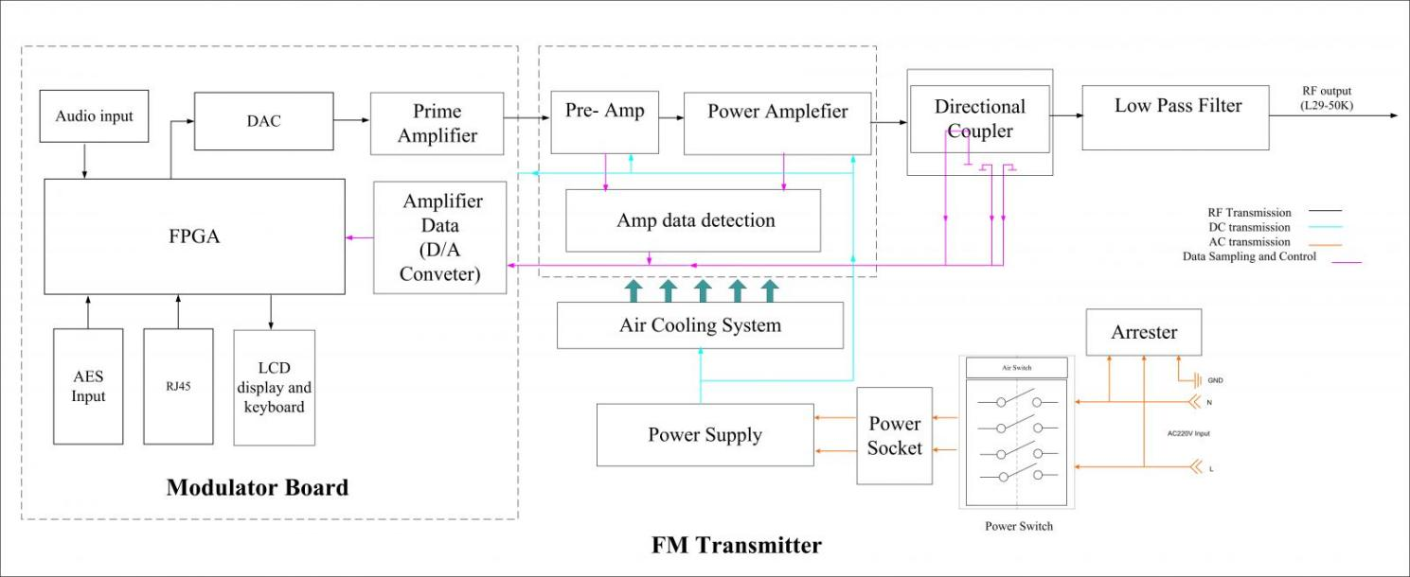

Order Information
DFT-7211: 10W | DFT-7212: 100W | DFT-7213: 1kW | DFT-7214: 10kW
DFT-7231: 30W | DFT-7232: 300W | DFT-7233: 3kW | DFT-7214: 10kW
DFT-7251: 50W | DFT-7252: 500W | DFT-7253: 5kW | DFT-7214: 10kW

About Us
FMUSER is a company specializing in broadcasting and television transmission systems and integrating hotel IPTV systems. The company was established in 2009 and has served over 180 countries worldwide. More than 20,000 television stations, radio stations, and hotel clients from different.

Contact:Tomleequan Email：sales@fmuser.com whatsapp: +8613922702227

