FUQ-72XX Series FM Stereo Broadcast Transmitter 1x RF Output FPGA Digital Modulation LDMOS Amplifier ≤0.2% Distortion GB/T4311-2000 Standard High Fidelity Transmission for FM Radio and Emergency Alert Systems 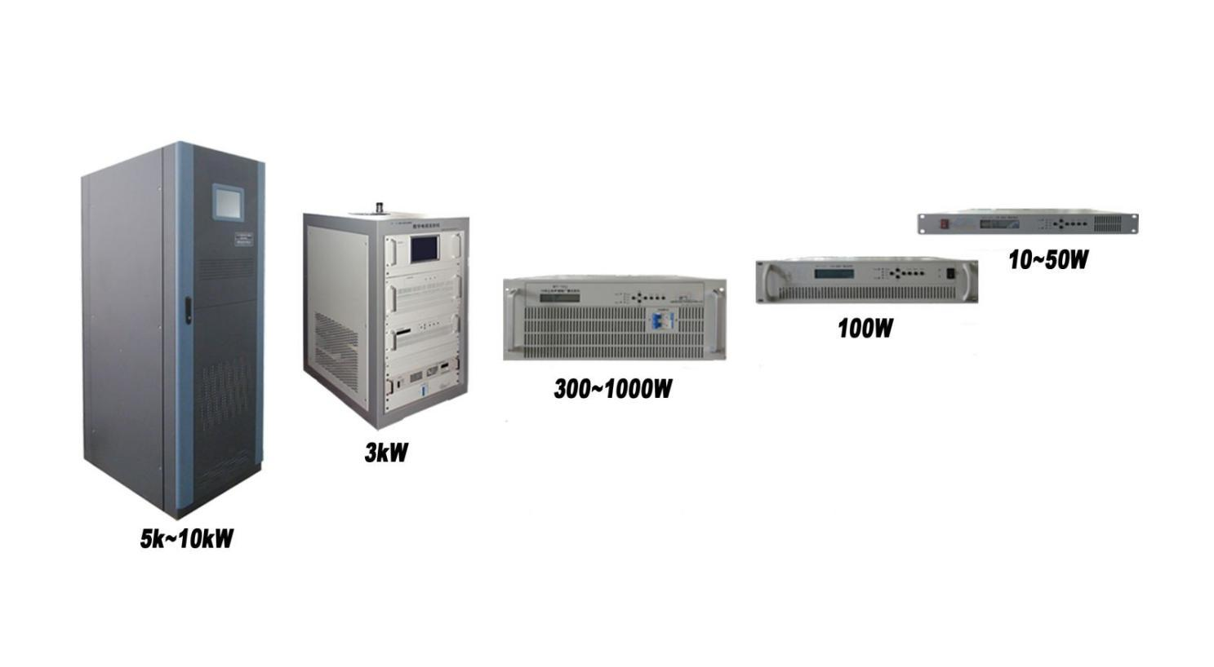
Product overview
The FUQ-72XX Series is a professional FM stereo broadcast transmitter with 1x RF output and LDMOS amplifier technology. It processes audio signals via FPGA-based digital modulation (DAC) and delivers 10W-10kW adjustable power with ≤0.2% distortion. The rack-mountable unit features air-cooled operation and complies with GB/T4311-2000/GY/T169-1 standards. Ideal for FM radio stations, emergency broadcast systems, and community radio networks requiring high-fidelity transmission.
Key feature
Universal PSU: Supports AC100–264V input and -20°C to +50°C operation for harsh environments.
Technical Specifications
S/No. | Item |  | Unit | Technical Index |  | Remark
1 | Output Power |  | W | 500
2 | Frequency |  | MHz | 1kW≤ | 65.5~87; 87~108
2 |  |  | MHz | 1kW＞ | 87～108
3 | Frequency deviation |  | Hz | ≤500
4 | Sparious Radiation |  | dB | ≤-70
5 | parasitic amplitude modulation noise |  | dB | -60
6 | Pilot frequency deviation |  | Hz | ±1
7 | S signal 38kHz Residual component |  | dB | ＜-40
8 | Deviation (100% modulation) |  | kHz | ±75
9 | pre-emphasis |  | µs | 50
10 | Distortion (100% modulation) | L | ％ | ＜0.2
10 | Distortion (100% modulation) | R | ％
11 | Frequency response (without emphasis, de-emphasis) | L | dB | ±0.2
11 | Frequency response (without emphasis, de-emphasis) | R | dB
12 | Frequency response (with emphasis, de-emphasis) | L | dB | ±0.2
12 | Frequency response (with emphasis, de-emphasis) | R | dB
13 | SNR (100% modulation) | L | dB | ≥75
13 | SNR (100% modulation) | R | dB
14 | L/R Separation | L R | dB | ＞70
14 | L/R Separation | R L | dB
15 | L/R level diffrence |  | dB | ＜0.1

Specifications and Environment Conditions
Item | Item | Technical Requirements |  | Remark
Output and Input Specifications | RDS input | BNC interface(57KHz)
Output and Input Specifications | Input interface | XLR, AES/EBU(Optional)
Output and Input Specifications | Output interface | L29-50K
Environment condition | Working temperature | -20～+50℃
Environment condition | Storage temperature | -30～+75℃
Environment condition | Relatively humidity | ＜95% (25℃ no condensation)
Environment condition | Cooling mode | inside forced air cooling
Environment condition | atm press | 86～106kPa
Environment condition | power supply | AC, 100～264V/50Hz
Environment condition | machine room | Less dust, shock-free
Environment condition | Demission  (L×W×H) | 10~30W | 482×420×44mm
Environment condition | Demission  (L×W×H) | 100W | 482×420×88mm
Environment condition | Demission  (L×W×H) | 300~1kW | 482×560×176mm
Environment condition | Demission  (L×W×H) | 3kW | 600×800×1080mm
Environment condition | Demission  (L×W×H) | 5kW | 600×1050×1695mm
Environment condition | Demission  (L×W×H) | 10kW | 650×1050×1695mm

System Principle
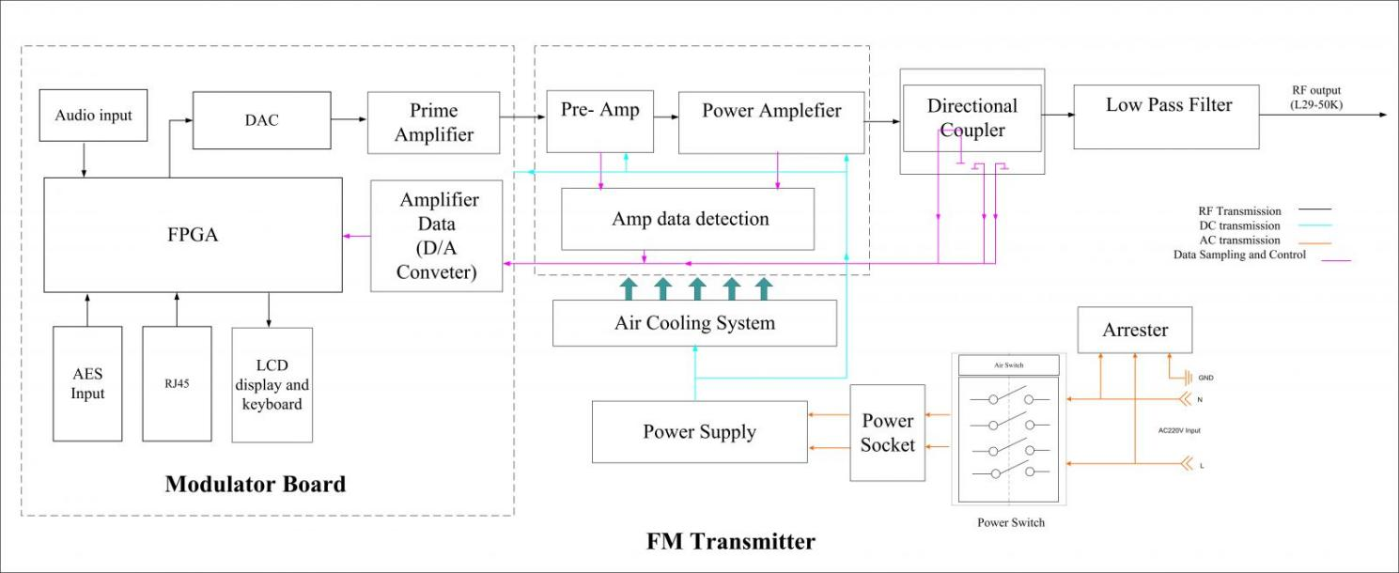

Order Information
DFT-7211: 10W | DFT-7212: 100W | DFT-7213: 1kW | DFT-7214: 10kW
DFT-7231: 30W | DFT-7232: 300W | DFT-7233: 3kW | DFT-7214: 10kW
DFT-7251: 50W | DFT-7252: 500W | DFT-7253: 5kW | DFT-7214: 10kW

About Us
FMUSER is a company specializing in broadcasting and television transmission systems and integrating hotel IPTV systems. The company was established in 2009 and has served over 180 countries worldwide. More than 20,000 television stations, radio stations, and hotel clients from different.

Contact:Tomleequan Email：sales@fmuser.com whatsapp: +8613922702227

