FMUSER FUQ-ADS Advertising System DVB-Compliant 1RU Rack Mount ASI-IP Interface Multi-Format Ad Delivery Text-Graphic-Video Support Targeted Digital TV Ads for Pay-TV Operators 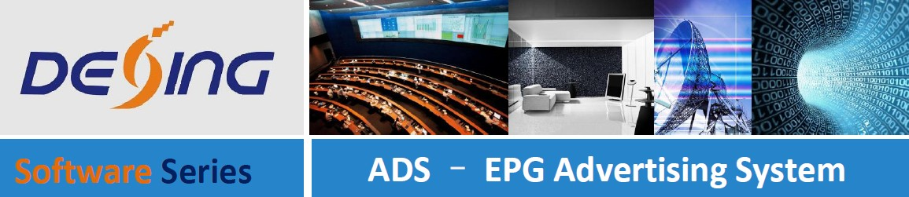
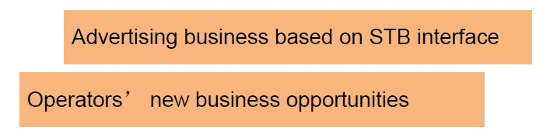
Product Overview:
The FMUSER FUQ-ADS Advertising System enables DVB-standard ad insertion with 4 placement types (boot/EPG/volume/menu) via STB output. It processes JPEG/GIF/video/text ads through centralized scheduling tools. This 1RU rack-mount system integrates with existing digital TV headends via ASI/IP interfaces. Ideal for pay-TV operators requiring non-skippable ads and broadcasters implementing targeted promotions.
Key feature:
Complies with DVB standards for seamless headend integration
System Structure:
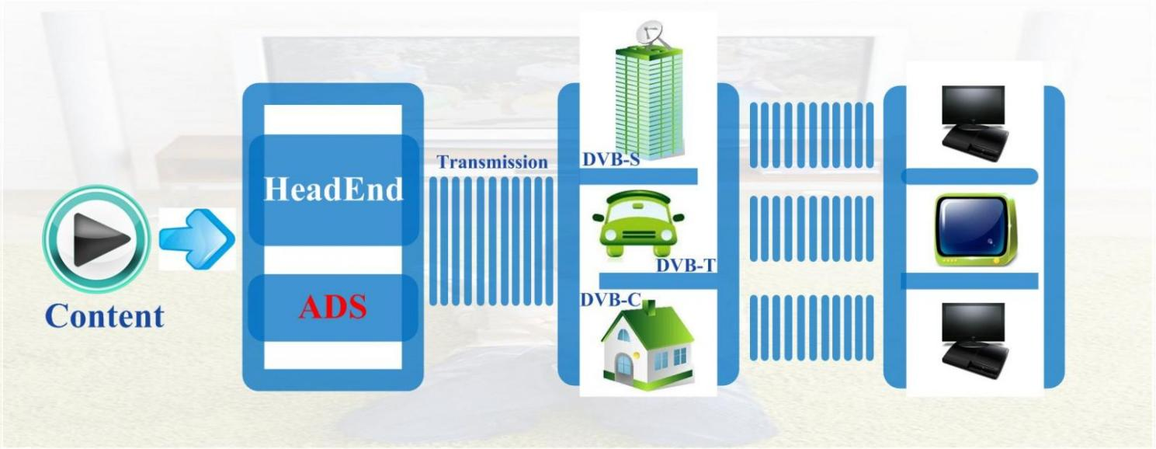
The FMUSER FUQ-ADS Advertising System enables DVB-standard ad insertion with 4 placement types (boot/EPG/volume/menu) via STB output. It processes JPEG/GIF/video/text ads through centralized scheduling tools. This 1RU rack-mount system integrates with existing digital TV headends via ASI/IP interfaces. Ideal for pay-TV operators requiring non-skippable ads and broadcasters implementing targeted promotions.The FMUSER FUQ-ADS Advertising System enables DVB-standard ad insertion with 4 placement types (boot/EPG/volume/menu) via STB output. It processes JPEG/GIF/video/text ads through centralized scheduling tools. This 1RU rack-mount system integrates with existing digital TV headends via ASI/IP interfaces. Ideal for pay-TV operators requiring non-skippable ads and broadcasters implementing targeted promotions.
Overall Solution:
The FMUSER FUQ-ADS Advertising System enables DVB-standard ad insertion with 4 placement types (boot/EPG/volume/menu) via STB output. It processes JPEG/GIF/video/text ads through centralized scheduling tools. This 1RU rack-mount system integrates with existing digital TV headends via ASI/IP interfaces. Ideal for pay-TV operators requiring non-skippable ads and broadcasters implementing targeted promotions.The FMUSER FUQ-ADS Advertising System enables DVB-standard ad insertion with 4 placement types (boot/EPG/volume/menu) via STB output. It processes JPEG/GIF/video/text ads through centralized scheduling tools. This 1RU rack-mount system integrates with existing digital TV headends via ASI/IP interfaces. Ideal for pay-TV operators requiring non-skippable ads and broadcasters implementing targeted promotions.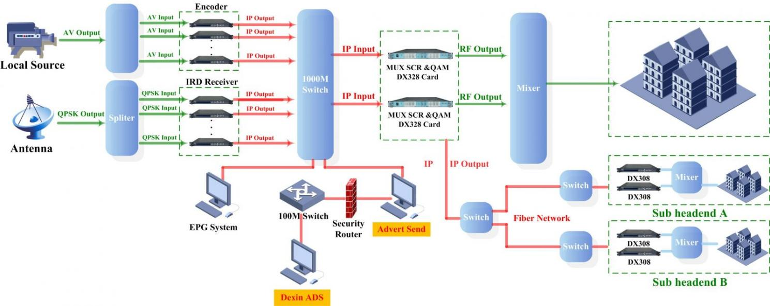
The FMUSER FUQ-ADS Advertising System enables DVB-standard ad insertion with 4 placement types (boot/EPG/volume/menu) via STB output. It processes JPEG/GIF/video/text ads through centralized scheduling tools. This 1RU rack-mount system integrates with existing digital TV headends via ASI/IP interfaces. Ideal for pay-TV operators requiring non-skippable ads and broadcasters implementing targeted promotions.The FMUSER FUQ-ADS Advertising System enables DVB-standard ad insertion with 4 placement types (boot/EPG/volume/menu) via STB output. It processes JPEG/GIF/video/text ads through centralized scheduling tools. This 1RU rack-mount system integrates with existing digital TV headends via ASI/IP interfaces. Ideal for pay-TV operators requiring non-skippable ads and broadcasters implementing targeted promotions.Specifications:
The FMUSER FUQ-ADS Advertising System enables DVB-standard ad insertion with 4 placement types (boot/EPG/volume/menu) via STB output. It processes JPEG/GIF/video/text ads through centralized scheduling tools. This 1RU rack-mount system integrates with existing digital TV headends via ASI/IP interfaces. Ideal for pay-TV operators requiring non-skippable ads and broadcasters implementing targeted promotions.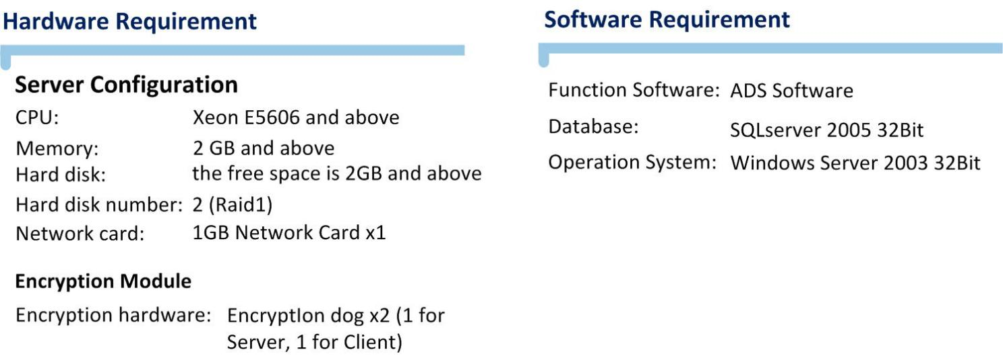
The FMUSER FUQ-ADS Advertising System enables DVB-standard ad insertion with 4 placement types (boot/EPG/volume/menu) via STB output. It processes JPEG/GIF/video/text ads through centralized scheduling tools. This 1RU rack-mount system integrates with existing digital TV headends via ASI/IP interfaces. Ideal for pay-TV operators requiring non-skippable ads and broadcasters implementing targeted promotions.Main Function Overview:
The FMUSER FUQ-ADS Advertising System enables DVB-standard ad insertion with 4 placement types (boot/EPG/volume/menu) via STB output. It processes JPEG/GIF/video/text ads through centralized scheduling tools. This 1RU rack-mount system integrates with existing digital TV headends via ASI/IP interfaces. Ideal for pay-TV operators requiring non-skippable ads and broadcasters implementing targeted promotions.The FMUSER FUQ-ADS Advertising System enables DVB-standard ad insertion with 4 placement types (boot/EPG/volume/menu) via STB output. It processes JPEG/GIF/video/text ads through centralized scheduling tools. This 1RU rack-mount system integrates with existing digital TV headends via ASI/IP interfaces. Ideal for pay-TV operators requiring non-skippable ads and broadcasters implementing targeted promotions.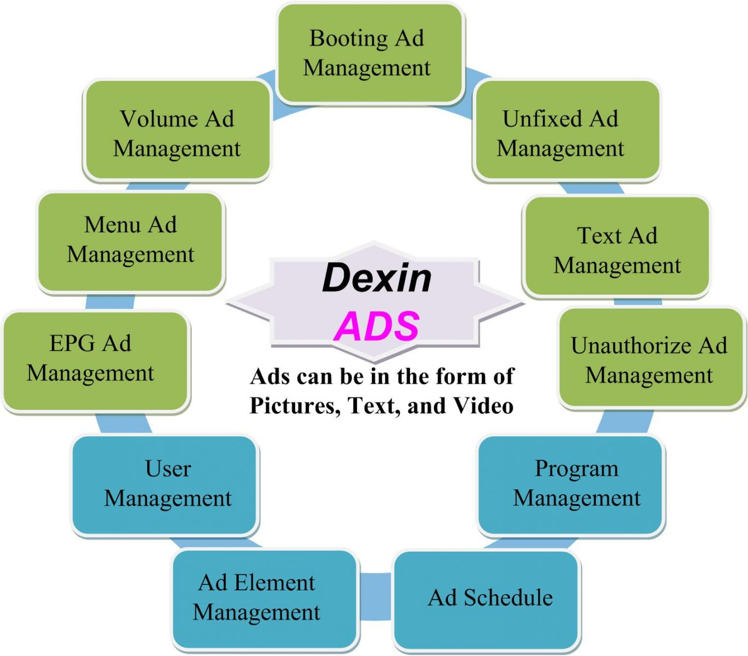
The FMUSER FUQ-ADS Advertising System enables DVB-standard ad insertion with 4 placement types (boot/EPG/volume/menu) via STB output. It processes JPEG/GIF/video/text ads through centralized scheduling tools. This 1RU rack-mount system integrates with existing digital TV headends via ASI/IP interfaces. Ideal for pay-TV operators requiring non-skippable ads and broadcasters implementing targeted promotions.The FMUSER FUQ-ADS Advertising System enables DVB-standard ad insertion with 4 placement types (boot/EPG/volume/menu) via STB output. It processes JPEG/GIF/video/text ads through centralized scheduling tools. This 1RU rack-mount system integrates with existing digital TV headends via ASI/IP interfaces. Ideal for pay-TV operators requiring non-skippable ads and broadcasters implementing targeted promotions.The FMUSER FUQ-ADS Advertising System enables DVB-standard ad insertion with 4 placement types (boot/EPG/volume/menu) via STB output. It processes JPEG/GIF/video/text ads through centralized scheduling tools. This 1RU rack-mount system integrates with existing digital TV headends via ASI/IP interfaces. Ideal for pay-TV operators requiring non-skippable ads and broadcasters implementing targeted promotions.User Management
As a basic function of advertising system, user management is for setting the user ID and login password to protect your ad information.The FMUSER FUQ-ADS Advertising System enables DVB-standard ad insertion with 4 placement types (boot/EPG/volume/menu) via STB output. It processes JPEG/GIF/video/text ads through centralized scheduling tools. This 1RU rack-mount system integrates with existing digital TV headends via ASI/IP interfaces. Ideal for pay-TV operators requiring non-skippable ads and broadcasters implementing targeted promotions.Program Management
User can import or add programs in this section and form a program table. Operators can edit information for each program as needed, like modify the program name or network ID etc.
Booting Ad Management
Booting Ad refers to the startup image showing on the TV screen when the STB is turned on. The image can be a JPEG, GIF, flash or video. The duration is better to be around 5 secoFU. Different startup images can not only bring fat profit to operators as this step often receives a 100% audience rating, but also make it more entertaining when the audience get their first sight of TV screen.The FMUSER FUQ-ADS Advertising System enables DVB-standard ad insertion with 4 placement types (boot/EPG/volume/menu) via STB output. It processes JPEG/GIF/video/text ads through centralized scheduling tools. This 1RU rack-mount system integrates with existing digital TV headends via ASI/IP interfaces. Ideal for pay-TV operators requiring non-skippable ads and broadcasters implementing targeted promotions.Menu Ad Management
As a navigation page, menu is where audience enter frequently. Menu Ad is the graphics synchronously displaying with Menu page. It can be a very eye-catching picture or video and it displays for a relative long time to ensure a good effect of advertising.
EPG Ad Management
Audience always change channels whenever they want to watch another program or dislike one program. It then comes an opportunity to display an Ad (a picture or a small video) next to the program information bar at the bottom of the screen. The ad duration will be as long as program info bar presents itself. Operators also can set different ads between different channel interval. The FMUSER FUQ-ADS Advertising System enables DVB-standard ad insertion with 4 placement types (boot/EPG/volume/menu) via STB output. It processes JPEG/GIF/video/text ads through centralized scheduling tools. This 1RU rack-mount system integrates with existing digital TV headends via ASI/IP interfaces. Ideal for pay-TV operators requiring non-skippable ads and broadcasters implementing targeted promotions.Volume Ad Management
Adjusting the volume is a common activity when audience watch TV. The Ad pops out next to the volume bar at the bottom of the screen. This ad conforms to the viewing habits of audience to boost the ad contact efficiency.
Unfixed Ad Management
This ad form is very flexible since it can be released in any channel, and placed at any place of the screen. It can be a picture or a video.
Unauthorize Ad Management
Unauthorize Ad refers to the picture or video showing on the screen when the audience browse channels and come across an unauthorized channel.
Text Ad Management
This ad is fixed to be text. It is a one-line passage scrolling at the top or bottom of the TV screen. It also can be published to the designated channel.
Ad Element Management
Ad element is a material library to offer ad content to booting ad, menu ad, volume ad and etc. Users can build an ad base to make it more convenient to insert an ad.
Ad Schedule
In this section, operators can have an overview of the settled EPG, volume and text ads and their publish channel, time duration. They also can be edited in this section, like adjusting the time duration and add new ads.
The FMUSER FUQ-ADS Advertising System enables DVB-standard ad insertion with 4 placement types (boot/EPG/volume/menu) via STB output. It processes JPEG/GIF/video/text ads through centralized scheduling tools. This 1RU rack-mount system integrates with existing digital TV headends via ASI/IP interfaces. Ideal for pay-TV operators requiring non-skippable ads and broadcasters implementing targeted promotions.The FMUSER FUQ-ADS Advertising System enables DVB-standard ad insertion with 4 placement types (boot/EPG/volume/menu) via STB output. It processes JPEG/GIF/video/text ads through centralized scheduling tools. This 1RU rack-mount system integrates with existing digital TV headends via ASI/IP interfaces. Ideal for pay-TV operators requiring non-skippable ads and broadcasters implementing targeted promotions.Real Case View:
The FMUSER FUQ-ADS Advertising System enables DVB-standard ad insertion with 4 placement types (boot/EPG/volume/menu) via STB output. It processes JPEG/GIF/video/text ads through centralized scheduling tools. This 1RU rack-mount system integrates with existing digital TV headends via ASI/IP interfaces. Ideal for pay-TV operators requiring non-skippable ads and broadcasters implementing targeted promotions.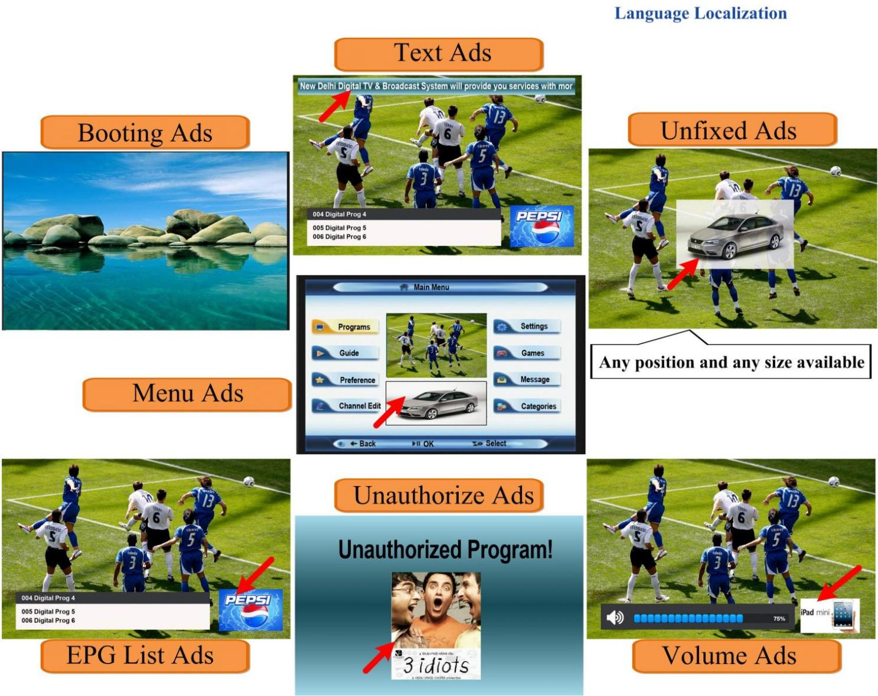
The FMUSER FUQ-ADS Advertising System enables DVB-standard ad insertion with 4 placement types (boot/EPG/volume/menu) via STB output. It processes JPEG/GIF/video/text ads through centralized scheduling tools. This 1RU rack-mount system integrates with existing digital TV headends via ASI/IP interfaces. Ideal for pay-TV operators requiring non-skippable ads and broadcasters implementing targeted promotions.

About Us
FMUSER is a company specializing in broadcasting and television transmission systems and integrating hotel IPTV systems. The company was established in 2009 and has served over 180 countries worldwide. More than 20,000 television stations, radio stations, and hotel clients from different.

Contact:Tomleequan Email：sales@fmuser.com whatsapp: +8613922702227

