FMUSER FUQ-NEP10 IP Gateway 8-12 HD-SD Program Conversion SRT-HTTP-UDP-RTP-RTSP-HLS to RTMP Dual Ethernet IP Anti-Jitter Broadcast IPTV Headend 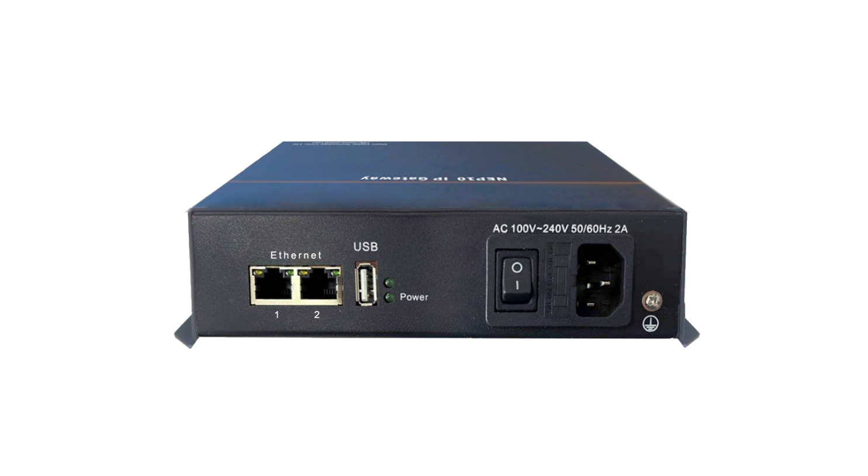
Product overview
The FMUSER FUQ-NEP10 IP Gateway converts broadcast IP streams between SRT/HTTP/UDP/RTP/RTSP/HLS protocols with RTMP output. It processes 8-12 concurrent HD/SD programs at 8Mbps using IP anti-jitter technology. Dual Ethernet ports (1x full I/O, 1x low-bitrate input) enable flexible deployment. Managed via web-based NMS, this 1RU device suits multi-screen IPTV headends and hybrid broadcast-OTT systems.
Key feature
IP anti-jitter: Ensures stable stream transmission
IP Protocol Conversion
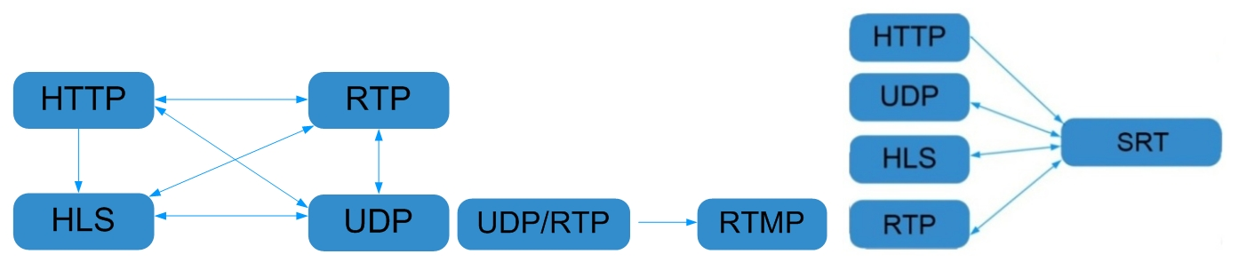

General Principle Chart
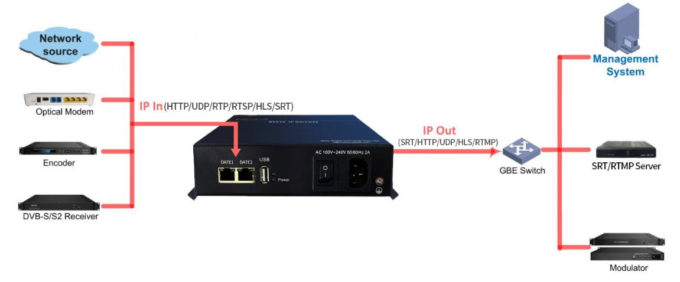

Specifications
IP Input | IP input through Ethernet1/ Ethernet2 over SRT, HTTP, UDP, RTP/RTSP and HLS.
IP output | IP output through Ethernet1 over SRT, HTTP, UDP, HLS, RTMP and RTP/RTSP.
System | Support about 8-12 HD/SD programs (Bitrate:8Mbps) conversion
System | Web-based NMS management through Ethernet port
General | Demission | 180mm×110mm×40mm (WxLxH)
General | Temperature | 0~45℃(operation), -20~80℃(storage)
General | Power Supply | AC100V±10%, 50/60Hz or AC 220V±10%, 50/60Hz

Test data for reference:
Protocol conversion | Bit-Rate | Programs
UDP to SRT/HTTP/RTP/RTSP/HLS/RTMP | 3Mbps | 20
UDP to SRT | 8Mbps | 10
UDP to HTTP | 8Mbps | 12
UDP to RTP/RTSP | 8Mbps | 12
UDP to RTMP | 8Mbps | 12
UDP to HLS | 8Mbps | 12

Protocol conversion | Bit-Rate | Programs
SRT to UDP/RTP/RTSP/HLS | 3Mbps | 20
SRT to UDP | 8Mbps | 12
SRT to RTP/RTSP | 8Mbps | 12
SRT to HLS | 8Mbps | 12

About Us
FMUSER is a company specializing in broadcasting and television transmission systems and integrating hotel IPTV systems. The company was established in 2009 and has served over 180 countries worldwide. More than 20,000 television stations, radio stations, and hotel clients from different.

Contact:Tomleequan Email：sales@fmuser.com whatsapp: +8613922702227

