FMUSER FUQ-OSD100 OSD Logo Insertion Device 1-Channel Input DVB-ASI-IP Interfaces Broadcast-Grade Signal Processing Logo-OSD Overlay for TV Stations and Hotel IPTV

Product overview
FMUSER OSD LOGO Insertion enables real-time logo/OSD overlay into broadcast streams via 1-channel DVB-ASI or IP input. The device preserves signal integrity during insertion, compliant with broadcast standards. Compact 1RU rack-mountable design with web-based control, ideal for television stations requiring on-screen branding and hospitality IPTV systems for customized guest content.
Key feature
Global client base with 20,000+ installations across 180+ countries
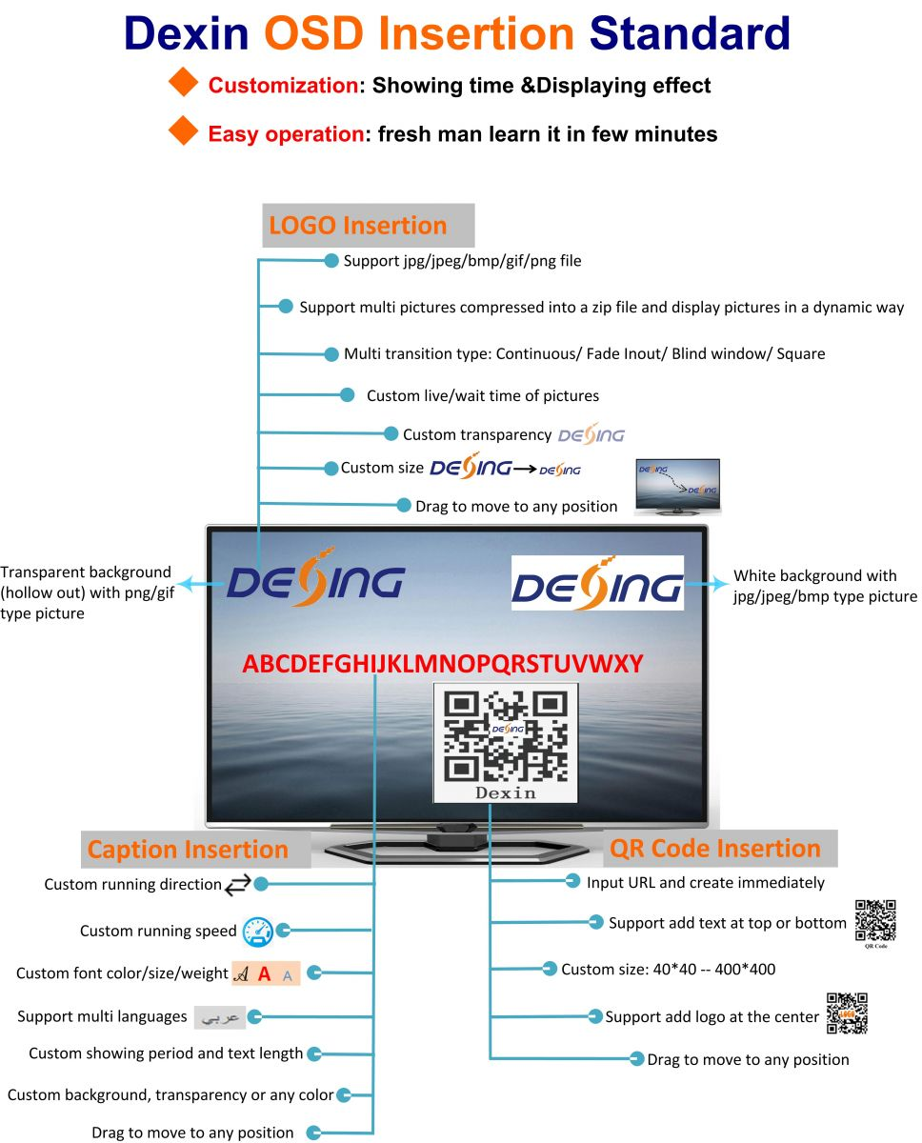
About Us
FMUSER is a company specializing in broadcasting and television transmission systems and integrating hotel IPTV systems. The company was established in 2009 and has served over 180 countries worldwide. More than 20,000 television stations, radio stations, and hotel clients from different.

Contact:Tomleequan Email：sales@fmuser.com whatsapp: +8613922702227

