FMUSER FUQ-SMS System Subscriber Management Platform Million-Level Capacity CAS Integration SMS-Based Mobile Charging Digital Headend Broadcast Operations Product Overview
The FMUSER FUQ-SMS System is a scalable subscriber management platform supporting million-level users with CAS-compatible interfaces. It processes entitlement data via batch distribution and enables SMS-based mobile charging. The system adopts modular C/S architecture for flexible deployment across IP networks. Ideal for digital TV operators requiring high-capacity user management and pay-per-view service providers needing multi-payment integration.
Solution Guide

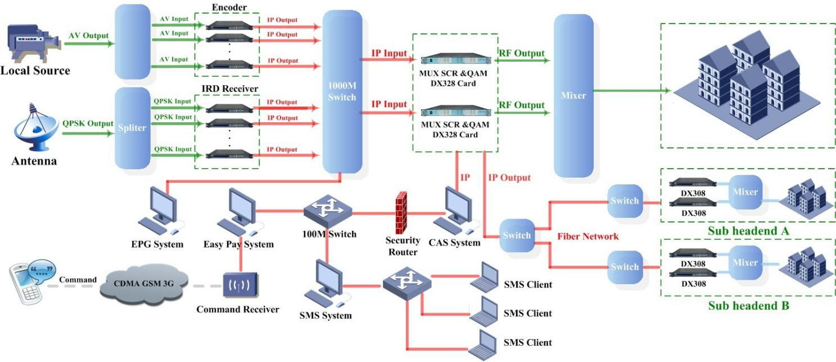

Key feature
API integration with SMS gateways and billing systems

About Us
FMUSER is a company specializing in broadcasting and television transmission systems and integrating hotel IPTV systems. The company was established in 2009 and has served over 180 countries worldwide. More than 20,000 television stations, radio stations, and hotel clients from different.

Contact:Tomleequan Email：sales@fmuser.com whatsapp: +8613922702227

