FMUSER FUQ-XQR Professional TS Player USB 2.0 Input DVB-ASI-BNC Output 108Mbps DVB-Compliant HDTV-SDTV Signal Generator for DTV Equipment Testing and Development 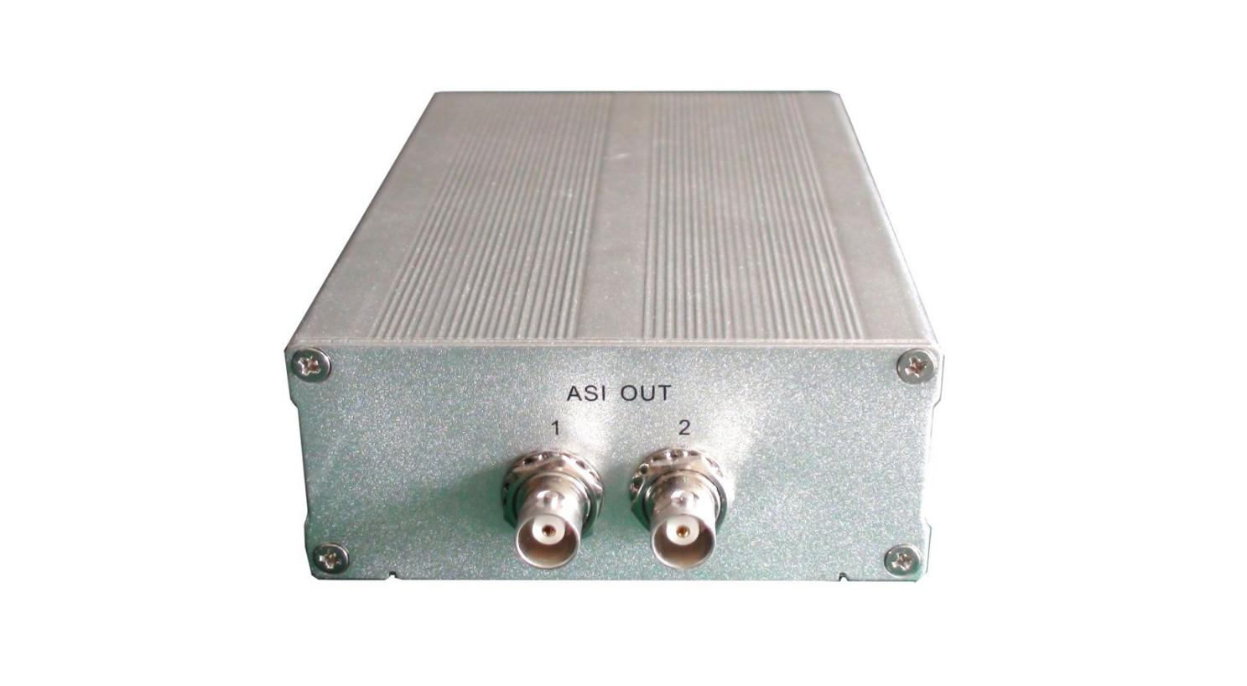
Product overview:
The FUQ-XQR Transport Stream Player provides DVB-standard TS file playback through USB 2.0 input and DVB-ASI/BNC output. It processes 188-byte packet Transport Streams at 108Mbps for HD/SD signal generation. Built with P4-2.0G CPU and 256MB DDR memory, this 1U rack-mount unit supports MPEG-2/MPEG-4/H.264 standards. Ideal for broadcast equipment R&D validation, manufacturing line testing, and digital headend system demonstrations.
Key feature:
Engineering-grade stability: P4-2.0G CPU sustains 108Mbps continuous throughput
Technical Specs:

Interfaces | INPUT: USB2.0
Interfaces | OUTPUT: DVB ASI , BNC
Packet Size | 188 bytes
System Configurations | OS: Windows 2000/XP Professional
System Configurations | CPU: P4-2.0G
System Configurations | Memory: 256M DDR
System Configurations | Storage: 80G WD JB hard disk
Applications | Signal generator for developing DTV system and equipments
Applications | Signal source for manufacturing of DTV system and equipments
Applications | Demo of DTV system and equipment
Physical/Environmental | Dimension: 160×114×33 (mm )
Physical/Environmental | Weight: 0.5kg
Physical/Environmental | Operating temperature: 0℃～+55℃
Physical/Environmental | Operating humidity: 10%～80%

About Us
FMUSER is a company specializing in broadcasting and television transmission systems and integrating hotel IPTV systems. The company was established in 2009 and has served over 180 countries worldwide. More than 20,000 television stations, radio stations, and hotel clients from different.

Contact:Tomleequan Email：sales@fmuser.com whatsapp: +8613922702227

