FMUSER FUQ-100 Network Encoder Processor 12-Channel Input HDMI-SDI to IP HEVC-H.265 H.264 Encoding Modular Encoder for Broadcast Streaming
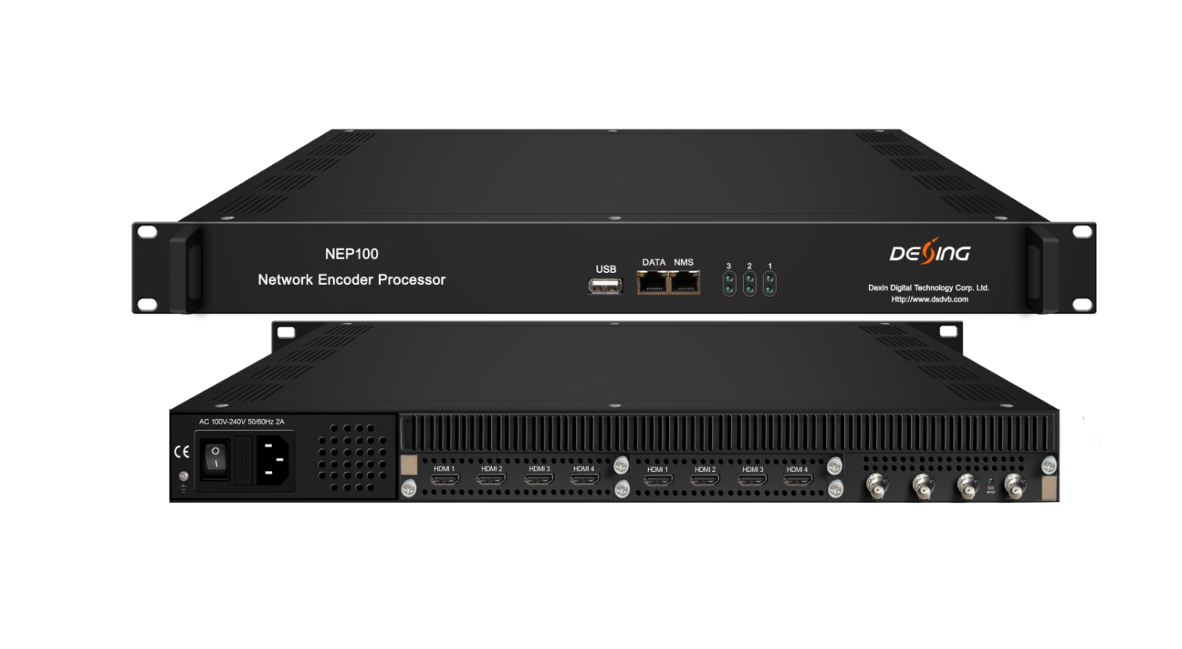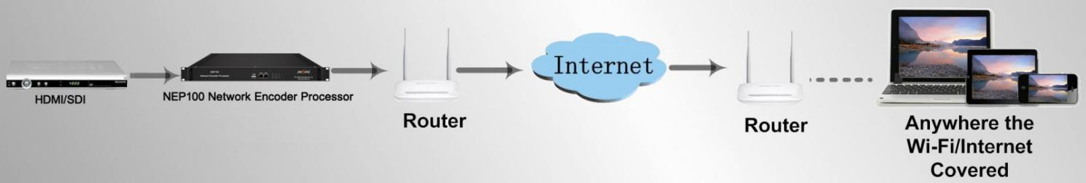

Product overview
The FMUSER FUQ-100 Network Encoder Processor converts HDMI or SDI inputs into IP streams for distribution. It encodes signals using HEVC/H.265 or H.264 standards. The compact 1U chassis features three slots for flexible modules. Ideal for broadcasting and streaming applications over LAN or internet.This 1-U chassis comes with 3 slots which allow loading different encoder modules with different interfaces and video formats.

Key feature
Modular 1U chassis with three slots supporting up to 12 HD inputs. Supports HDMI and SDI inputs with HEVC/H.265 or H.264 encoding. IP output via UDP, RTP, RTSP, RTMP, HTTP, HLS with 180Mbps throughput. Web-based management and USB upgrade for control.

Encoder Module Specifications
4 HDMI/SDI Encoding Module (DX224H/HV) 
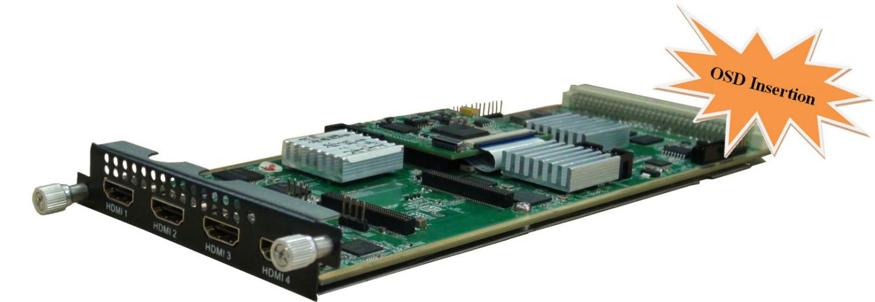
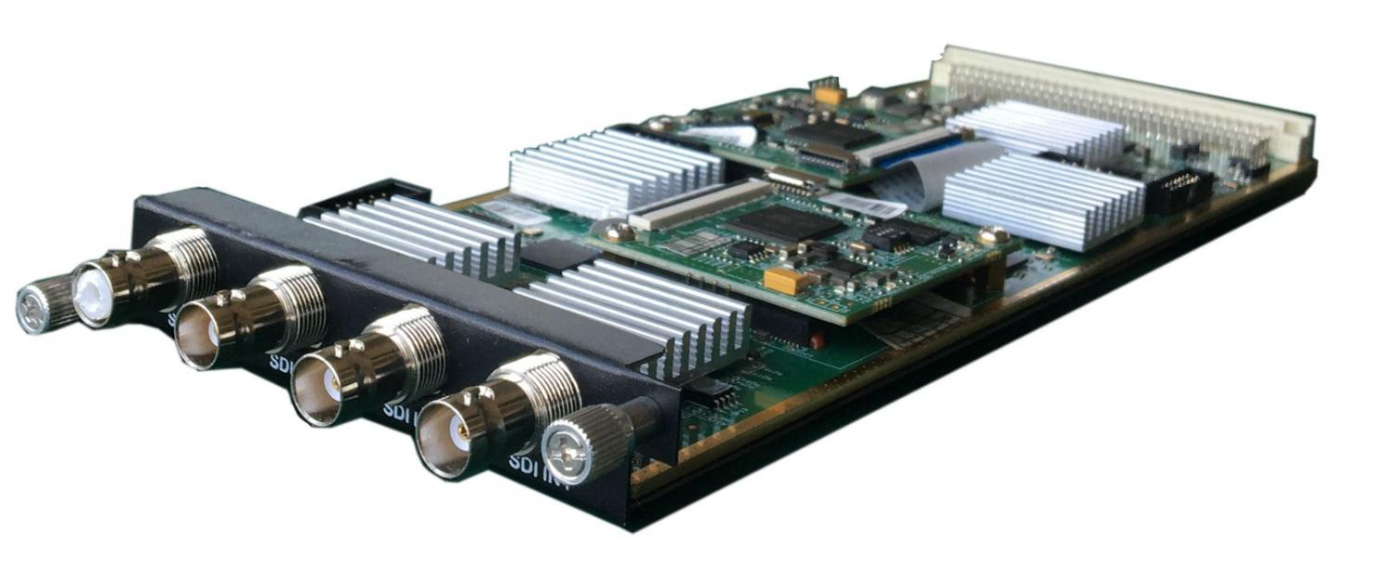
Module Specifications:
Input: 4×HDMI (1.4) input, HDCP 1.4, or 4×SDI input
Video Encoding:
Video format: HEVC/H.265 & MPEG 4 AVC/H.264
Resolution:
DX224HV | Input | Output
DX224HV | Input | HEVC/H.265 | MPEG-4 AVC/H.264
DX224HV | 4*1080P-50 | 4*1080P-50 | 4*1080P-25  2*1080P-50
DX224HV | 4*1080P-60/59.94 | 4*1080P-60,  4*1080P-59.94 | 4*1080P-30  4*1080P-29.97  2*1080P-60  2*1080P-59.94
DX224HV | 4*1080I-50 | 4*1080P-50,  4*1080P-25 | 4*1080I-50  4*1080P-25  2*1080P-50
DX224HV | 4*1080I-60/59.94 | 4*1080P-60,  4*1080P-30 | 4*1080I-60  4*1080P-30  2*1080P-60
DX224HV | 4*720P-50 | 4*720P-50 | 4*720P-50
DX224HV | 4*720P-60/59.94 | 4*720P-60,  4*720P-59.94 | 4*720P-60  4*720P-59.94
DX224H | Input | Output
DX224H | Input | HEVC/H.265 | MPEG-4 AVC/H.264
DX224H | 4*1080P-50 | 4*1080P-50 | 4*1080P-50
DX224H | 4*1080P-60/59.94 | 4*1080P-60,  4*1080P-59.94 | 4*1080P-60  4*1080P-59.94
DX224H | 4*1080I-50 | 4*1080P-50,  4*1080P-25 | 4*1080P-25  4*1080P-50  4*1080I-50
DX224H | 4*1080I-60/59.94 | 4*1080P-60,  4*1080P-30 | 4*1080P-30  4*1080P-60  4*1080I-60
DX224H | 4*720P-50 | 4*720P-50 | 4*720P-50
DX224H | 4*720P-60/59.94 | 4*720P-60,  4*720P-59.94 | 4*720P-60  4*720P-59.94
Chroma: 4:2:0
Bit rate (each channel): 0.5Mbps~20Mbps (H.265), 4 Mbps~20Mbps (H.264)
Rate Control: CBR/VBR
GOP structure: IBBP, IPPP
Audio Encoding:
Audio format: MPEG-1 Layer 2, LC-AAC, HE-AAC, HE-AAC V2, AC3 Passthrough
Sampling rate: 48KHz
Bit-rate (each channel):
48Kbps~384Kbps (MPEG-1 Layer 2 & LC-AAC)
24 Kbps~128 Kbps (HE-AAC)
18 Kbps~56 Kbps (HE-AAC V2)
Audio Gain: 0~255
Support Logo, QR Code insertion--Optional as per order

System Diagram Illustration:
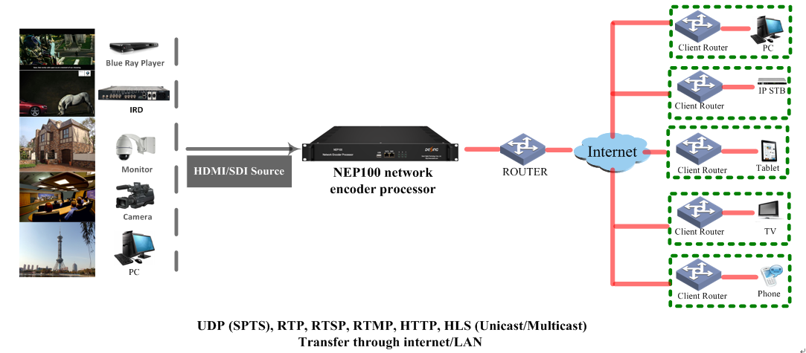

Equipment Specifications:

Dimension(W×L×H): 440mm×324mm×44mm
Approx weight: 6kg
Environment: 0~45℃(work); -20~80℃(Storage）
Power requirements: AC 110V± 10%, 50/60Hz, AC 220 ± 10%, 50/60Hz

About Us
FMUSER is a company specializing in broadcasting and television transmission systems and integrating hotel IPTV systems. The company was established in 2009 and has served over 180 countries worldwide. More than 20,000 television stations, radio stations, and hotel clients from different.

Contact:Tomleequan Email：sales@fmuser.com whatsapp: +8613922702227

