FMUSER FUQ-1000 USB-IR Control Cable 10 Remote Keys IR Learning Modes STB Signal Stabilization Headend System Accessory 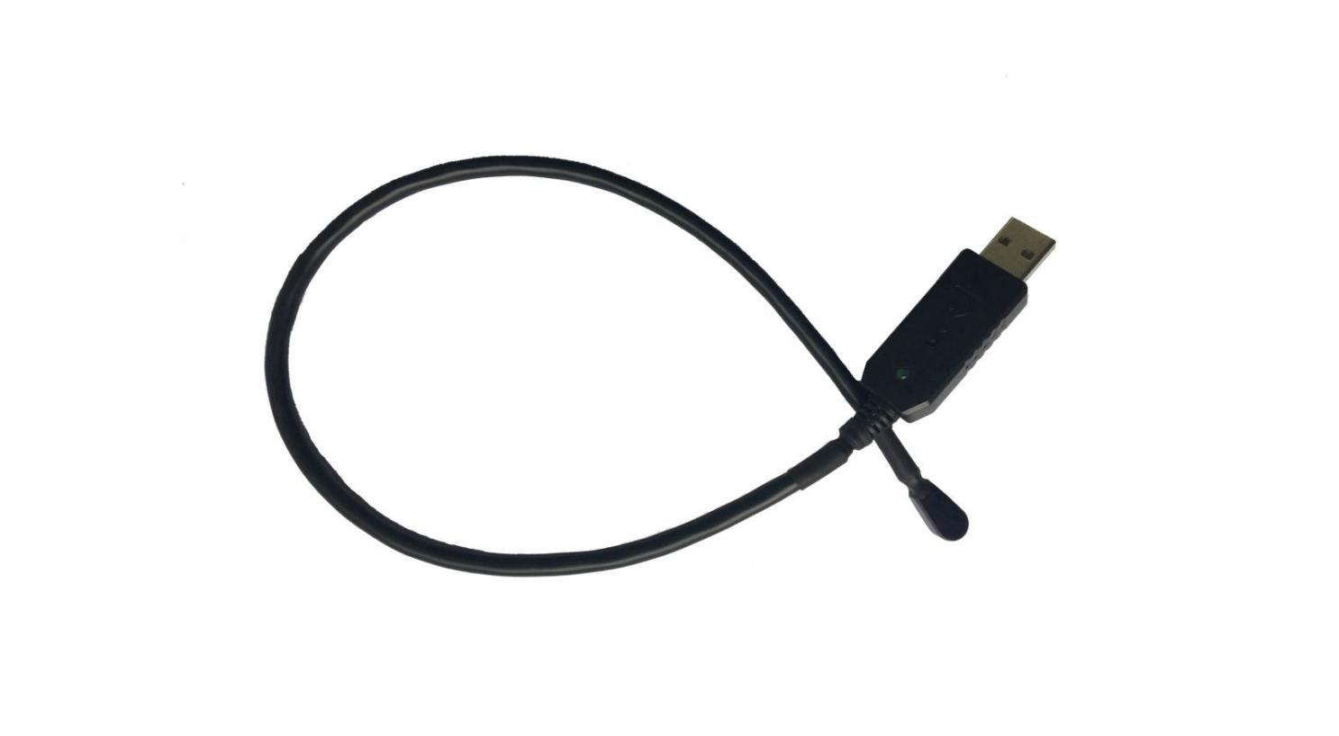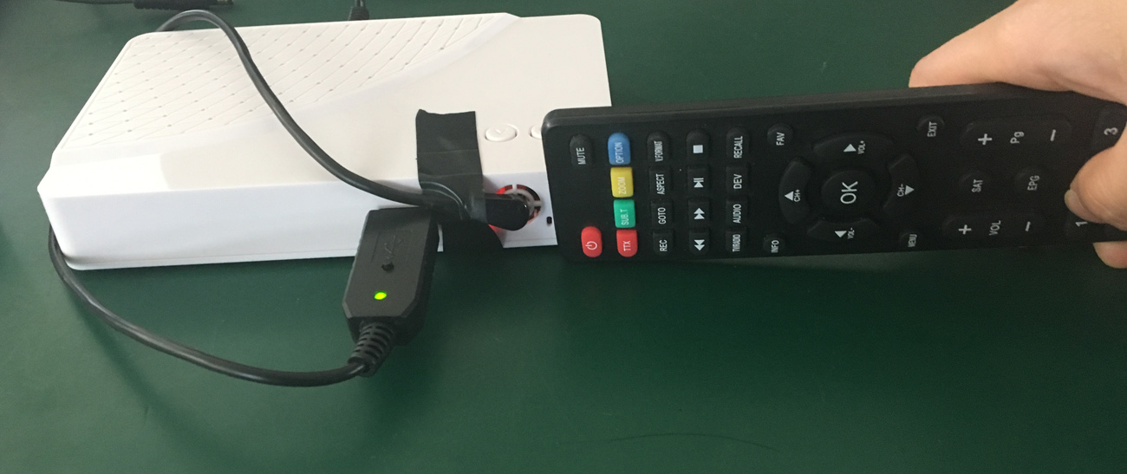
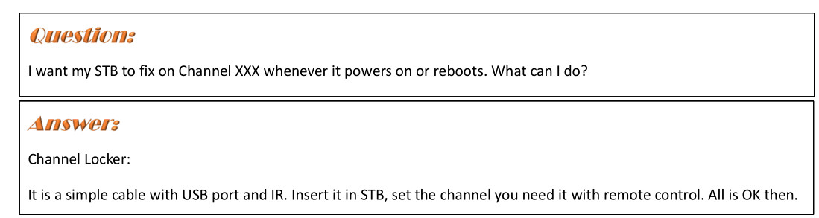

Product Overview
The FMUSER Channel Locker is a 45cm USB-to-infrared probe cable designed to stabilize headend systems with multiple STBs. It learns and emulates up to 10 remote control keys to maintain uninterrupted signal flow during disruptions. Features 5 adjustable IR learning modes for compatibility with various STB response speeds. Ideal for broadcast facilities and cable operators requiring fail-safe STB control during power outages or system reboots.
Key feature
Ensures signal continuity during unplanned STB reboots or power failures
About Us
FMUSER is a company specializing in broadcasting and television transmission systems and integrating hotel IPTV systems. The company was established in 2009 and has served over 180 countries worldwide. More than 20,000 television stations, radio stations, and hotel clients from different.

Contact:Tomleequan Email：sales@fmuser.com whatsapp: +8613922702227

