FMUSER FUQ-1000A IPTV Hotel System Integrated Platform Live TV VOD CAS PMS IP Output Hardware Decoding Ad Insertion Hospitality Healthcare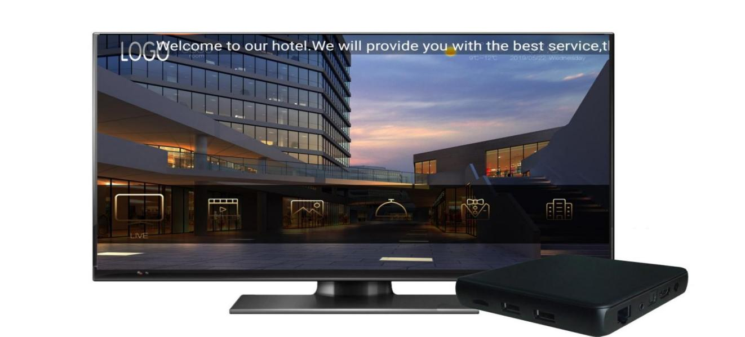
Solution Map
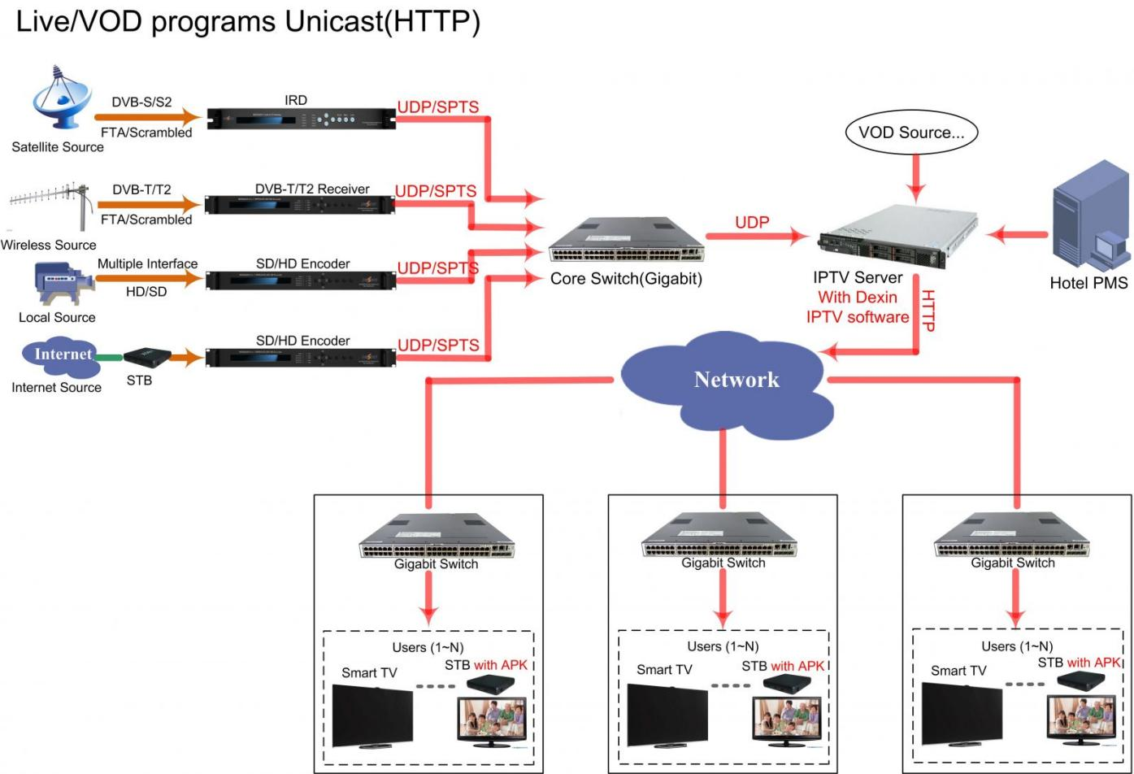

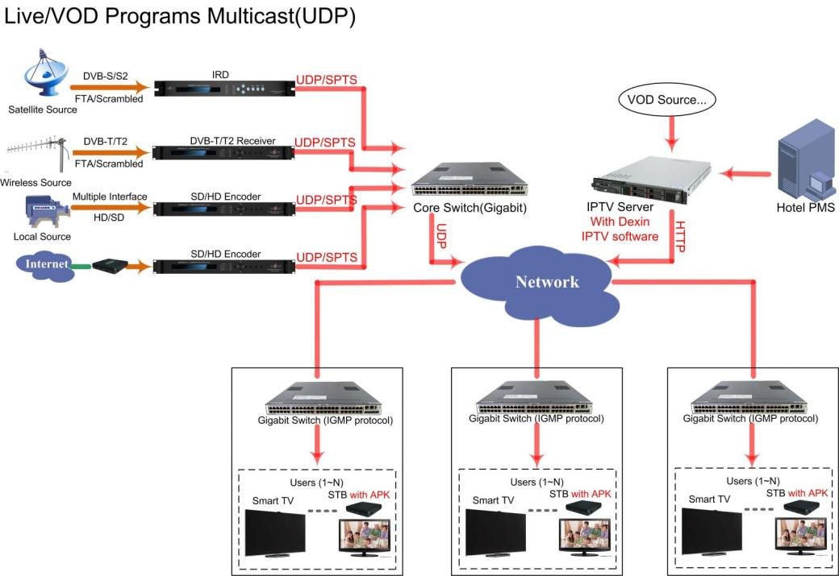

Product Overview
The FMUSER IPTV System is a multifunctional platform supporting Live TV, VOD (1080P/60Hz), CAS, and PMS integration via IP output. It processes satellite/cable signals and hotel-generated content through hardware decoding and ad insertion. The 1U rack-mountable unit is controllable via web-based NMS, designed for hotels and hospitals to enhance guest services and operational workflows.
Key feature
Features web-based NMS control for centralized system administration
Functions
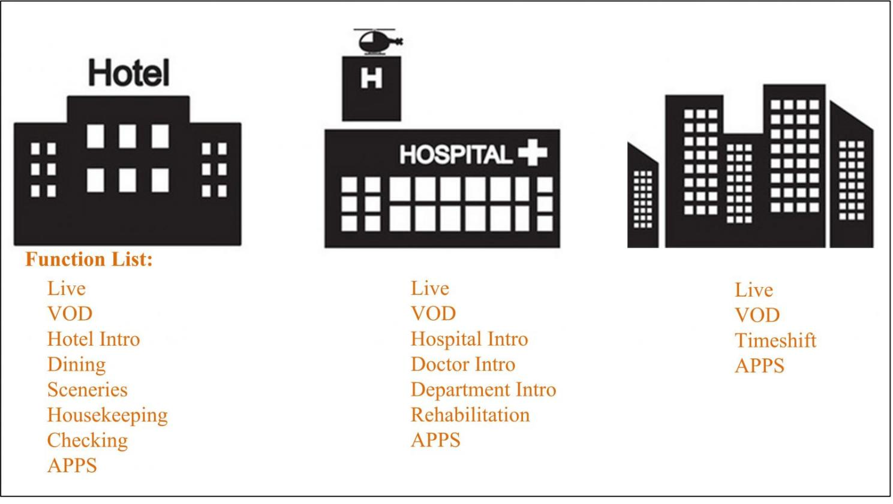
Advantages
Live Channel/Playback
- Support HD/SD cable channel, satellite channel and hotel self-made channel broadcast
- Support playback shifted live channel, shifting duration can be customized

VOD
- Support up to 1080P/60Hz full HD video
- Support hardware decoding, play HD videos smoothly
- Classify movie files, convenient for selecting

Advertisement System—Value added Services
- Hotel or hospital owners can set up advertisement business to increase revenues.
- Ad modes include booting ad, VOD ad, pictures and text ad etc

Mass HD Programs
- Support 1080P/60Hz full HD video
- Mass resource of Video on Demand including movies, entertainments, factual shows and etc

CAS (Conditional Access System)
- Our conditional access system gives the customer choice over pay channels and which prevent unauthorized access.

PMS integration
- Support IPTV system integrate with hotel PMS

IPTV Server Recommended configuration
Number of STB | Server Configuration |  |  | Switch | Remarks
300≤ | IPTV Server：Dell730 | CPU: Xeon E5-2609 v3  Memory:16G  Network: Four-port Gigabit NIC  Storage：configure as needed (suggest 1T above) | 1 set | Gigabit | If the UDP protocol is adopted in live services, switches of access layer should support IGMP protocol.
500≤ | IPTV Server：Dell730 | CPU: Xeon E5-2640 v4  Memory:32G  Network: Four port Gigabit NIC  Storage：configure as needed (suggest 1T above) | 1 set | Gigabit | (1) If the system has high requirements for VOD services and video playback services, like online VOD is with over 300 terminals, it is strongly suggested to configure a storage server.  (2) If the UDP protocol is adopted in Live services, Switches of Access Layer should support IGMP protocol.
500≤ | IPTV Storage Server：OceanStor S2200T | Cache：16G  Storage：configure as needed | 1 set (Optional) | Gigabit
＞500 | IPTV Server：Dell730 | CPU: Xeon E5-2640 v4  Memory:32G  Network: Four port Gigabit NIC  Storage：configure as r needed (suggest 1T above) | 1 set | Gigabit Switches and Switches of Access Layer should support IGMP protocol | If the system has high requirements for VOD services and video playback services, like online VOD is with over 300 terminals, it is strongly suggested to configure a storage server. The specific model should consult storage server supplier.
＞500 | IPTV Storage Server | Storage：configure as needed | 1 set (Optional)
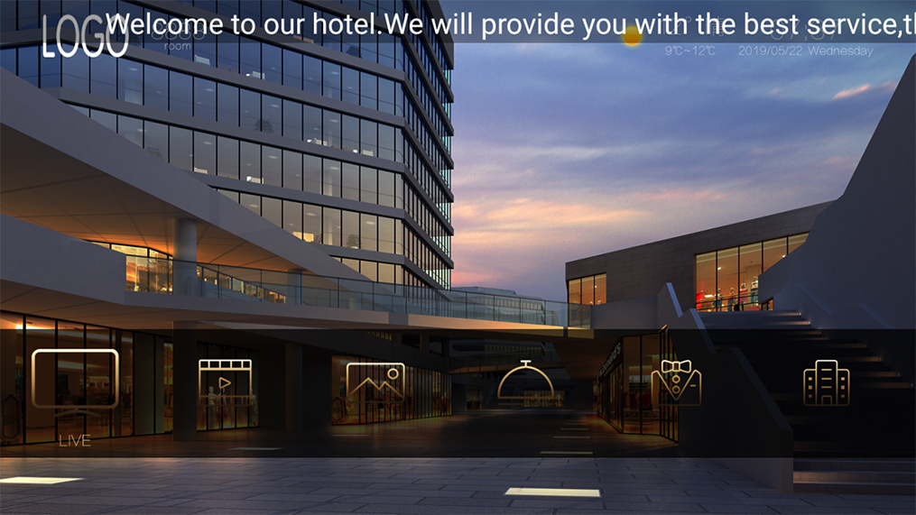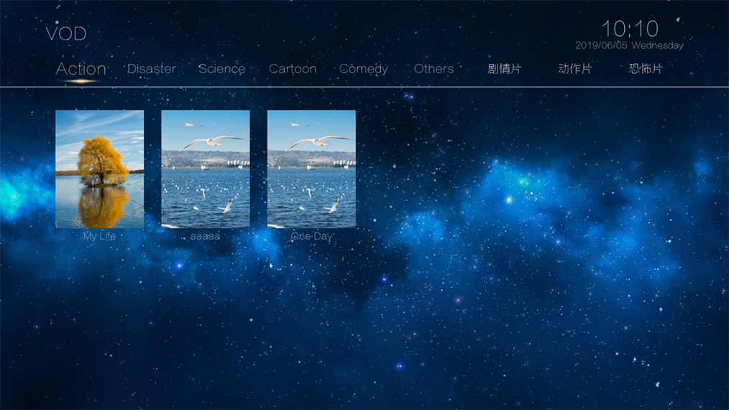
Main Interface VOD
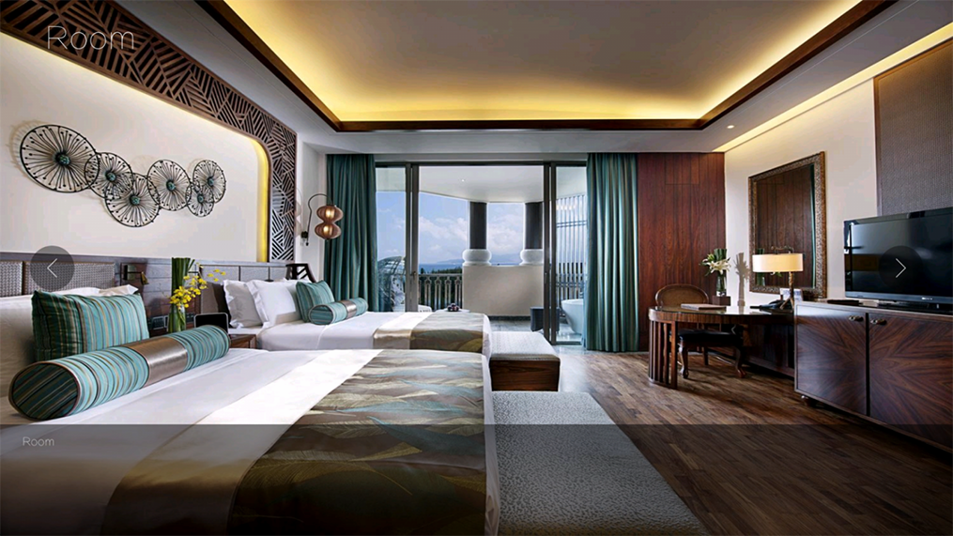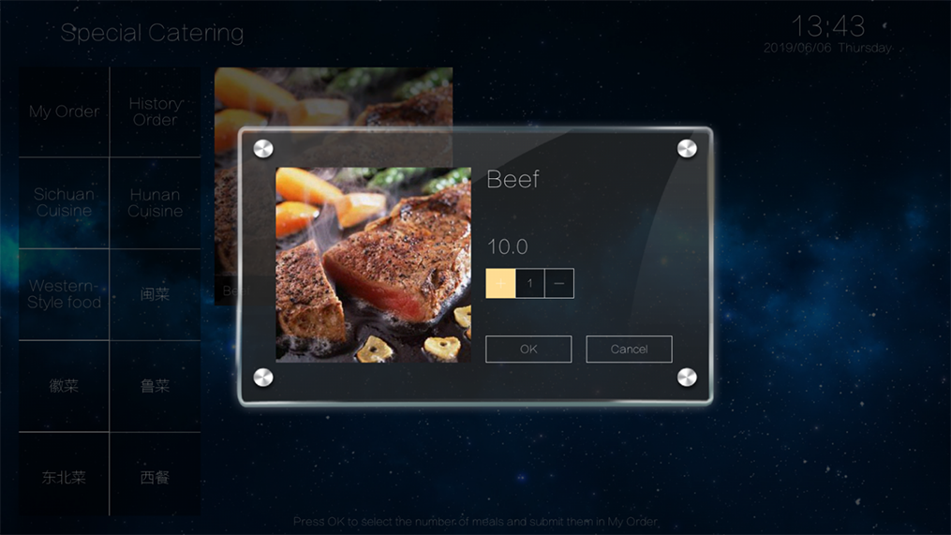
Hotel Introduction Food Ordering
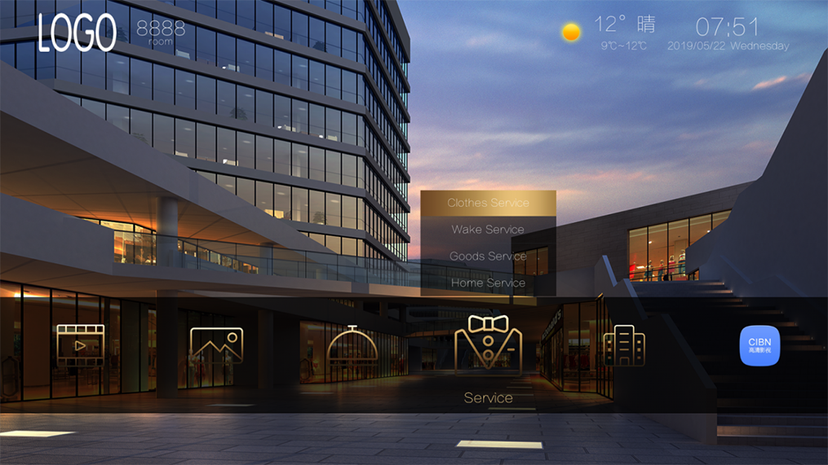
Scenery Introduction Service
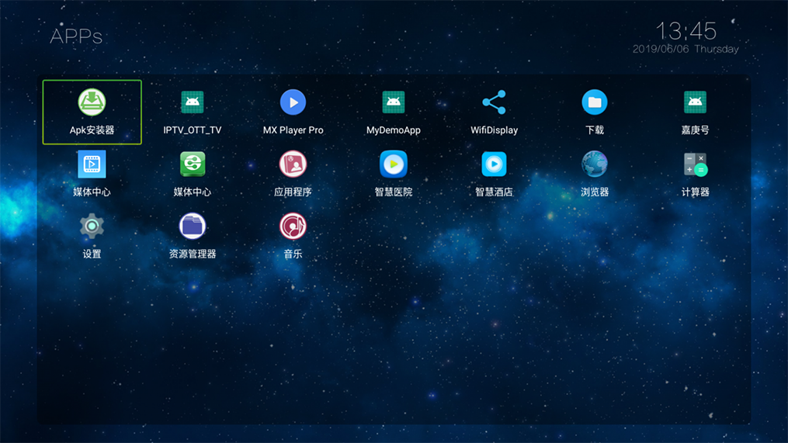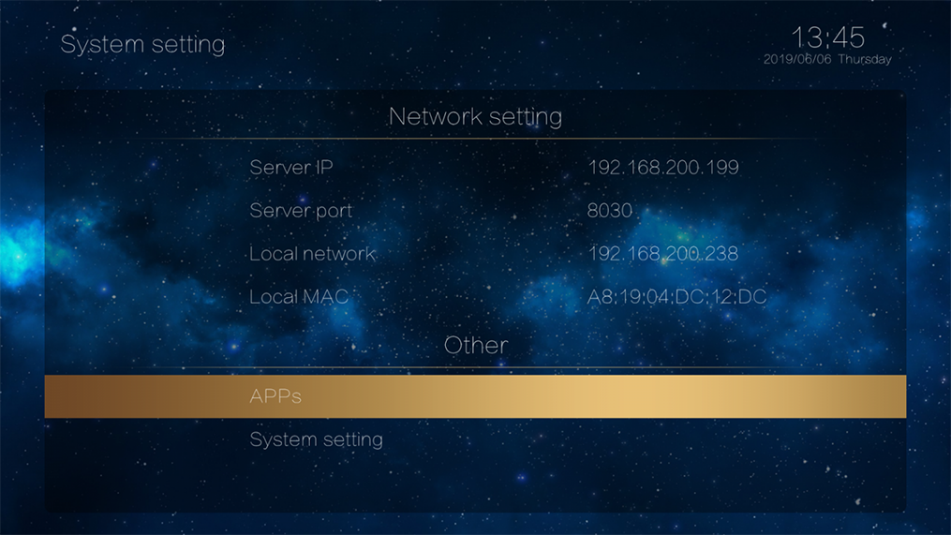
APPS Setting

About Us
FMUSER is a company specializing in broadcasting and television transmission systems and integrating hotel IPTV systems. The company was established in 2009 and has served over 180 countries worldwide. More than 20,000 television stations, radio stations, and hotel clients from different.

Contact:Tomleequan Email：sales@fmuser.com whatsapp: +8613922702227

