FMUSER FUQ-100B IPTV Server Modular System 1x HDMI-1x Tuner-IP Inputs SRT-HTTP-UDP-RTP-HLS Outputs RTMP-HLS-RTSP for Broadcast and Hospitality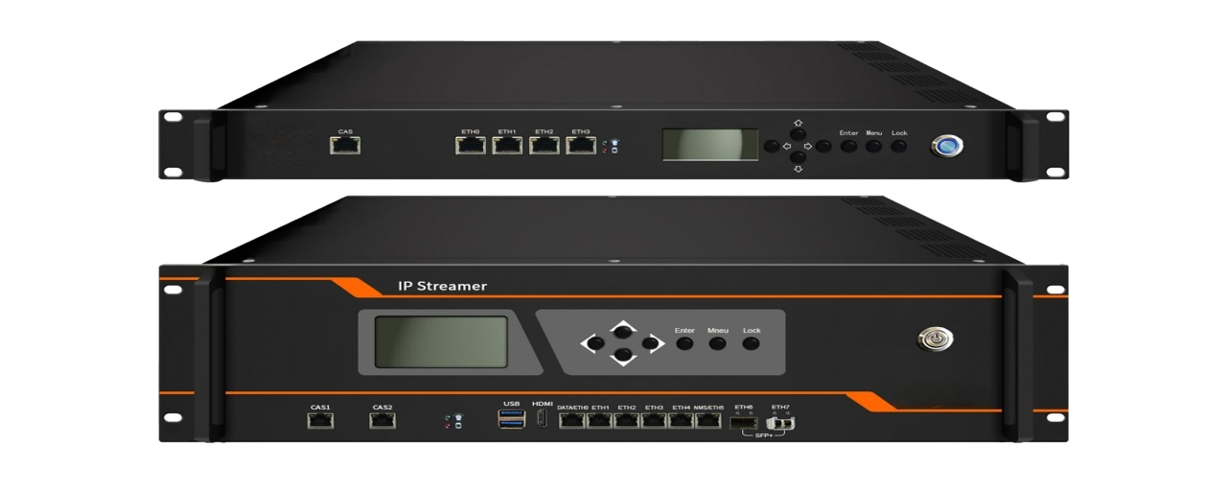products
Mutiple Inputs (HDMI+Tuner+IP over Multi-Protocol+TS file) + Multi-Protocol Conversion + IPTV Server

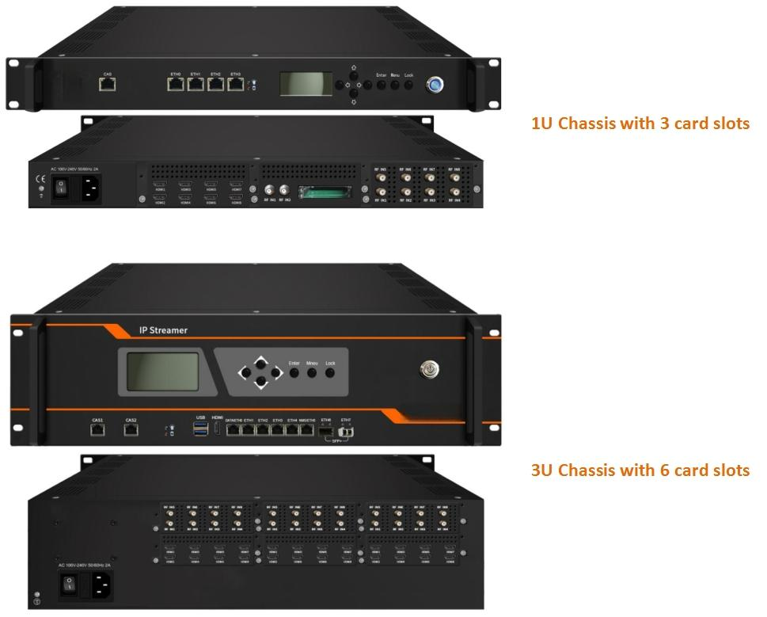

Application Example:
IPTV System as a Server
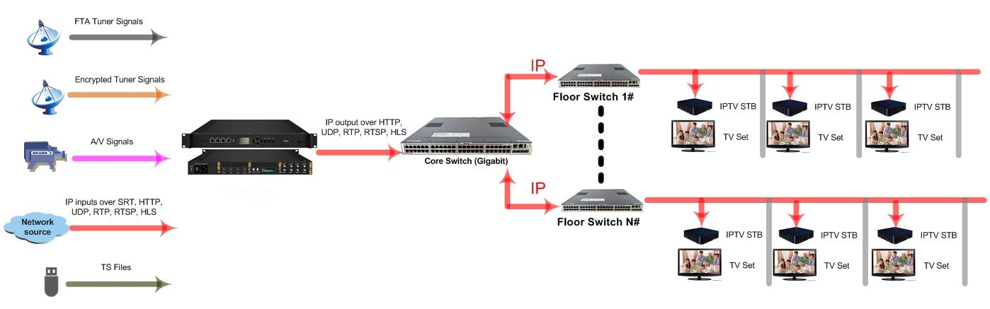

Protocol Conversion as a Streamer
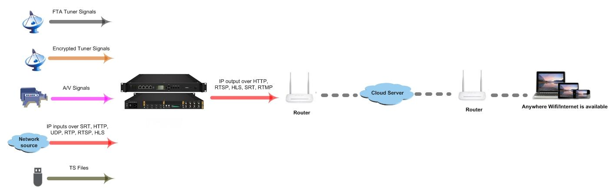

Product overview
The FMUSER FUQ-100B is a 1U/3U rack-mount modular system integrating IPTV server, stream transcoding, and multi-protocol gateway functions. It accepts 1x HDMI, 1x tuner signal, IP streams, and local TS files, converting them to RTMP/HLS/RTSP outputs via FMUSER's proprietary software. The chassis supports 3-6 hot-swappable cards (e.g., encoding/descrambling modules) with dual web GUIs for stream control and content management. Ideal for hotel TV systems and IP-based broadcast headends requiring modular scalability.
Key Features
Broadcast-grade IP tools: jitter compensation, LCD panel for network diagnostics* 2 separate Web GUI, one for Cards and Gateway, the other for IPTV Server
IP Protocol Conversion (example)
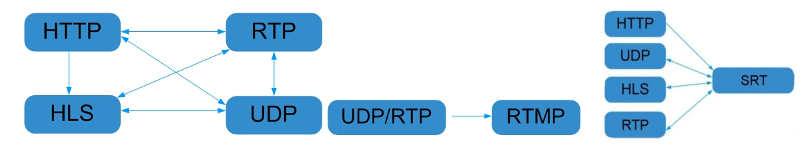

Specifications
Input | IP inputs thru ETH 1&2, GE ports over SRT,HTTP, UDP (SPTS), RTP(SPTS), RTSP (over UDP, payload: mpeg TS) and HLS | For 1U model
Input | IP inputs thru ETH 1-4 GE ports & 6-7 SFP+ ports over SRT,HTTP, UDP (SPTS), RTP(SPTS), RTSP (over UDP, payload: mpeg TS) and HLS | For 3U model
Input | TS files uploading through Web management
Input | Encoder card and Tuner card etc (Please refer to the detailed card spec below)
IP output | IP outputs thru ETH0, GE port over SRT, HTTP (Unicast), UDP(SPTS, Multicast) , RTP, RTSP, HLS and RTMP (Program source should be H.264 and AAC encoding)
System | Channel switching time with FMUSER’ STB: HTTP (1-3s), HLS (0.4-0.7s)
System | It is closely related with the program bitrate and protocol type etc for Max program numbers involved in protocol conversion, and the actual application shall prevail with maximum 80% CPU utilization (Please refer to Test data for reference in the end of the spec)
System | It is closely related with the program bitrate and protocol type etc for Max affordable terminal numbers in IPTV application of the STB/Android TV installed with FMUSER IPTV APK, and the actual application shall prevail with maximum 80% CPU utilization (Please refer to Test data for reference in the end of the spec)
System | IPTV Features: Live channel, VOD, Hotel intro, Dining, Hotel service, Scenery intro, APPS,Adding scrolling caption, welcome words, pictures, advertisement, video, music etc (the features are only applicable to IP out application in the STB/Android TV installed with FMUSER IPTV APK)
General | Demission (WxLxH) | 482mm×464mm×44mm (1U model)  482mm×493mm×133mm (3U model)
General | Management | 2 separate Web GUI (one for Cards and Gateway, the other for IPTV Server) through ETH3 (3U model through ETH5)
General | Temperature | 0~45℃(operation), -20~80℃(storage)
General | Power Supply | AC100V±10%, 50/60Hz or AC 220V±10%, 50/60Hz

Available Card Specification (more available cards later for development)
DX902A 2 Tuner Descrambling Card
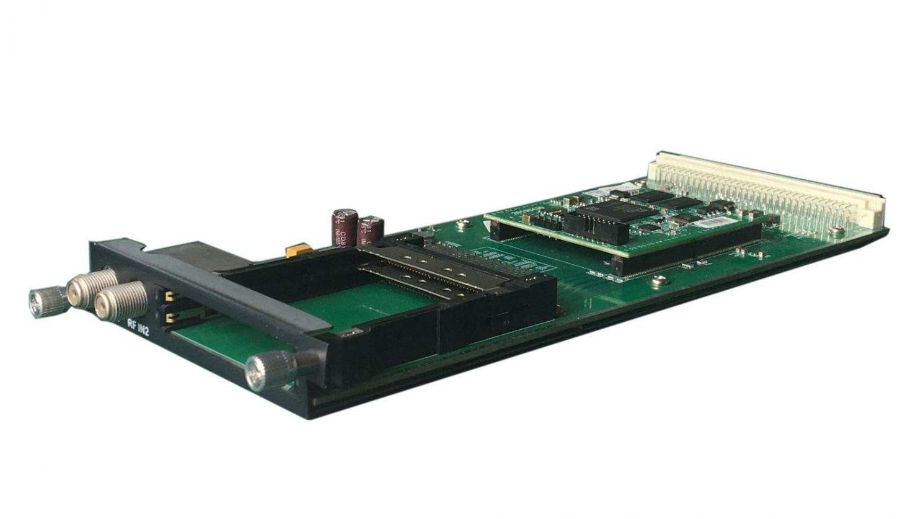
Stream in:
2 Tuner input, F Type,
Stream out:
16 SPTS output over UDP/RTP
DVB-CI:
2 independent common interface slots
Standard:
DVB-S/S2/S2X;

DVB-S
Input Frequency: 950-2150MHz
Symbol Rate: QPSK 1~45Msps
Signal Strength: -65~ -25dBm
FEC Demodulation: 1/2, 2/3, 3/4, 5/6, 7/8

DVB-S2
Input Frequency: 950-2150MHz
Symbol rate: QPSK/8PSK 1~45Msps
16APSK 1~45 Msps
32APSK1~32 Msps
FEC Demodulation: 1/2, 2/3, 3/4,5/6,7/8, 4/5,5/6,8/9, 9/10

DVB-S2X
Input Frequency: 950-2150MHz
Symbol rate: QPSK/8PSK/16APSK 0.5~45 Msps;
8APSK/32APSK: 0.5~40Msps
FEC Demodulation:
QPSK: 1/2, 3/5, 2/3, 3/4, 4/5, 5/6, 8/9, 9/10, 13/45, 9/20, 11/20
8PSK: 3/5, 2/3, 3/4, 5/6, 8/9, 9/10, 23/36, 25/36, 13/18
8APSK: 5/9-L, 26/45-L
16APSK: 2/3, 3/4, 4/5, 5/6, 8/9, 9/10,1/2-L, 8/15-L, 5/9-L, 26/45, 3/5, 3/5-L, 28/45, 23/36, 2/3-L, 25/36, 13/18, 7/9, 77/90
32APSK: 3/4, 4/5, 5/6, 8/9, 2/3-L, 32/45, 11/15, 7/9

Support Diseqc function

Multiplexing:
Maximum PID Remapping: 256 output pids
Function: PID remapping (automatically or manually), Accurate PCR adjusting, generate PSI/ SI table automatically
Descrambling:
CAM/CI Quantity: 2
BISS Mode: Mode 1, Mode E; 32 BISS Keys

DX942A 4 frequencies Descrambling Card
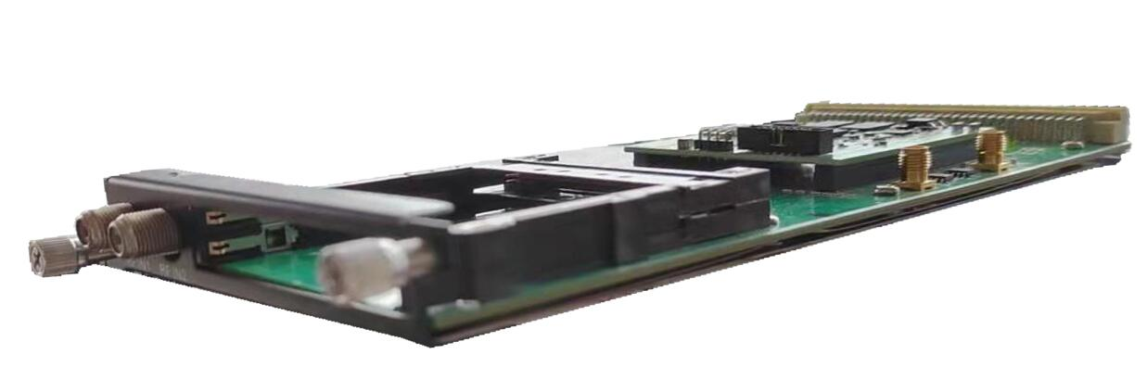
Stream in:
4 frequencies input (each RF in interface for 2 frequencies locking), F Type,
Stream out:
16 SPTS output over UDP/RTP
DVB-CI:
2 independent common interface slots
Standard: DVB-C (J.83 A/C)/J.83B/ DVB-T/DVB-T2/ISDB-T switchable

Standard: DVB-C (J.83 A/C); J.83B
Input Frequency: 60MHz~890MHz
Symbol rate: 1000~9000Ksps
Constellation: 16/32/64/128/256 QAM; 64/256 QAM for J.83B

Standard: DVB-T/T2
Frequency In: 60MHz~890MHz
Bandwidth: 5/6/7/8M bandwidth
PLP supported for DVB-T2

Standard: ISDB-T
Input Frequency: 60-890MHz

Multiplexing:
Maximum PID Remapping: 256 output pids
Function: PID remapping (automatically or manually), generate PSI/ SI table automatically
Descrambling:
CAM/CI Quantity: 2
BISS Mode: Mode 1, Mode E; 32 BISS Keys

DX228S 8 HDMI Encoder Card
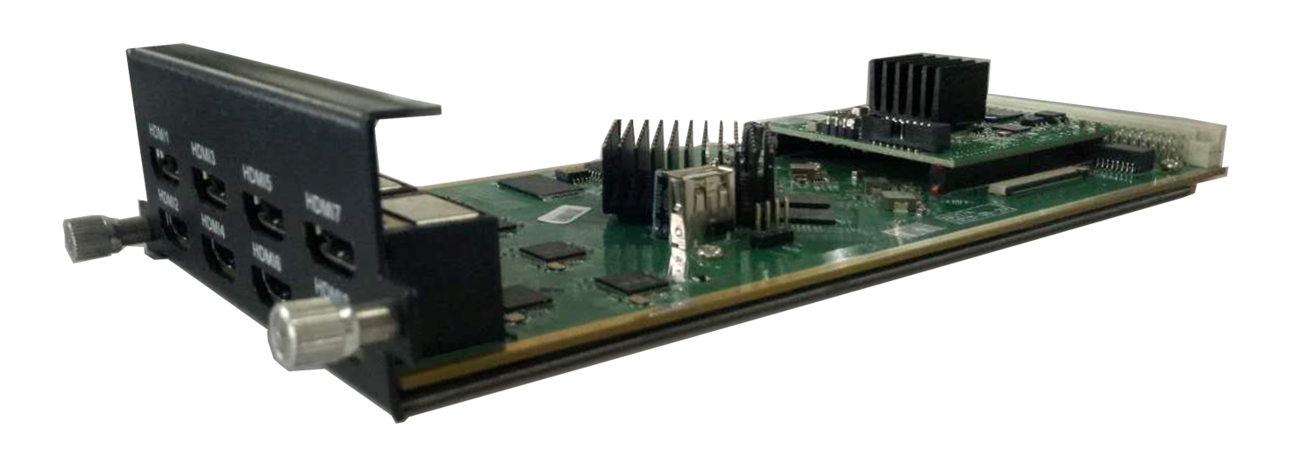

Input: 8*HDMI (4 HDMI is available)
Output: 8*SPTS (4 SPTS if 4 HDMI) output over UDP/RTP/RTSP, Unicast/Multicast
Video Encoding:
Video format: MPEG-4 AVC/H.264
Input resolution: 1920×1080_60P, 1920×1080_60i, 1920×1080_50P, 1920×1080_50i,1280×720_60P, 1280×720_50P, 720×576_50i, 720×480_60i,
Output resolution: 1920×1080_30P, 1920×1080_25P, 1280×720_30P, 1280×720_25P, 720×576_25P,720×480_30P,
GOP structure: IP…P (P Frame adjustment, without B Frame)
Video Bit-rate: 1Mbps~13Mbps each channel
Rate Control: CBR/VBR
Audio Encoding:
Audio format: MPEG1 Layer II, LC-AAC, HE-AAC and AC3 Pass through, support audio gain adjustment
Sampling rate: 48 KHz
Audio Bit-rate:
MPEG-1 Layer 2: 48/56/64/80/96/112/128/160/192/224/256/320/384 kbps
LC-AAC: 48/56/64/80/96/112/128/160/192/224/256/320/384 kbps
HE-AAC: 48/56/64/80/96/112/128 kbps

Support Logo, Caption, QR Code insertion

DX228S-V2 8 HDMI Encoder Card

Input: 8*HDMI (4 HDMI is available)
Output: 8*SPTS (4 SPTS if 4 HDMI) output over UDP/RTP/RTSP, Unicast/Multicast
Video Encoding:
Video format: HEVC/H.265, MPEG-4 AVC/H.264
Input resolution: 1920×1080_60P, 1920×1080_60i, 1920×1080_50P, 1920×1080_50i,1280×720_60P, 1280×720_50P, 720×576_50i, 720×480_60i,
Output resolution: 1920×1080_30P, 1920×1080_25P, 1280×720_30P, 1280×720_25P, 720×576_25P,720×480_30P,
GOP structure: IP…P (P Frame adjustment, without B Frame)
Video Bit-rate: 1Mbps~13Mbps each channel
Rate Control: CBR/VBR
Audio Encoding:
Audio format: MPEG1 Layer II, LC-AAC, HE-AAC and AC3 Pass through, support audio gain adjustment
Sampling rate: 48 KHz
Audio Bit-rate:
MPEG-1 Layer 2: 48/56/64/80/96/112/128/160/192/224/256/320/384 kbps
LC-AAC: 48/56/64/80/96/112/128/160/192/224/256/320/384 kbps
HE-AAC: 48/56/64/80/96/112/128 kbps

Support Logo, Caption, QR Code insertion

DX908 8 FTA DVB-S/S2/S2X Tuner Card
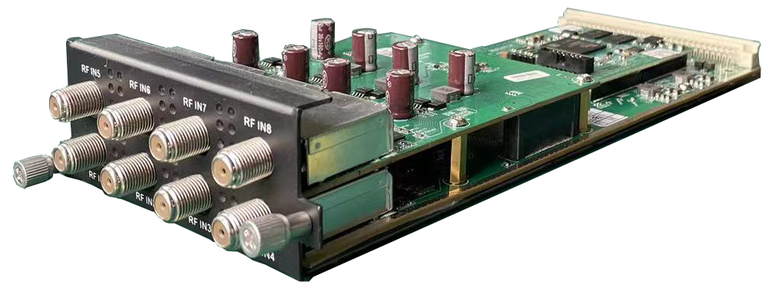

Stream in: 8 Tuner input, F Type,
Stream out: 512 SPTS out over UDP/RTP/RTSP, Unicast/Multicast
Tuner input: DVB-S/S2/S2X
Symbol rate: QPSK/8PSK/16APSK 0.5~45 Msps; 8APSK/32APSK: 0.5~40Msps
Input Frequency: 950-2150MHz

DVB-S Constellation: QPSK
FEC Demodulation: 1/2, 2/3, 3/4, 5/6, 7/8
DVB-S2 Constellation: QPSK/8PSK/16APSK/32APSK
FEC Demodulation:
QPSK: 1/2, 2/3, 3/4, 5/6, 3/5, 4/5, 8/9, 9/10
8PSK: 3/5, 2/3, 3/4, 5/6, 8/9, 9/10
16APSK: 2/3, 3/4, 4/5, 5/6, 8/9, 9/10
32APSK: 3/4, 4/5, 5/6, 8/9, 9/10
DVB-S2X Constellation: QPSK/8PSK/8APSK/16APSK/32APSK
FEC Demodulation:
QPSK: 1/2, 3/5, 2/3, 3/4, 4/5, 5/6, 8/9, 9/10, 13/45, 9/20, 11/20
8PSK: 3/5, 2/3, 3/4, 5/6, 8/9, 9/10, 23/36, 25/36, 13/18
8APSK: 5/9-L, 26/45-L
16APSK: 2/3, 3/4, 4/5, 5/6, 8/9, 9/10,1/2-L, 8/15-L, 5/9-L, 26/45, 3/5, 3/5-L, 28/45, 23/36, 2/3-L, 25/36, 13/18, 7/9, 77/90
32APSK: 3/4, 4/5, 5/6, 8/9, 2/3-L, 32/45, 11/15, 7/9, 9/10

Support Diseqc function

Multiplexing:
Maximum PID Remapping: 256 output pids
Function: PID remapping (automatically or manually), Accurate PCR adjusting, generate PSI/ SI table automatically

Descrambling:
BISS Mode: Mode 1, Mode E; up to 120Mbps, 32 BISS Key

DX928 8 FTA DVB-C/T/T2/ISDB-T Multi-Mode Tuner Card
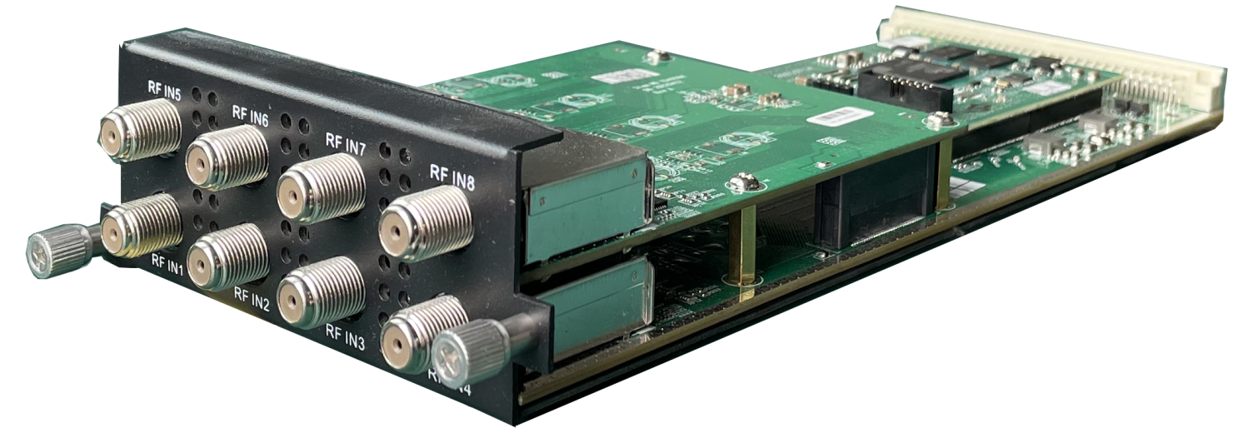

Stream in: 8 tuner input, F Type
Stream out: 512 SPTS out over UDP/RTP/RTSP, Unicast/Multicast

Tuner input: DVB-C (J.83 A/C)/J.83B/ DVB-T/DVB-T2/ISDB-T switchable

Standard: DVB-C (J.83 A/C); J.83B
Input Frequency: 60MHz~890MHz
Symbol rate: 1000~9000Ksps
Constellation: 16/32/64/128/256 QAM; 64/256 QAM for J.83B

Standard: DVB-T/T2
Frequency In: 60MHz~890MHz
Bandwidth: 5/6/7/8M bandwidth
PLP Index: 0~255 for DVB-T2

Standard: ISDB-T
Input Frequency: 60-890MHz

Multiplexing:
Maximum PID Remapping: 256 output pids
Function: PID remapping (automatically or manually), generate PSI/ SI table automatically

Descrambling:
BISS Mode: Mode 1, Mode E; up to 120Mbps, 32 BISS Keys

Test data for reference (1U Model:
Protocol conversion | Programs | Bitrate | Terminals | CPU utilization
UDP to HTTP | 60 | 8M | 100 | 80%
UDP to HLS | 60 | 8M | 120 | 65%
UDP to HTTP | 60 | 2M | 400 | 80%
UDP to HLS | 60 | 2M | 400 | 40%
UDP to SRT | 45 | 8M | --- | 80%
UDP to RTMP | 50 | 8M | --- | 80%

Test data for reference (3U model):
Protocol conversion | Programs | Bitrate | Terminals | CPU utilization
UDP to HTTP | 150 | 8M | 600 | 82%
UDP to HLS | 150 | 8M | 1300 | 30%
UDP to SRT | 130 | 8M | --- | 75%
UDP to RTMP | 150 | 8M | --- | 80%

About Us
FMUSER is a company specializing in broadcasting and television transmission systems and integrating hotel IPTV systems. The company was established in 2009 and has served over 180 countries worldwide. More than 20,000 television stations, radio stations, and hotel clients from different.

Contact:Tomleequan Email：sales@fmuser.com whatsapp: +8613922702227

