FMUSER FUQ-200A 10G IP QAM Processor 64-128 DVB-C QAM Channels IP-to-QAM Conversion 3x SFP+-SFP Ports EN300 429 ITU-T J.83A-B-C Multiplexer Scrambler Modulator for Broadcast Systems 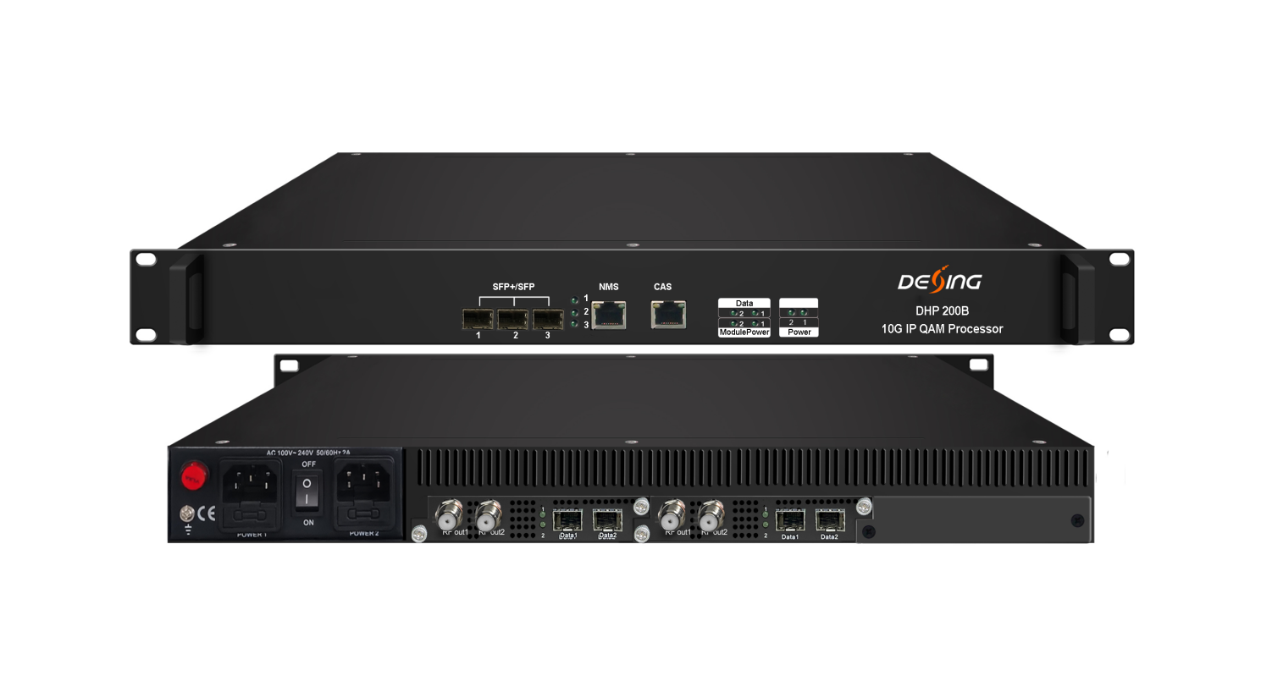Product Overview
The FMUSER FUQ-200C integrates multiplexer, scrambler, and modulator functions, delivering up to 128 DVB-C QAM channels via RF ports. It processes input signals through SFP+ ports, supporting TS over UDP/RTP and multicast protocols. Housed in a 1U chassis, it features web-based management for easy control. Ideal for broadcast systems requiring high-density signal processing.The device is equipped with 1 (or 2) 64ch QAM card and characterized with dual RF output ports on each card to broaden the bandwidth for QAM carriers. Its high density helps operators to save cost to the most extent.

Key feature
High-Density Design: Features a 1U chassis with plug-in cards for up to 128 non-adjacent carrier outputs.
Advanced Processing: Supports multiplexing, scrambling with 6 CAS Simul-cryption, PCR adjusting, PID remapping, and PSI/SI editing.
Flexible Interfaces: Includes 3 SFP+ (10G)/SFP (1G) ports for TS over UDP/RTP and multicast.
Web-Based Management: Enables easy monitoring and configuration via a network interface.

Inner Principle Chart (two cards)
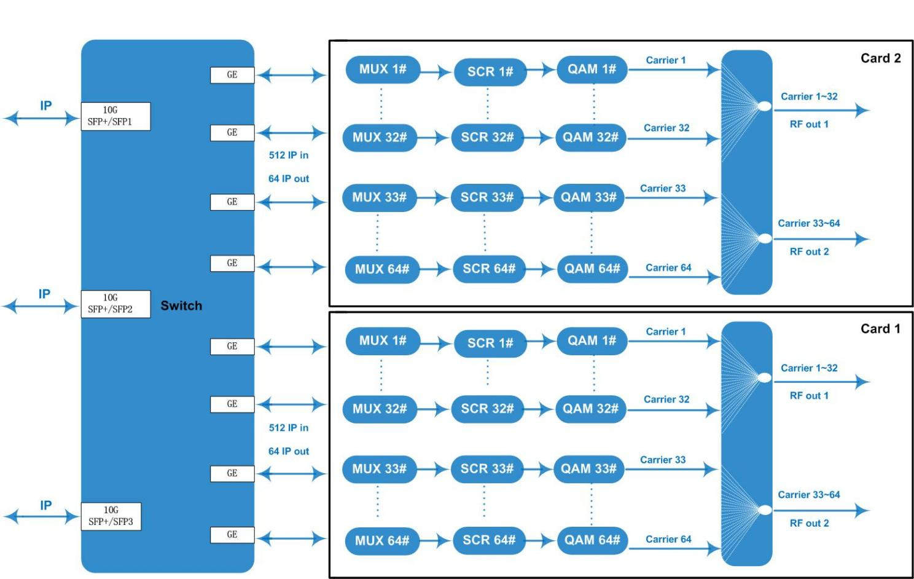

Carrier Setting Illustration (per card)
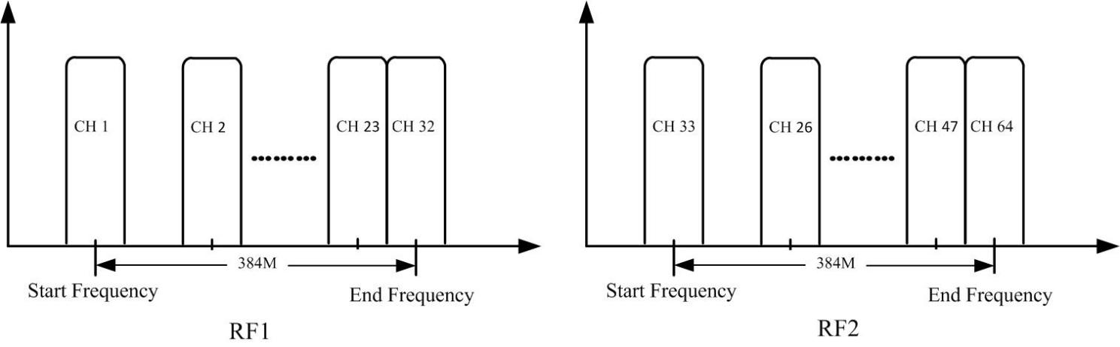

Specifications
Input | Input | Max 512 IP in per card through SFP+/SFP ports 1-3
Input | Transmission Rate | Max 9600Mbps for each 10G SFP+/SFP input
Input | Transport Protocol | TS over UDP/RTP, unicast and multicast, IGMP V2/V3
Mux | Max PIDs Remapping | 256 per output channel
Mux | Functions | PID remapping (auto/manually optional)
Mux | Functions | PCR accurate adjusting
Mux | Functions | PSI/SI table automatically generating
Scrambling | Max simulcrypt CA | 6
Scrambling | Scramble Standard | ETR289, ETSI 101 197, ETSI 103 197
Scrambling | Connection | Local/remote connection
Modulation | Modulation Standard | EN300 429/ITU-T J.83A/B/C
Modulation | Constellation | J.83A | Constellation :16/32/64/128/256QAM
Modulation | Constellation | J.83A | Bandwidth :8M
Modulation | Constellation | J.83B/C | Constellation :64/256QAM
Modulation | Constellation | J.83B/C | Bandwidth :6M
Modulation | QAM Channel | 64/128 non-adjacent carrier outputs, 384Mbps bandwidth for each RF port
Modulation | Symbol Rate | 3600~7000Ksps, 1ksps stepping  5057Ksps (J.83B, 64QAM) ; 5361Ksps (J.83B, 256QAM)
Modulation | Constellation | 16, 32, 64 , 128, 256QAM
Modulation | FEC | RS (204, 188)
RF Output | Interface (per card) | 2 F type output ports for 64 carriers, 75Ω  Carrier 1~32 out thru RF1, 33~64 thru RF2
RF Output | RF Range | 50~960MHz, 1kHz stepping
RF Output | Output Level | -20dBm~+10dBm(87~117dbµV), 0.1dB stepping
RF Output | MER | ≥ 40dB
TS output | Per Daughter QAM Card | 64 IP output over UDP/RTP/RTSP, unicast/multicast,  through SFP+/SFP ports 1-3
System | Web-based Network management
General | Dimension | 420mm×440mm×44.5mm (WxLxH)
General | Temperature | 0~45℃(operation), -20~80℃(storage)
General | Power Supply | AC 100V±10%, 50/60Hz; or AC 220V±10%, 50/60Hz  Redundancy power supply (optional as per order)
General | Consumption | 50W(1 daughter QAM card)/75W(2 daughter QAM cards)

About Us
FMUSER is a company specializing in broadcasting and television transmission systems and integrating hotel IPTV systems. The company was established in 2009 and has served over 180 countries worldwide. More than 20,000 television stations, radio stations, and hotel clients from different.

Contact:Tomleequan Email：sales@fmuser.com whatsapp: +8613922702227

