FMUSER FUQ-200B QAM Modulator 256 IP Input 96 QAM Output 10G SFP+-GE Interfaces DVB-C EN300-429 ITU-T J.83A-B-C Multiplex Scrambler Modulation for Broadcast Systems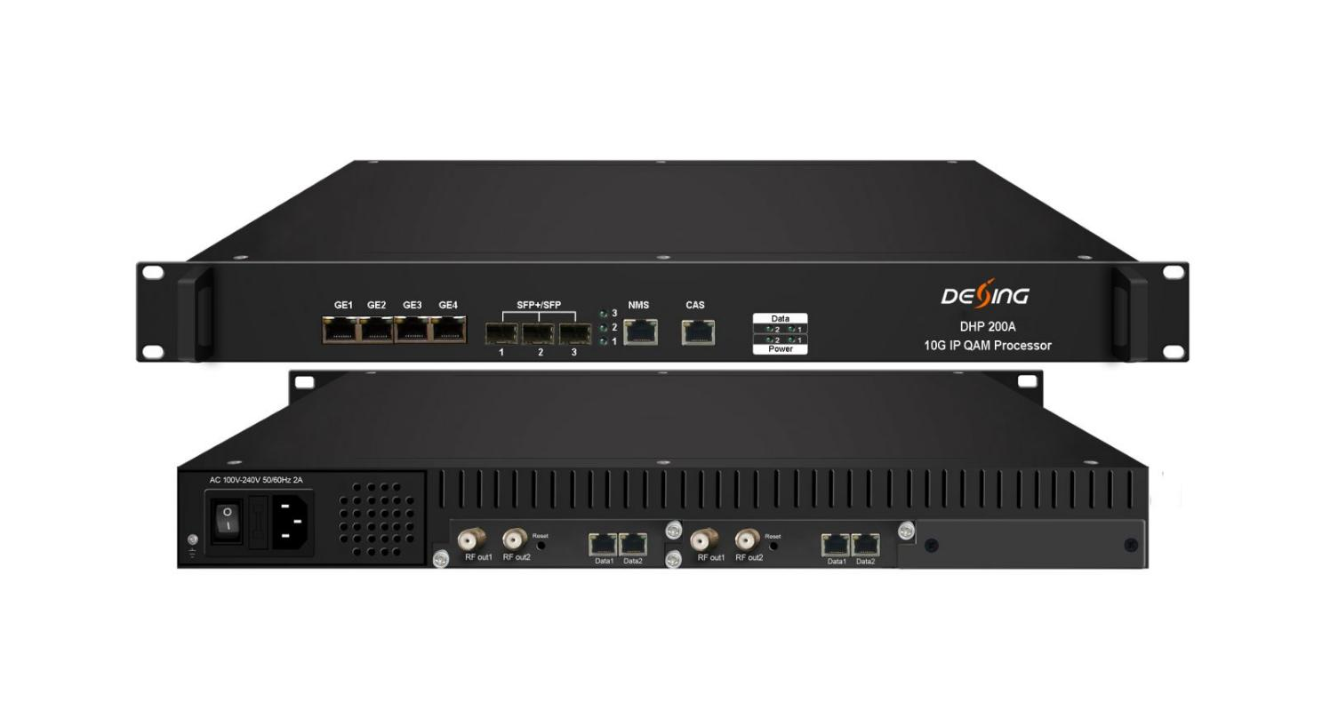
Product Overview
The FMUSER FUQ-200B integrates multiplex, scrambler, and modulator functions, outputting 48/96 non-adjacent DVB-C QAM carriers via 2/4 RF ports and SFP+/GE ports. It processes signals through multiplexing, scrambling, and modulating in a 1U chassis with modular design and web-based management. Ideal for broadcast operators to save costs in high-density signal distribution.The device is equipped with 1 (or 2) 48ch QAM card and characterized with dual RF output ports on each card to broaden the bandwidth for QAM carriers. Its high density helps operators to save cost to the most extent.

Key feature
Integrates multiplex, scrambler, and modulator with 6 CAS Simul-cryption., Features 2/4 RF outputs and multiple interfaces including SFP+/SFP/GE ports., Outputs 48/96 non-adjacent DVB-C QAM carriers., Supports web-based network management for easy control.
Inner Principle Chart (per card)

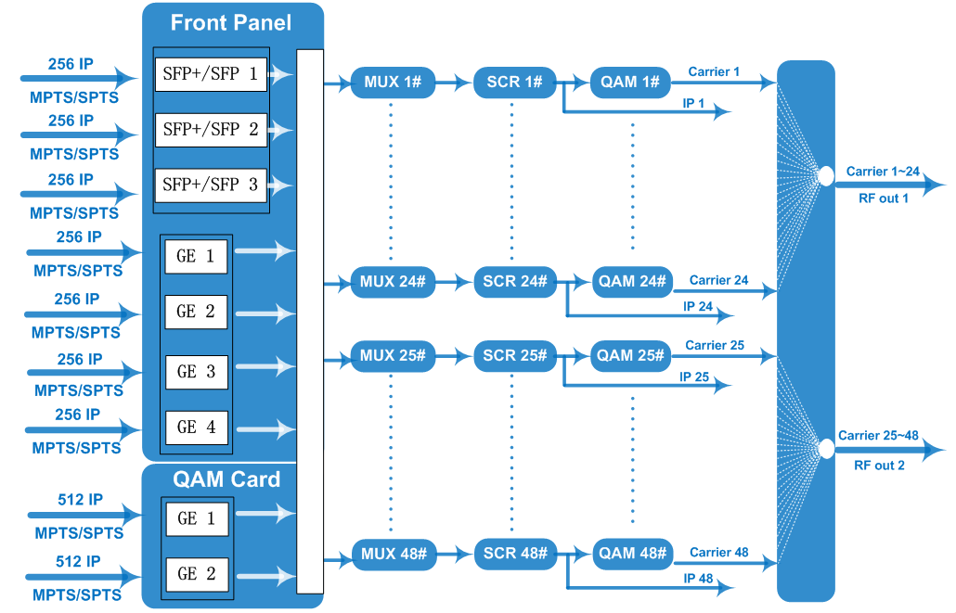

Carrier Setting Illustration (per card)

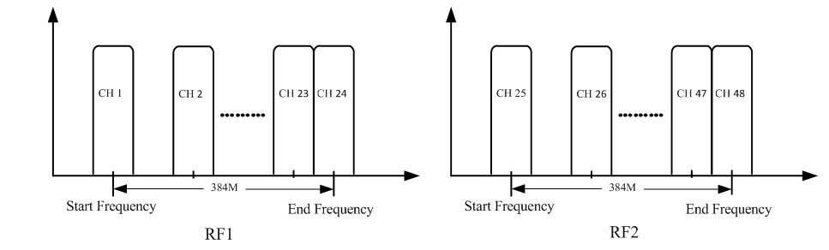

Specifications
Input | Input | Max 256*4 IP in through GE ports 1-4  Max 256*3 IP in through SFP+/SFP ports 1-3
Input | Transmission Rate | Max 960Mbps for each GE input, and  Max 9600Mbps for each 10G SFP+/SFP input
Input | Transport Protocol | TS over UDP/RTP, unicast and multicast, IGMP V2/V3
Mux | Max PIDs Remapping | 256 per output channel
Mux | Functions | PID remapping (auto/manually optional)
Mux | Functions | PCR accurate adjusting
Mux | Functions | PSI/SI table automatically generating
Scrambling | Max simulcrypt CA | 6
Scrambling | Scramble Standard | ETR289, ETSI 101 197, ETSI 103 197
Scrambling | Connection | Local/remote connection
Modulation | Modulation Standard | EN300 429/ITU-T J.83A/B/C
Modulation | Constellation | J.83A | Constellation :16/32/64/128/256QAM
Modulation | Constellation | J.83A | Bandwidth :8M
Modulation | Constellation | J.83B/C | Constellation :64/256QAM
Modulation | Constellation | J.83B/C | Bandwidth :6M
Modulation | QAM Channel | 48/96 non-adjacent carrier outputs, 384Mbps bandwidth for each RF port
Modulation | Symbol Rate | 3600~7000Ksps, 1ksps stepping  5057Ksps (J.83B, 64QAM) ; 5361Ksps (J.83B, 256QAM)
Modulation | Constellation | 16, 32, 64 , 128, 256QAM
Modulation | FEC | RS (204, 188)
RF Output | Interface (per card) | 2 F type output ports for 48 carriers, 75Ω  Carrier 1~24 out thru RF1, 25~48 thru RF2
RF Output | RF Range | 50~960MHz, 1kHz stepping
RF Output | Output Level | -20dBm~+10dBm(87~117dbµV), 0.1dB stepping
RF Output | MER | ≥ 40dB
TS output | Per Daughter QAM Card | 48 IP output over UDP/RTP/RTSP, 2*100/1000M self-adaption, Ethernet Ports, unicast/multicast  IP 1~24 out thru Data1, IP 25~48 out thru Data2.
System | Network management software (NMS) supporting
General | Demission | 420mm×440mm×44.5mm (WxLxH)
General | Weight | 5kg
General | Temperature | 0~45℃(operation), -20~80℃(storage)
General | Power Supply | AC 100V±10%, 50/60Hz ; or AC 220V±10%, 50/60Hz
General | Consumption | 15.4W

About Us
FMUSER is a company specializing in broadcasting and television transmission systems and integrating hotel IPTV systems. The company was established in 2009 and has served over 180 countries worldwide. More than 20,000 television stations, radio stations, and hotel clients from different.

Contact:Tomleequan Email：sales@fmuser.com whatsapp: +8613922702227

