FMUSER FUQ-200B Multiplexer Scrambler Modulator 112 DVB-C QAM Channels 10G SFP+-RJ45 IP Input-Output Web-Based Management Broadcast Cable TV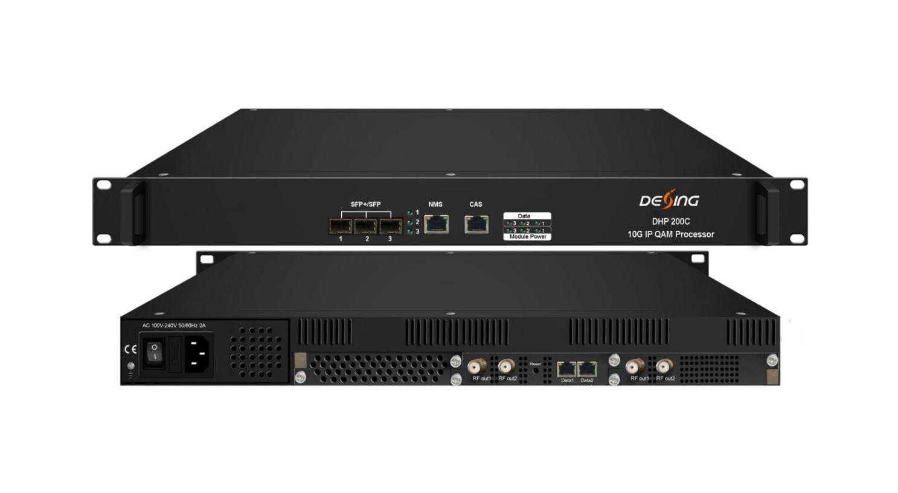Product Overview
The FMUSER FUQ-200B integrates a multiplexer, scrambler, and modulator, featuring 10G SFP+/SFP ports and GE ports for IP input/output. It processes 10G optical signals efficiently, supporting up to 112 DVB-C QAM channels. Housed in a compact 1U chassis, it offers web-based management for easy control. Ideal for broadcast systems, enabling high-density operations in cable TV and digital broadcasting.The device is equipped with one fixed 64ch QAM card and another card slot to expand qam card (16/32/48QAM optional). Its high density helps operators to save cost to the most extent.

Key feature
Supports high-density modular design in a 1U chassis with plug-in QAM cards, accommodating up to 112 non-adjacent carriers.
Features 10G SFP+/SFP ports and GE ports for flexible IP input/output, handling up to 9600Mbps per channel.
Integrates multiplexer and scrambler with 6 CAS Simul-cryption, PID remapping, and PSI/SI editing.
Enables web-based management for easy network control and configuration.

Inner Principle Chart (Example: one 64qam card + one 48qam card)
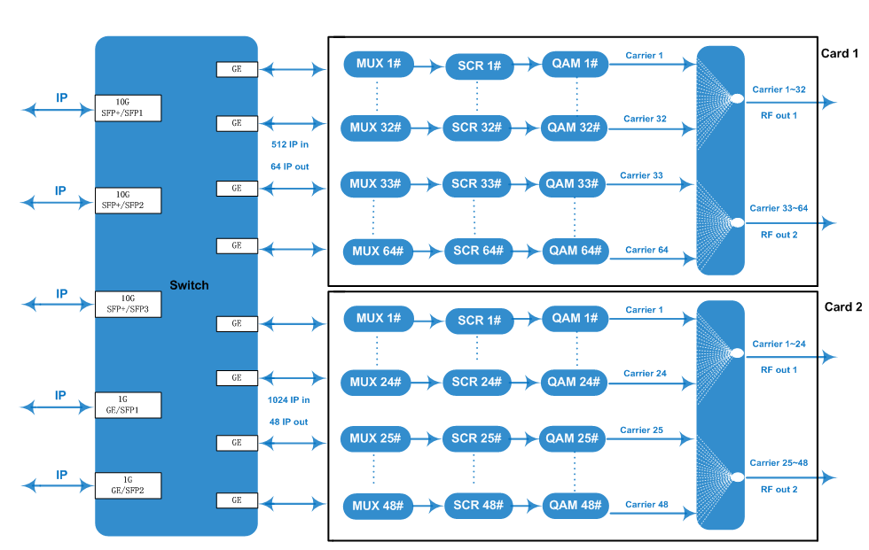

Carrier Setting Illustration (Example: 64qam card)
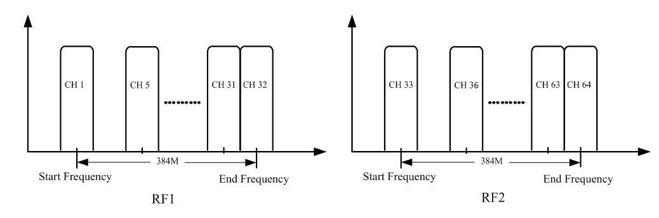

Specifications
Input | Input from Front Panel | Max 512 IP in per card through SFP+/SFP ports 1-3
Input | Input from Daughter Card | IP from 2 GE ports (SFP port optional)
Input | Transmission Rate | Max 9600Mbps for each 10G SFP+/SFP input
Input | Transport Protocol | TS over UDP/RTP, unicast and multicast, IGMP V2/V3
Mux | Max PIDs Remapping | 256 per output channel
Mux | Functions | PID remapping (auto/manually optional)
Mux | Functions | PCR accurate adjusting
Mux | Functions | PSI/SI table automatically generating
Scrambling | Max simulcrypt CA |  | 6
Scrambling | Scramble Standard |  | ETR289, ETSI 101 197, ETSI 103 197
Scrambling | Connection |  | Local/remote connection
Modulation | Modulation Standard |  | EN300 429/ITU-T J.83A/B/C
Modulation | Constellation |  | J.83A | Constellation :16/32/64/128/256QAM
Modulation |  |  | J.83A | Bandwidth :8M
Modulation |  |  | J.83B/C | Constellation :64/256QAM
Modulation |  |  | J.83B/C | Bandwidth :6M
Modulation | QAM Channel |  | 32/48/64/80/96/112 non-adjacent carriers output,  192 or 384Mbps bandwidth for each RF port
Modulation | Symbol Rate |  | 3600~7000Ksps, 1ksps stepping  5057Ksps (J.83B, 64QAM) ; 5361Ksps (J.83B, 256QAM)
Modulation | Constellation |  | 16, 32, 64, 128, 256QAM
Modulation | FEC |  | RS (204, 188)
RF Output | Interface (per card) | 1 or 2 F type output ports for 16/32/48/64 carriers card, 75Ω.  16 or 32 ch qam card : all Carrier out thru one RF port  48ch qam card : Carrier 1~24 out thru RF1, 25~48 thru RF2  64ch qam card : Carrier 1~32 out thru RF1, 33~64 thru RF2
RF Output | RF Range | 50~960MHz, 1kHz stepping
RF Output | Output Level | -20dBm~+10dBm(87~117dbµV), 0.1dB stepping
RF Output | MER | ≥ 40dB
TS output | Per Daughter QAM Card | 16/32/48/64 IP output over UDP/RTP/RTSP, unicast/multicast,  through SFP+/SFP ports 1-3 or GE port RJ45
System | Web-based Network management
General | Dimension | 420mm×440mm×44.5mm (WxLxH)
General | Temperature | 0~45℃(operation), -20~80℃(storage)
General | Power Supply | AC 100V±10%, 50/60Hz ; or AC 220V±10%, 50/60Hz
General | Consumption | 50W(1 daughter QAM card)/75W(2 daughter QAM cards)

Order Guide
Options Available | Combinations
32ch QAM out | 32qam card * 1
48ch QAM out | 48qam card * 1
64ch QAM out | 64qam card * 1
80ch QAM out | 64qam card * 1 + 16qam card *1
96ch QAM out | 64qam card * 1 + 32qam card *1
112ch QAM out | 64qam card * 1 + 48qam card *1

About Us
FMUSER is a company specializing in broadcasting and television transmission systems and integrating hotel IPTV systems. The company was established in 2009 and has served over 180 countries worldwide. More than 20,000 television stations, radio stations, and hotel clients from different.

Contact:Tomleequan Email：sales@fmuser.com whatsapp: +8613922702227

