FMUSER FUQ-200E QAM Processor 112 Channels 10G-SFP+-1G-SFP GE Input DVB-C EN300-429 ITU-T J.83 A-B-C Output Multiplexer Scrambler Modulator Web Network Management Cable TV Headend
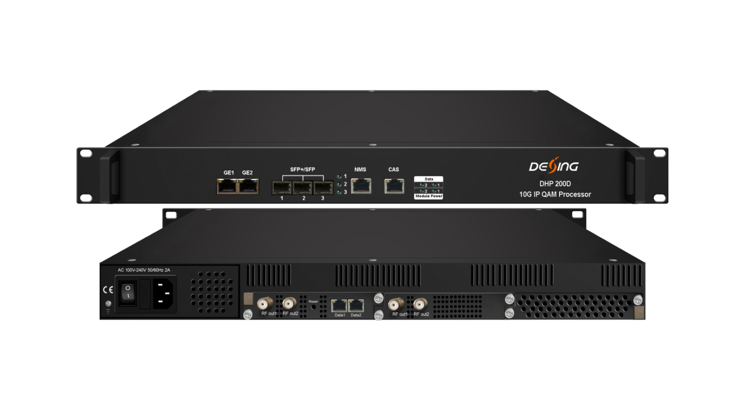Product Overview
The FMUSER FUQ-200E is a 10G IP QAM processor integrating multiplexer, scrambler, and modulator functions. It processes signals through multiplexing, scrambling, and modulation, supporting up to 112 DVB-C QAM channels with 3 SFP+(10G)/SFP(1G) ports and 2 GE ports. Housed in a 1U chassis with modular card slots, it features web-based network management and is ideal for cable television headends and broadcast systems requiring high-density processing.This processor is equipped with 2 card slots to load 32ch or 48ch or 64ch QAM card. Its high density helps operators to save cost to the most extent.

Key feature
Enables web-based network management for remote monitoring and control.

Inner Principle Chart (Example: one 64qam card + one 48qam card)
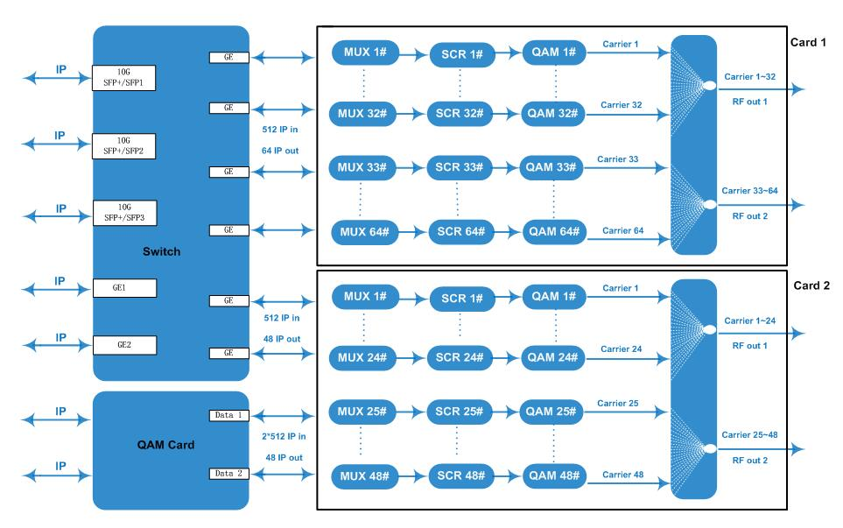

Carrier Setting Illustration (Example: 64qam card)
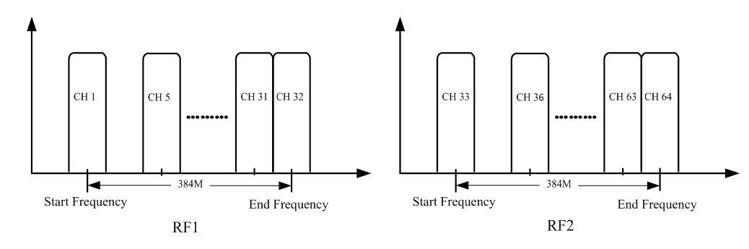

Specifications
Input | Input from Front Panel | Max 512 IP in per card through SFP+/SFP ports 1-3 and 2 GE ports
Input | Input from Daughter Card | 2*512 IP in from 2 GE ports (SFP port optional)--32/48 QAM
Input | Transmission Rate | Max 9600Mbps for each 10G SFP+/SFP input
Input | Transport Protocol | TS over UDP/RTP, unicast and multicast, IGMP V2/V3
Mux | Max PIDs Remapping | 256 per output channel
Mux | Functions | PID remapping (auto/manually optional)
Mux | Functions | PCR accurate adjusting
Mux | Functions | PSI/SI table automatically generating
Scrambling | Max simulcrypt CA |  | 6
Scrambling | Scramble Standard |  | ETR289, ETSI 101 197, ETSI 103 197
Scrambling | Connection |  | Local/remote connection
Modulation | Modulation Standard |  | EN300 429/ITU-T J.83A/B/C
Modulation | Constellation |  | J.83A | Constellation :16/32/64/128/256QAM
Modulation |  |  | J.83A | Bandwidth :8M
Modulation |  |  | J.83B/C | Constellation :64/256QAM
Modulation |  |  | J.83B/C | Bandwidth :6M
Modulation | QAM Channel |  | 32/48/64/96/112 non-adjacent carriers output,  384Mbps bandwidth for each RF port
Modulation | Symbol Rate |  | 3600~7000Ksps, 1ksps stepping  5057Ksps (J.83B, 64QAM) ; 5361Ksps (J.83B, 256QAM)
Modulation | Constellation |  | 16, 32, 64, 128, 256QAM
Modulation | FEC |  | RS (204, 188)
RF Output | Interface (per card) | 1 or 2 F type output ports for 32/48/64 carriers card, 75Ω.  32ch qam card : all Carrier out thru one RF port  32ch/48ch qam card : Carrier 1~16/1~24 out thru RF1, 17~32/25~48 thru RF2  64ch qam card : Carrier 1~32 out thru RF1, 33~64 thru RF2
RF Output | RF Range | 50~960MHz, 1kHz stepping
RF Output | Output Level | -20dBm~+10dBm(87~117dbµV), 0.1dB stepping
RF Output | MER | ≥ 40dB
TS output | Per Daughter QAM Card | 32/48/64 IP output over UDP/RTP/RTSP, unicast/multicast,  through SFP+/SFP ports 1-3 or GE ports RJ45
System | Web-based Network management
General | Dimension | 420mm×440mm×44.5mm (WxLxH)
General | Temperature | 0~45℃(operation), -20~80℃(storage)
General | Power Supply | AC 100V±10%, 50/60Hz ; or AC 220V±10%, 50/60Hz
General | Consumption | 50W(1 daughter QAM card)/75W(2 daughter QAM cards)

Order Guide
Options Available | Combinations
32ch QAM out | 32qam card * 1
48ch QAM out | 48qam card * 1
64ch QAM out | 64qam card * 1
96ch QAM out | 64qam card * 1 + 32qam card *1
112ch QAM out | 64qam card * 1 + 48qam card *1

About Us
FMUSER is a company specializing in broadcasting and television transmission systems and integrating hotel IPTV systems. The company was established in 2009 and has served over 180 countries worldwide. More than 20,000 television stations, radio stations, and hotel clients from different.

Contact:Tomleequan Email：sales@fmuser.com whatsapp: +8613922702227

