FMUSER FUQ-200F QAM Processor Multiplexer Scrambler Modulator 1024 IP Input DVB-C 192 QAM Output 10G-1G SFP+ Ports CAS Encryption for Cable TV Broadcasting 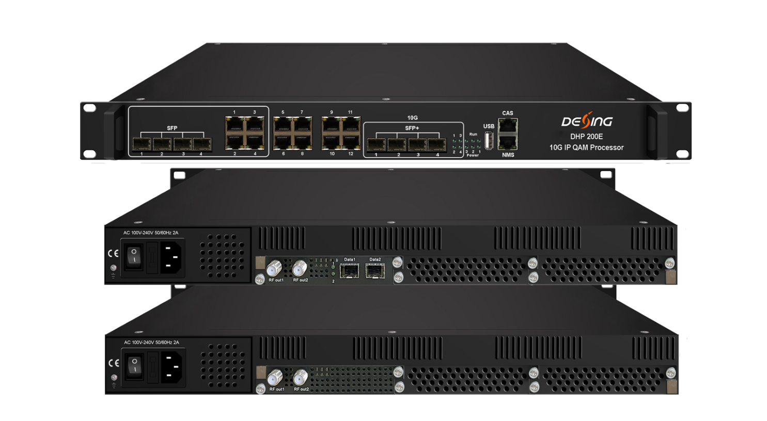Product Overview
The FUQ-200F integrates multiplexer, scrambler, and modulator in a 1U chassis, with IP inputs via SFP+, SFP, and GE ports to output up to 192 DVB-C QAM carriers. It processes IP streams using CAS encryption and PSI/SI editing for signal modulation. This modular solution features QAM cards (32/48/64ch) and web-based control for easy operation. Ideal for broadcast headend and cable TV systems requiring high-density signal processing.This processor is equipped with 3 card slots to load 32ch or 48ch or 64ch QAM card. Its high density helps operators to save cost to the most extent.

Key feature
Supports modular QAM cards (32/48/64ch) in 1U for high-density output.
Features IP inputs via 4× SFP+ (10G), 4× SFP (1G), and 12× GE ports.
Enables multiplexer/scrambler functions with up to 6 CAS encryption standards.
Generates 192 non-adjacent DVB-C QAM carriers via J.83A/B/C modulation.
Provides web-based control for RF output (-20dBm~+10dBm) and symbol rates (3600-7200Ksps).

Inner Principle Chart (Example: one 64qam card + one 48qam card + one 32qam card)
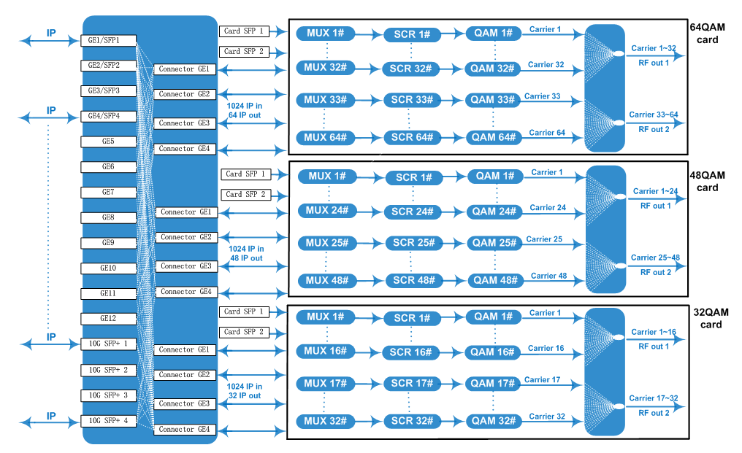

Carrier Setting Illustration (Example: 64qam card)
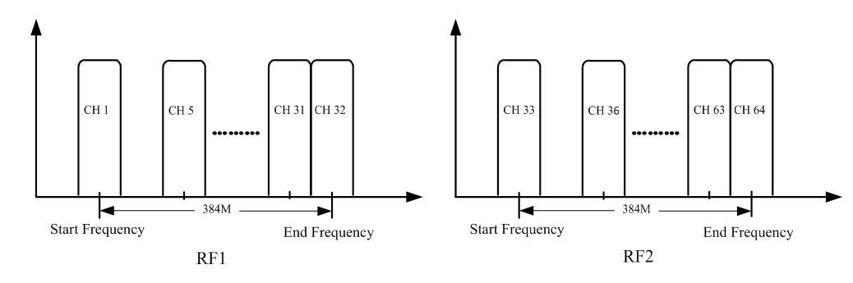

Specifications
Input | IP Input | Max1024 IP inputs per card through 4 SFP+, 4 SFP and 12 GE ports in the front panel and 2 SFP ports in the card itself
Input | Transmission Rate | Max 9600Mbps for each 10G SFP+ input/Max 960Mbps for each GE and SFP input
Input | Transport Protocol | TS over UDP/RTP, unicast and multicast, IGMP V2/V3
Mux | Max PIDs Remapping | 256 per output channel
Mux | Functions | PID remapping (auto/manually optional)
Mux | Functions | PCR accurate adjusting
Mux | Functions | PSI/SI table automatically generating
Scrambling | Max simulcrypt CA | 6
Scrambling | Scramble Standard | ETR289, ETSI 101 197, ETSI 103 197
Scrambling | Connection | Local/remote connection
Modulation | Modulation Standard | EN300 429/ITU-T J.83A/B/C
Modulation | Constellation | J.83A | Constellation :16/32/64/128/256QAM
Modulation | Constellation | J.83A | Bandwidth :8M
Modulation | Constellation | J.83B/C | Constellation :64/256QAM
Modulation | Constellation | J.83B/C | Bandwidth :6M
Modulation | QAM Channel | 32/48/64/80/96/112/128/144/160/176/192 non-adjacent carriers output,  384Mbps bandwidth for each RF port
Modulation | Symbol Rate | 3600~7200Ksps, 1ksps stepping  5057Ksps (J.83B, 64QAM) ; 5361Ksps (J.83B, 256QAM)
Modulation | Constellation | 16, 32, 64, 128, 256QAM
Modulation | FEC | RS (204, 188)
RF Output | Interface (per card) | 2 F type output ports for 32/48/64 carriers card, 75Ω.  32ch/48ch/64ch qam card : Carrier 1~16/1~24/1~32 out thru RF1, 17~32/25~48/33~64 thru RF2
RF Output | RF Range | 50~960MHz, 1kHz stepping
RF Output | Output Level | -20dBm~+10dBm(87~117dbµV), 0.1dB stepping
RF Output | MER | ≥ 40dB
TS output | Per Daughter QAM Card | 32/48/64 IP output over UDP/RTP/RTSP, unicast/multicast,  through 4 SFP+ ports, 4 SFP ports and 12 GE ports in the front panel
System | Web-based Network management
General | Dimension | 480mm×440mm×44.5mm (WxLxH)
General | Temperature | 0~45℃(operation), -20~80℃(storage)
General | Power Supply | AC 100V±10%, 50/60Hz ; or AC 220V±10%, 50/60Hz
General | Consumption | About 200W (3 daughter QAM cards)

Major Technical Comparison
 | DHP200D | DHP200E
Card Number | Max 2 | Max 3
SFP+/SFP/RJ45 ports in the front panel | 3 SFP+(10G)/SFP(1G) ports and 2 GE ports | 4 SFP+ (10G)/4 SFP(1G) ports and 12 GE ports
Max Carriers number | 112 | 192
Inner connector GE ports | 6 | 12
DATA Port in card | DepeFU on card spec | 2 SFP ports as input per card

Order Guide
- Card Type Option: 32, 48 or 64 QAM card
- Card Number Option: 1, 2 or 3 pcs
- SFP ports option in card: With or Without
- PSU option: 1*220VAC or 2*220VAC not hot-swapping PSU

About Us
FMUSER is a company specializing in broadcasting and television transmission systems and integrating hotel IPTV systems. The company was established in 2009 and has served over 180 countries worldwide. More than 20,000 television stations, radio stations, and hotel clients from different.

Contact:Tomleequan Email：sales@fmuser.com whatsapp: +8613922702227

