FMUSER FUQ-2044TL EPG System DVB-Compliant 2044 TS Streams ASI-IP Output PSI-SI Tables Generation 64-Day EIT Scheduling Digital TV Broadcasting 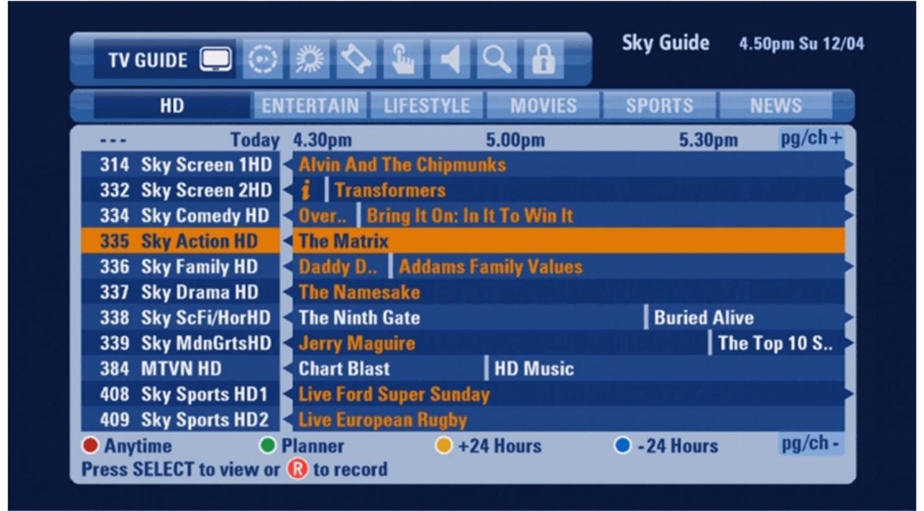Product Overview
The FMUSER FUQ-2044TL EPG System delivers DVB-standard program guide data with PSI/SI tables generation. It processes up to 2,044 transport streams via ASI/IP outputs, managing 65,530 programs with 64-day EIT scheduling. This 1RU rack-mount device operates through client/server software on Windows/Linux. Ideal for cable headends and terrestrial broadcasters requiring compliant EPG distribution.
Solution Guide

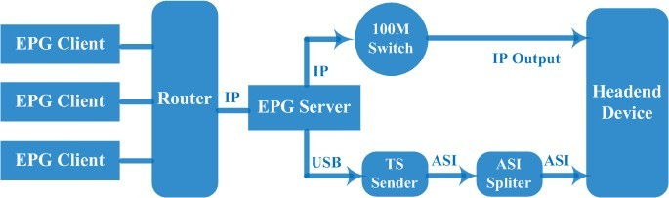

Key Feather
Support ASI and IP Output Solution
C/S System mode
Support maximum 2044 TS stream
Support maximum 65530 Program
Support maximun 64 days EIT event
Friendly user interface
Self-define events formats Support
Total support DVB Standards

How to use it ?
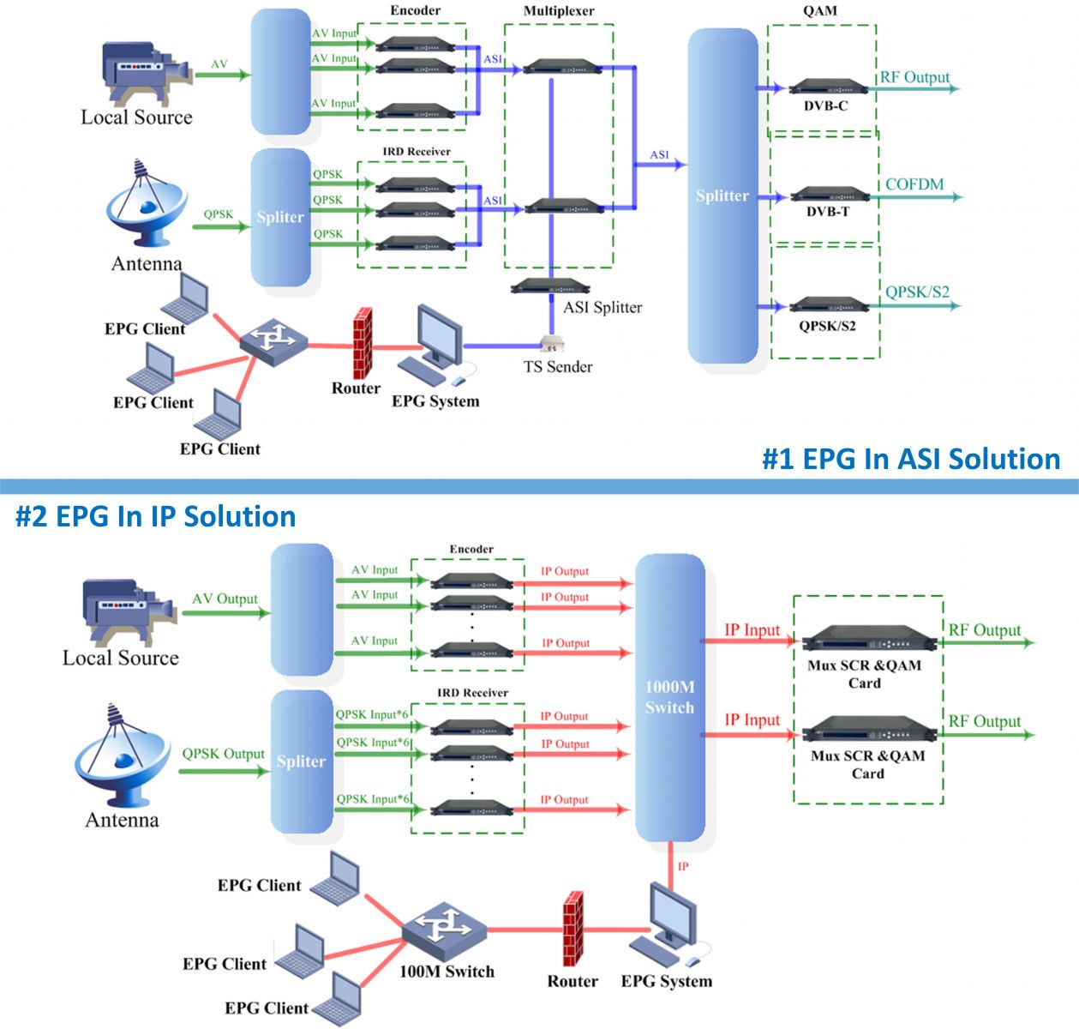

EGP Function Explain
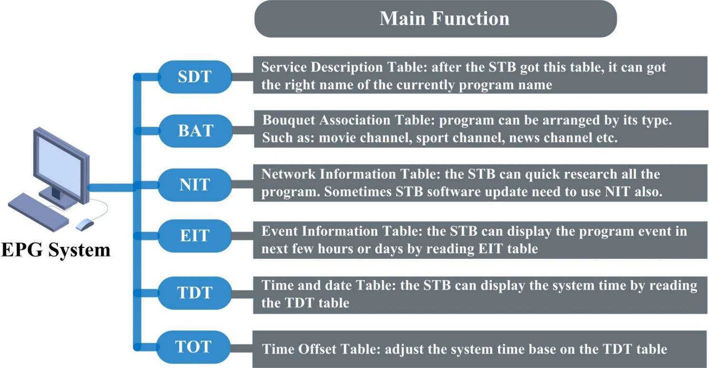

Specification
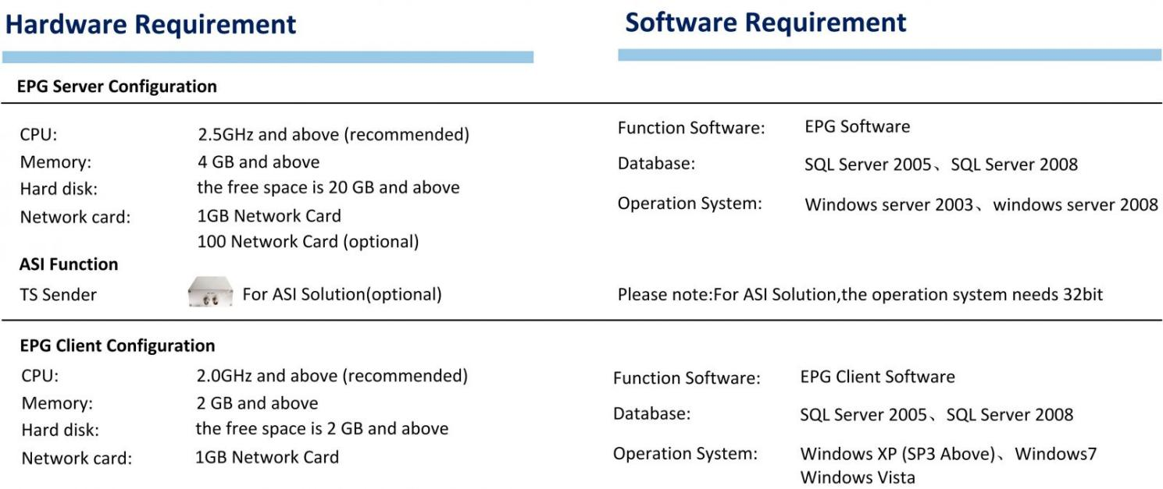

More Example
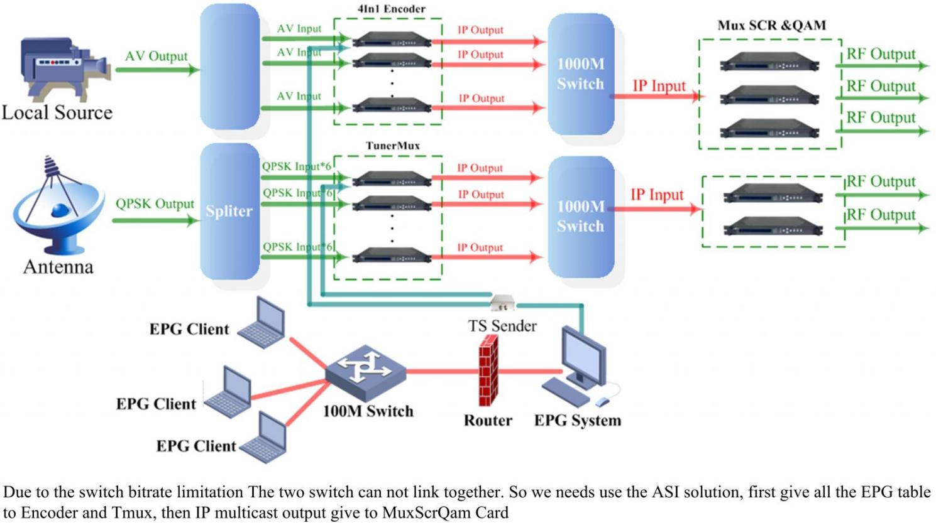

About Us
FMUSER is a company specializing in broadcasting and television transmission systems and integrating hotel IPTV systems. The company was established in 2009 and has served over 180 countries worldwide. More than 20,000 television stations, radio stations, and hotel clients from different.

Contact:Tomleequan Email：sales@fmuser.com whatsapp: +8613922702227

