FMUSER FUQ-204B Capture Card 4x3G-SDI Level A-B Inputs 6x Bi-Directional ASI Ports PCIe3 x4 Interface SMPTE 424M DVB-ASI Standards Low Latency DMA Live Broadcast Production
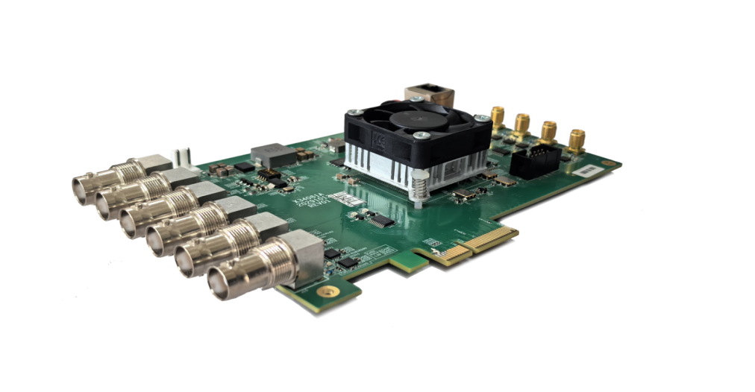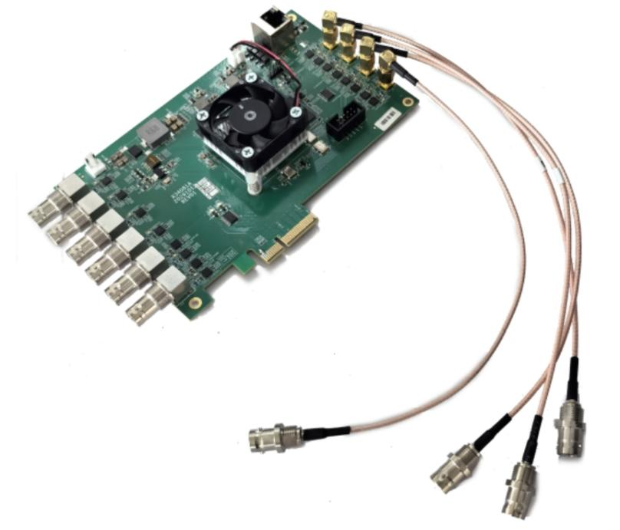

Product overview
The FMUSER FUQ-204B is a professional capture card with 4x3G-SDI inputs and 6 bi-directional ASI ports. It captures uncompressed SDI and compressed TS video, outputting via PCIe. Supported by free Linux drivers for OS ≥4.x/5.x, it enables easy integration. Ideal for software encoding, live production, and broadcast monitoring.
Key feature
Supports 4x3G-SDI Inputs configurable in Level A or B mode.
Features 6 bi-directional ASI Ports for flexible transport stream handling.
Enables API Access for direct control of video and audio streams.
Utilizes Low Latency DMA for efficient data transfer.
Includes Free Linux Drivers supporting OS ≥4.x/5.x.
Applications
* Software encoder with 3G-SDI interface
* Live production mixer, effects generator
* SDI monitoring, recorder; ASI monitoring, recorder, broadcast

Block diagram
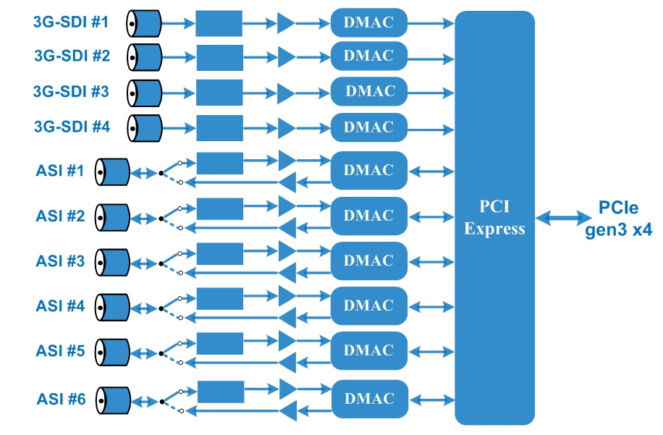

Technical specifications
Connectors | 4 SDI inputs (SD, HD, 3G level A/B), BNC, 75Ω  1-6 xASI self-defined inputs/outputs, BNC, 75Ω
SDI formats | 1080p50/59.94/60; 1080i50/59.94/60;  720p50/59.94/60  525i, 625i
PCI Express | PCIe3 x4 low profile
Physical layer | 3G-SDI | SMPTE 424M Standard
Physical layer | HD-SDI | SMPTE 292M Standard
Physical layer | SD-SDI | SMPTE 259M Standard
Physical layer | DVB-ASI | EN50083-9
PC Support | Operating system | Linux ≥ 4.x, 5.x
PC Support | Processor | Core i5 minimum  Core i7 recommended (or equivalent AMD processors)

About Us
FMUSER is a company specializing in TV broadcasting and transmission systems and hotel IPTV system integration. The company was established in 2009 and has served more than 180 countries around the world. More than 20,000 TV stations, radio stations and hotel customers from different countries.

Contact: Tomleequan Email: sales@fmuser.com Whatsapp: +8613922702227

