FMUSER FUQ-230 Modular Headend Processor 128 IP Inputs 3 Module Slots DVB-C-DVB-T-ATSC-ISDB-T ASI-S2X-USB Multi-Standard Demodulation Remultiplexing for Terrestrial Cable Satellite Networks 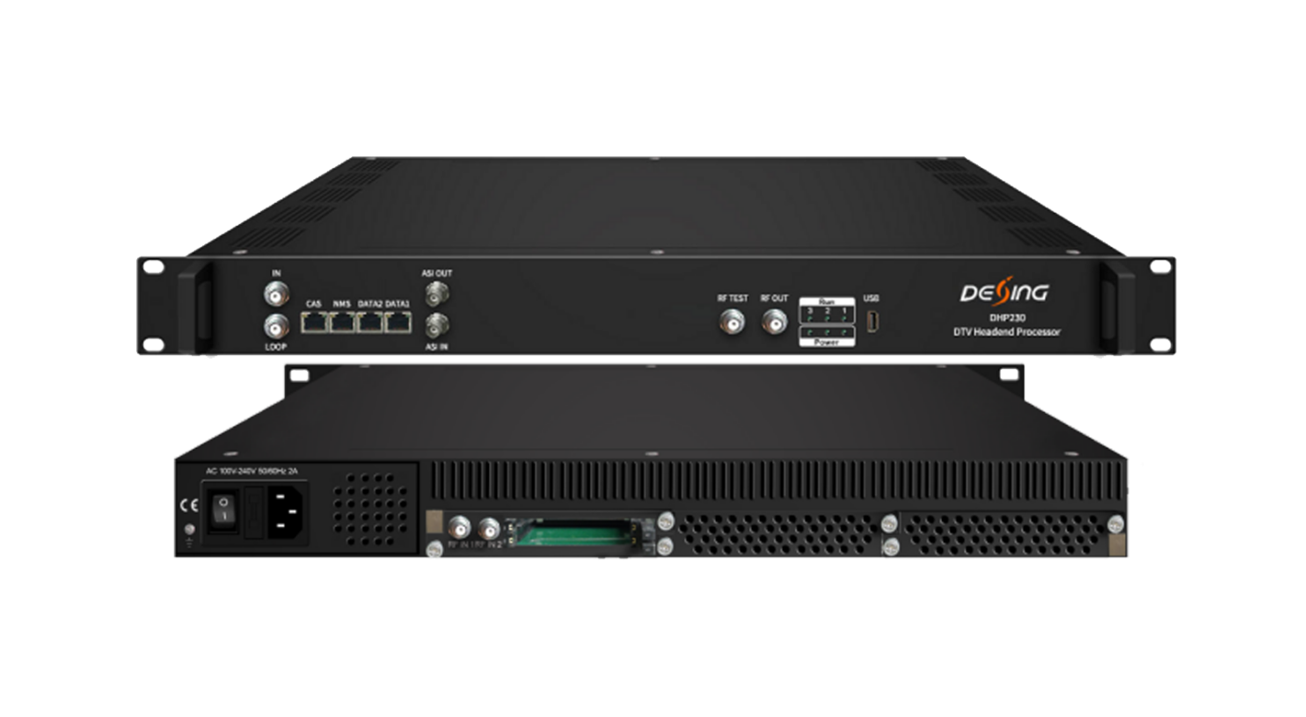Product overview
The FMUSER FUQ-230 is a 1U modular headend processor with 128 IP inputs, 1 ASI, 1 DVB-S/S2/S2X, and 1 USB interface. It processes signals via demodulation, descrambling, and remultiplexing using 3 swappable modules. Web-based NMS control enables remote management for cable headends, terrestrial transmitters, and IPTV distribution.
Key feature
MPTS over UDP/RTP/RTSP with 256 PIDs per channel
Principle Chart
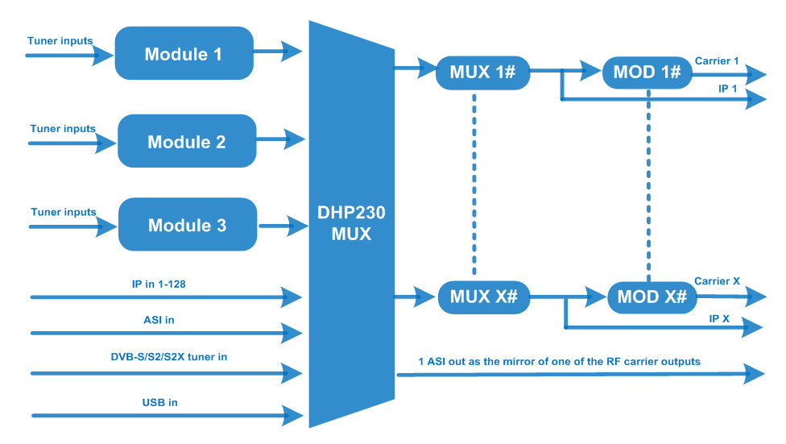

Chassis Specifications
Input | 3 Modules inputs(see the module specification)  1 ASI in for re-multiplexing  128 IP(SPTS/MPTS) inputs over UDP and RTP, RJ45, 1000M/100M DATA 1 , Unicast/Multicast  1 DVB-S/S2/S2X tuner in for re-multiplexing  1 USB Player input for re-mux (“xxx.ts” video)
Multiplexing | Maximum PID  Remapping | 256 input per channel
Multiplexing | Function | A/V PID Filtering
Multiplexing | Function | PID remapping ( automatically or manually)
Multiplexing | Function | Accurate PCR adjusting
Multiplexing | Function | Generate PSI/ SI table automatically
Modulation | DVB-C | QAM Channel |  | 16 non-adjacent carriers output (maximum bandwidth 192MHz)
Modulation | DVB-C | Standard |  | EN300 429/ITU-T J.83A/B
Modulation | DVB-C | MER |  | ≥40db
Modulation | DVB-C | RF frequency |  | 50~960MHz, 1KHz step
Modulation | DVB-C | RF output level |  | -20~+3dbm, 0.1db step
Modulation | DVB-C | Symbol Rate |  | 5.0Msps~7.0Msps, 1ksps stepping
Modulation | DVB-C |  |  | J.83A | J.83B
Modulation | DVB-C | Constellation |  | 16/32/64/128/256QAM | 64/256 QAM
Modulation | DVB-C | Bandwidth |  | 8M | 6M
Modulation | DVB-T | Standard |  | EN300744
Modulation | DVB-T | FFT mode |  | 2K,4K, 8K
Modulation | DVB-T | Bandwidth |  | 6M, 7M, 8M
Modulation | DVB-T | Constellation |  | QPSK, 16QAM, 64QAM
Modulation | DVB-T | Guard Interval |  | 1/4, 1/8, 1/16, 1/32
Modulation | DVB-T | FEC |  | 1/2, 2/3, 3/4, 5/6, 7/8
Modulation | DVB-T | MER |  | ≥42 dB
Modulation | DVB-T | RF frequency |  | 50~960MHz, 1KHz step
Modulation | DVB-T | RF out |  | 8 non-adjacent carriers output (maximum bandwidth 192MHz)
Modulation | DVB-T | RF output level |  | -20~ +3dBm, 0.1db step
Modulation | ATSC | Standard |  | ATSC A/53
Modulation | ATSC | Bandwidth |  | 6M
Modulation | ATSC | Constellation |  | 8VSB
Modulation | ATSC | FEC |  | RS(208 188)+Trellis
Modulation | ATSC | MER |  | ≥40dB
Modulation | ATSC | ACL |  | -55 dBc
Modulation | ATSC | RF frequency |  | 50~960MHz, 1KHz step
Modulation | ATSC | RF out |  | 8 non-adjacent carriers output (maximum bandwidth 192MHz)
Modulation | ATSC | RF output level |  | -20~+3dbm (for all carriers), 0.5db stepping
Modulation | ISDB-T | Standard |  | ARIB STD-B31
Modulation | ISDB-T | Bandwidth |  | 6M
Modulation | ISDB-T | Constellation |  | QPSK, 16QAM, 64QAM
Modulation | ISDB-T | Guard Interval |  | 1/32, 1/16, 1/8, 1/4
Modulation | ISDB-T | Transmission Mode |  | 2K, 4K, 8K
Modulation | ISDB-T | Code rate |  | 1/2, 2/3, 3/4, 5/6, 7/8
Modulation | ISDB-T | MER |  | ≥40dB
Modulation | ISDB-T | RF frequency |  | 50~960MHz, 1KHz step
Modulation | ISDB-T | RF out |  | 6 non-adjacent carriers output (maximum bandwidth 192MHz)
Modulation | ISDB-T | RF output level |  | -20dBm~+3dBm, 0.1dB stepping
Stream output | 1 ASI output as mirror of one of RF output carriers  16 MPTS output over UDP and RTP/RTSP as mirror of 16 DVB-C carriers,  8 MPTS output over UDP and RTP/RTSP as mirror of 8 DVB-T/ATSC carriers(Optional)  6 MPTS output over UDP and RTP/RTSP as mirror of 6 ISDB-T carriers(Optional)  1*100M/1000M Base-T Ethernet interface, DATA 2
System function | Network management (WEB)
System function | Chinese and English language
System function | Ethernet software upgrade
Miscellaneous | Dimension (W×L×H) |  | 482mm×380mm×44mm
Miscellaneous | Environment |  | 0~45℃(work)；-20~80℃（Storage）
Miscellaneous | Power requirements |  | AC 110V± 10%, 50/60Hz, AC 220 ± 10%, 50/60Hz

Module Specifications
DX902A 2 Tuner Descrambling Module
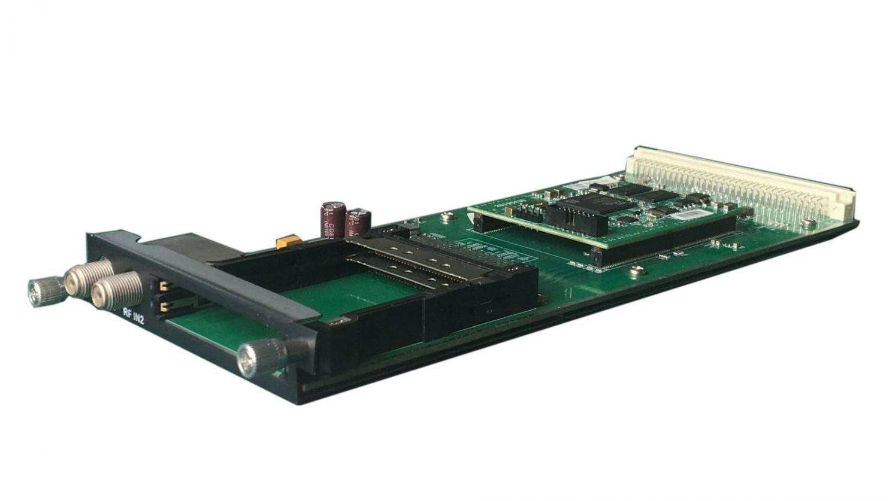
Stream in:
2 Tuner input, F Type,
Stream out: 1 MPTS output to DHP230 chassis for re-multiplexing
DVB-CI:
2 independent common interface slots
Standard: DVB-S/S2/S2X;

DVB-S
Input Frequency: 950-2150MHz
Symbol Rate: QPSK 1~45Msps
Signal Strength: -65~ -25dBm
FEC Demodulation: 1/2, 2/3, 3/4, 5/6, 7/8

DVB-S2
Input Frequency: 950-2150MHz
Symbol rate: QPSK/8PSK 1~45Msps; 16APSK 1~45 Msps; 32APSK1~32 Msps
FEC Demodulation: 1/2, 2/3, 3/4,5/6,7/8, 4/5,5/6,8/9, 9/10

DVB-S2X
Input Frequency: 950-2150MHz
Symbol rate: QPSK/8PSK/16APSK 0.5~45 Msps;
8APSK/32APSK: 0.5~40Msps
FEC Demodulation:
QPSK: 1/2, 3/5, 2/3, 3/4, 4/5, 5/6, 8/9, 9/10, 13/45, 9/20, 11/20
8PSK: 3/5, 2/3, 3/4, 5/6, 8/9, 9/10, 23/36, 25/36, 13/18
8APSK: 5/9-L, 26/45-L
16APSK: 2/3, 3/4, 4/5, 5/6, 8/9, 9/10,1/2-L, 8/15-L, 5/9-L, 26/45, 3/5, 3/5-L, 28/45, 23/36, 2/3-L, 25/36, 13/18, 7/9, 77/90
32APSK: 3/4, 4/5, 5/6, 8/9, 2/3-L, 32/45, 11/15, 7/9

Support Diseqc function

Multiplexing:
Maximum PID Remapping: 256 output pids
Function: PID remapping (automatically or manually), Accurate PCR adjusting, generate PSI/ SI table automatically
Descrambling:
CAM/CI Quantity: 2
BISS Mode: Mode 1, Mode E; 32 BISS Keys

DX942A 4 frequencies Descrambling Module
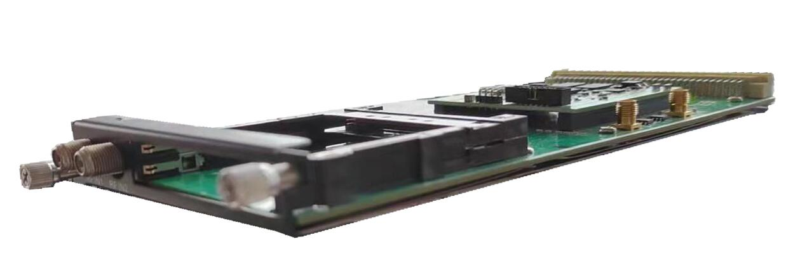
Stream in:
4 frequencies input(each RF in interface for 2 frequencies locking), F Type,
Stream out: 1 MPTS output to DHP230 chassis for re-multiplexing
DVB-CI: 2 independent common interface slots
Standard: DVB-C (J.83 A/C)/J.83B/ DVB-T/DVB-T2/ISDB-T switchable

Standard: DVB-C (J.83 A/C); J.83B
Input Frequency: 60MHz~890MHz
Symbol rate: 1000~9000Ksps
Constellation: 16/32/64/128/256 QAM; 64/256 QAM for J.83B

Standard: DVB-T/T2
Frequency In: 60MHz~890MHz
Bandwidth: 5/6/7/8M bandwidth
PLP supported for DVB-T2

Standard: ISDB-T
Input Frequency: 60-890MHz

Multiplexing:
Maximum PID Remapping: 256 output pids
Function: PID remapping (automatically or manually), generate PSI/ SI table automatically
Descrambling:
CAM/CI Quantity: 2
BISS Mode: Mode 1, Mode E; 32 BISS Keys

About Us
FMUSER is a company specializing in broadcasting and television transmission systems and integrating hotel IPTV systems. The company was established in 2009 and has served over 180 countries worldwide. More than 20,000 television stations, radio stations, and hotel clients from different.

Contact:Tomleequan Email：sales@fmuser.com whatsapp: +8613922702227

