FMUSER FUQ-2500B Analog RF Modulator 32-64 Channel IP-HDMI-AV Input PAL-NTSC-SECAM Output HEVC-H.265-H.264-MPEG-2 A2-NICAM728 OSD Insertion Broadcast Systems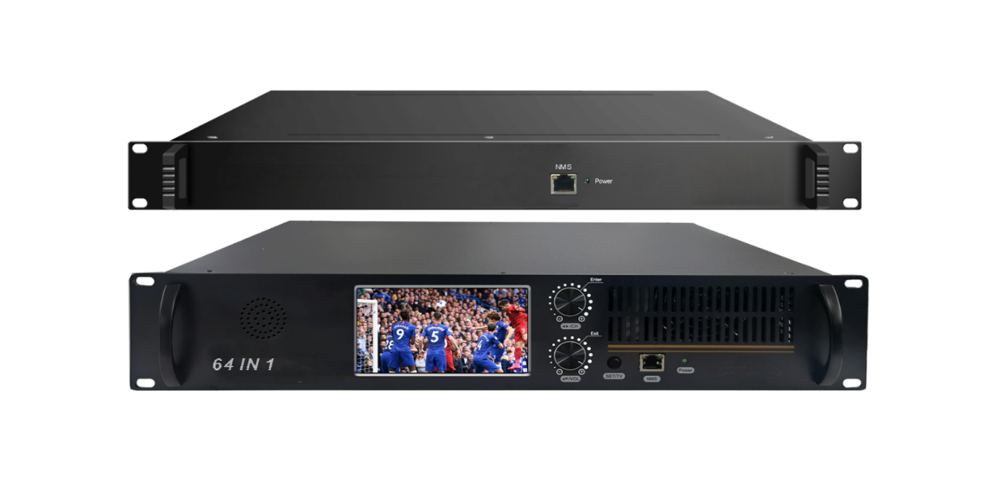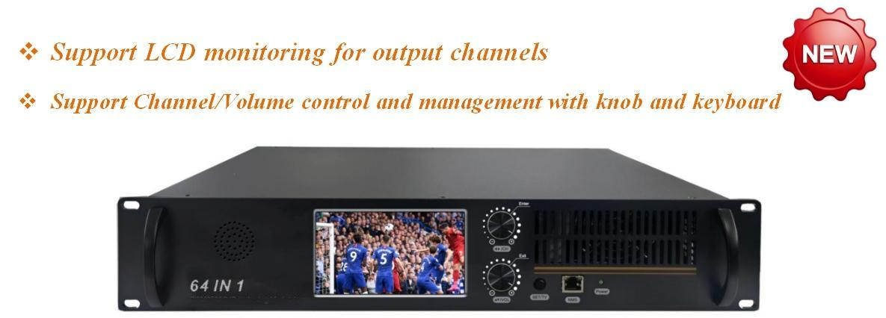

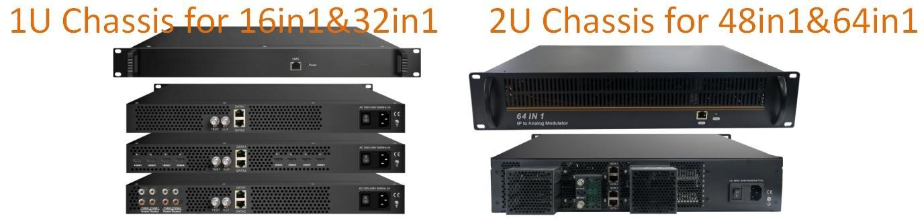

Product overview
The FMUSER FUQ-2500B converts IP/HDMI/AV inputs to analog RF outputs for up to 64 channels. It processes signals with full digital processing for high SFDR performance, supporting A2 and NICAM728 audio standards and PAL/NTSC/SECAM modulation including OSD insertion. Applications include television broadcasting for PAL, NTSC, or SECAM systems.
Key feature
- Supports A2 and NICAM728 audio standards with dual-channel mono and stereo modes.
- Ensures high SFDR performance through full digital processing for superior RF output.
- Provides OSD customization with logo/caption insertion, adjustable scrolling, and multilingual support per channel.
- Features hybrid input flexibility for 16-64 IP channels or HDMI/AV + IP combinations.
- Delivers multi-standard output with 32/64 carriers within 400MHz for PAL, NTSC, or SECAM broadcasts.

Support A2 and NICAM728 mono and stereo audio, up to dual channels
Audio options available:
- Mono L, Mono R, Mono L+R
- A2 Dual Mono (L, R), A2 Stereo
- NICAM Dual Mono (L, R), NICAM Stereo

Knowledge about A2 and NICAM 728 audio:
NICAM 728: It is transmission of two-channel digital sound with terrestrial television systems B, G, H, l, K1 and L
A2 Stereo: Known as "two-channel sound", it is an analog television sound transmission system used in Germany, Austria, Australia, Switzerland, NetherlaFU and some other countries that use or used PAL-B or PAL-G. .It relies on two separate FM ca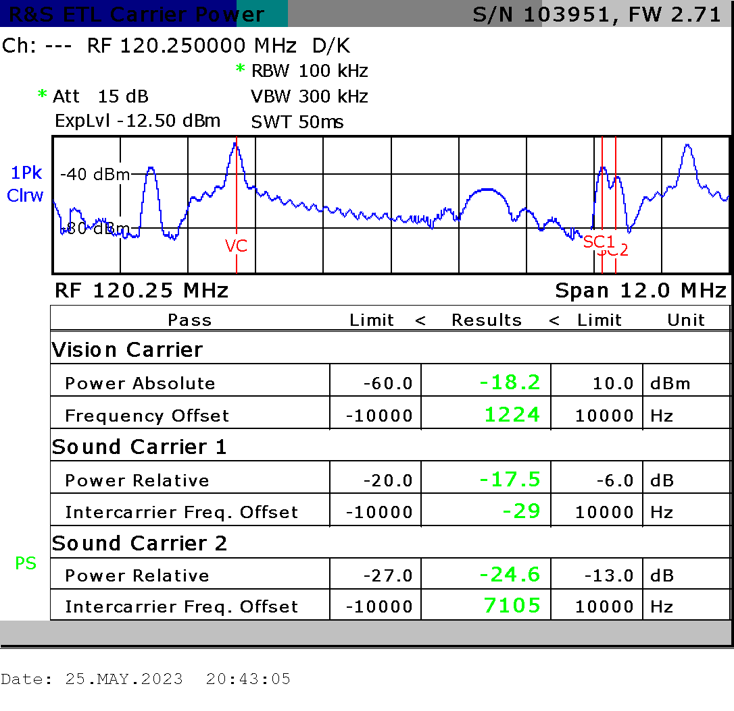rriers.
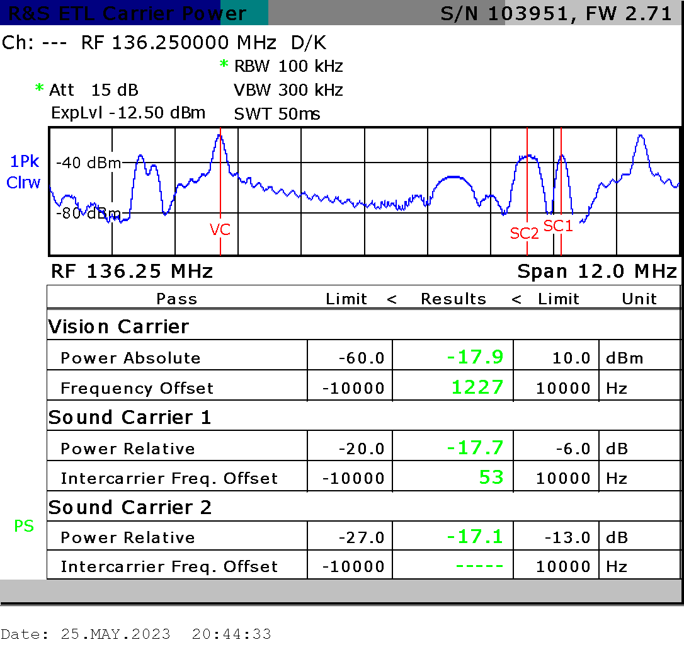
A2 Audio Spectral Diagram NICAM Audio Spectral Diagram

Support High SFDR Performance
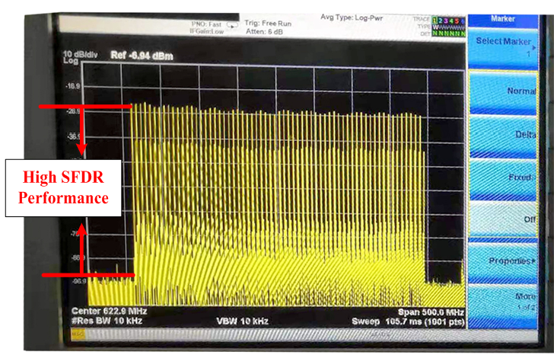

Full Digital Processing, Super RF out performance
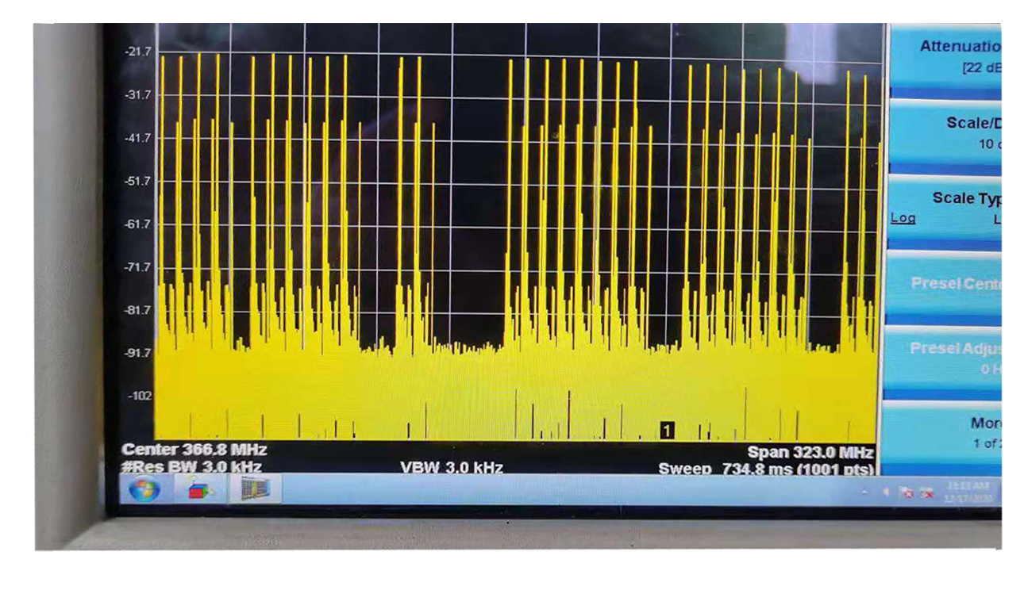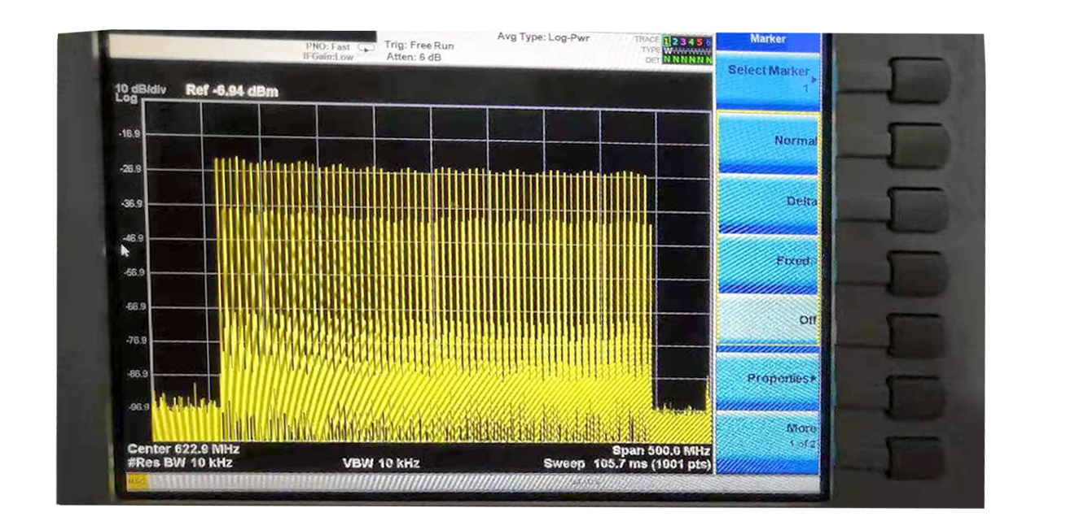

Support OSD (Logo&Caption) insertion for each channel, easy operation
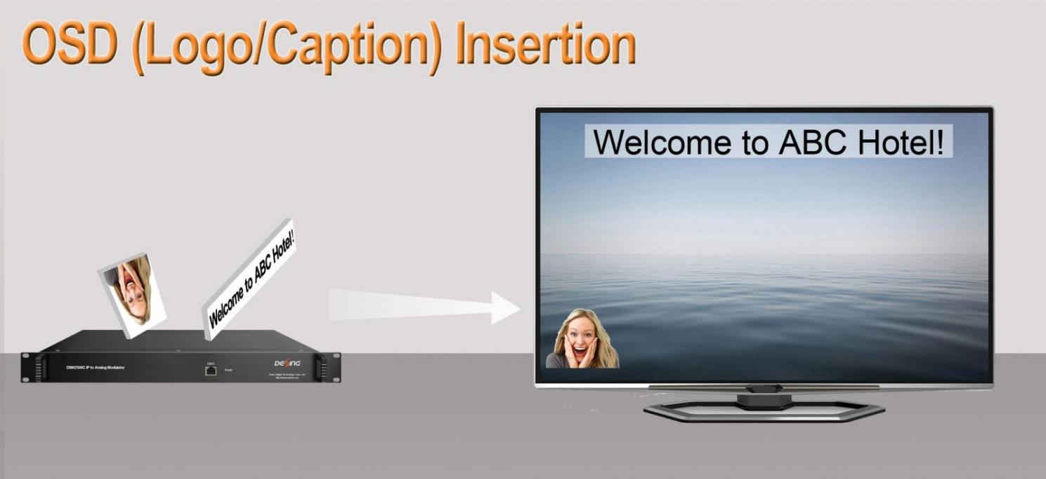

Support Multiple-modulation Standard
32 (or 16/48/64) standard PAL or NTSC or SECAM TV programs output via 32 (or 16/48/64) non-adjacent or adjacent carriers output within 400MHz

Other Key feature
Support to convert 32 (or 16/48/64) IP channels (or 4 HDMI/AV+28 IP channels, or 8 HDMI/AV+24 IP channels) to analog RF out
Suport CC/Subtitle/Teletext
Support BISS De-scrambling
Support program info modify, multiple audio select l
2 (or 4) GE ports for IP MPTS/SPTS input, Max 840Mbps for each GE input
Support HEVC/H.265, H.264/AVC, MPEG-2 TS Decoding
32 (or 16/48/64) standard PAL or NTSC or SECAM TV programs output via 32 (or 16/48/64) non-adjacent or adjacent carriers output within 400MHz
Redundancy power supply for option
Compact body, Freight saving
Support Web-based Network management

Specifications
Input | Interface/rate | 32(or 16/48/64) IP (or 4 HDMI/AV+28 IP, or 8 HDMI/AV+24 IP) input  2 /4 GE ports (max 64 IP input)  Max 840Mbps for each GE input
Input | Stream | UDP, UDP / RTP, 1-7 packets (SPTS/MPTS)
Input | Transport Protocol | UDP/RTP, unicast and multicast, IGMP V2/V3
Input | Packet Length | 188 / 204 Bytes
Decoding  Parameters | Video | HEVC/H.265, H.264/AVC, MPEG-2
Decoding  Parameters | Audio | MPEG-1/2 Layer 1/2, (HE-)AAC
Decoding  Parameters | Audio Channel | Mono L, Mono R, Mono L+R  A2 Dual Mono (L, R), A2 Stereo  NICAM Dual Mono (L, R), NICAM Stereo  (Note: when applying dual audio, one TV program with dual audio will occupy 2 frequencies, which means the total output channels will reduce respectively.)
Decoding  Parameters | Data | CC, Teletext, Subtitles, DVB Subtitling
Decoding  Parameters | Resolutions | HEVC/H.265:  1080@60P, 1080@60I, 1080@50P, 1080@50I, 720@60P, 720@50P  H.264/AVC:  1080@60I, 1080@50P, 1080@50I, 1080@30P, 1080@25P, 720@60P, 720@50P, 576@50I, 480@60I  MPEG2:  1080@60I, 1080@50I, 720@60P, 720@50P, 576@50I, 480@60I
Decoding  Parameters | Aspect ratio | 4:3
Modulation  Parameters | Number of channels | 32 (or 16/48/64) non-adjacent or adjacent carriers output
Modulation  Parameters | Connectors | 75Ω, F-jack
Modulation  Parameters | Frequency range | 43.25 – 951.252MHz
Modulation  Parameters | Output Bandwidth | 400MHz
Modulation  Parameters | Output level | -5 ~ 2dBm (102 ~ 109dBμV)
Modulation  Parameters | Return loss | ≥ 14dB
Modulation  Parameters | Spurious frequency dist. | ≥ 60dB
Modulation  Parameters | Residual carrier accuracy | 1%
Modulation  Parameters | TV standard | PAL B/G/D/K/M/N/I,  NTSC M, SECAM
Modulation  Parameters | Video-signal to noise ratio | ≥ 60dB
Modulation  Parameters | Carrier to noise ratio | ≥ 60dB (when single carrier on)  ≥ 55.5dB (when all 32 carriers on)
Network Interface | Management | 1 x 100 Base-T Ethernet (RJ 45)
Network Interface | Data | 2 x 1000 Base-T Ethernet (RJ 45)
Others | Image resolution output | 480i/576i
Others | OSD | Logo : JPG, BMP, PNG
Others | OSD | Caption : support multiple languages, scrolling direction and speed customized
Others | Output volume adjustment | 0 - 100 %
General | Demission | 483mm×330mm×44.5mm (1U)  483mm×330mm×88mm (2U)
General | Temperature | 0~45℃(operation), -20~80℃(storage)
General | Power Supply | AC100V±10%, AC 220V±10%, 50/60Hz  Redundancy power supply (Optional)

Order Guide
Options | Configuration
Option 1 | 16 or 32 IP input, 16 or 32 analog channel outputs
Option 2 | 4 HDMI+28 IP input, 32 analog channel outputs
Option 3 | 8 HDMI+24 IP input, 32 analog channel outputs
Option 4 | 4 AV+28 IP input, 32 analog channel outputs
Option 5 | 8 AV+24 IP input, 32 analog channel outputs
Option 6 | 48 or 64 IP input, 48 or 64 analog channel outputs

System Construction Illustration
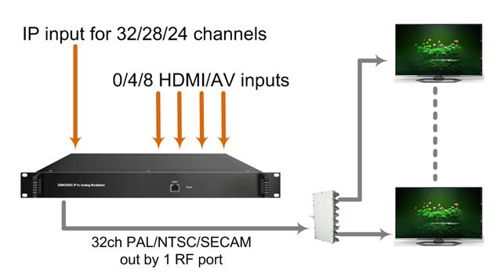

About Us
FMUSER is a company specializing in broadcasting and television transmission systems and integrating hotel IPTV systems. The company was established in 2009 and has served over 180 countries worldwide. More than 20,000 television stations, radio stations, and hotel clients from different.

Contact:Tomleequan Email：sales@fmuser.com whatsapp: +8613922702227

