FMUSER FUQ-2500E Agile Modulator 1×CVBS Video 1×L-R Audio Input 1×RF Output PAL-NTSC-SECAM Standards Configurable RF 47-870MHz Hotel Community Entertainment 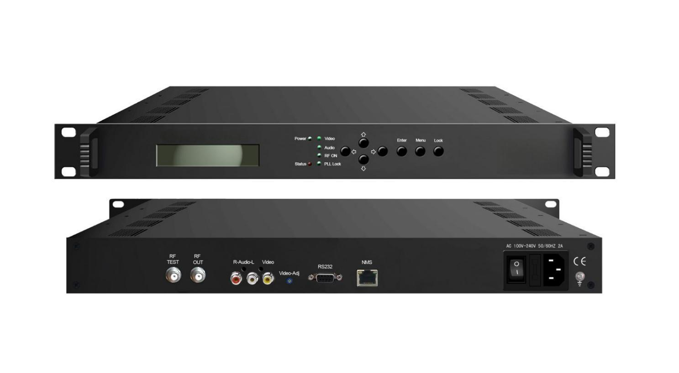Product overview
The FMUSER FUQ-2500E Agile Modulator offers RF modulation with 1 audio (L/R) and 1 video (CVBS) input, plus configurable RF output. It processes signals using video input AGC for stability. This unit features a 19-inch 1U rack-mount design and keyboard/LCD operation with online upgrade. Ideal for hotels, communities, and entertainment venues.
Key feature
- Supports 1 audio (L/R) and 1 video (CVBS) input for versatile connectivity.
- Configurable RF output (47-870MHz) with test port and ±5kHz accuracy.
- Features video input AGC and compatibility with PAL B/G, PAL D/K, NTSC, SECAM standards.
- Enables keyboard and LCD operation with online upgrade capability.
- Integrates 19-inch 1U rack-mount design for easy installation.

Principle Chart
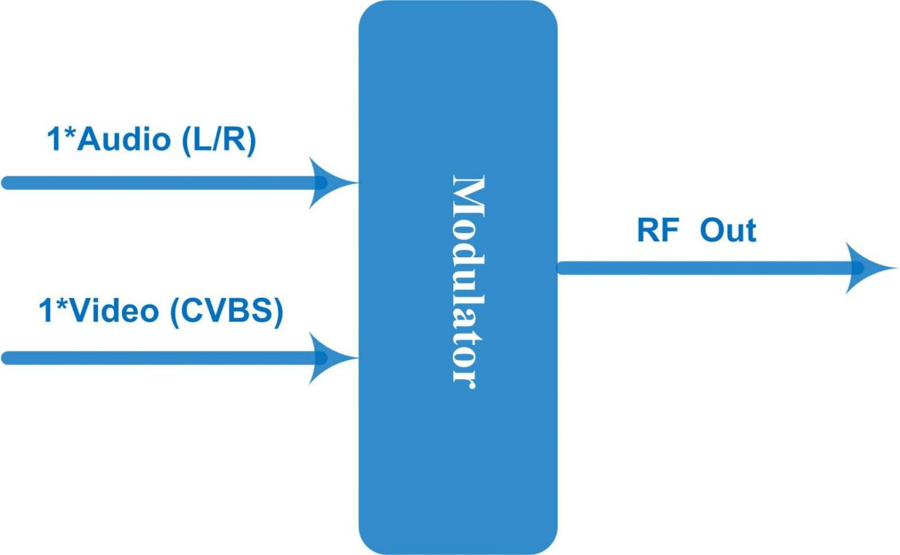

Specifications
Input | 1* audio (L/R) input and 1*video (CVBS)
Video | A/V ration |  | -10~-20dB
Video | Input level |  | 1V_{PP}
Video | Video clamping capacity |  | ≥26dB
Video | Color / light delay difference |  | ≤45nS
Video | Differential gain |  | ≤2% (Modulation 87.5%)
Video | Differential phase |  | ≤2° (Modulation 87.5%)
Video | SNR |  | ≥50dB
Video | Image carrier drift |  | ≤5kHz
Video | 2T-K impulse ratio |  | ≤4%
Video | Flatness in band |  | ≤1dB
Audio | Pre-emphasis of audio |  | 50μs
Audio | Input level |  | 0.7V
Audio | SNR |  | ≥60dB
Audio | Flatness in band |  | ≤1dB
Audio | Distortion degree |  | ≤0.5%
Audio | Audio modulation frequency offset |  | ± 50kHz
Audio | V/A interval |  | According to TV System standard
RF Output | Interface |  | 1 F typed output port, 75Ω
RF Output | Frequency range |  | 47~870MHz, 1kHz step
RF Output | TV system standard |  | PAL B/G, PAL D/K, NTSC, SECAM
RF Output | Output return loss |  | ≥14dB
RF Output | Output level |  | ≥113dBμV
RF Output | Output level adjustable range |  | 0~16dB
RF Output | Error of video/audio carrier interval |  | ≤5 kHz
RF Output | Carrier to noise ratio (C/N) |  | ≥62dB
RF Output | Output suppression |  | ≥60dB (≥130dBuV testing)
RF Output | Flatness in band |  | ≤1dB
RF Output | Frequency accuracy |  | ≤5kHz
RF Output | Adjacent Frequency suppression |  | ≥45dB
System function | Keyboard and LCD operation
System function | Multiple languages
System function | Ethernet software upgrade
Miscellaneous | Dimension(W×L×H) | 482*256*44mm
Miscellaneous | Environment | -10~45℃(work); -20~80℃ (storage）
Miscellaneous | Power requirements | AC 90-264V, 50Hz

About Us
FMUSER is a company specializing in broadcasting and television transmission systems and integrating hotel IPTV systems. The company was established in 2009 and has served over 180 countries worldwide. More than 20,000 television stations, radio stations, and hotel clients from different.

Contact:Tomleequan Email：sales@fmuser.com whatsapp: +8613922702227

