FMUSER FUQ-300 6-Slot Modular Headend Processor Dual IP RJ45-SFP Input-Output UDP-RTP-ASII-HDMI-SDI-RF Encoding Decoding Multiplexing CATV IPTV Broadcast

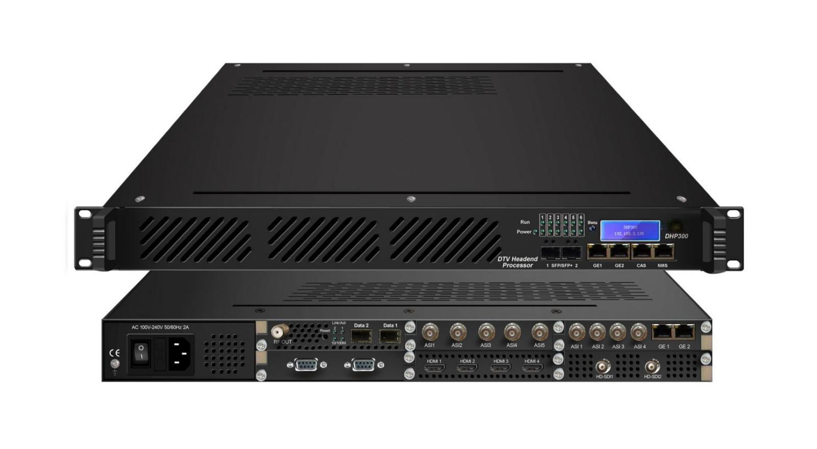
Product overview
The FUQ-300 is a modular 1U headend processor with six slots for flexible encoding, decoding, transcoding, multiplexing, descrambling, and modulating, featuring dual IP input/output via RJ45/SFP interfaces. Signals are processed through customizable modules for various functions. This 1U rack unit includes web-based management and optional redundant power. It is designed for CATV systems and broadcast headends, ensuring reliable performance.
Key Fetures
Integrated six modular slots for customizable encoding, decoding, transcoding, multiplexing, descrambling, and modulating
Supports dual IP input/output via RJ45/SFP interfaces for Unicast/Multicast MPTS/SPTS streams
Features web-based management for configuration, monitoring, and firmware updates
Offers redundant power supply option for enhanced reliability
Provides multi-format support including MPEG-2, H.264, HEVC, DVB-S2/S2X, DVB-T/T2, ATSC, and ISDB-T
Module Specifications

4 CVBS/SDI Encoding Module (DX214B)
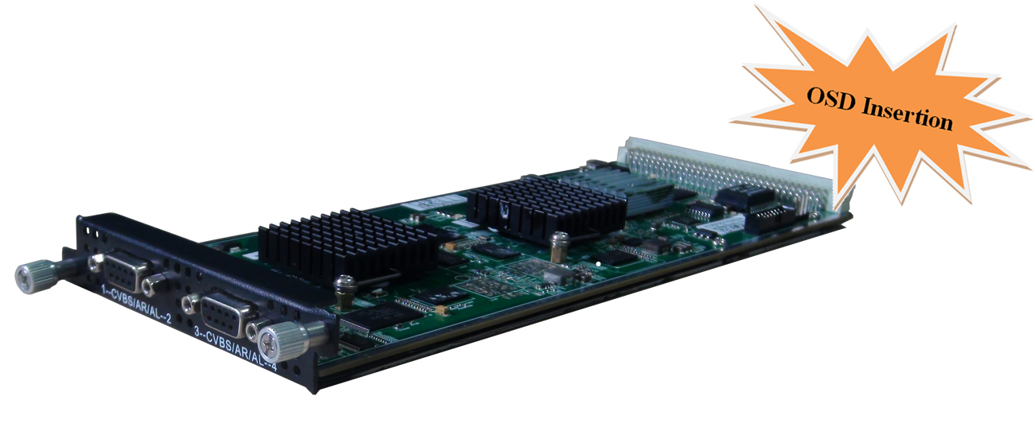
Module Specifications:
Input: 4 CVBS (DB9 to RCA) or 4 SDI (BNC)
Output: 1MPTS and 4 SPTS output over UDP/RTP, unicast and multicast
Video Encoding:
Video format: MPEG-2, MPEG4 AVC/H.264
Image format: PAL, NTSC SD signal (Only for CVBS input)
Resolution:
Input: 720*576 -50i
Output: 720*576/352*288/320*240/320*180/176*144/160*120/160*90-50Hz
Input: 720*480 -60i
Output: 720*480/352*288/320*240/320*180/176*144/160*120/160*90-60Hz
Rate Control: CBR/VBR
GOP structure: IPPP, IBPBP, IBBPB, IBBBP
Video bitrate: 0.5~5Mbps
Audio Encoding:
Audio format: MPEG1 Audio Layer 2, LC-AAC, HE-AAC
Sampling rate: 48KHz
Bit-rate: 48/56/64/80/96/112/128/160/192/224/256/320/384 Kbps

Support Logo, Caption, QR Code insertion

4 CVBS Encoding Module (DX214/214A)
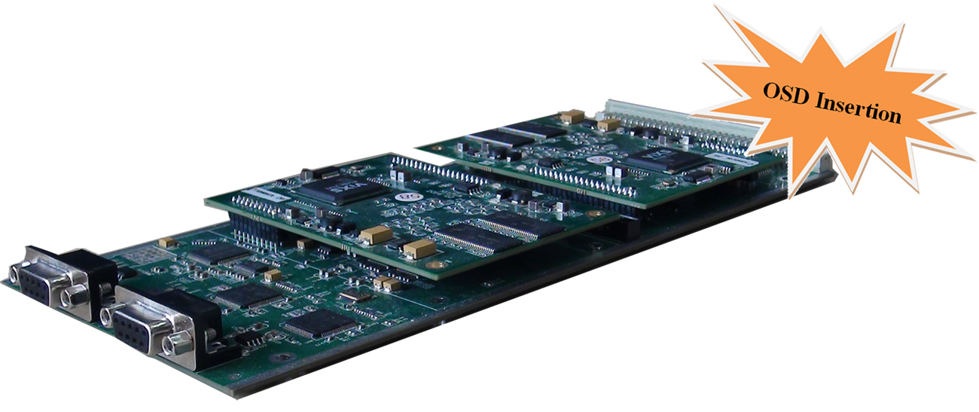
Module Specifications:
Input: 4 CVBS video, 4 Stereo Audio (DB9 to RCA)
Output: 1MPTS and 4 SPTS output over UDP/RTP, unicast and multicast
Video Encoding:
Video format: MPEG-2 (4:2:0)
Image format: PAL, NTSC SD signal
Output resolution: 720×480_60i, 544×480_60i, 352×480_60i, 352×240_60i,
320×240_60i, 176×240_60i, 176×120_60i, 720×576_50i,
704×576_50i, 640×576_50i, 352×288_50i, 320×288_50i,
176×288_50i, 176×144_50i
GOP structure: IP, IBP, IBBP, IBBBP
Video bitrate: 0.1Mbps~8Mbps per channel
Support CC (closed caption)
Audio Encoding:
Audio format: MPEG-1 Layer 2, DD AC3 (2.0)
Sampling rate: 48KHz
Audio bitrate:128/192/256/320/384kbps each channel

Support Logo, Caption, QR Code insertion (for DX214A only)

8 CVBS Encoding Module(DX218S)
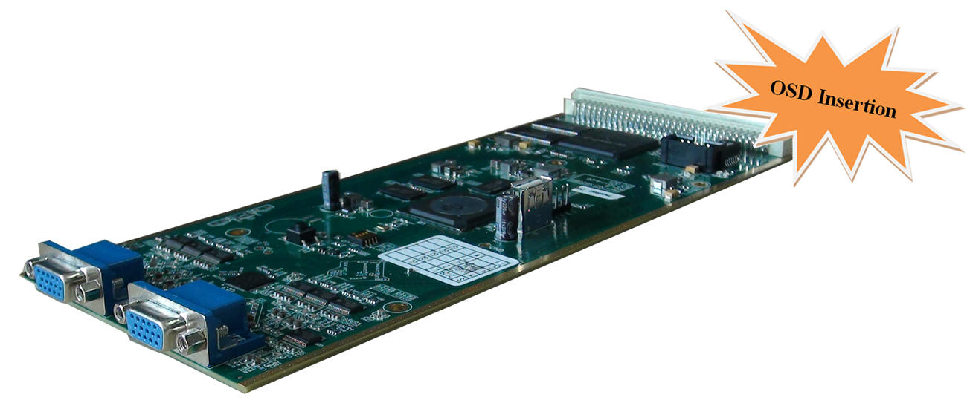
Module Specifications:
Input: 8 CVBS video, 8 Stereo Audio (DB15 to RCA), or 8 ch analog audio input to work as audio encoder module
Output: 1 MPTS and 8 SPTS output over UDP/RTP, unicast and multicast
Video Encoding:
Video format: MPEG4 AVC/H.264
Image format: PAL, NTSC SD signal
Resolution: 720×576i, 720×480i
Rate Control: CBR/VBR
GOP structure: IPP
Video bitrate: 1~7Mbps each channel
Audio Encoding:
Audio format: MPEG-1 Layer 2
Sampling rate: 48KHz
Bit-rate: 64/128/192/224/256/320/384Kbps each channel

Support Logo, Caption, QR Code insertion

2 HDMI/SDI Encoding/Transcoding Module (DX202A/DX202A-D)
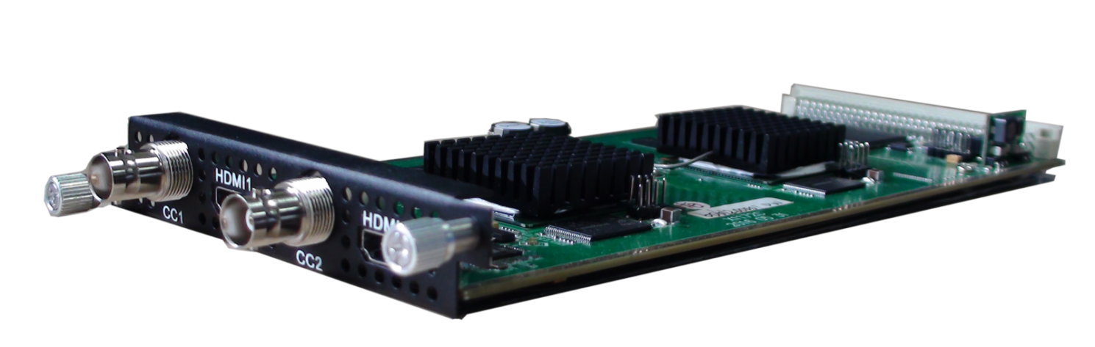
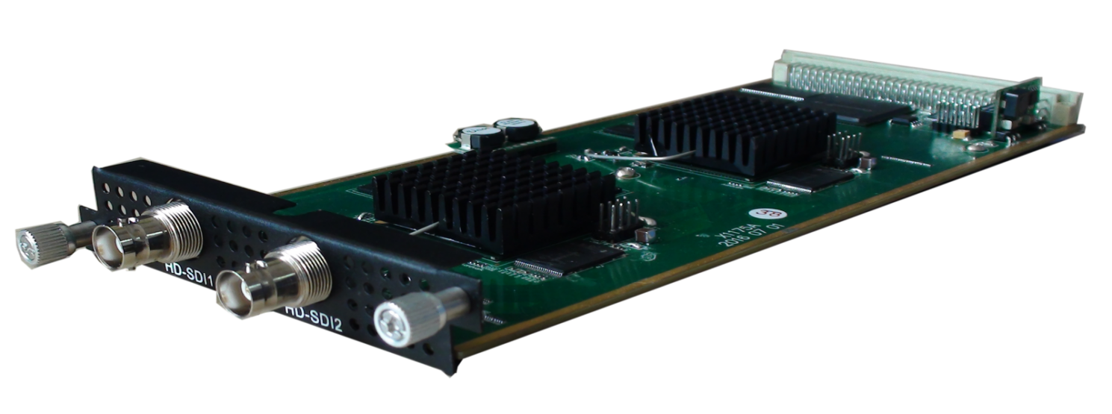
Module Specifications:
Input: 2*HDMI, 2*BNC for CC (Closed Caption) input - (DX202A)
Input: 2*HD/SD SDI - (DX202A-D)
Output: 1*MPTS output over UDP, Unicast/Multicast
Video Encoding:
Video format: MPEG2 & MPEG4 AVC/H.264
Input resolution: 1920*1080_60P, 1920*1080_50P, 1920*1080_60i, 1920*1080_50i, 1280*720_60p, 1280*720_50P, 720*480_60i, 720*576_50i
Aspect ratio: 16:9, 4:3
Video bitrate: 0.8~19Mbps
Support CC (closed caption)
Audio Encoding:
Audio format: MPEG1 Layer II, MPEG2-AAC, MPEG4-AAC,
Dolby Digital AC3 (2.0) encoding (Optional); AC3 (2.0/5.1) passthrough
Sampling rate: 48KHz Audio bitrate: 64Kbps-320kbps each channel

Video Tanscoding:
2*MPEG2 HD → 2*MPEG2/H.264 HD; 4*MPEG2 HD → 4*MPEG2/H.264 SD;
2*H.264 HD → 2*MPEG2/H.264 HD; 4*H.264 HD → 4*MPEG2/H.264 SD;
4*MPEG2 SD → 4*MPEG2/H.264 SD; 4*H.264 SD → 4*MPEG2/H.264 SD
Audio Tanscoding:
MPEG-1 Layer 2, AC3 (Optional) and AAC any-to-any

8 HDMI Encoding Module (DX228S)
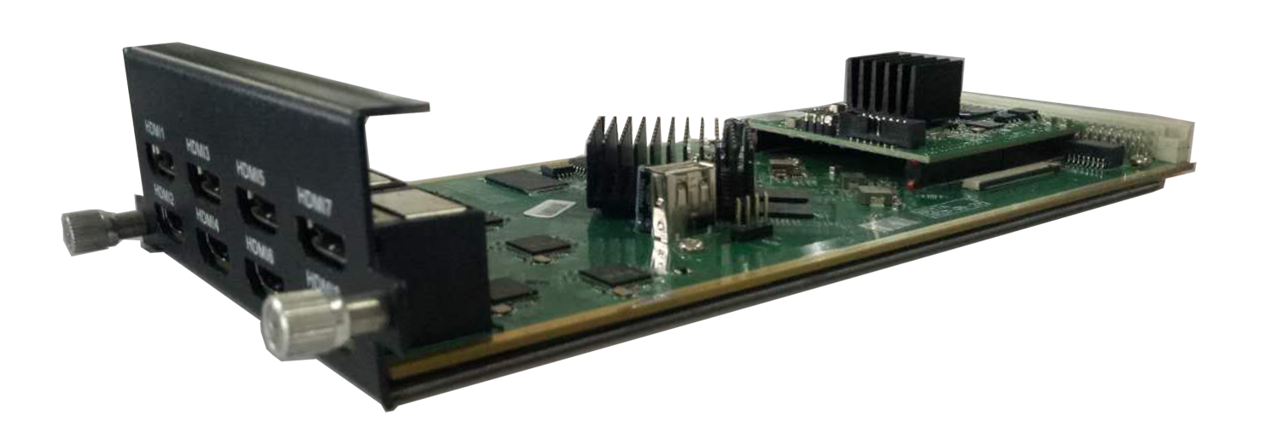
Module Specifications:
Input: 8*HDMI
Output: 1*MPTS and 8*SPTS output over UDP/RTP/RTSP, Unicast/Multicast
Video Encoding:
Video format: MPEG-4 AVC/H.264
Input resolution: 1920×1080_60P, 1920×1080_60i, 1920×1080_50P, 1920×1080_50i,1280×720_60P, 1280×720_50P, 720×576_50i, 720×480_60i,
Output resolution: 1920×1080_30P, 1920×1080_25P, 1280×720_30P, 1280×720_25P, 720×576_25P,720×480_30P,
GOP structure: IP…P (P Frame adjustment, without B Frame)
Video Bit-rate: 1Mbps~13Mbps each channel
Rate Control: CBR/VBR
Audio Encoding:
Audio format: MPEG1 Layer II, LC-AAC, HE-AAC and AC3 Pass through, support audio gain adjustment
Sampling rate: 48 KHz
Audio Bit-rate:
MPEG-1 Layer 2: 48/56/64/80/96/112/128/160/192/224/256/320/384 kbps
LC-AAC: 48/56/64/80/96/112/128/160/192/224/256/320/384 kbps
HE-AAC: 48/56/64/80/96/112/128 kbps

Support Logo, Caption, QR Code insertion

4 HDMI/SDI Encoding Module (DX224H/HV)
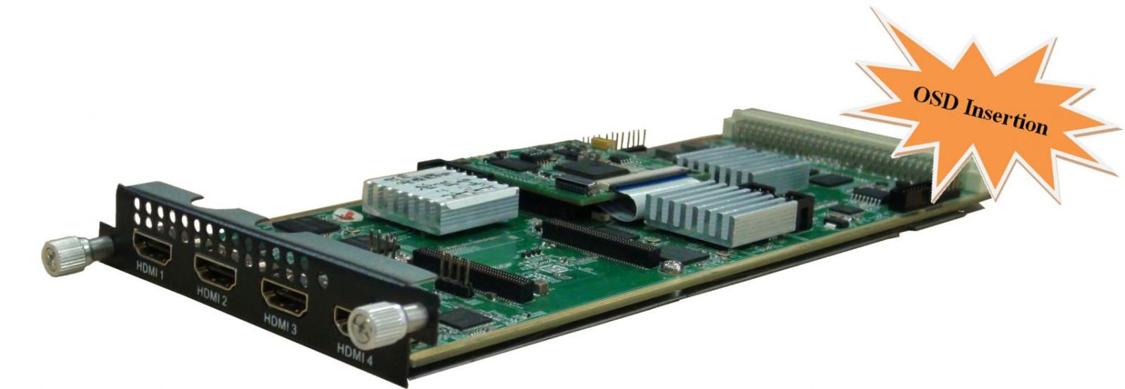
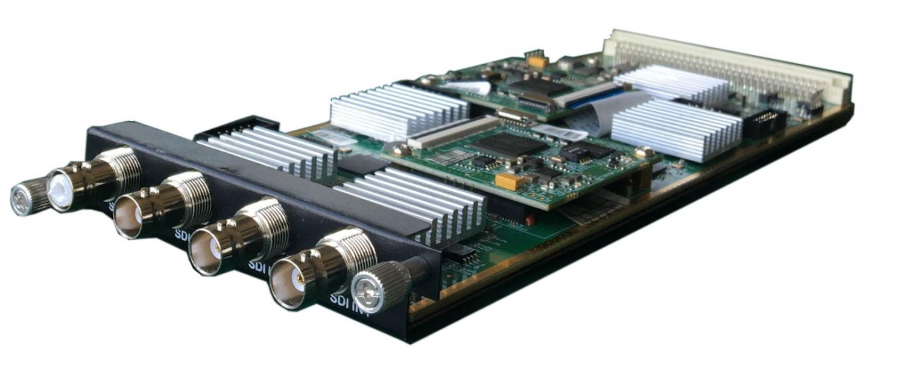

Module Specifications:
Input: 4×HDMI (1.4) /SDI input, HDCP 1.4
Output: 1 MPTS and 4 SPTS output over UDP/RTP/RTSP
Video Encoding:
Video format: HEVC/H.265 & MPEG 4 AVC/H.264
Resolution:
DX224HV | Input | Output
DX224HV | Input | HEVC/H.265 | MPEG-4 AVC/H.264
DX224HV | 4*1080P-50 | 4*1080P-50 | 4*1080P-25  2*1080P-50
DX224HV | 4*1080P-60/59.94 | 4*1080P-60,  4*1080P-59.94 | 4*1080P-30  4*1080P-29.97  2*1080P-60  2*1080P-59.94
DX224HV | 4*1080I-50 | 4*1080P-50,  4*1080P-25 | 4*1080I-50  4*1080P-25  2*1080P-50
DX224HV | 4*1080I-60/59.94 | 4*1080P-60,  4*1080P-30 | 4*1080I-60  4*1080P-30  2*1080P-60
DX224HV | 4*720P-50 | 4*720P-50 | 4*720P-50
DX224HV | 4*720P-60/59.94 | 4*720P-60,  4*720P-59.94 | 4*720P-60  4*720P-59.94
DX224H | Input | Output
DX224H | Input | HEVC/H.265 | MPEG-4 AVC/H.264
DX224H | 4*1080P-50 | 4*1080P-50 | 4*1080P-50
DX224H | 4*1080P-60/59.94 | 4*1080P-60,  4*1080P-59.94 | 4*1080P-60  4*1080P-59.94
DX224H | 4*1080I-50 | 4*1080P-50,  4*1080P-25 | 4*1080P-25  4*1080P-50  4*1080I-50
DX224H | 4*1080I-60/59.94 | 4*1080P-60,  4*1080P-30 | 4*1080P-30  4*1080P-60  4*1080I-60
DX224H | 4*720P-50 | 4*720P-50 | 4*720P-50
DX224H | 4*720P-60/59.94 | 4*720P-60,  4*720P-59.94 | 4*720P-60  4*720P-59.94
Chroma: 4:2:0
Bit rate (each channel): 0.5Mbps~20Mbps (H.265); 4 Mbps~20Mbps (H.264)
Rate Control: CBR/VBR
GOP structure: IBBP, IPPP
Audio Encoding:
Audio format: MPEG-1 Layer 2, LC-AAC, HE-AAC, HE-AAC V2, AC3 Passthrough
Bit-rate (each channel):
48Kbps~384Kbps (MPEG-1 Layer 2 & LC-AAC);
24 Kbps~128 Kbps (HE-AAC); 18 Kbps~56 Kbps (HE-AAC V2)
Sampling rate: 48KHz
Support Audio Gain adjust

Support Logo, QR Code insertion--Optional as per order

4 HDMI/SDI Encoding Module (DX224V)
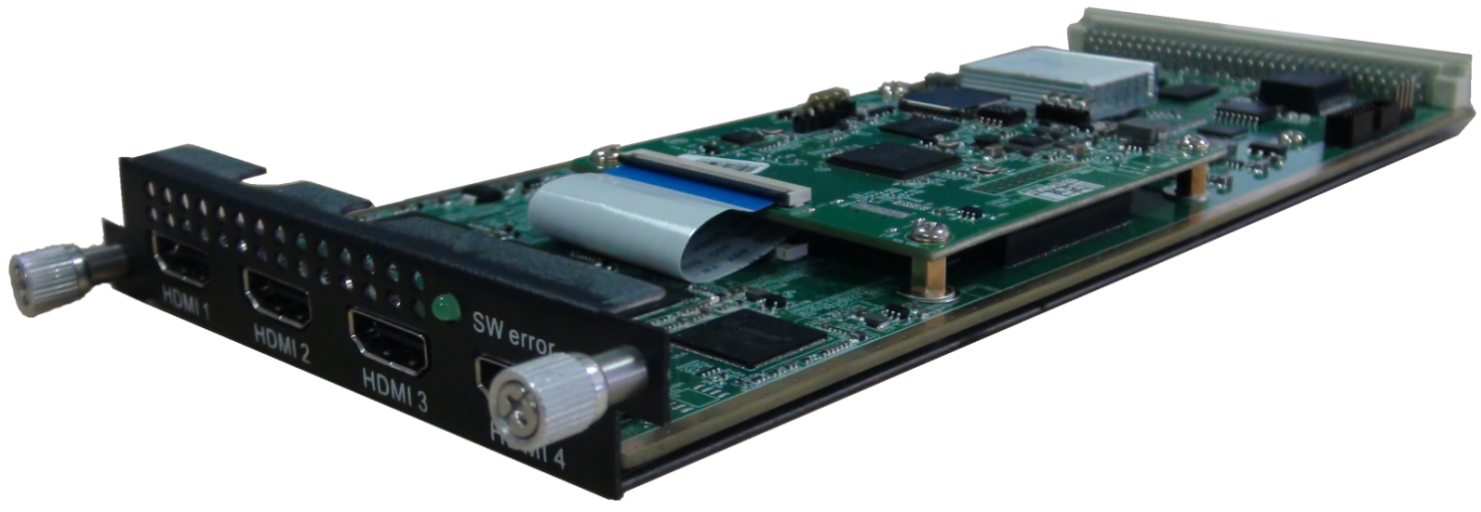
Module Specifications:
Input: 4×SDI/HDMI (1.4) input, HDCP 1.4
Video Encoding:
Video format: HEVC/H.265 & MPEG 4 AVC/H.264
Resolution:
HDMI VI & SDI：
Input | Output
Input | HEVC/H.265 | MPEG-4 AVC/H.264
4*1080P-50 | 4*1080P-50 | 2*1080P-50
4*1080P-60/59.94 | 4*1080P-60/59.94 | 2*1080P-60/59.94
4*1080I-50 | 4*1080P-50 | 4*1080I-50  2*1080P-50
4*1080I-60/59.94 | 4*1080P-60/59.94 | 4*1080I-60/59.94  2*1080P-60/59.94
4*720P-50 | 4*720P-50 | 4*720P-50
4*720P-60/59.94 | 4*720P-60/59.94 | 4*720P-60/59.94

HDMI V2:

Input | Output
Input | HEVC/H.265 | MPEG-4 AVC/H.264
4*2160P_25/30/29.97 | 2*2160P_25/30/29.97 | 1*2160P_25/30/29.97
4*1080P_50/60/59.94 | 4*1080P_50/60/59.94 | 2*1080P_50/60/59.94
4*720P_50/60/59.94 | 4*720P_50/60/59.94 | 4*720P_50/60/59.94
Chroma: 4:2:0 Bit rate: 0.5Mbps~20Mbps (H.265); 4 Mbps~20Mbps (H.264)
Rate Control: CBR/VBR
GOP structure: IBBP, IPPP
Audio Encoding:
Audio format: MPEG-1 Layer 2, LC-AAC, HE-AAC, HE-AAC V2, AC3 Passthrough
Sampling rate: 48KHz
Bit-rate (each channel):
48Kbps~384Kbps (MPEG-1 Layer 2 & LC-AAC)
24 Kbps~128 Kbps (HE-AAC), 18 Kbps~56 Kbps (HE-AAC V2)
Support audio gain adjust

Support Logo, QR Code insertion--available on HDMI V1

2 Tuner Descrambling Module (DX902A)
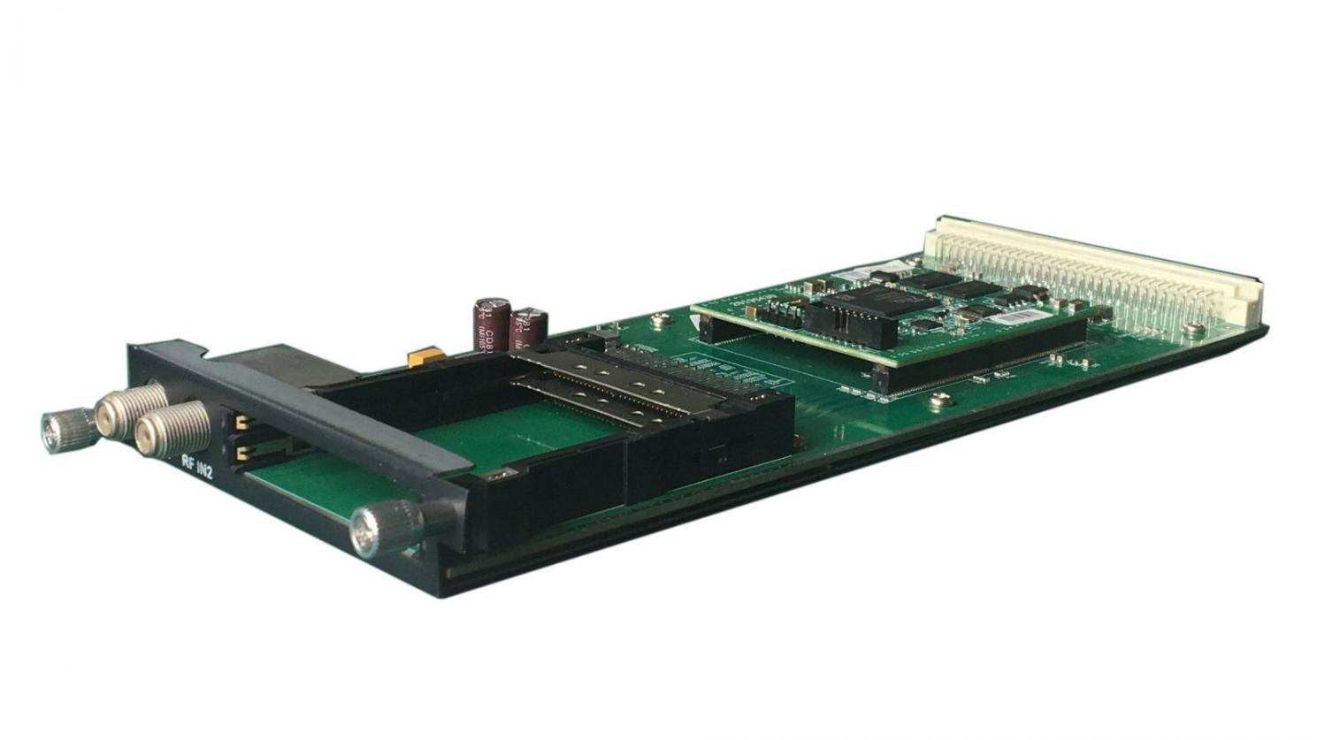
Stream in: 2 Tuner input, F Type,
16 IP inputs from data port, UDP/RTP, unicast and multicast, IGMP V2/V3
Stream out: 1 MPTS and 16 SPTS outputs over UDP/RTP/RTSP, Unicast/Multicast
DVB-CI: 2 independent common interface slots
Tuner input: DVB-S/S2/S2X
Symbol rate: QPSK/8PSK/16APSK 0.5~45 Msps; 8APSK/32APSK: 0.5~40Msps
Input Frequency: 950-2150MHz

DVB-S:
Constellation: QPSK
FEC Demodulation: 1/2, 2/3, 3/4, 5/6, 7/8
DVB-S2:
Constellation: QPSK/8PSK/16APSK/32APSK
FEC Demodulation:
QPSK: 1/2, 2/3, 3/4, 5/6, 3/5, 4/5, 8/9, 9/10
8PSK: 3/5, 2/3, 3/4, 5/6, 8/9, 9/10
16APSK: 2/3, 3/4, 4/5, 5/6, 8/9, 9/10
32APSK: 3/4, 4/5, 5/6, 8/9, 9/10
DVB-S2X:
Constellation: QPSK/8PSK/8APSK/16APSK/32APSK
FEC Demodulation:
QPSK: 1/2, 3/5, 2/3, 3/4, 4/5, 5/6, 8/9, 9/10, 13/45, 9/20, 11/20
8PSK: 3/5, 2/3, 3/4, 5/6, 8/9, 9/10, 23/36, 25/36, 13/18
8APSK: 5/9-L, 26/45-L
16APSK: 2/3, 3/4, 4/5, 5/6, 8/9, 9/10,1/2-L, 8/15-L, 5/9-L, 26/45, 3/5, 3/5-L, 28/45, 23/36, 2/3-L, 25/36, 13/18, 7/9, 77/90
32APSK: 3/4, 4/5, 5/6, 8/9, 2/3-L, 32/45, 11/15, 7/9, 9/10

Support Diseqc function

Multiplexing:
Maximum PID Remapping: 256 output pids
Function: PID remapping (automatically or manually), Accurate PCR adjusting, generate PSI/ SI table automatically

Descrambling:
CAM/CI Quantity: 2
BISS Mode: Mode 1, Mode E; up to 120Mbps, 32 BISS key

4 FTA Tuner Module (DX904B)
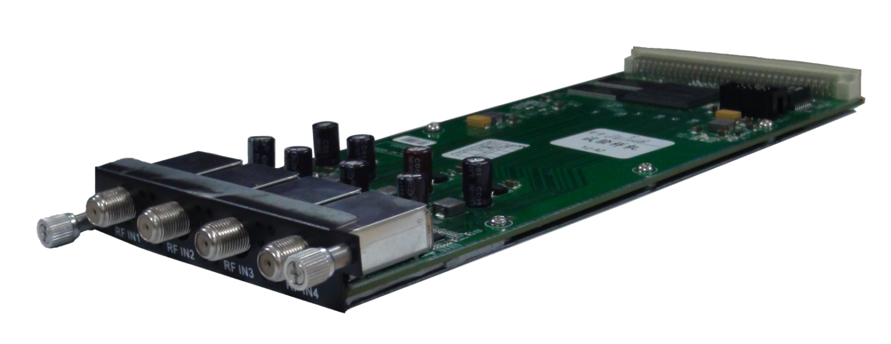
Module Specifications:
Stream in: 4 Tuner input, F Type
Stream out: 1 MPTS out for mux, 4 MPTS out for 4 tuner input pass through over UDP/RTP/RTSP, unicast/multicast
Tuner input: DVB-S/S2/S2X
Symbol rate: QPSK/8PSK/16APSK 0.5~45 Msps; 8APSK/32APSK: 0.5~40Msps
Input Frequency: 950-2150MHz

DVB-S:
Constellation: QPSK
FEC Demodulation: 1/2, 2/3, 3/4, 5/6, 7/8
DVB-S2 :
Constellation: QPSK/8PSK/16APSK/32APSK
FEC Demodulation:
QPSK: 1/2, 2/3, 3/4, 5/6, 3/5, 4/5, 8/9, 9/10
8PSK: 3/5, 2/3, 3/4, 5/6, 8/9, 9/10
16APSK: 2/3, 3/4, 4/5, 5/6, 8/9, 9/10
32APSK: 3/4, 4/5, 5/6, 8/9, 9/10
DVB-S2X :
Constellation: QPSK/8PSK/8APSK/16APSK/32APSK
FEC Demodulation:
QPSK: 1/2, 3/5, 2/3, 3/4, 4/5, 5/6, 8/9, 9/10, 13/45, 9/20, 11/20
8PSK: 3/5, 2/3, 3/4, 5/6, 8/9, 9/10, 23/36, 25/36, 13/18
8APSK: 5/9-L, 26/45-L
16APSK: 2/3, 3/4, 4/5, 5/6, 8/9, 9/10,1/2-L, 8/15-L, 5/9-L, 26/45, 3/5, 3/5-L, 28/45, 23/36, 2/3-L, 25/36, 13/18, 7/9, 77/90
32APSK: 3/4, 4/5, 5/6, 8/9, 2/3-L, 32/45, 11/15, 7/9, 9/10

Support Diseqc function

Multiplexing:
Max number of managing PID: 256
Function: PID remapping (automatically/ manually), Accurate PCR adjust, PID pass-through

Descrambling:
BISS Mode: Mode 1, Mode E; up to 120Mbps, 32 BISS Key

8 FTA Tuner Module (DX908)
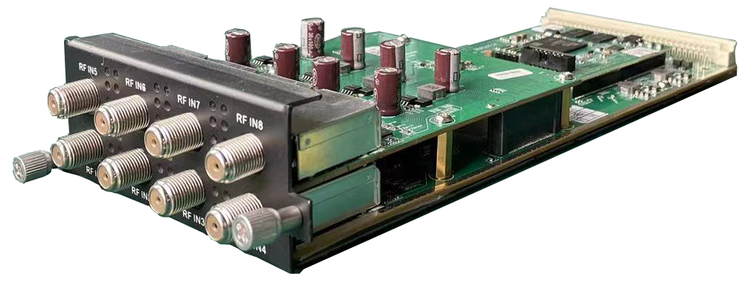
Stream in: 4/8 Tuner input, F Type,
Stream out: 8 MPTS passthrough out for 8 tuner input, or 2 MPTS out after multiplexing, or 512 SPTS out over UDP/RTP/RTSP, Unicast/Multicast
Tuner input: DVB-S/S2/S2X
Symbol rate: QPSK/8PSK/16APSK 0.5~45 Msps; 8APSK/32APSK: 0.5~40Msps
Input Frequency: 950-2150MHz

DVB-S
Constellation: QPSK
FEC Demodulation: 1/2, 2/3, 3/4, 5/6, 7/8
DVB-S2
Constellation: QPSK/8PSK/16APSK/32APSK
FEC Demodulation:
QPSK: 1/2, 2/3, 3/4, 5/6, 3/5, 4/5, 8/9, 9/10
8PSK: 3/5, 2/3, 3/4, 5/6, 8/9, 9/10
16APSK: 2/3, 3/4, 4/5, 5/6, 8/9, 9/10
32APSK: 3/4, 4/5, 5/6, 8/9, 9/10
DVB-S2X
Constellation: QPSK/8PSK/8APSK/16APSK/32APSK
FEC Demodulation:
QPSK: 1/2, 3/5, 2/3, 3/4, 4/5, 5/6, 8/9, 9/10, 13/45, 9/20, 11/20
8PSK: 3/5, 2/3, 3/4, 5/6, 8/9, 9/10, 23/36, 25/36, 13/18
8APSK: 5/9-L, 26/45-L
16APSK: 2/3, 3/4, 4/5, 5/6, 8/9, 9/10,1/2-L, 8/15-L, 5/9-L, 26/45, 3/5, 3/5-L, 28/45, 23/36, 2/3-L, 25/36, 13/18, 7/9, 77/90
32APSK: 3/4, 4/5, 5/6, 8/9, 2/3-L, 32/45, 11/15, 7/9, 9/10

Support Diseqc function

Multiplexing:
Maximum PID Remapping: 256 output pids
Function: PID remapping (automatically or manually), Accurate PCR adjusting, generate PSI/ SI table automatically

Descrambling:
BISS Mode: Mode 1, Mode E; up to 120Mbps, 32 BISS Key

4 frequencies Descrambling Module (DX942A)
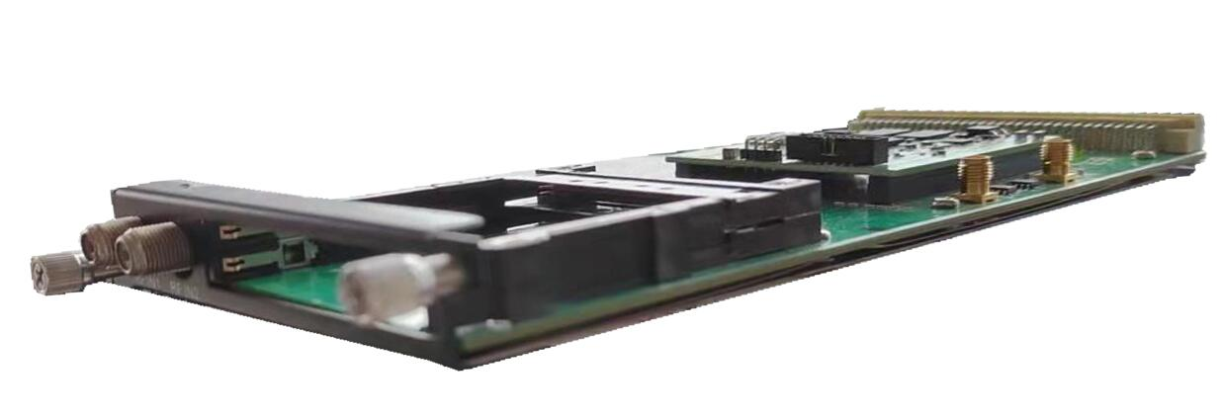
Stream in: 4 frequencies input(each RF in interface for 2 frequencies locking), F Type, 16 IP inputs(UDP/RTP) from data port, unicast and multicast, IGMP V2/V3
Stream out: 1 MPTS and 16 SPTS output over UDP and RTP/RTSP, Unicast/Multicast
DVB-CI: 2 independent common interface slots
Tuner input: DVB-C (J.83 A/C)/J.83B/ DVB-T/DVB-T2/ISDB-T switchable

Standard: DVB-C (J.83 A/C); J.83B
Input Frequency: 60MHz~890MHz
Symbol rate: 1000~9000Ksps
Constellation: 16/32/64/128/256 QAM; 64/256 QAM for J.83B

Standard: DVB-T/T2
Frequency In: 60MHz~890MHz
Bandwidth: 5/6/7/8M bandwidth
PLP Index: 0~255 for DVB-T2

Standard: ISDB-T
Input Frequency: 60-890MHz

Multiplexing:
Maximum PID Remapping: 256 output pids
Function: PID remapping (automatically or manually), generate PSI/ SI table automatically
Descrambling:
CAM/CI Quantity: 2
BISS Mode: Mode 1, Mode E; up to 120Mbps, 32 BISS Keys

8 frequencies Descrambling Module (DX928)
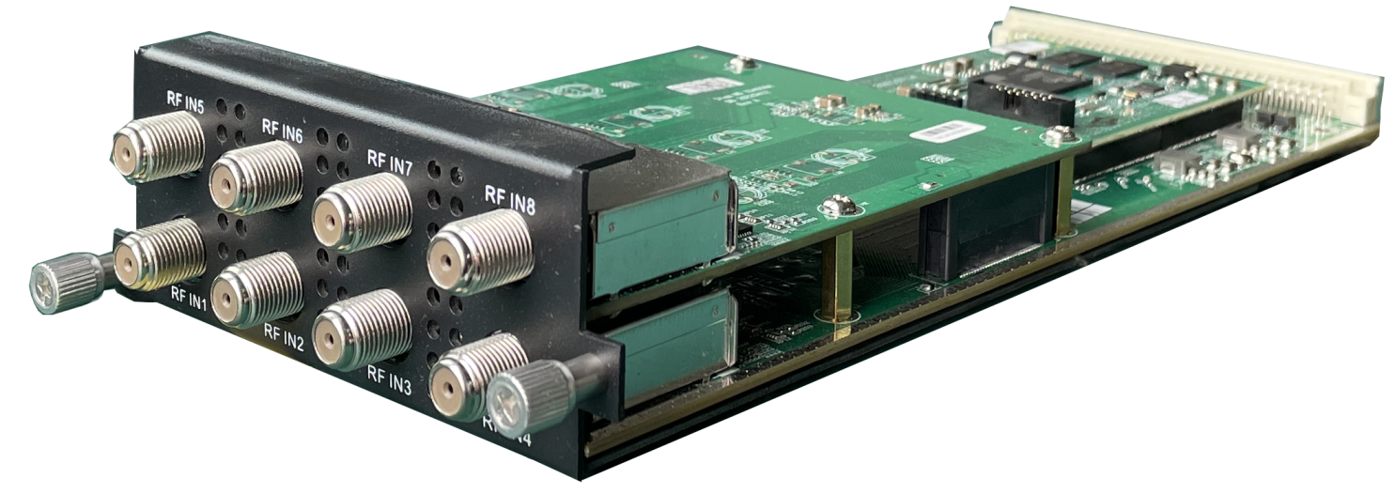
Stream in: 8 tuner input, F Type
Stream out: 8 MPTS passthrough out for 8 tuner input, or 2 MPTS out after multiplexing, or 512 SPTS out over UDP/RTP/RTSP, Unicast/Multicast

Tuner input: DVB-C (J.83 A/C)/J.83B/ DVB-T/DVB-T2/ISDB-T switchable

Standard: DVB-C (J.83 A/C); J.83B
Input Frequency: 60MHz~890MHz
Symbol rate: 1000~9000Ksps
Constellation: 16/32/64/128/256 QAM; 64/256 QAM for J.83B

Standard: DVB-T/T2
Frequency In: 60MHz~890MHz
Bandwidth: 5/6/7/8M bandwidth
PLP Index: 0~255 for DVB-T2

Standard: ISDB-T
Input Frequency: 60-890MHz

Multiplexing:
Maximum PID Remapping: 256 output pids
Function: PID remapping (automatically or manually), generate PSI/ SI table automatically

Descrambling:
BISS Mode: Mode 1, Mode E; up to 120Mbps, 32 BISS Keys

4 ASI/IP Multiplexing Module (DX504)
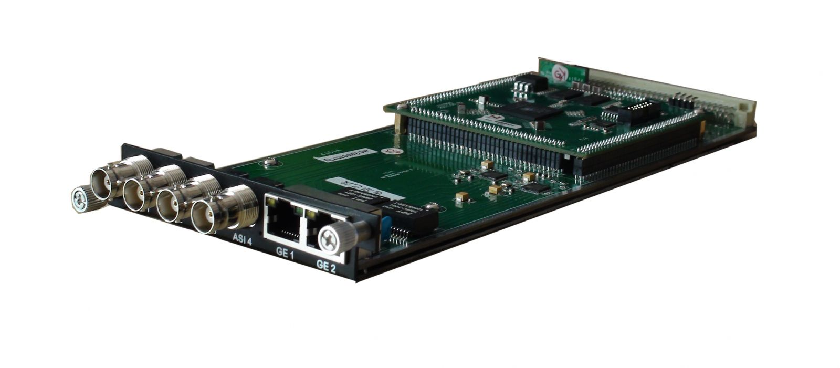
Module Specifications:
ASI inputs/outputs: 4 ASI bi-direction, BNC 75Ω (manually set input or output)
IP inputs/outputs: 2 GE Ports in the module (100/1000Mbps self-adaption) and the DHP300 chassis (data ports or other modules)
Re-multiplexing: PID remapping, PCR correction, generate PSI/ SI table automatically
Stream In: maximum 4 ASI input, 768 IP inputs over UDP/RTP (256 IP inputs thru GE1, GE2 in the module and the DHP300 chassis respectively)
Stream Out: maximum 4 ASI output, 4 MPTS output over UDP/RTP thru GE1, GE2 in the module and thru the DHP300 chassis

5 ASI Multiplexing Module (DX505)
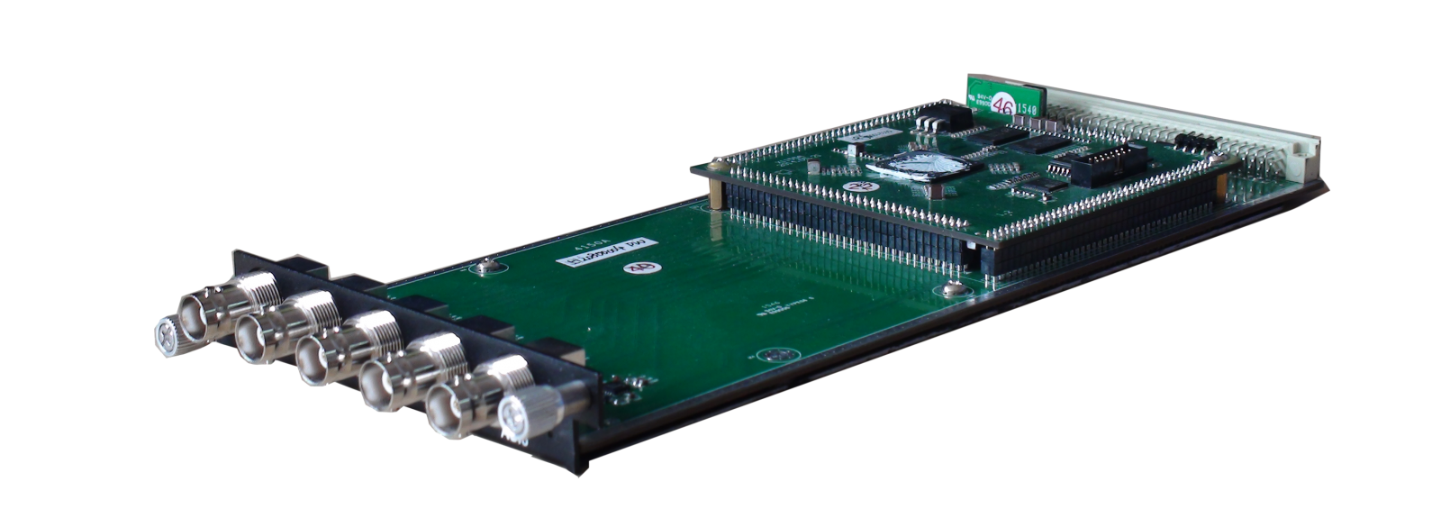

Module Specifications:
ASI inputs/outputs: 5 ASI bi-direction, BNC 75Ω (manually set input or output)
IP inputs/outputs: the DHP300 chassis (data ports or other modules)
Stream in: maximum 5 ASI input, 256 IP inputs over UDP/RTP thru the DHP300 chassis
Re-multiplexing: PID remapping, PCR correction, generate PSI/ SI table automatically
Stream out: maximum 5 ASI output, 5 MPTS out over UDP/RTP thru the DHP300 chassis

IP Multiplexing Module (DX506)
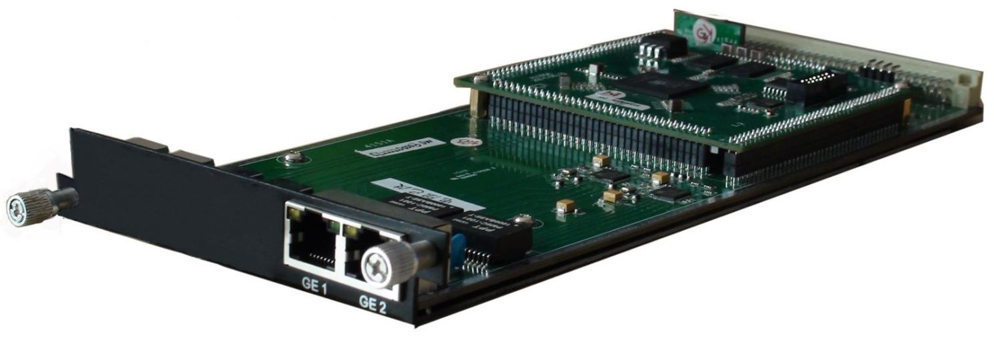
Module Specifications:
IP input: 512 SPTS or MPTS input over UDP, RTP, Unicast and Multicast thru GE1 Ethernet Port (100/1000M)
Re-multiplexing: PID remapping, PCR correction, generate PSI/ SI table automatically
Stream Out: 512 SPTS output over UDP, RTP, Unicast and Multicast through GE2 Ethernet Port (100/1000M)

ASI/IP Mux-Scrambler Module (DX514)

Module Specifications:
ASI inputs/outputs: 4 ASI bi-direction, BNC 75Ω
IP inputs/outputs: 2 Ethernet Port (100/1000M)
Stream connector input
Re-multiplexing: PID remapping, PCR correction, generate PSI/ SI table automatically
Stream In: maximum 4 ASI input, 32 IP input per channel over UDP/RTP
Stream Out: maximum 4 ASI output, 4 IP (MPTS) output over UDP/RTP/RTSP

Scrambling:
Maximum simulcrypt CA: 4
Standard: ETR289, ETSI 101 197, ETSI 103 197
Connection: Local/remote connection

ASI TS Switch Module (DX515)

Module Specifications:
Input: 3 ASI
Output: 2 ASI output (output 1 for one of the switch steams out, output 2 for main input stream)
TS packet: 188/204
Switch Mode: Manually/Auto
Support monitor program status (bitrate, continuous counting, synchronization status)
Support channel mode and program mode switching
Support to switch back to the main stream manually or automatically once the main stream recovers

16/32 QAM Modulating Module (DX316/DX332)
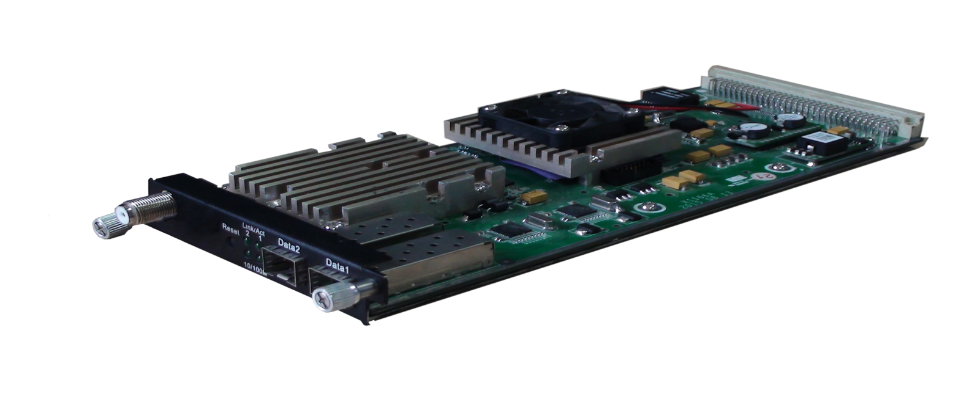

Module Specifications:
Data input: 512*3 IP input over UDP/RTP from 2 GE Ports (RJ45/SFP) and internal stream connector board, unicast/multicast
Data output: 16 or 32 IP output over UDP/RTP/RTSP, unicast/multicast, 2 GE Ports (RJ45/SFP)
Trans Rate: Max 840Mbps/GE Port
RF output (F type): 16/32 channels of multiplexing, scrambling and modualtion.
Multiplexing:
Maximum PID Remapping: 256 output pids per channel
Function: PID remapping (automatically or manually), Accurate PCR adjusting, generate PSI/SI table automatically
Scrambling:
Maximum simulcrypt CA: 6
Standard: ETR289, ETSI 101 197, ETSI 103 197
Connection: Local/remote connection
Modulation:
Standard: EN300 429/ITU-T J.83A/B/C MER: ≥40dB
RF frequency: 50~960MHz, 1KHz step
RF output level: -20~+10dBm (87~117 dBµV), 0.1dB step for all carriers
Symbol Rate: 3600~7200Ksps, 1ksps stepping
5057Ksps (J.83B, 64QAM), 5361Ksps (J.83B, 256QAM)
Constellation/Bandwidth: J.83A: 16/32/64/128/256QAM, 8M
J.83B/C: 64/256QAM, 6M
DX316 Output: 16 non-adjacent carrier outputs within 192M bandwidth
DX332 Output: 32 non-adjacent carrier outputs within 384M bandwidth

48 QAM Modulating Module (DX348D)
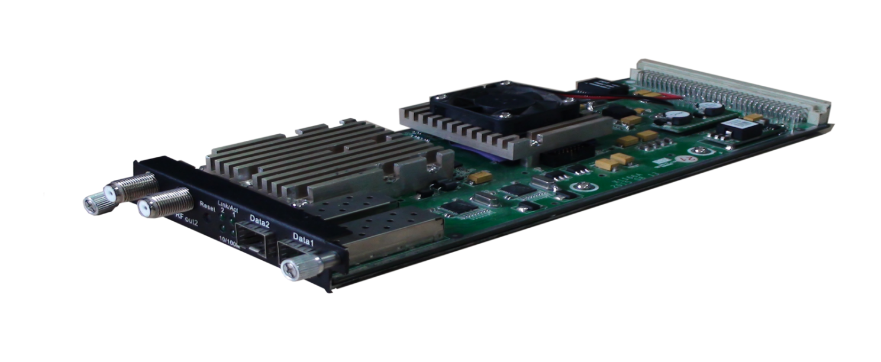
Module Specifications:
Data input: 512*3 IP input over UDP/RTP from 2 GE Ports (RJ45/SFP) and internal stream connector board, unicast/multicast
Data output: 48 IP output over UDP/RTP/RTSP, unicast/multicast, 2 GE Ports (RJ45/SFP), GE1 for IP #1-#24, GE2 for IP #25-#48
Trans Rate: Max 840Mbps/GE Port
Multiplexing:
Maximum PID Remapping: 256 output PIDs per channel
Function: PID remapping (automatically or manually), Accurate PCR adjusting, generate PSI/SI table automatically
Scrambling:
Maximum simulcrypt CA: 6
Standard: ETR289, ETSI 101 197, ETSI 103 197
Connection: Local/remote connection
Modulation:
Standard: EN300 429/ITU-T J.83A/B/C MER: ≥40dB
RF frequency: 50~960MHz, 1KHz step
RF output level: -20~+10dBm (87~117 dBµV), 0.1dB step for all carriers
Symbol Rate: 3600~7200Ksps, 1ksps stepping
5057Ksps (J.83B, 64QAM), 5361Ksps (J.83B, 256QAM)
Constellation/Bandwidth: J.83A: 16/32/64/128/256QAM, 8M
J.83B/C: 64/256QAM, 6M
RF output: 2 F type output ports for 48 non-adjacent carriers, 75Ω
Carrier 1~24 out thru RF1, 25~48 thru RF2, each RF supports 384M bandwidth

8/16 ISDB-Tb Modulating Module (DX306I)
Module Specifications:
Data input: 512*3 IP input over UDP/RTP from 2 GE Ports (RJ45/SFP) and internal stream connector board, unicast/multicast
Data output: 8/16 IP output over UDP/RTP/RTSP, unicast/multicast, 2 GE Ports (RJ45/SFP)
Trans Rate: Max 840Mbps/GE Port
RF output (F type): 8/16 channels of multiplexing and modulation.
Multiplexing:
Maximum PID Remapping: 256 input per channel
Function: PID remapping (automatically or manually), Accurate PCR adjusting, generate PSI/ SI table automatically
Modulation:
Standard: ARIB STD-B31
Bandwidth: 6M
Constellation: QPSK, 16QAM, 64QAM
Guard Interval: 1/32, 1/16, 1/8, 1/4
Transmission Mode: 2K, 4K, 8K
Code rate: 1/2, 2/3, 3/4, 5/6, 7/8
MER: ≥40dB
RF frequency: 50~960MHz, 1KHz step
RF output level: -20dBm~+10dBm (87~117dbµV), 0.1dB stepping
RF Output: 8/16 non-adjacent carrier outputs within 192M bandwidth

Order Guide:
DX306i-8: 8 non-adjacent ISDB-T carrier output + 8 IP MPTS output
DX306i-16: 16 non-adjacent ISDB-T carrier output + 16 IP MPTS output

8/16 DVB-T Modulating Module (DX308T)
Module Specifications:
Data input: 512*3 IP input over UDP/RTP from 2 GE Ports (RJ45/SFP) and internal stream connector board, unicast/multicast
Data output: 8/16 IP output over UDP/RTP/RTSP, unicast/multicast, 2 GE Ports (RJ45/SFP)
Trans Rate: Max 840Mbps/GE Port
Multiplexing:
Channel Number: 8/16 multiplexing channels
Maximum PID Remapping: 256 input per channel
Function: PID remapping (automatically or manually), Accurate PCR adjusting, generate PSI/ SI table automatically
Modulation:
Standard: ETSI EN300 744 MER: ≥40db
RF Frequency: 50~960MHz, 1KHz step
Constellation: QPSK/16QAM/64QAM Bandwidth: 6/7/8 MHz
Trans mode: 2K/4K/8K FEC: 1/2, 2/3, 3/4, 5/6, 7/8
RF Output Level: -20~+10dbm (for all carriers), 0.1dB stepping
RF Output (F type): 8/16 non-adjacent carrier outputs within 192M bandwidth

Order Guide:
DX308T-8: 8 non-adjacent DVB-T carrier output + 8 IP MPTS output
DX308T-16: 16 non-adjacent DVB-T carrier output + 16 IP MPTS output

8 ATSC Modulating Module (DX308AT)
Module Specifications:
Data input: 512*3 IP input over UDP/RTP from 2 GE Ports (RJ45/SFP) and internal stream connector board, unicast/multicast
Data output: 8 IP output over UDP/RTP/RTSP, unicast/multicast, 2 GE Ports (RJ45/SFP)
Trans Rate: Max 840Mbps/GE Port
Multiplexing:
Channel Number: 8 multiplexing channels
Maximum PID Remapping: 256 input per channel
Function: PID remapping (automatically or manually), Accurate PCR adjusting, generate PSI/ SI table automatically
Modulation:
Standard: ATSC A/53 MER: ≥40db RF Frequency: 50~960MHz, 1KHz step
Constellation: 8VSB Bandwidth: 6MHz FEC: RS(208 188)+Trellis
RF Output Level: -20~+10dbm (for all carriers), 0.1db stepping
RF Output (F Type) : 8 non-adjacent carrier outputs within 192M bandwidth

2 HD-SDI Decoding Module (DX702)
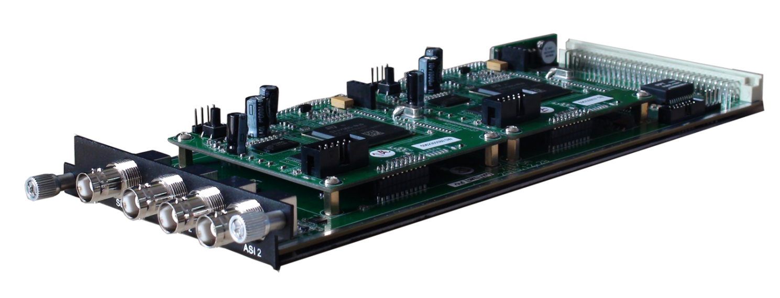
Module Specifications:
ASI input/output: 2 ASI bi-directions, BNC 75Ω
IP Stream input support
IP output: 1 MPTS output over UDP, Unicast/Multicast
Decoding:
Video/Audio Out: 2 HD/SD SDI output
Video Format: MPEG-2, MPEG-4 AVC/H.264
Resolution: 480i,480p,576i,576p,720p@50/59.94/60,1080i@50/59.94/60
Chroma: 4:2:0
Audio Format: MPEG1 Layer2, LC-AAC, HE-AAC, AC3 (2.0/5.1), AC3 Passthrough,
Support Dual Audio Out
Support CC/Subtitle

4 HDMI Decoding Module (DX714A)
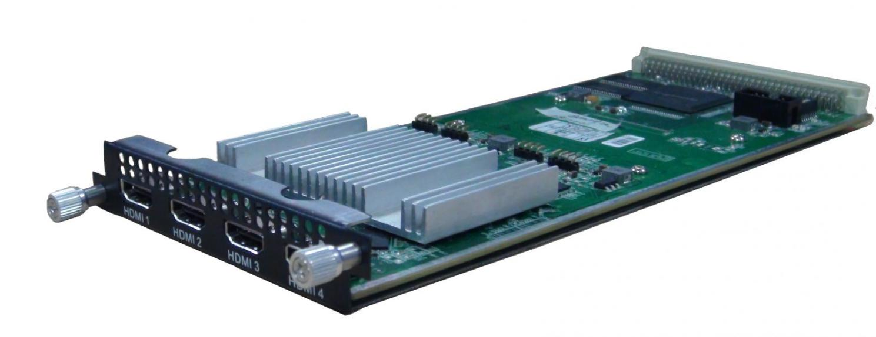
Module Specifications:
Input: 8 IP (MPTS/SPTS) input over UDP/RTP thru stream connector, Unicast/Multicast
Output: 4 HDMI output
Decoding:
Video/Audio Out: 4 HDMI output with 1 channel stereo audio embedded in each port
Video Format: MPEG-2, MPEG-4 AVC/H.264, HEVC/H.265, AVS, AVS+
Audio Format: MPEG 1 Layer 2, LC-AAC, HE-AAC, AC3 (2.0), DRA
Resolution: 480i, 480p, 576i, 576p,1280×720_50p, 1280×720_60p, 1920×1080_50i, 1920×1080_50p 1920×1080_60i, 1920×1080_60p
Support manually upscale/downscale resolution

Equipment Specifications:

Dimension(W×L×H): 482mm×410mm×44mm
Environment: 0~45℃(work); -20~80℃ (Storage)
Power requirements AC 110V± 10%, 50/60Hz, AC 220 ± 10%, 50/60Hz
Power Supply: Single or Redundancy power supply for option as per order

Parameters Comparison:

 | DHP400 | DHP300
IP Data Transport | One-way Transport:  GE1/GE2 support output maximum 8 MPTS & 512 SPTS | Bi-directional Transport:  GE1/GE2. SFP1/ SFP2 for IP stream input and output
TS Processing Number | Support 1 TS (MPTS/SPTS) input from each module, and maximum bit rate is 350Mbps | N/A
Multiplexing | Support multiplexing function:  It can mux TSs from different modules to one TS and output through one module or GE1/GE2 port | Doesn’t support multiplexing function:  It can combine TSs from different modules and output these TSs through one module or GE1/GE2 SFP1/SFP2 port
Output Per Module | 1 MPTS after multiplexing | 1 or Multiple MPTS/SPTS
LED | N/A | LED in the front panel show IP address

About Us
FMUSER is a company specializing in broadcasting and television transmission systems and integrating hotel IPTV systems. The company was established in 2009 and has served over 180 countries worldwide. More than 20,000 television stations, radio stations, and hotel clients from different.

Contact:Tomleequan Email：sales@fmuser.com whatsapp: +8613922702227

