FMUSER FUQ-3214B Professional Encoder 4 CVBS Inputs MPEG-2 PAL-NTSC SD Video Encoding IP Output UDP-RTP MPTS-SPTS for CATV Satellite Terrestrial TV Headends
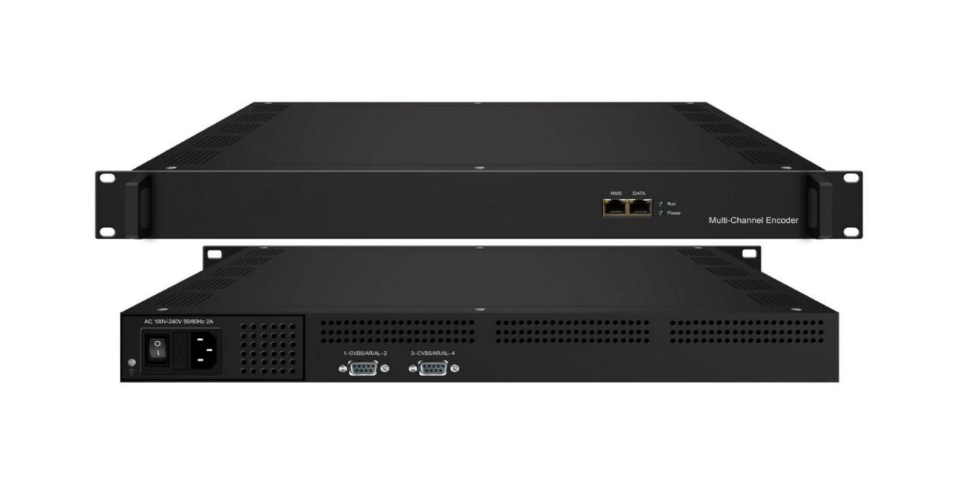
- 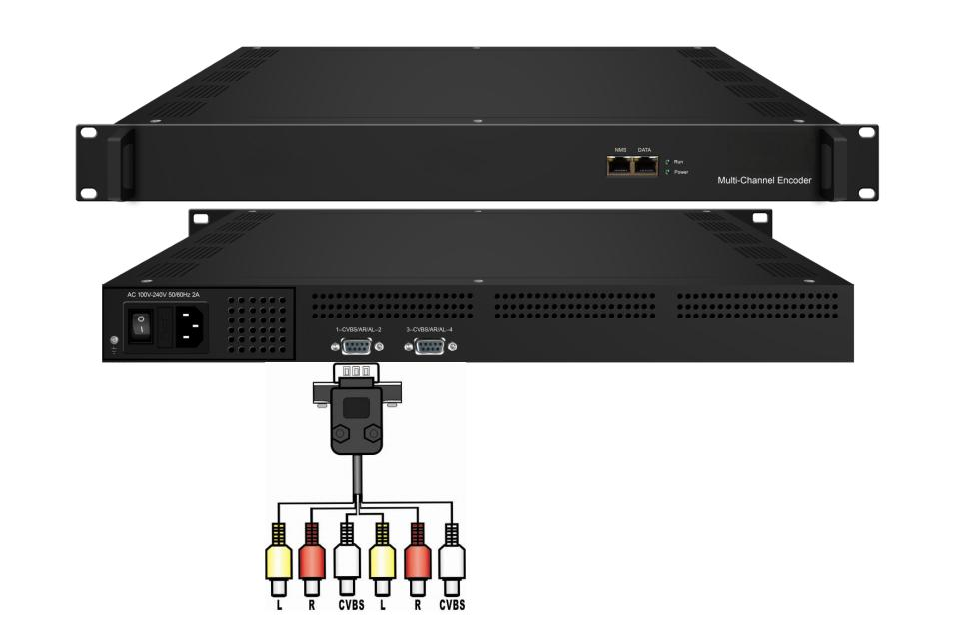
Product Overview
The FMUSER FUQ-3214B is a multi-channel SD encoder and multiplexer with 4 CVBS inputs and IP output via UDP/RTP. It encodes video in MPEG-2 format and audio in MPEG-1 Layer 2 or DD AC3 (2.0), then multiplexes signals into MPTS or SPTS streams. Controlled via a web-based interface for real-time monitoring. Ideal for CATV, satellite, and terrestrial digital TV systems.
Key feature
- Supports 4 CVBS inputs with MPEG-2 video encoding for PAL/NTSC SD formats.
- Provides dual audio encoding: MPEG-1 Layer 2 and DD AC3 (2.0) at 48kHz sampling.
- Delivers multiplexed IP output via UDP/RTP for MPTS and SPTS streams.
- Includes broadcast enhancements like Null PKT Filter, CC, and logo insertion.
- Features web-based control for real-time monitoring and updates.

Principle Chart

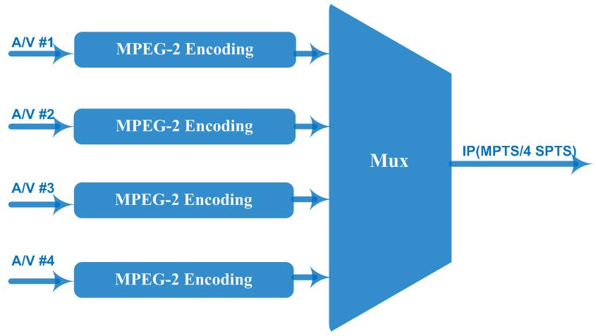

Technical Specification
Input | 4 CVBS inputs , RCA interface
Video | Resolution | Input |  | Output
Video | Resolution | 720*576 |  | 720×576_50i, 704×576_50i,  640×576_50i, 352×288_50i,  320×288_50i, 176×288_50i,176×144_50i
Video | Resolution | 720*480 |  | 720×480_60i, 544×480_60i, 352×480_60i, 352×240_60i, 320×240_60i, 176×240_60i, 176×120_60i,
Video | Encoding | MPEG-2
Video | Bit-rate | 0.5Mbps~8Mbps per channel
Video | Rate Control | CBR/VBR
Video | GOP Structure | GOP_0_B, 1B, 2B,3B
Video | Aspect Ratio | 4:3; 16:9
Audio | Encoding | MPEG-1 Layer 2, DD AC3 (2.0)
Audio | Sampling rate | 48KHz
Audio | Resolution | 24-bit
Audio | Audio Gain | -12~+40 adjustable
Audio | Bit-rate | 64Kbps, 128Kbps,192kbps,256kbps,320kbps,384kbps each channel
Stream output | IP (1*MPTS and 4*SPTS) output over UDP and RTP, 1000 Base-T Ethernet interface (multicast)
System function | Network management (WEB)
System function | Chinese and English language
System function | Ethernet software upgrade
Miscellaneous | Dimension(W×L×H) |  | 482mm×328mm×44mm
Miscellaneous | Approx weight |  | 5kg
Miscellaneous | Environment |  | 0~45℃(work)；-20~80℃（Storage）
Miscellaneous | Power requirements |  | AC 110V± 10%, 50/60Hz, AC 220 ± 10%, 50/60Hz

About Us
FMUSER is a company specializing in broadcasting and television transmission systems and integrating hotel IPTV systems. The company was established in 2009 and has served over 180 countries worldwide. More than 20,000 television stations, radio stations, and hotel clients from different.

Contact:Tomleequan Email：sales@fmuser.com whatsapp: +8613922702227

