FMUSER FUQ-3214C Multi-Channel SD Encoder 4-8-12 CVBS-SDI Input to IP Output MPEG-2 H.264 Encoding Web-Based Control CATV Headend Broadcast
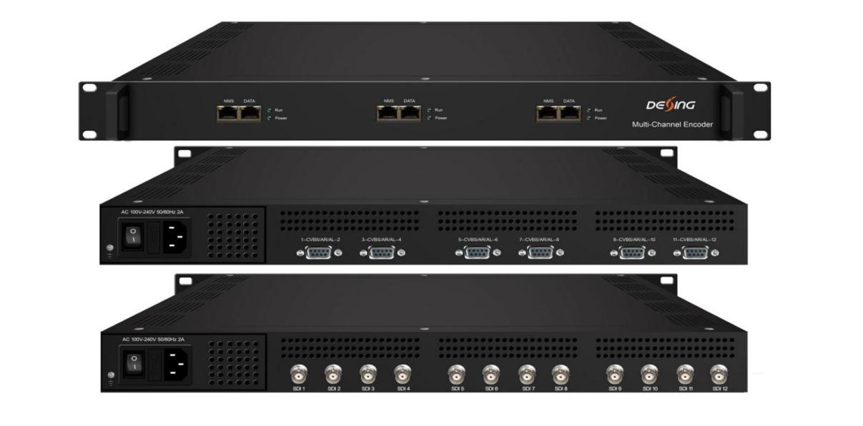

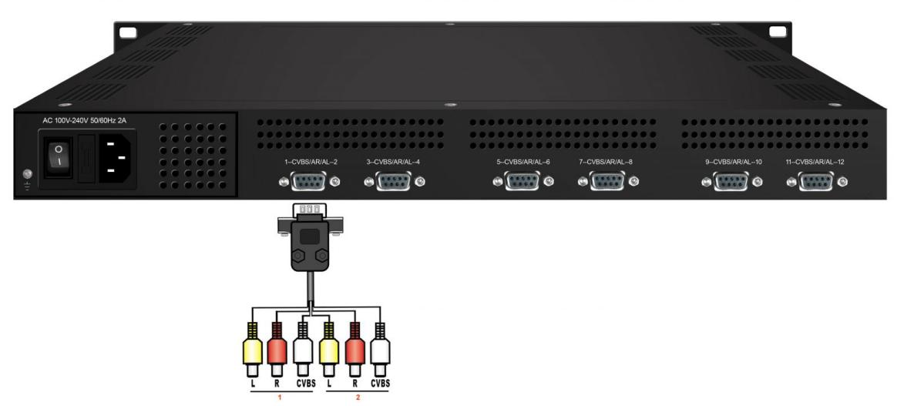
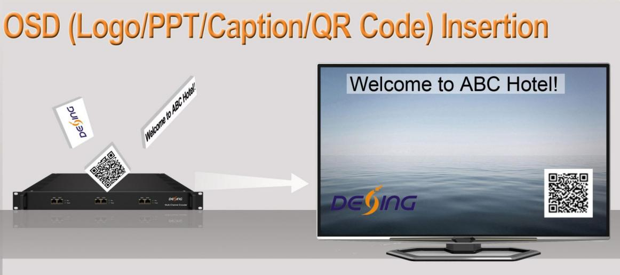

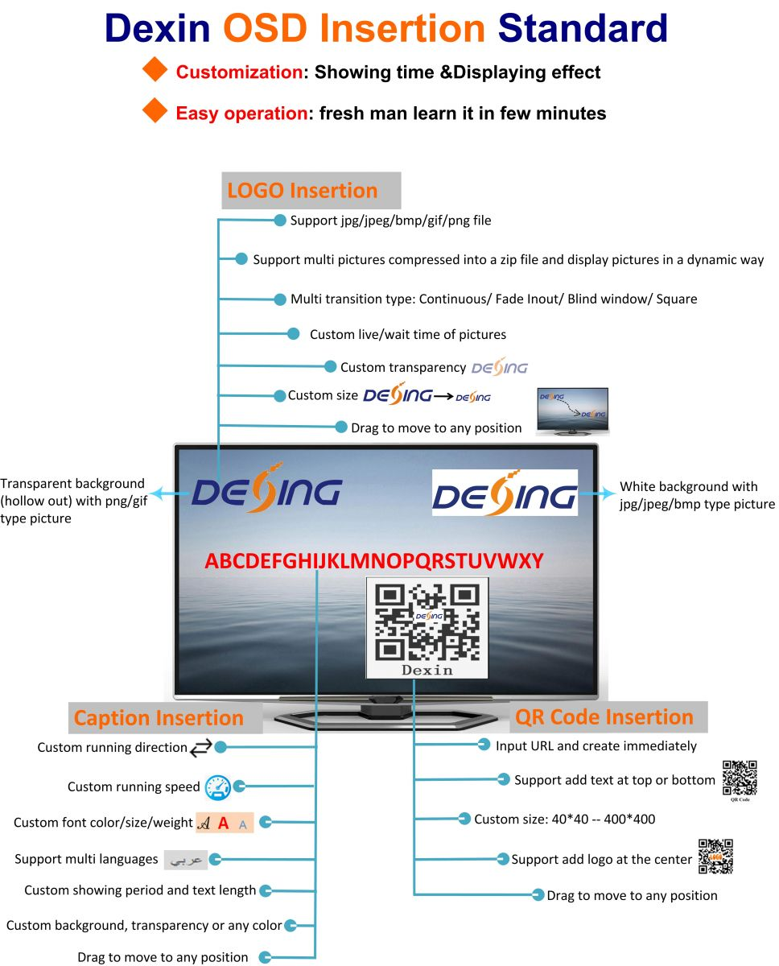

Product Overview
The FMUSER FUQ-3214C is a multi-channel SD encoder supporting 4/8/12 CVBS or SDI inputs with MPEG-2 and H.264 encoding. It processes signals by encoding and multiplexing to TS for IP output. This modular device fits in a 1U chassis with up to three independent modules, controlled via a web-based interface. Ideal for CATV digital headends and broadcast distribution systems.
Key feature
The FMUSER FUQ-3214C is a multi-channel SD encoder supporting 4/8/12 CVBS or SDI inputs with MPEG-2 and H.264 encoding. It processes signals by encoding and multiplexing to TS for IP output. This modular device fits in a 1U chassis with up to three independent modules, controlled via a web-based interface. Ideal for CATV digital headends and broadcast distribution systems.
Principle Chart (per daughter module)
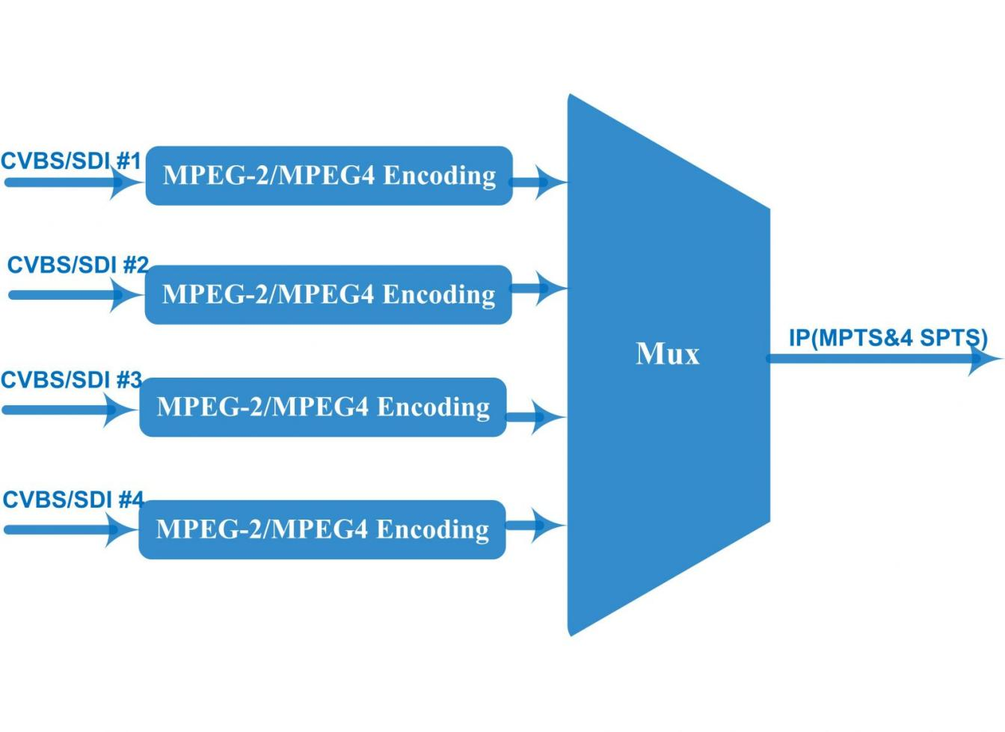
Technical Specification
Input | 4/8/12 CVBS input , DB15-To-RCA interface ---OptionⅠ  4/8/12 SDI input, BNC interface ---OptionⅡ
Video | Resolution | Input |  | Output
Video | Resolution | 720*576 @50i |  | 720*576/352*288/320*240/320*180/176*144  /160*120/160*90@50Hz
Video | Resolution | 720*480 @60i |  | 720*480/352*288/320*240/320*180/176*144  /160*120/160*90@60Hz
Video | Encoding format | MPEG-2, MPEG4 AVC/H.264
Video | Bit-rate | 0.5~5Mbps
Video | Rate Control | CBR/VBR
Video | GOP Structure | IPPP, IBPBP, IBBPB, IBBBP
Video | Aspect Ratio | 4:3, 16:9
Audio | Encoding format | MPEG1 Layer 2, LC-AAC, HE-AAC
Audio | Sampling rate | 48KHz
Audio | Bits per sample | 32-bit
Audio | Audio Gain | -20~+12 adjustable
Audio | Bit-rate | 48Kbps~384Kbps (each channel)
Stream output | IP (1*MPTS and 4*SPTS) output over UDP and RTP/RTSP (unicast/multicast) per module,100M/1000M self-adaption
System function | Network management (WEB)
System function | Chinese and English language
System function | Ethernet software upgrade
Miscellaneous | Dimension(W×L×H) |  | 482mm×328mm×44mm
Miscellaneous | Environment |  | 0~45℃(work)；-20~80℃（Storage）
Miscellaneous | Power requirements |  | AC 110V± 10%, 50/60Hz, AC 220 ± 10%, 50/60Hz

Technical Comparison
 | FU-4339A | DX3214B-4/8/12
Chipset | Magnum | Magnum
Input interface | 8× CVBS, BNC | 4/8/12× CVBS Optional, RCA interface  4/8/12×SD-SDI , BNC interface  (Modular design with each module supporting 4 channels, one chassis supporting up to 3 modules)
Input interface | 8×SD-SDI input with embedded audio
Bitrate | 0.25~15Mbps for H.264 encoding  0.5~15Mbps for MPEG-2 encoding | 0.5~5Mbps for both H.264 and MPEG-2 encoding
ASI In&Mux | 1 ASI IN | N/A
ASI Output | 2*ASI mirrored Output | N/A
IP Output | - 8 SPTS or 1 MPTS output over UDP (unicast / multicast)  - 10/100Base-T Ethernet interface * 1  - one data port for all channels | - 4 SPTS and 1 MPTS output over UDP and RTP/RTSP for each module (unicast/multicast)  - 1000 Base-T Ethernet interface*1/2/3  - one data port for one module (4 channels)
OSD insertion | N/A | Support logo/caption/QR Code insertion
Operation | - Web-based NMS  - SNMP (Optional)  - Front panel with LCD+Key board | - Web-based NMS
Control Mode | One NMS port for all channels | One NMS port for each module (4 channels)

About Us
FMUSER is a company specializing in broadcasting and television transmission systems and integrating hotel IPTV systems. The company was established in 2009 and has served over 180 countries worldwide. More than 20,000 television stations, radio stations, and hotel clients from different.

Contact:Tomleequan Email：sales@fmuser.com whatsapp: +8613922702227

