FMUSER FUQ-3224K/FUQ-3224GJ 4-8-12 Channel HD-SDI-HDMI 1.4 Encoder HEVC-H.265 H.264 Gigabit IP Output Web-Based Control for Broadcast IPTV
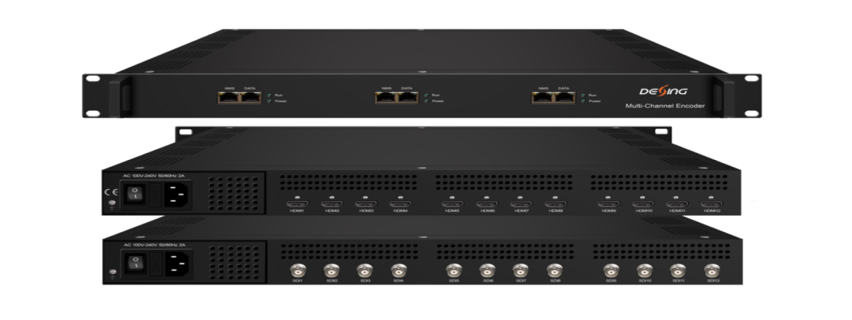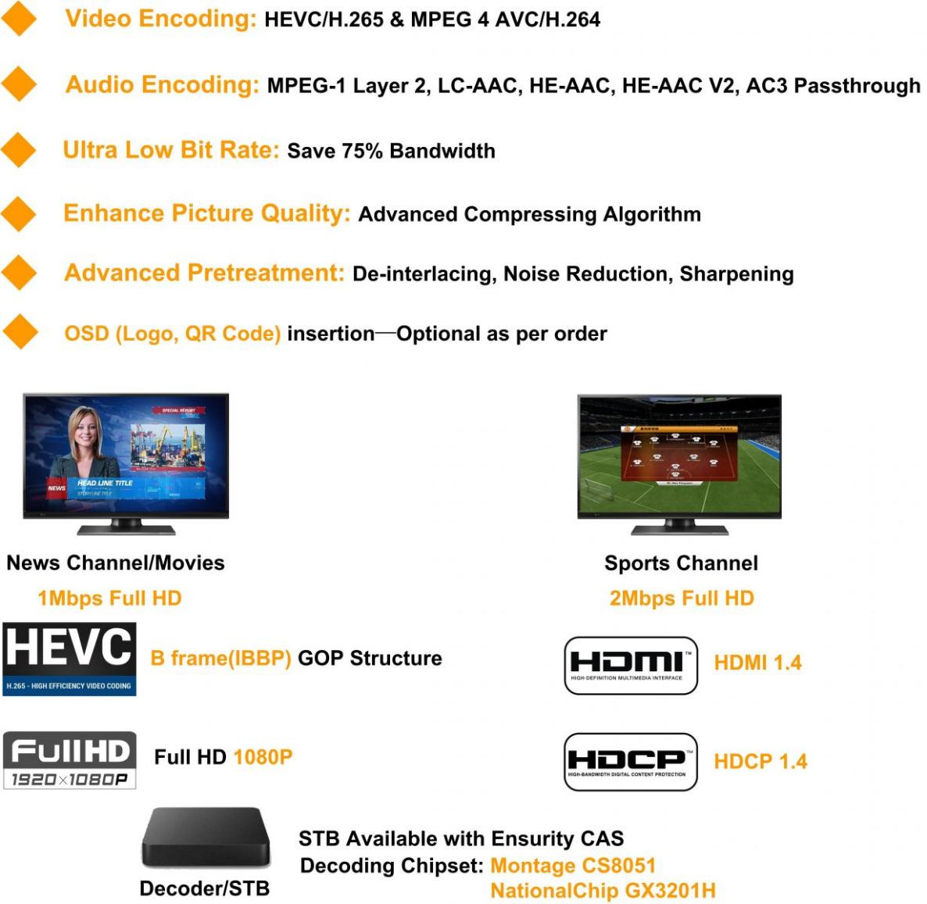

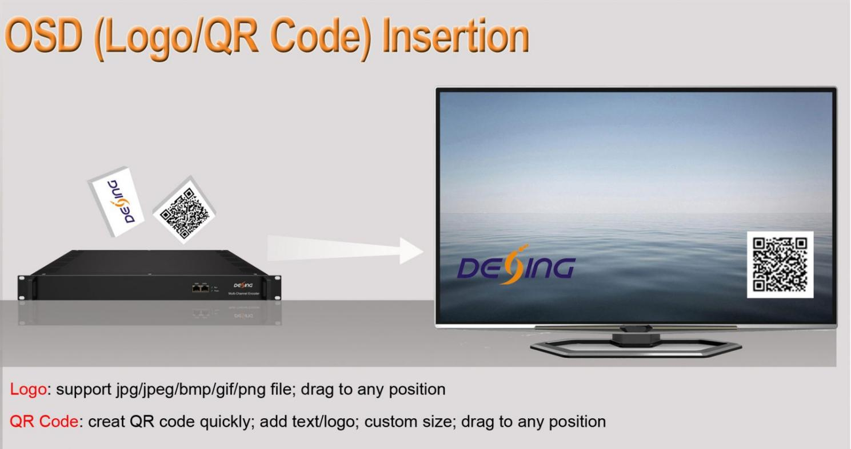

Principle Chart of Per Module
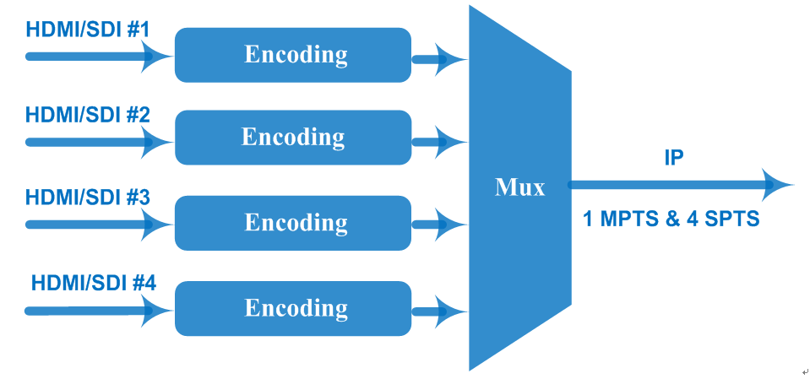
Product overview
The FUQ-3224K/FUQ-3224GJ modular encoder processes 4/8/12×HD-SDI/HDMI 1.4 inputs with HDCP 1.4 compliance. It encodes signals to HEVC/H.265 or MPEG-4 AVC/H.264 formats at 0.5-20Mbps, outputting via Gigabit IP (UDP/RTP/RTSP). The 1RU chassis supports 4K-ready processing and web-based control. Ideal for live event production, IPTV headends, and remote contribution systems.
Key feature
Web-based management with Chinese/English UI and 48kHz audio processing
Technical Specification
Input | 4/8/12×HD-SDI or HDMI(1.4) input for option, HDCP 1.4
Video Encoding | Encoding Format | HEVC/ H.265, MPEG 4 AVC/H.264
Video Encoding | Resolution (DX3224HV) | Input | Output
Video Encoding | Resolution (DX3224HV) | Input | HEVC/H.265 |  | MPEG-4 AVC/H.264
Video Encoding | Resolution (DX3224HV) | 4*1080P-50 | 4*1080P-50 |  | 4*1080P-25  2*1080P-50
Video Encoding | Resolution (DX3224HV) | 4*1080P-60/59.94 | 4*1080P-60,  4*1080P-59.94 |  | 4*1080P-30  4*1080P-29.97  2*1080P-60  2*1080P-59.94
Video Encoding | Resolution (DX3224HV) | 4*1080I-50 | 4*1080P-50,  4*1080P-25 |  | 4*1080I-50  4*1080P-25  2*1080P-50
Video Encoding | Resolution (DX3224HV) | 4*1080I-60/59.94 | 4*1080P-60,  4*1080P-30 |  | 4*1080I-60  4*1080P-30  2*1080P-60
Video Encoding | Resolution (DX3224HV) | 4*720P-50 | 4*720P-50 |  | 4*720P-50
Video Encoding | Resolution (DX3224HV) | 4*720P-60/59.94 | 4*720P-60,  4*720P-59.94 |  | 4*720P-60  4*720P-59.94
Video Encoding | Resolution (DX3224H) |  | Output
Video Encoding | Resolution (DX3224H) | Input | HEVC/H.265 |  | MPEG-4 AVC/H.264
Video Encoding | Resolution (DX3224H) | 4*1080P-50 | 4*1080P-50 |  | 4*1080P-50
Video Encoding | Resolution (DX3224H) | 4*1080P-60/59.94 | 4*1080P-60,  4*1080P-59.94 |  | 4*1080P-60  4*1080P-59.94
Video Encoding | Resolution (DX3224H) | 4*1080I-50 | 4*1080P-50,  4*1080P-25 |  | 4*1080P-25  4*1080P-50  4*1080I-50
Video Encoding | Resolution (DX3224H) | 4*1080I-60/59.94 | 4*1080P-60,  4*1080P-30 |  | 4*1080P-30  4*1080P-60  4*1080I-60
Video Encoding | Resolution (DX3224H) | 4*720P-50 | 4*720P-50 |  | 4*720P-50
Video Encoding | Resolution (DX3224H) | 4*720P-60/59.94 | 4*720P-60,  4*720P-59.94 |  | 4*720P-60  4*720P-59.94
Video Encoding | Chroma | 4:2:0
Video Encoding | Bitrate  (per channel) | 0.5Mbps~20Mbps (HEVC/ H.265)  4 Mbps~20Mbps (MPEG 4 AVC/H.264)
Video Encoding | Rate Control | CBR/VBR
Video Encoding | GOP Structure | IBBP, IPPP
Video Encoding | Advanced Pretreatment | De-interlacing, Noise Reduction, Sharpening
Audio Encoding | Encoding Format | MPEG-1 Layer 2, LC-AAC, HE-AAC, HE-AAC V2, AC3 Passthrough
Audio Encoding | Sampling rate | 48KHz
Audio Encoding | Bit-rate  (each channel) | 48Kbps~384Kbps (MPEG-1 Layer 2 & LC-AAC)  24 Kbps~128 Kbps (HE-AAC)  18 Kbps~56 Kbps (HE-AAC V2)
Audio Encoding | Audio Gain | 0~255
Stream output | 1 MPTS and 4 SPTS output over UDP/RTP/RTSP per module, Base-T Ethernet interface (1000M/100M self-adaption) (unicast/ multicast)  IP null packet filterd
System | Web based management
System | Chinese-English control interface
System | Ethernet software upgrade
Miscellaneous | Dimension (W× L× H) |  |  | 482mm×328mm×44mm
Miscellaneous | Approx weight |  |  | 5kg
Miscellaneous | Temperature |  |  | 0~45℃(work), -20~80℃（Storage）
Miscellaneous | Power |  |  | AC 100V-220V±10%, 50/60Hz

Technical Comparison
 |  | FU-4335V-HDMI | FU-4335V-SDI | DX3224H | DX3224HV
Input Interface |  | 4/8/12*HDMI | 4/8/12*SDI | 4/8/12*HDMI/SDI | 4/8/12*HDMI/SDI
Video Encoding |  | H.265, H.264 | H.265, H.264 | H.265, H.264 | H.265,H.264
Audio Encoding |  | MPEG-1 Layer 2, LC-AAC, HE-AAC, HE-AAC V2, AC3 Passthrough
Input Resolution | H.265 | 3840x2160P@30*2CHs  1920x1080P@50/60*4CHs  1280x720P@50/60*4CHs | 1920x1080P@50/60*4CHs  1280x720P@50/60*4CHs 1920x1080I@50/60*4CHs | 1920x1080P@50/60*4CHs  1920x1080I@50/60*4CHs  1280x720P@50/60*4CHs | 4*1920×1080_60P/59.94P 4*1920×1080_50P  4*1920×1080_60i 4*1920×1080_50i 4*1280×720_60P 4*1280×720_50P
Input Resolution | H.264 | 3840x2160P@30*1CH  1920x1080P@50/60*2CHs  1280x720P@50/60*4CHs | 1920x1080P@50/60*2CHs  1920x1080I@50/60*2CHs  1280x720P@50/60*4CHs |  | 4 or 2*1920×1080_60P/59.94P  4 or 2*1920×1080_50P  4 or 2*1920×1080_60i  4 or 2*1920×1080_50i 4*1280×720_60P 4*1280×720_50P
Output Resolution | H.265 | Same as input resolution | 1920x1080P@50/60*4CHs  1280x720P@50/60*4CHs | 1920x1080P@50/60*4CHs  1280x720P@50/60*4CHs | 4*1920×1080_60P/59.94P 4*1920×1080_50P  4*1920×1080_30P 4*1920×1080_25P 4*1280×720_60P 4*1280×720_50P
Output Resolution | H.264 | Same as input resolution | 1920x1080P@50/60*2CHs  1280x720P@50/60*4CHs | 1920x1080P@50/60*4CHs  1280x720P@50/60*4CHs | 2*1920×1080_60P/59.94P (HDMI 3 and HDMI 4) 2*1920×1080_50P  (HDMI 3 and HDMI 4) 4*1920×1080_30P/29.97P 4*1920×1080_25P 4*1920×1080_60i 4*1920×1080_50i 4*1280×720_60P 4*1280×720_50P
OSD |  | N/A | N/A | Optional as per order | Optional as per order
Caption Language |  | N/A | N/A | Not support caption | Not support caption
Note: “CH” means encoding channel, different encoding format can encode different channel with different resolution.

About Us
FMUSER is a company specializing in broadcasting and television transmission systems and integrating hotel IPTV systems. The company was established in 2009 and has served over 180 countries worldwide. More than 20,000 television stations, radio stations, and hotel clients from different.

Contact:Tomleequan Email：sales@fmuser.com whatsapp: +8613922702227

