FMUSER FUQ-3504 IP Multiplexer 4 ASI Bidirectional Inputs-Outputs 768 UDP-RTP IP Inputs 4 MPTS UDP-RTP Outputs PID Re-mapping PSI-SI Auto-Generation for CATV Headend 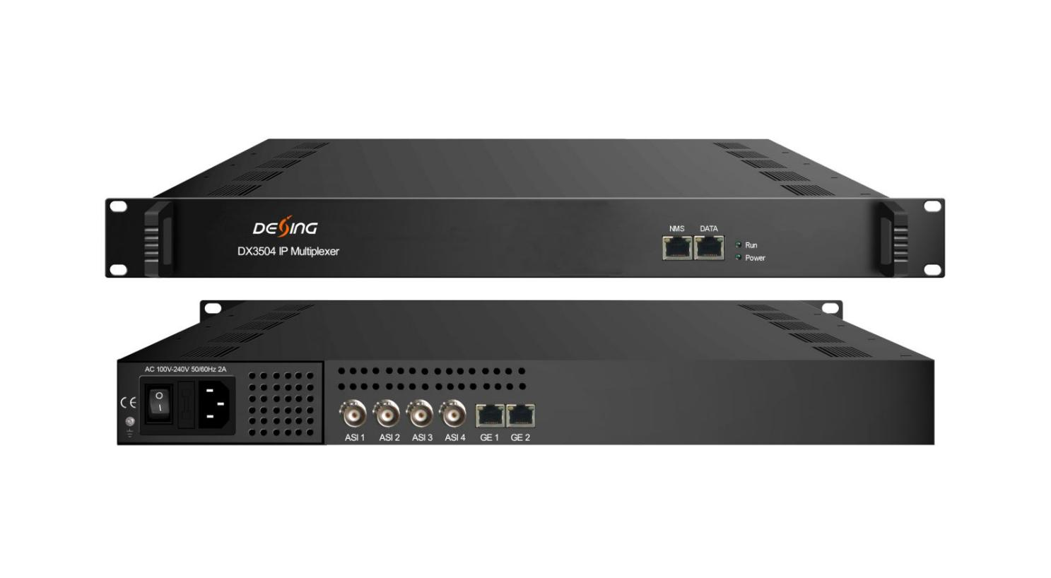Product Overview
The FUQ-3504 IP Multiplexer provides high-density MPTS multiplexing with 4 bidirectional ASI inputs and 768 IP streams via UDP/RTP, outputting to 4 MPTS streams. It processes signals through PID remapping, PCR adjustment, and PSI/SI auto-generation. Controlled via web-based NMS over a dedicated 10/100M port, this 1RU rack-mountable unit is designed for digital broadcast headends and CATV systems.
Key feature
- Supports 4 bidirectional ASI ports and 768 IP inputs via UDP/RTP.
- Performs PID remapping, PCR adjustment, and PSI/SI auto-generation.
- Includes large buffer memory to prevent overflow and bypass output capability.
- Features web-based NMS for centralized monitoring and control.

Principle Chart
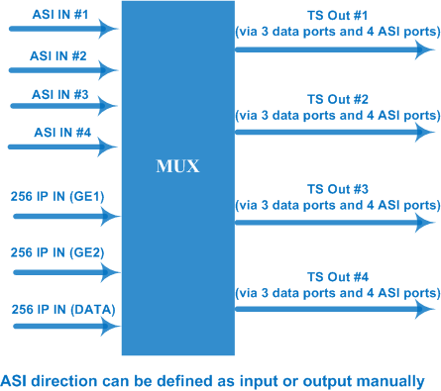

Specifications
Input / Output | 4 bi-direction ASI ports: max 4 ASI input/output, BNC 75Ω  3 bi-direction Data ports (RJ45)  768 IP inputs over UDP/RTP (256 IP inputs thru GE1, GE2 and DATA port respectively)  4 MPTS outputs over UDP/RTP thru GE1, GE2 and DATA port  100/1000Mbps self-adaption for all data ports
Input / Output | Packet format | 204/188 self-adaption for input, 204/188 is settable for output
Input / Output | Output TS Mode | bytes/packets
Re-multiplex | Max PID numbers | 748 PID numbers for GE1
Re-multiplex | Max PID numbers | 748 PID numbers for GE 2
Re-multiplex | Max PID numbers | 748 PID numbers for DATA port and 4 ASI ports together
Re-multiplex | Functions | PID re-mapping
Re-multiplex | Functions | PCR accurate adjusting
Re-multiplex | Functions | Automatic generating PSI/SI table
Re-multiplex | PID transparent | PID transparent and mapping achievable
System | Web management:10/100M NMS port
System | Language: English and Chinese
System | Ethernet software upgrade
General | Dimensions | 482mm×300mm×44mm (WxLxH)
General | Weight | 3.5kg
General | Temperature | 0~45℃(operation), -20~80℃(storage)
General | Power supply | AC 110V±10%, 50/60Hz Or AC 220V±10%, 50/60Hz
General | Consumption | ≤40W

About Us
FMUSER is a company specializing in broadcasting and television transmission systems and integrating hotel IPTV systems. The company was established in 2009 and has served over 180 countries worldwide. More than 20,000 television stations, radio stations, and hotel clients from different.

Contact:Tomleequan Email：sales@fmuser.com whatsapp: +8613922702227

