FMUSER FUQ-3504 IP Multiplexer 4 ASI I-O 768 UDP-RTP Inputs 4 MPTS UDP-RTP Outputs Web-Based NMS Management CATV Broadcasting 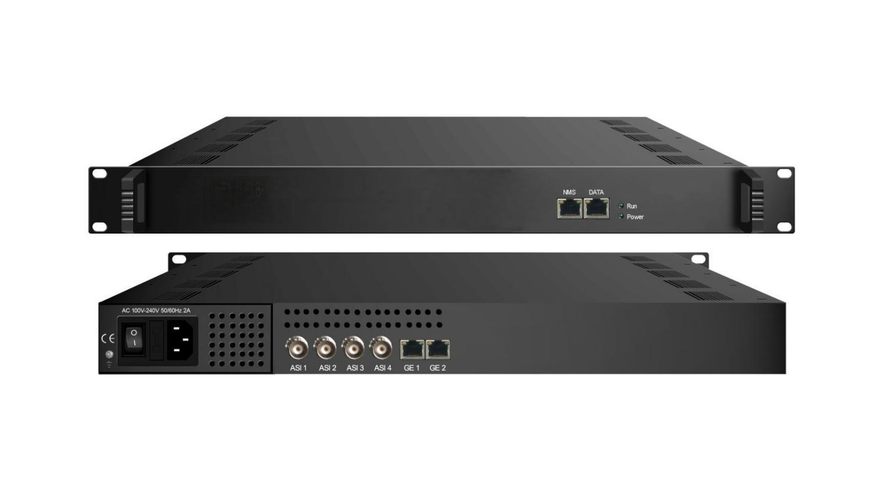Product Overview
The FUQ-3504 IP Multiplexer integrates 4 ASI and 768 IP inputs, multiplexing them into 4 MPTS outputs. It processes signals with PSI/SI auto-generation, PID remapping, and PCR adjustment. Managed via web-based NMS through a 10/100M Ethernet port. Ideal for CATV broadcasting and digital TV head-end systems.
Key feature
Supports 4 bi-directional ASI ports with manual direction control.
Features 768 UDP/RTP inputs via GE1, GE2, and DATA ports.
Delivers 4 MPTS outputs through GE1, GE2, and DATA ports.
Enables PCR adjustment, PID filtering/remapping, and PSI/SI editing.
Provides web-based NMS management via 10/100M Ethernet port.
Principle Chart
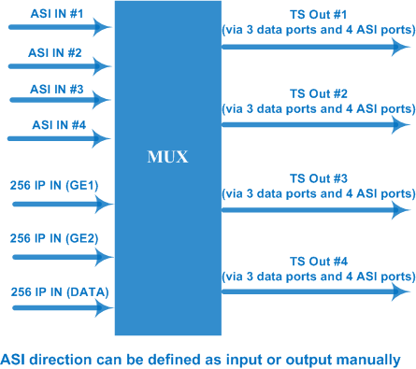

Specifications
Input / Output | 4 bi-direction ASI ports: max 4 ASI input/output, BNC 75Ω  3 bi-direction Data ports (RJ45)  768 IP inputs over UDP/RTP (256 IP inputs thru GE1, GE2 and DATA port respectively)  4 MPTS outputs over UDP/RTP thru GE1, GE2 and DATA port  100/1000Mbps self-adaption for all data ports
Input / Output | Packet format | 204/188 self-adaption for input, 204/188 is settable for output
Input / Output | Output TS Mode | bytes/packets
Re-multiplex | Max PID numbers | 748 PID numbers for GE1
Re-multiplex | Max PID numbers | 748 PID numbers for GE 2
Re-multiplex | Max PID numbers | 748 PID numbers for DATA port and 4 ASI ports together
Re-multiplex | Functions | PID re-mapping
Re-multiplex | Functions | PCR accurate adjusting
Re-multiplex | Functions | Automatic generating PSI/SI table
Re-multiplex | PID transparent | PID transparent and mapping achievable
System | Web management:10/100M NMS port
System | Language: English and Chinese
System | Ethernet software upgrade
General | Dimensions | 482mm×300mm×44mm (WxLxH)
General | Weight | 3.5kg
General | Temperature | 0~45℃(operation), -20~80℃(storage)
General | Power supply | AC 110V±10%, 50/60Hz Or AC 220V±10%, 50/60Hz
General | Consumption | ≤40W

About Us
FMUSER is a company specializing in broadcasting and television transmission systems and integrating hotel IPTV systems. The company was established in 2009 and has served over 180 countries worldwide. More than 20,000 television stations, radio stations, and hotel clients from different.

Contact:Tomleequan Email：sales@fmuser.com whatsapp: +8613922702227

