FMUSER FUQ-3512B DVB-T Modulator 2 ASI 2 IP Input RF Output EN300744 QPSK-16QAM-64QAM DPD SFN-MFN Network Web Management TV Broadcasting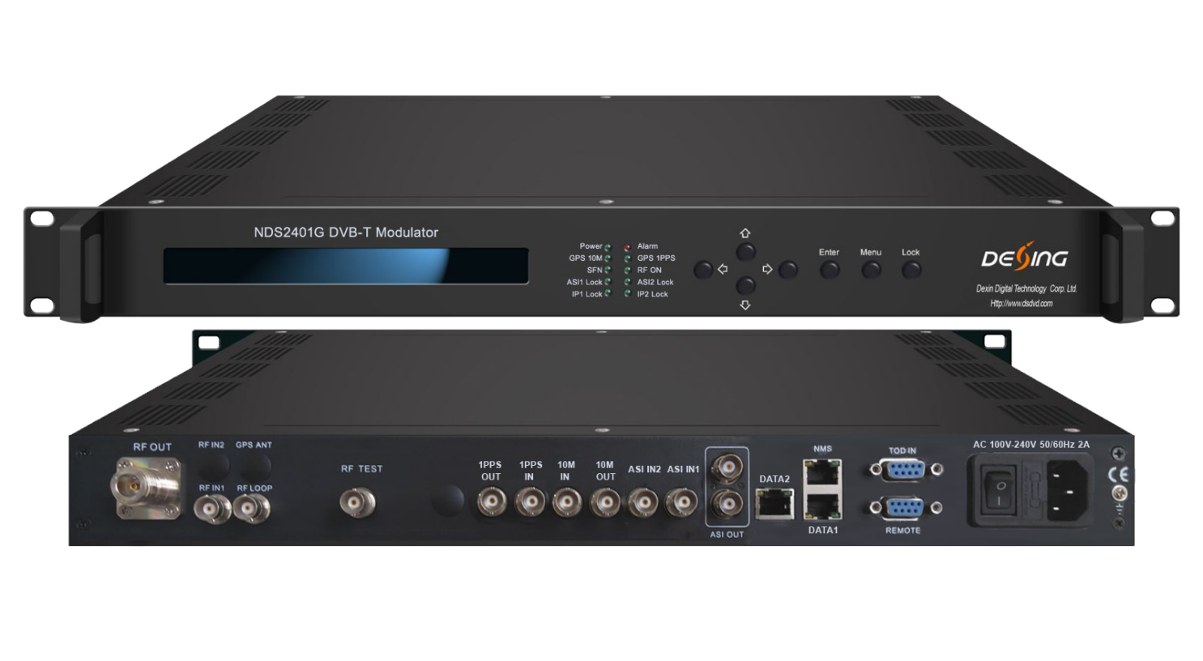Product overview
The FMUSER FUQ-3512A DVB-T Modulator provides DVB-T (EN300744) compliant modulation with RF output. It processes signals for digital transmission and features web-based management for control. Ideal for MFN and SFN digital TV networks.
Key feature
Supports DVB-T (EN300744) compliance for reliable broadcasting.
Features SFN and MFN network operation flexibility.
Delivers MER ≥42dB with superior phase noise performance.
Provides RF output at 50-1000MHz with 1Hz tuning precision.
Includes adaptive non-linear digital pre-distortion (DPD) for efficiency optimization.
Specifications
Input | 2channels ASI input& 2 IP input, can only select 1 input as source, but all 4 inputs ports are hot backup  IP with UDP/RTP protocol, with Multicast/Unicast  IP with PCR adjust feature also
Input | GPS 10Mhz reference clock input, BNC port
Input | GPS 1PPS input, BNC port
Input | 1 RF input for DPD -25dbm~+5dbm
Modulation | Standard | EN300 744
Modulation | FFT | 2K, 8K
Modulation | Bandwidth | 5M, 6M, 7M, 8M
Modulation | Constellation | QPSK, 16QAM, 64QAM
Modulation | Guard interval | 1/4, 1/8, 1/16, 1/32
Modulation | FEC | 1/2, 2/3, 3/4, 5/6, 7/8
RF output | Interface | N type, 50Ω impedance
RF output | RF range | 50~1000MHz，1hz step
RF output | RF output level | -15dbm~+5dbm, 0.1db step
RF output | RF level offset | -3dbm~+3dbm, 0.1db step
RF output | MER | ≥ 42db
ASI output | 2 ASI ports output for the passthrough of the input ASI Signal, both ASI out are the same
Non-linear DPD | over 10db ACPR improvement (normally)
System | LCD display & keyboard operation, web management
System | Software upgrading through NMS port
General | Demission (W*L*H) | 440mm×414mm×44.5mm
General | Weight | 4.9kg
General | Temperature | 0~45℃(operation), -20~80℃(storage)
General | Power Supply | AC 110V±10%, 50/60Hz or AC 220V±10%, 50/60Hz
General | Power Consumption | To be tested

Principle Chart

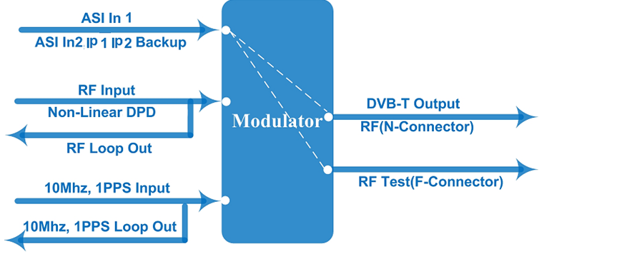

About Us
FMUSER is a company specializing in broadcasting and television transmission systems and integrating hotel IPTV systems. The company was established in 2009 and has served over 180 countries worldwide. More than 20,000 television stations, radio stations, and hotel clients from different.

Contact:Tomleequan Email：sales@fmuser.com whatsapp: +8613922702227

