FMUSER FUQ-3514 Multiplexer Scrambler 4 ASI I-O 128 IP Inputs 4 MPTS Outputs ASI-IP Interfaces ETR289 ETSI 101-197 ETSI 103-197 Scrambling CATV IPTV Headend 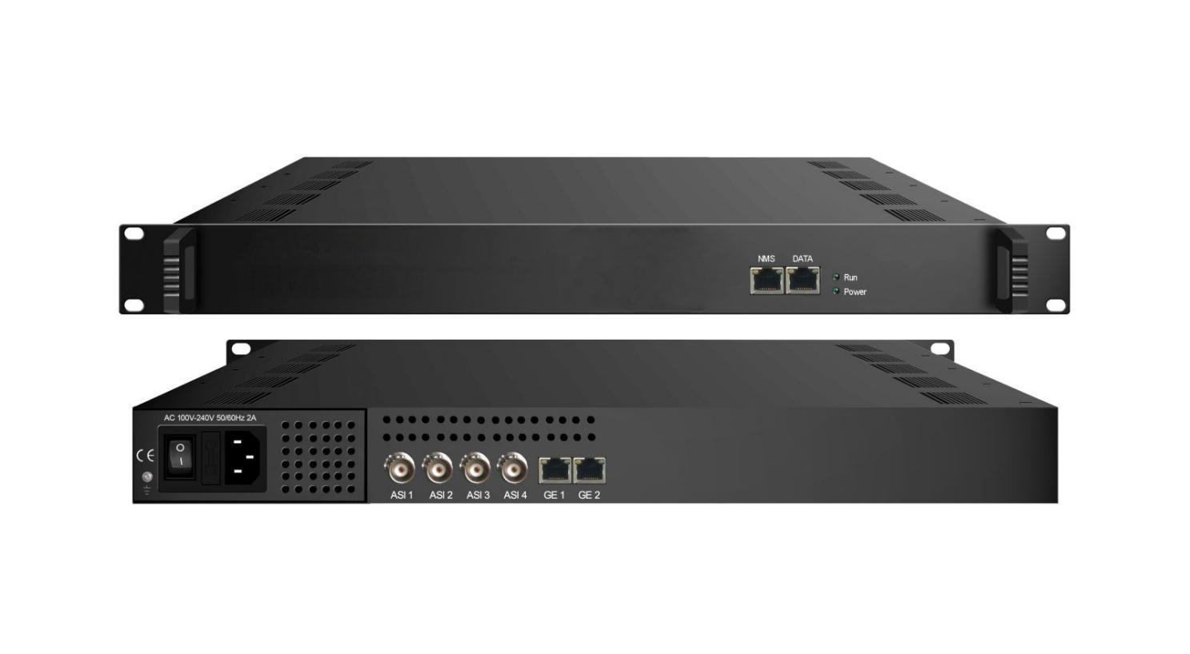Product Overview
The FUQ-3514 Multiplexer Scrambler provides multiplexing and scrambling functions with 4 ASI inputs, 128 IP inputs, and 4 MPTS outputs. It processes signals through PSI/SI auto-generation, PID re-mapping, service filtering, and PCR adjusting. Managed via web-based NMS, this device is ideal for CATV broadcasting systems, ensuring efficient integration and reliable performance.
Key feature
Supports up to 4 ASI inputs/outputs and 128 IP inputs with 4 MPTS outputs.
Enables scrambling compliant with ETR289, ETSI 101 197, and ETSI 103 197, supporting up to 4 simulcrypt CAs.
Allows PID management including filtering, re-mapping up to 512 PIDs per channel, and PSI/SI rebuilding.
Features PCR adjusting, buffer memory for overflow protection, alarming function, and web-based NMS management.

Inner Principle Chart
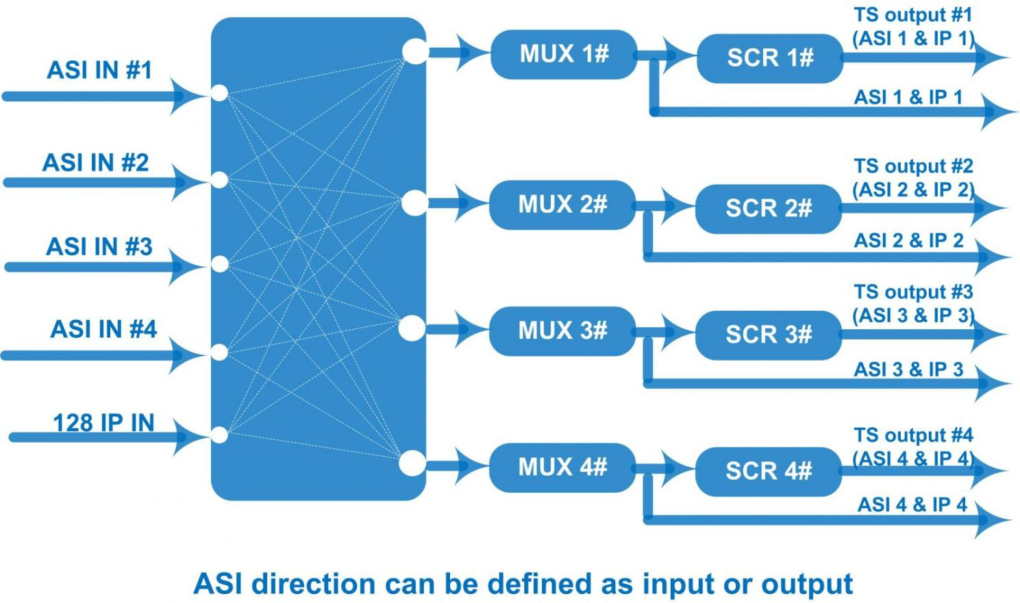

Specifications
Input / Output | 4 bi-direction ASI ports: max 4 ASI input/output, BNC 75Ω  3 bi-direction Data ports (RJ45): 128 IP input over UDP/RTP  4 IP (MPTS) output over UDP/RTP/RTSP  100/1000Mbps self-adaption
Input / Output | Input Packet format: 204/188 self-adaption
Input / Output | ASI: Max output bit-rate: 200Mbps (Each channel)
Mux | Max PIDs |  | 512 per channel
Mux | Functions |  | PID re-mapping
Mux |  |  | PCR accurate adjusting
Mux |  |  | Automatic generating PSI/SI table
Mux | PID transparent |  | Any PID transparent and mapping achievable
Scrambling  Parameters | Max simulcrypt CA |  | 4
Scrambling  Parameters | Scramble Standard |  | ETR289, ETSI 101 197, ETSI 103 197
Scrambling  Parameters | Scramble Channel |  | 1
Scrambling  Parameters | Connection |  | Local/remote connection
System | Web-based management
System | Language: English and Chinese
System | Ethernet software upgrade
General | Dimensions | 482mm×300mm×44mm (WxLxH)
General | Weight | 3.5kg
General | Temperature | 0~45℃(operation), -20~80℃(storage)
General | Power supply | AC 110V±10%, 50/60Hz Or AC 220V±10%, 50/60Hz
General | Consumption | ≤40W

About Us
FMUSER is a company specializing in broadcasting and television transmission systems and integrating hotel IPTV systems. The company was established in 2009 and has served over 180 countries worldwide. More than 20,000 television stations, radio stations, and hotel clients from different.

Contact:Tomleequan Email：sales@fmuser.com whatsapp: +8613922702227

