FMUSER FUQ-3514B Modulator Dual DVB-ASI-SMPTE-310 Inputs RF Output 50-860MHz ATSC A-53 8-VSB Modulation Adaptive DPD IP Remote Control for ATSC Broadcasting and Set-top Box Testing 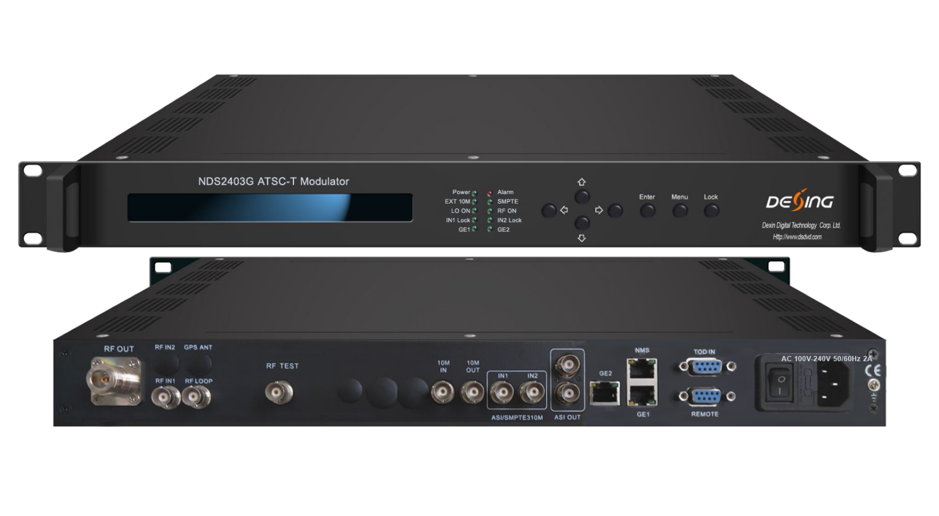Product Overview
The FMUSER FUQ-3514F modulator processes dual-channel DVB-ASI and SMPTE-310 inputs, delivering RF output from 50MHz to 860MHz. It employs ATSC 8-VSB modulation compliant with ATSC A/53 standard. Features adaptive digital pre-distortion (DPD) and remote control via IP and front panel. Ideal for ATSC broadcasting networks and set-top box testing applications.
Key feature
Supports ATSC A/53 compliance for reliable digital broadcasting.
Features dual-channel DVB-ASI/SMPTE-310 inputs with automatic switch-over.
Delivers RF output from 50MHz to 860MHz with 1Hz stepping.
Integrates adaptive digital pre-distortion (DPD) for signal optimization.
Enables remote control via IP and front panel for monitoring and upgrades.

Specifications

Input |  | Self-adapted 2 Asi/SMPTE 310M input  2 ASI ports input, one for hot backup, BNC interface
 |  | Dual IP input ports, one for hot backup , over UDP/RTP, Unicast/Multicast, GE ports
 |  | 1 channel 10MHz reference clock input
Modulation | Standard | ATSC A/53
Modulation | Constellation | 8VSB
Modulation | Bandwidth | 6 MHz
Modulation | FEC | RS(208 188)+Trellis
RF output | Port | N Type, 50Ω impedance
RF output | RF range | 50~860Mhz,1Hz stepping
RF output | Output Level ATT | -20dBm~6dBm,0.1dB stepping
RF output | Shoulder Level | 60dB
RF output | MER | ≥ 40dB
DPD | Non-linear DPD | over 10dB ACPR improvement (normally)
DPD | linear DPD | over 10dB non-flatness adjustment(normally)
System |  | LCD display & keyboard operation, NMS, Chinese & English operation display
 |  | Software upgraded through network
General | Demission(WxLxH) | 482mm×455mm×44.5mm
General | Weight | 6.0kg
General | Temperature | 0~45℃( operation),-20~80℃( storage)
General | Power Supply | AC 110V±10%,50/60Hz or AC 220V±10%, 50/60Hz
General | Consumption | 25W

Principle chart
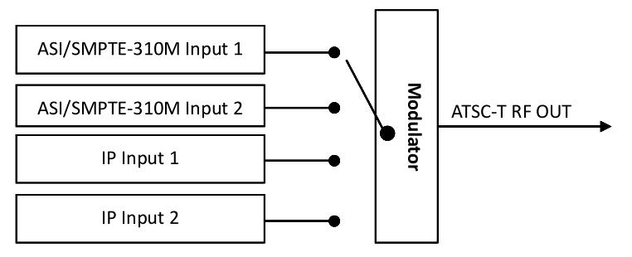

About Us
FMUSER is a company specializing in broadcasting and television transmission systems and integrating hotel IPTV systems. The company was established in 2009 and has served over 180 countries worldwide. More than 20,000 television stations, radio stations, and hotel clients from different.

Contact:Tomleequan Email：sales@fmuser.com whatsapp: +8613922702227

