FUQ-3515 ASI TS Switcher 3 ASI Inputs 2 ASI Outputs 188 TS Packet Format BNC Interface Auto-Failback Manual Switching Broadcast Headend Redundancy Solution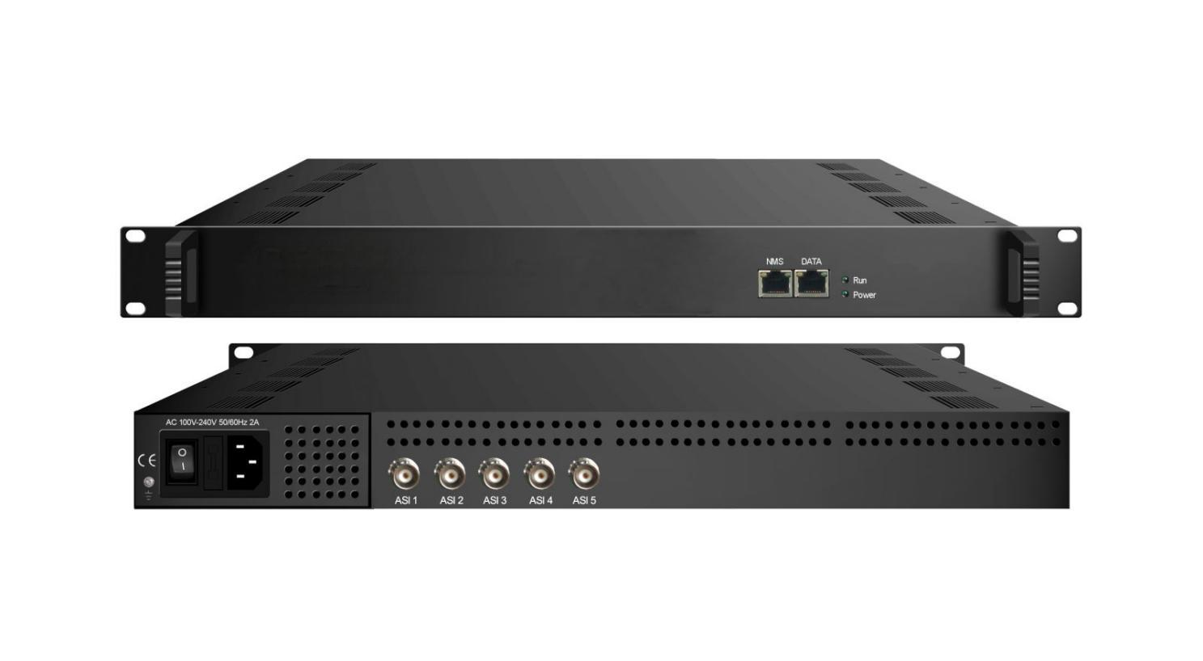
Product Overview
The FUQ-3515 ASI TS Switcher provides 1 main + 2 backup ASI inputs and 2 independent ASI outputs for transport stream redundancy. It performs automatic failback switching based on TS packet integrity monitoring (bitrate/sync/continuity). This 1RU rack-mount unit supports web-based control and firmware upgrades. Ideal for broadcast headend redundancy and cable TV signal backup systems.
Key feature
WEB-based management: Remote control via HTTP/HTTPS with upgrade support
Specifications
Input | 3 ASI input: ASI 3 is main stream, ASI 2 is secondary stream (backup 1), ASI 1 is third stream (back up 2)
Output | 2 ASI output: ASI 4 output bypass, ASI 5 loop out ASI 3
Interface | BNC interface
TS Package Format | 188
ASI in/out bitrate | 1~210Mbps
System | language | English/Chinese
System | Remote Control | web-server management (WEB)
System | Upgrade | Web upgrade
General | Size | 482mmx410mmx44mm
General | Temprature | 0~45℃ (working); -20~80 (Storage)
General | Power Supply | 110VAC±10%, 50/60Hz  220VAC±10%, 50/60Hz
General | Consumption | 15W

ADD: No.10 and NO.12 Wuxing Fourth Road, Wuhou District, Chengdu, Sichuan, P.R.China 蜀ICP备17000710号-1

About Us
FMUSER is a company specializing in broadcasting and television transmission systems and integrating hotel IPTV systems. The company was established in 2009 and has served over 180 countries worldwide. More than 20,000 television stations, radio stations, and hotel clients from different.

Contact:Tomleequan Email：sales@fmuser.com whatsapp: +8613922702227

