FMUSER FUQ-3516R ISDB-T Modulator Dual ASI-Dual IP Inputs ARIB STD-B31 6MHz Bandwidth Network Control SFN-MFN Broadcasting STB Testing 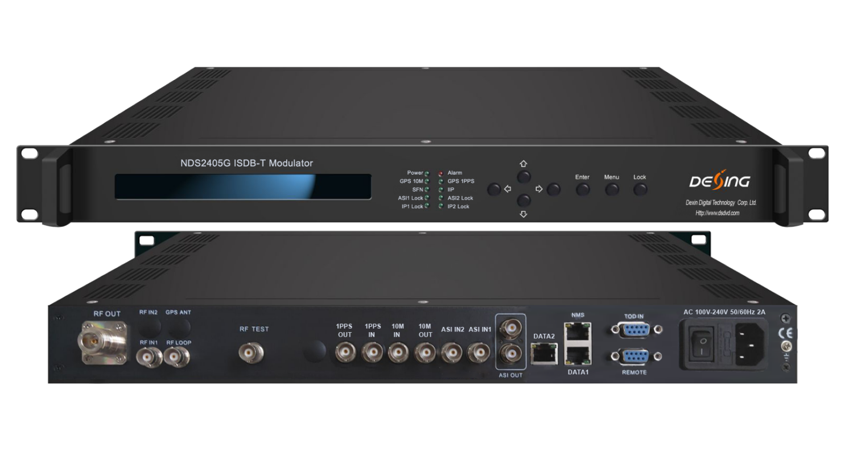Product overview
The FMUSER FUQ-3516R ISDB-T Modulator delivers terrestrial digital television broadcasting, featuring dual ASI and dual IP inputs. It modulates signals compliant with ARIB STD-B31 standards, supporting single frequency network (SFN) and multi-frequency network (MFN). With network-based control via WEB interface, LCD, and keyboard, it enables easy management. Ideal for broadcasting network setup and set-top box testing in South American markets like Brazil and Argentina.
Key feature
Enables network control via WEB, LCD, and keyboard for easy upgrades.

Specifications
Input | 2 ASI ports input, one for hot backup, BNC interface
Input | Dual IP input ports over UDP/RTP, Unicast/Multicast, GE ports
Input | 1 channel 10MHz reference clock input
Input | 1 RF input for DPD -15.2dbm~+5dbm
Modulation | Standard |  | ARIB STD-B31
Modulation | Mode |  | mode 1(2k), mode 2(4k), mode 3(8k)
Modulation | Constellation |  | DQPSK, QPSK, 16QAM, 64QAM
Modulation | External coding |  | RS (204，188)
Modulation | Internal coding |  | Convolution (1/2, 2/3, 3/4, 5/6, 7/8)
Modulation | Guard interval |  | 1/4, 1/8, 1/16, 1/32
Modulation | Hierarchy mode |  | A、A+B、A+B+C
Modulation | Time domain interlacing |  | mode 1: 0, 4, 8, 16 mode 2: 0, 2, 4, 8  mode 3: 0, 1, 2, 4
Modulation | Bandwidth |  | 6MHz
RF Out | Connector |  | N Type, 50ΩImpedance
RF Out | RF range |  | 50~999Mhz，1Hz step
RF Out | Output level ATT |  | -20dbm~+5dbm，0.1db step
RF Out | MER |  | ≥ 42db
Non-linear DPD | over 10db ACPR improvement (normally)
linear DPD | over 10db non-flatness adjustment(normally)
System | LCD display & keyboard operation, WEB, Chinese & English operation display
System | Supporting software upgrading through WEB
General | Demission (W*L*H) | 440mm×414mm×44.5mm
General | Weight | 4.9kg
General | Temperature | 0~45℃(operation),-20~80℃(storage)
General | Power supply | AC 100V~240V,50/60Hz
General | Consumption | 25W

Principle chart

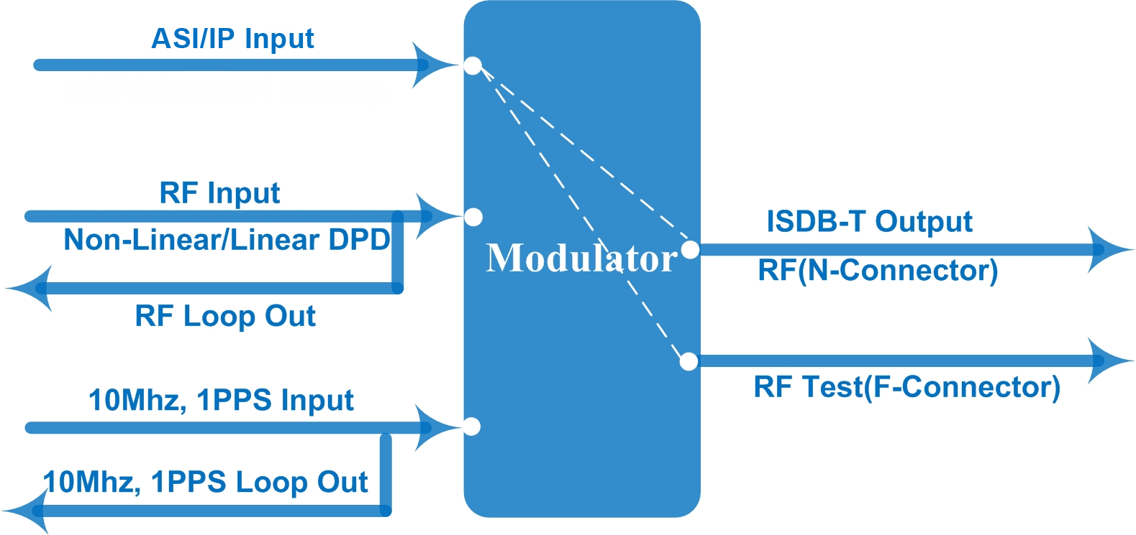

About Us
FMUSER is a company specializing in broadcasting and television transmission systems and integrating hotel IPTV systems. The company was established in 2009 and has served over 180 countries worldwide. More than 20,000 television stations, radio stations, and hotel clients from different.

Contact:Tomleequan Email：sales@fmuser.com whatsapp: +8613922702227

