FMUSER FUQ-3517X Modulator Dual 2 ASI 2 IP Inputs DVB-T-T RF Output Non-linear DPD Web Control Broadcast and LabsModulator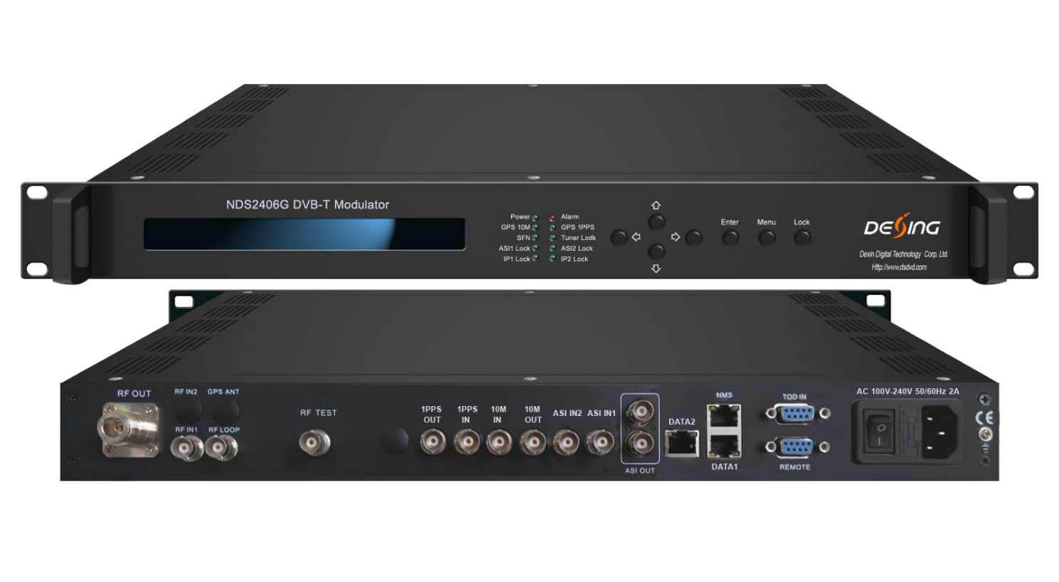
Product overview
The FMUSER FUQ-3517X modulator delivers DVB-T/(T) modulation with dual ASI and IP inputs and RF output. It processes signals using non-linear DPD to enhance spectrum efficiency. Featuring web-based control and a high-stability oscillator, it supports broadcast applications for fixed/mobile devices and DVB-T/(T) STBs.

Principle chart
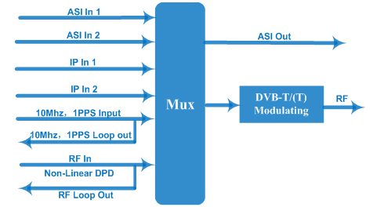
Key feature
Supports dual ASI and IP inputs over UDP protocol.
Integrates non-linear DPD enhancing MER (>43dB) and shoulder attenuation (>56dB).
Provides web network management for remote upgrades, PID remapping, and MFN net mode control.
Includes constant temperature crystal oscillator with 0.1ppm stability.
Supports DVB-T/(T) RF output in 150–999MHz range with configurable guard intervals and constellations.

Specifications
Input | TS input over 2 ASI and 2 IP port (UDP)
Input | 10MHz reference clock input and loop out, BNC interface
Input | 1PPS input and loop out, BNC interface
Multiplexing(option) | Maximum PID Remapping | 128 input per channel
Multiplexing(option) | Function | PID remapping (automatically or manually)
Multiplexing(option) | Function | Accurate PCR adjusting
Multiplexing(option) | Function | Generate PSI/SI table automatically
Modulation | DVB-(T) | Standard |  | EN302 755
Modulation | DVB-(T) | Mode |  | Mode A: single-PLP;
Modulation | DVB-(T) | PLP Constellation |  | QPSK, 16QAM, 64QAM, 256QAM (Normal or Rotated)
Modulation | DVB-(T) | L1 Post Constellations |  | BPSK, QPSK, 16QAM, 64QAM
Modulation | DVB-(T) | FEC Length |  | Short(16K), Normal (64K)
Modulation | DVB-(T) | FEC Rate |  | 1/2, 3/5, 2/3, 3/4, 4/5, 5/6
Modulation | DVB-(T) | Pilot Pattern |  | PP1 - PP8
Modulation | DVB-(T) | Guard Interval |  | 1/128, 1/32, 1/16, 19/256, 1/8, 19/128, 1/4
Modulation | DVB-(T) | FFT Mode |  | 1k, 2k, 4k  8k, 16k, 32k (normal or extended)
Modulation | DVB-(T) | Bandwidth |  | 5MHz, 6MHz, 7MHz, 8MHz
Modulation | DVB-(T) | Net Mode |  | MFN
Modulation | DVB-T | Standard |  | EN300 744
Modulation | DVB-T | FFT |  | 2K, 8K
Modulation | DVB-T | Bandwidth |  | 5MHz, 6MHz, 7MHz, 8MHz
Modulation | DVB-T | Constellation |  | QPSK, 16QAM, 64QAM
Modulation | DVB-T | Guard interval |  | 1/4, 1/8, 1/16, 1/32
Modulation | DVB-T | FEC |  | 1/2, 2/3, 3/4, 5/6, 7/8
Modulation | DVB-T | Net Mode |  | MFN
RF Out | Connector | N Type, 50ΩImpedance
RF Out | RF range | 150~999Mhz, 1hz stepping
RF Out | Output level ATT | -15~+5 dBm, 0.1db stepping
RF Out | MER | > 43db
RF Out | Shoulder Level | >56dB
System | LCD display, keyboard and web Network management
System | Supporting software upgrading through network
General | Demission (W*L*H) |  | 482mm×410mm×44mm
General | Temperature |  | 0~45℃(operation),-20~80℃(storage)
General | Power supply |  | AC 220V±10%,50/60Hz

Shoulder Level with DPD enabled:
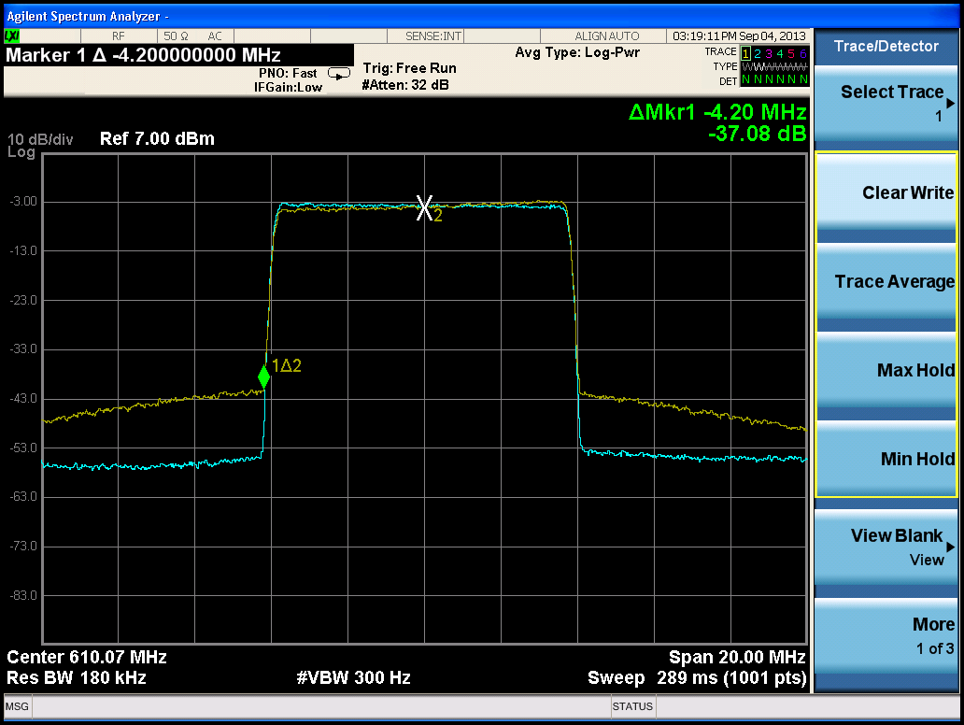
MER:
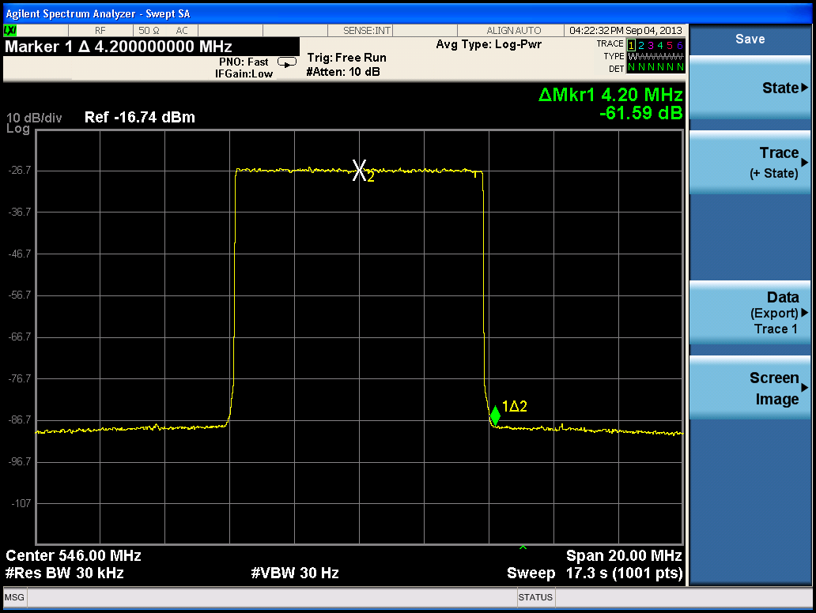

About Us
FMUSER is a company specializing in broadcasting and television transmission systems and integrating hotel IPTV systems. The company was established in 2009 and has served over 180 countries worldwide. More than 20,000 television stations, radio stations, and hotel clients from different.

Contact:Tomleequan Email：sales@fmuser.com whatsapp: +8613922702227

