FMUSER FUQ-3532AB Encoder Modulator 32 CVBS-256 IP Inputs 8 MPTS IP-8 RF Outputs MPEG-4 AVC-H.264 DVB-C-T Encoding Modulation for DTV Broadcasting 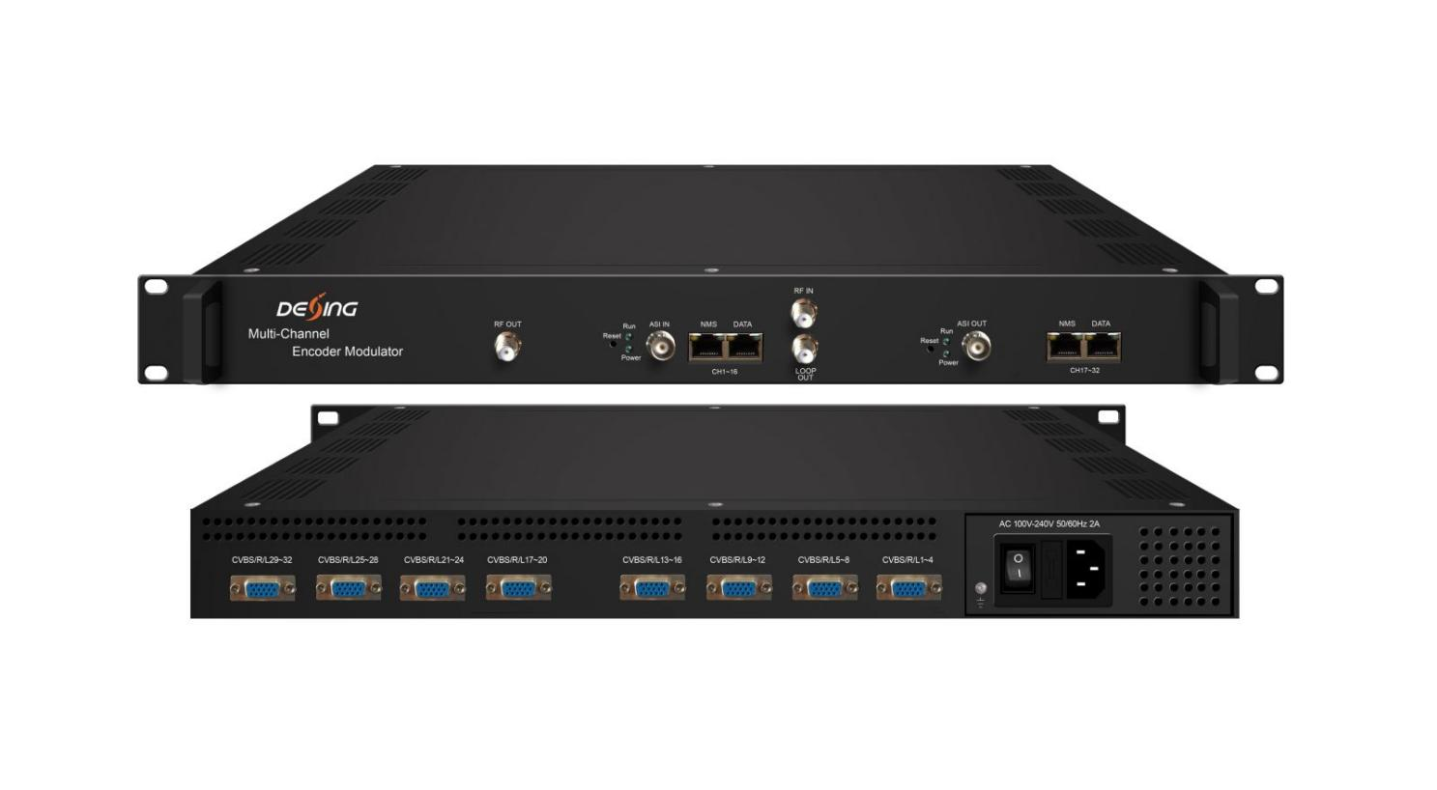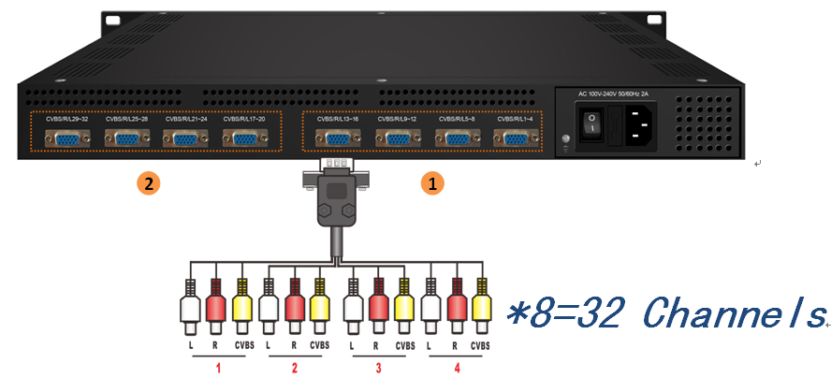
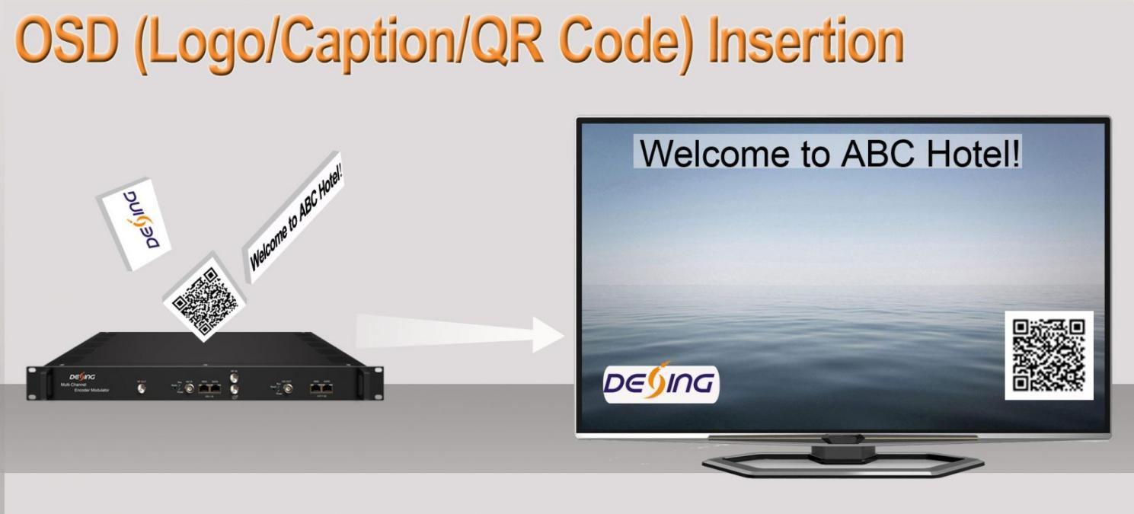
Product Overview
The FMUSER FUQ-3532AB integrates encoding, multiplexing, and modulating functions, supporting 32 CVBS inputs, 1 DVB-C tuner, 1 ASI, and 256 IP inputs, with 8 MPTS outputs via IP and 8 RF outputs. It processes signals by encoding with MPEG4 AVC/H.264, multiplexing, and modulating for transmission. Housed in a standard 1U case, it offers web-based management for real-time monitoring and updates. Ideal for DTV broadcasting systems, enabling cost-effective multi-channel distribution in cable and IPTV networks.DX3532SA also supports 1 DVB-C tuner input, 1 ASI and 256 IP input and 8 non-adjacent carriers output through RF output interface and data port output. The device is also characterized with high integrated level, high performance and low cost. This is very adaptable to newly generation DTV broadcasting system.

Key feature
Integrated Encoding and Modulating: Combines encoding and modulating in a compact 1U case for efficient processing.
Versatile Input Support: Accepts 32 CVBS, 1 DVB-C tuner, 1 ASI, and 256 IP inputs over UDP/RTP.
Advanced Output Capabilities: Generates 8 MPTS outputs via IP and 8 RF outputs for flexible broadcasting.
Stream Management Tools: Enables PID remapping, PCR adjustment, PSI/SI editing, and logo insertion.
Web-Based Control: Features real-time monitoring and easy updates via web interface.

Principle Chart

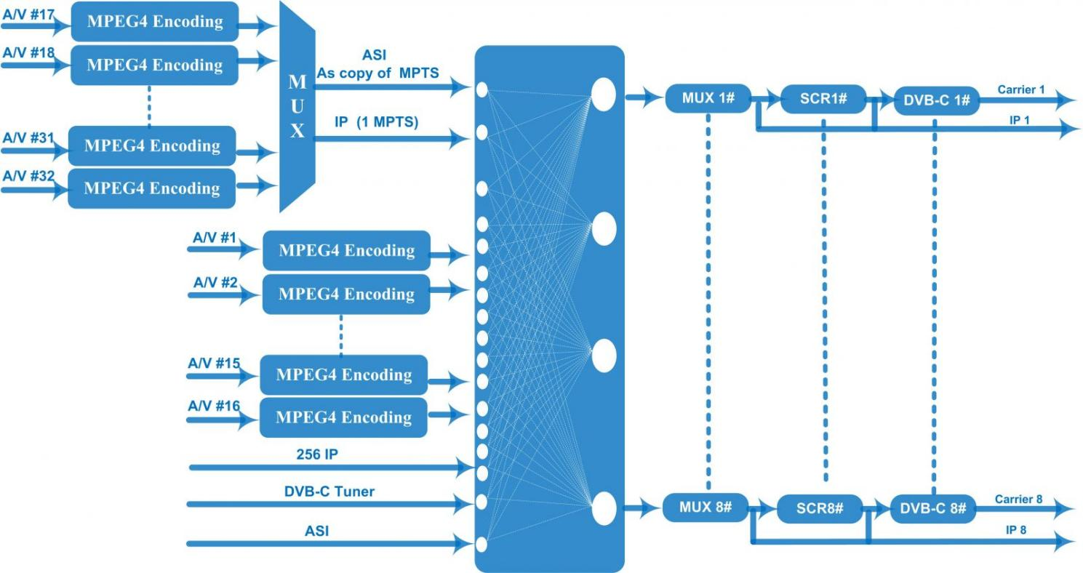
DVB-C RF Out
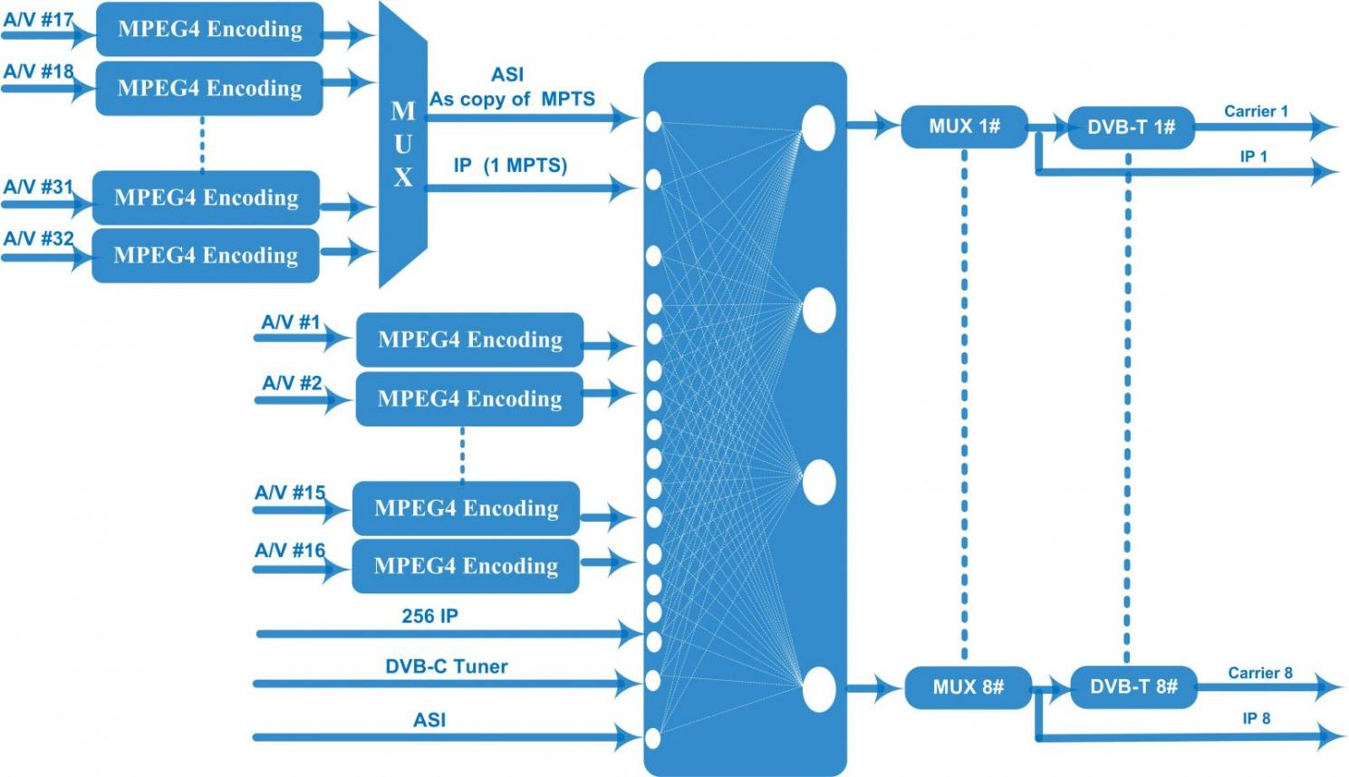
DVB-T RF Out
Technical specification
Input | 32 CVBS inputs , DB15-To-RCA interface
Input | 1ASI input port
Input | 256 IP (100/1000M)input over UDP and RTP protocol
Input | 1 DVB-C Tuner input
Video | Resolution | 720×576i (PAL-B, D, G, H, I), 720×480i (NTSC-M, J)
Video | Encoding | MPEG4 AVC/H.264（HP/MP/BP）
Video | Bit-rate | 1Mbps~5Mbps each channel
Video | Rate Control | CBR/VBR
Video | GOP Structure | IPP(P frame is adjustable)
Audio | Encoding | MPEG-1 Layer 2
Audio | Sampling rate | 48KHz
Audio | Resolution | 24-bit
Audio | Audio Gain | 0-255 adjustable
Audio | Bit-rate | 64/128/192/224/256/320/384Kbps each channel
Modulation | DVB-C | QAM Channel: 8 non-adjacent carriers output (maximum bandwidth 192MHz)  Standard: EN300 429/ITU-T J.83A/B  MER: ≥40dB  RF frequency: 50~960MHz, 1KHz step  RF output level: -20~+3dBm (87~110 dBµV), 0.1dB step  Symbol Rate: 5.0Msps~7.0Msps, 1ksps step
Modulation | DVB-C |  |  | J.83A | J.83B
Modulation | DVB-C | Constellation |  | 16/32/64/128/256QAM | 64/256 QAM
Modulation | DVB-C | Bandwidth |  | 8M | 6M
Modulation | DVB-T | Standard |  | EN300744
Modulation | DVB-T | FFT mode |  | 2K, 4K, 8K
Modulation | DVB-T | Bandwidth |  | 6M, 7M, 8M
Modulation | DVB-T | Constellation |  | QPSK, 16QAM, 64QAM
Modulation | DVB-T | Guard Interval |  | 1/4, 1/8, 1/16, 1/32
Modulation | DVB-T | FEC |  | 1/2, 2/3, 3/4, 5/6, 7/8
Modulation | DVB-T | MER |  | ≥40 dB
Modulation | DVB-T | RF frequency |  | 50~960MHz, 1KHz step
Modulation | DVB-T | RF out |  | 8*COFDM DVB-T non-adjacent carriers output (maximum bandwidth 192MHz)
Modulation | DVB-T | RF output level |  | -20~+3 dBm (87~110 dBµV), 0.1dB step
Scrambling  Parameters | Max simulscrypt CA | 4
Scrambling  Parameters | Scramble Standard | ETR289, ETSI 101 197, ETSI 103 197
Scrambling  Parameters | Connection | Local/remote connection
Stream output | IP (8*MPTS) output over UDP and RTP, 100/1000 Base-T Ethernet interface (Multicast/unicast)
System function | Network management (WEB)
System function | Ethernet software upgrade
Miscellaneous | Dimension(W×L×H) |  | 482mm×328mm×44mm
Miscellaneous | Environment |  | 0~45℃(work)；-20~80℃（Storage）
Miscellaneous | Power requirements |  | AC 110V± 10%, 50/60Hz, AC 220 ± 10%, 50/60Hz

About Us
FMUSER is a company specializing in broadcasting and television transmission systems and integrating hotel IPTV systems. The company was established in 2009 and has served over 180 countries worldwide. More than 20,000 television stations, radio stations, and hotel clients from different.

Contact:Tomleequan Email：sales@fmuser.com whatsapp: +8613922702227

