FMUSER FUQ-3702 HD IP Decoder Dual IP Inputs 1 IP Output 2 ASI Bidirectional Ports MPEG-2 AVC/H.264 Decoding Dual HD-SDI Outputs Web-Based Management Broadcast Headend Cable TV IPTV
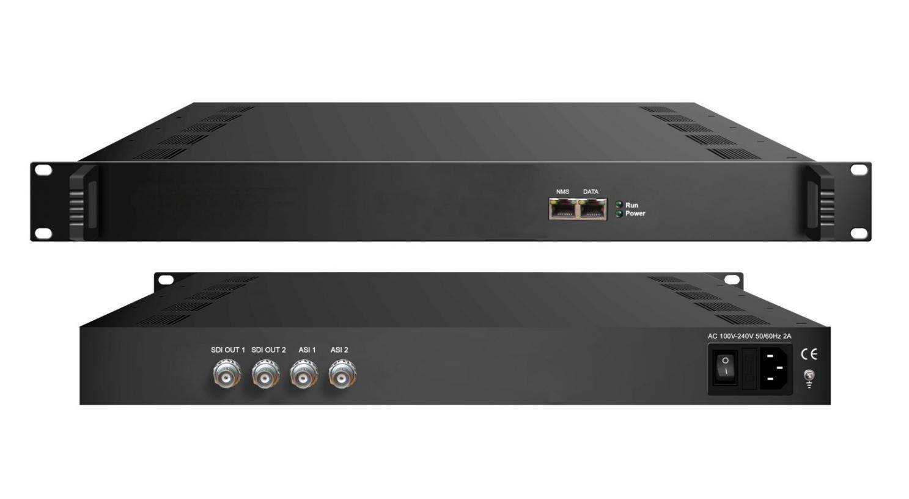Product Overview
The FMUSER FUQ-3702 is a 1U HD IP decoder with dual IP inputs, single IP output, two bi-directional ASI ports, and dual HD/SD-SDI outputs featuring embedded audio. It decodes MPEG-2 and H.264 video streams, supporting audio formats like MPEG1 Layer2, LC-AAC, and HE-AAC. This rack-mountable unit includes web-server remote control for management. Ideal for broadcast headends, cable television systems, and IPTV deployments. It is a 1-U case supporting both IP and ASI input. After decoding process, it outputs 2 channels of HD/SD-SDI videos with dual stereo audios embedded in each port. It also supports 1 IP (MPTS) output and featured with dual bi-directional ASI ports for input and output alternatively.

Key feature
Integrated dual IP inputs and single IP output for versatile connectivity.
Features two bi-directional ASI ports configurable as input or output.
Provides dual HD/SD-SDI decoding outputs with embedded dual stereo audio per port.
Supports MPEG-2 and H.264 video decoding, and audio formats including MPEG1 Layer2, LC-AAC, and HE-AAC.
Offers web-server remote control for easy management and CC/Subtitle support.
Principle Chart
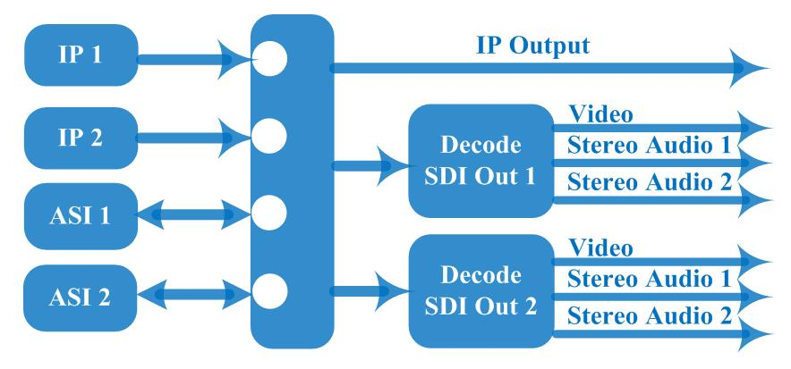
Specification

Input | 2 IP (MPTS/SPTS, 100M/1000Mbps Ethernet, RJ45, UDP protocol, Unicast/multicast)
Input | 2* ASI bi-direction, BNC 75Ω
Decode | Video Format | MPEG-2, MPEG4 AVC/H.264
Decode | Interface | 2* SDI HD/SD
Decode | Video Resolution | 480i, 480p, 576i, 576p, 720p@50/59.94/60, 1080i@50/59.94/60
Decode | Audio Format | MPEG1 Layer2, LC-AAC, HE-AAC, AC3 Passthrough
Decode | Audio Channel | dual stereo audios embedded in each port
Output | 2*HD/SD-SDI decoding out
Output | 0-2 ASI output
Output | 1 IP output over UDP protocol
General | Operation | Web-server
General | Language | Chinese/English
General | Dimension (LxWxH) | 328 mm×482 mm×45mm
General | Environment | 0~45℃(Work)；-20~80℃(Storage)
General | Power Supply | 220VAC±10%，50Hz
General | Consumption | <25W

About Us
FMUSER is a company specializing in broadcasting and television transmission systems and integrating hotel IPTV systems. The company was established in 2009 and has served over 180 countries worldwide. More than 20,000 television stations, radio stations, and hotel clients from different.

Contact:Tomleequan Email：sales@fmuser.com whatsapp: +8613922702227

