FMUSER FUQ-3702 HD Decoder 2 IP & 2 ASI Inputs 2 SDI Outputs MPEG-2 MPEG-4 AVC-H.264 AAC MPEG1 Layer2 IP-ASD Interfaces Web-Based Control for Professional Broadcast IPTV Systems
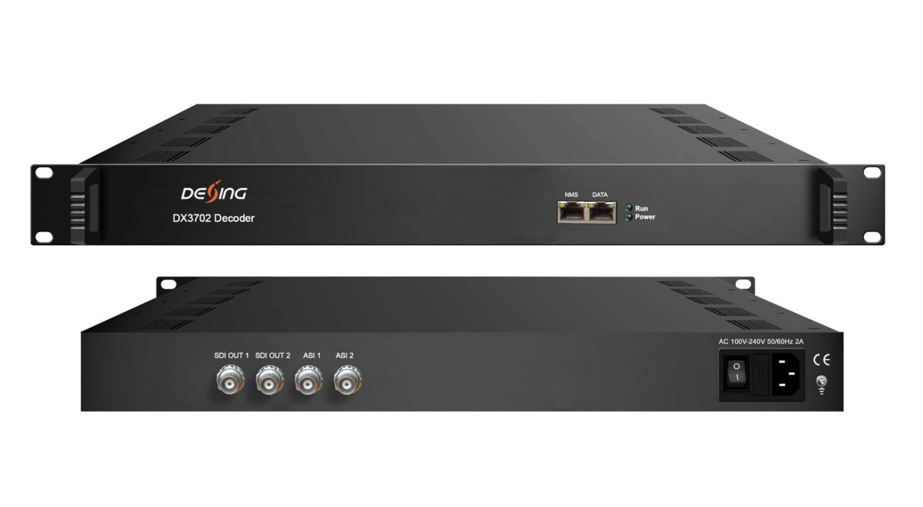Product Overview
The FUQ-3702 is an HD decoder supporting IP and ASI inputs with dual HD/SD-SDI outputs. It decodes signals to output high-quality video and audio. Features web-based management for remote control. Ideal for broadcast systems and professional video distribution.It is a 1-U case supporting both IP and ASI input. After decoding process, it outputs 2 channels of HD/SD-SDI videos with dual stereo audios embedded in each port. It also supports 1 IP (MPTS) output and featured with dual bi-directional ASI ports for input and output alternatively.

Key feature
Features dual IP inputs and single IP output handling MPTS/SPTS over UDP.,
Includes bi-directional ASI ports for flexible input/output switching.,
Outputs dual HD/SD-SDI channels with embedded stereo audio.,
Supports MPEG-2, MPEG-4 AVC/H.264 video, and CC/Subtitle.,
Enables web-based management via web server for easy operation.
Principle Chart
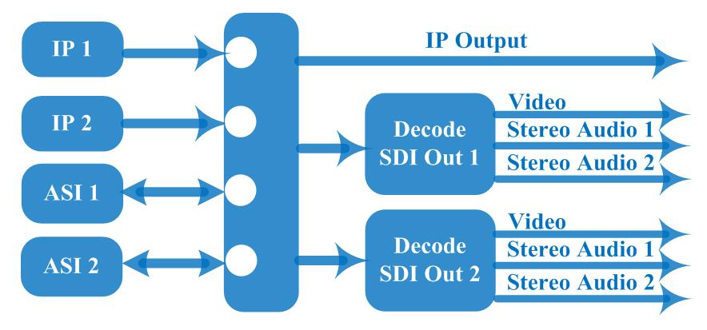
Specification

Input | 2 IP (MPTS/SPTS, 100M/1000Mbps Ethernet, RJ45, UDP protocol, Unicast/multicast)
Input | 2* ASI bi-direction, BNC 75Ω
Decode | Video Format | MPEG-2, MPEG4 AVC/H.264
Decode | Interface | 2* SDI HD/SD
Decode | Video Resolution | 480i, 480p, 576i, 576p, 720p@50/59.94/60, 1080i@50/59.94/60
Decode | Audio Format | MPEG1 Layer2, LC-AAC, HE-AAC, AC3 Passthrough
Decode | Audio Channel | dual stereo audios embedded in each port
Output | 2*HD/SD-SDI decoding out
Output | 0-2 ASI output
Output | 1 IP output over UDP protocol
General | Operation | Web-server
General | Language | Chinese/English
General | Dimension (LxWxH) | 328 mm×482 mm×45mm
General | Environment | 0~45℃(Work)；-20~80℃(Storage)
General | Power Supply | 220VAC±10%，50Hz
General | Consumption | <25W

About Us
FMUSER is a company specializing in broadcasting and television transmission systems and integrating hotel IPTV systems. The company was established in 2009 and has served over 180 countries worldwide. More than 20,000 television stations, radio stations, and hotel clients from different.

Contact:Tomleequan Email：sales@fmuser.com whatsapp: +8613922702227

