FMUSER FUQ-3902B DVB-S2X Receiver 2 Tuner Inputs 32 IP Inputs UDP-RTP IP Output CAM-CI BISS Descrambling Remote Web NMS for Broadcast Engineers
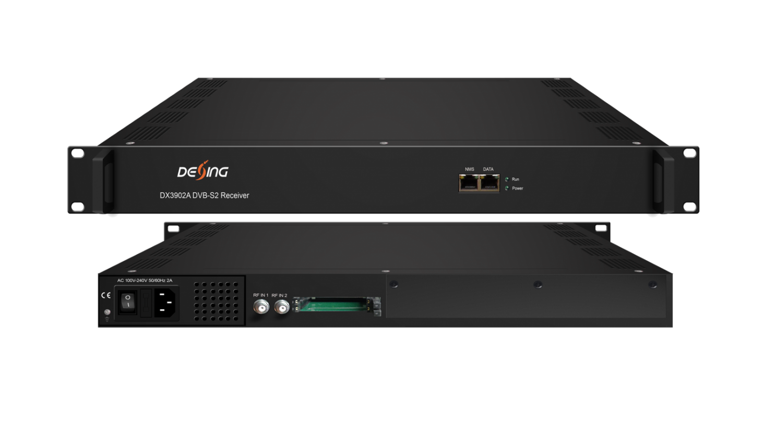Product Overview
The FMUSER FUQ-3902B is a DVB-S2X receiver that integrates demodulation, descrambling, and remuxing, featuring 2 RF tuner inputs and 32 IP inputs supporting UDP/RTP, with IP output. It converts satellite signals into IP streams through efficient processing. This compact unit enables remote control via web-based NMS management. Ideal for broadcast facilities, satellite reception, and IP streaming applications.
Key feature
- Supports dual DVB-S/S2/S2X tuner inputs for versatile reception.
- Features 32 IP inputs with UDP/RTP support for remuxing.
- Integrates decryption via CAM/CI slots and BISS.
- Enables remote monitoring and control through web-based NMS.
- Allows high PID mapping with up to 256 mappings per input channel.

Principle Chart

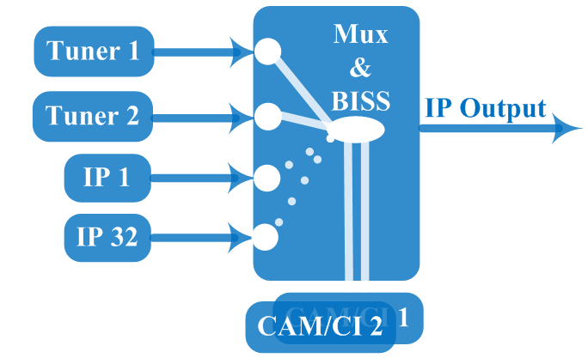

Technical specification
Input | 2*RF (DVBS/S2/S2X), F type  32*IP input for re-mux (UDP/RTP) through data(1000M/100M) ports
Tuner | DVB-S | Input Frequency |  | 950-2150MHz
Tuner | DVB-S | Symbol Rate |  | QPSK 0.5Msps~45Msps
Tuner | DVB-S | Signal Strength |  | -65~ -25dBm
Tuner | DVB-S | FEC Demodulation |  | 1/2, 2/3, 3/4, 5/6, 7/8
Tuner | DVB-S2 | Input Frequency |  | 950-2150MHz
Tuner | DVB-S2 | Symbol Rate |  | QPSK/8PSK/16APSK 0.5Msps~45Msps  32APSK0.5Msps~40 Msps
Tuner | DVB-S2 | FEC Demodulation |  | QPSK: 1/2, 3/5, 2/3, 3/4, 4/5, 5/6, 8/9, 9/10  8PSK: 3/5, 2/3, 3/4, 5/6, 8/9, 9/10  16APSK: 2/3, 3/4, 4/5, 5/6, 8/9, 9/10  32APSK: 3/4, 4/5, 5/6, 8/9
Tuner | DVB-S2X | Input Frequency |  | 950-2150MHz
Tuner | DVB-S2X | Symbol Rate |  | QPSK/8PSK/16APSK: 0.5~45 Msps;  8APSK/32APSK: 0.5~40 Msps
Tuner | DVB-S2X | FEC Demodulation |  | QPSK: 1/2, 3/5, 2/3, 3/4, 4/5, 5/6, 8/9, 9/10, 13/45, 9/20, 11/20  8PSK: 3/5, 2/3, 3/4, 5/6, 8/9, 9/10, 23/36, 25/36, 13/18  8APSK: 5/9-L, 26/45-L  16APSK:2/3,3/4,4/5, 5/6, 8/9, 9/10,1/2-L, 8/15-L, 5/9-L, 26/45, 3/5, 3/5-L, 28/45, 23/36, 2/3-L, 25/36, 13/18, 7/9, 77/90  32APSK: 3/4, 4/5, 5/6, 8/9, 2/3-L, 32/45, 11/15, 7/9
Multiplexing | Maximum PID Remapping | 256 PIDs per input channel
Multiplexing | Function | PID remapping (automatically or manually), Accurate PCR adjusting, generate PSI/ SI table automatically
Descrambling | CAM/CI Quantity | 2
Descrambling | BISS Mode | Mode 1, Mode E; up to 120Mbps
Output | 1*MPTS over UDP and RTP, 1000M/100M Base-T Ethernet interfaces (unicast / multicast)
System function | Network management (WEB)
System function | English language
System function | Ethernet software upgrade
Miscellaneous | Dimension(W×L×H) |  | 482mm×328mm×44mm
Miscellaneous | Environment |  | 0~45℃(work)；-20~80℃（Storage）
Miscellaneous | Power requirements |  | AC 110V± 10%, 50/60Hz, AC 220 ± 10%, 50/60Hz

About Us
FMUSER is a company specializing in broadcasting and television transmission systems and integrating hotel IPTV systems. The company was established in 2009 and has served over 180 countries worldwide. More than 20,000 television stations, radio stations, and hotel clients from different.

Contact:Tomleequan Email：sales@fmuser.com whatsapp: +8613922702227

