FMUSER FUQ-3902B DVB-S-S2-S2X Demodulator Descrambler IP Multiplexer 2 Tuner Inputs 32 IP Stream Outputs UDP-RTP Web-NMS Headend IPTV
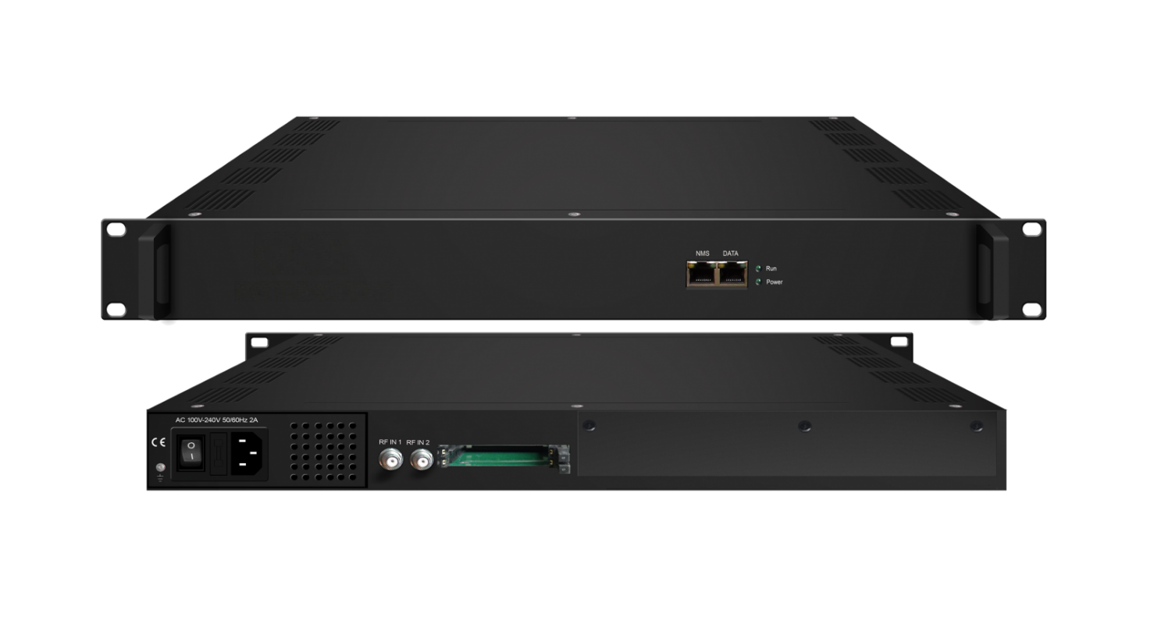Product Overview
The FMUSER FUQ-3902B is a professional DVB-S/S2/S2X demodulator, descrambler, and IP multiplexer with 2 tuner inputs (950-2150MHz) and 32 IP stream outputs (UDP/RTP). It demodulates satellite signals, decrypts via CAM/CI or BISS, and remuxes up to 32 channels into a single MPTS output. This 1RU rack-mount unit supports DiSEqC control and web-based NMS, ideal for broadcast headends and IPTV distribution.
Key feature
Web-based NMS for remote configuration and monitoringPrinciple Chart

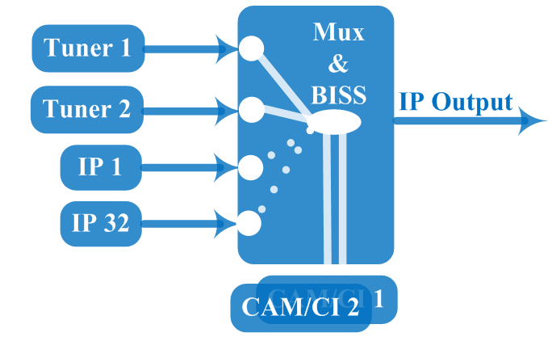

Technical specification
Input | 2*RF (DVBS/S2/S2X), F type  32*IP input for re-mux (UDP/RTP) through data(1000M/100M) ports
Tuner | DVB-S | Input Frequency |  | 950-2150MHz
Tuner | DVB-S | Symbol Rate |  | QPSK 0.5Msps~45Msps
Tuner | DVB-S | Signal Strength |  | -65~ -25dBm
Tuner | DVB-S | FEC Demodulation |  | 1/2, 2/3, 3/4, 5/6, 7/8
Tuner | DVB-S2 | Input Frequency |  | 950-2150MHz
Tuner | DVB-S2 | Symbol Rate |  | QPSK/8PSK/16APSK 0.5Msps~45Msps  32APSK0.5Msps~40 Msps
Tuner | DVB-S2 | FEC Demodulation |  | QPSK: 1/2, 3/5, 2/3, 3/4, 4/5, 5/6, 8/9, 9/10  8PSK: 3/5, 2/3, 3/4, 5/6, 8/9, 9/10  16APSK: 2/3, 3/4, 4/5, 5/6, 8/9, 9/10  32APSK: 3/4, 4/5, 5/6, 8/9
Tuner | DVB-S2X | Input Frequency |  | 950-2150MHz
Tuner | DVB-S2X | Symbol Rate |  | QPSK/8PSK/16APSK: 0.5~45 Msps;  8APSK/32APSK: 0.5~40 Msps
Tuner | DVB-S2X | FEC Demodulation |  | QPSK: 1/2, 3/5, 2/3, 3/4, 4/5, 5/6, 8/9, 9/10, 13/45, 9/20, 11/20  8PSK: 3/5, 2/3, 3/4, 5/6, 8/9, 9/10, 23/36, 25/36, 13/18  8APSK: 5/9-L, 26/45-L  16APSK:2/3,3/4,4/5, 5/6, 8/9, 9/10,1/2-L, 8/15-L, 5/9-L, 26/45, 3/5, 3/5-L, 28/45, 23/36, 2/3-L, 25/36, 13/18, 7/9, 77/90  32APSK: 3/4, 4/5, 5/6, 8/9, 2/3-L, 32/45, 11/15, 7/9
Multiplexing | Maximum PID Remapping | 256 PIDs per input channel
Multiplexing | Function | PID remapping (automatically or manually), Accurate PCR adjusting, generate PSI/ SI table automatically
Descrambling | CAM/CI Quantity | 2
Descrambling | BISS Mode | Mode 1, Mode E; up to 120Mbps
Output | 1*MPTS over UDP and RTP, 1000M/100M Base-T Ethernet interfaces (unicast / multicast)
System function | Network management (WEB)
System function | English language
System function | Ethernet software upgrade
Miscellaneous | Dimension(W×L×H) |  | 482mm×328mm×44mm
Miscellaneous | Environment |  | 0~45℃(work)；-20~80℃（Storage）
Miscellaneous | Power requirements |  | AC 110V± 10%, 50/60Hz, AC 220 ± 10%, 50/60Hz

About Us
FMUSER is a company specializing in broadcasting and television transmission systems and integrating hotel IPTV systems. The company was established in 2009 and has served over 180 countries worldwide. More than 20,000 television stations, radio stations, and hotel clients from different.

Contact:Tomleequan Email：sales@fmuser.com whatsapp: +8613922702227

