FMUSER FUQ-3904C Receiver Card 4 Tuner Inputs 5 MPTS UDP-RTP Outputs DVB-S-S2-S2X PID Remapping DiSEqC Support Broadcast IPTV Integration
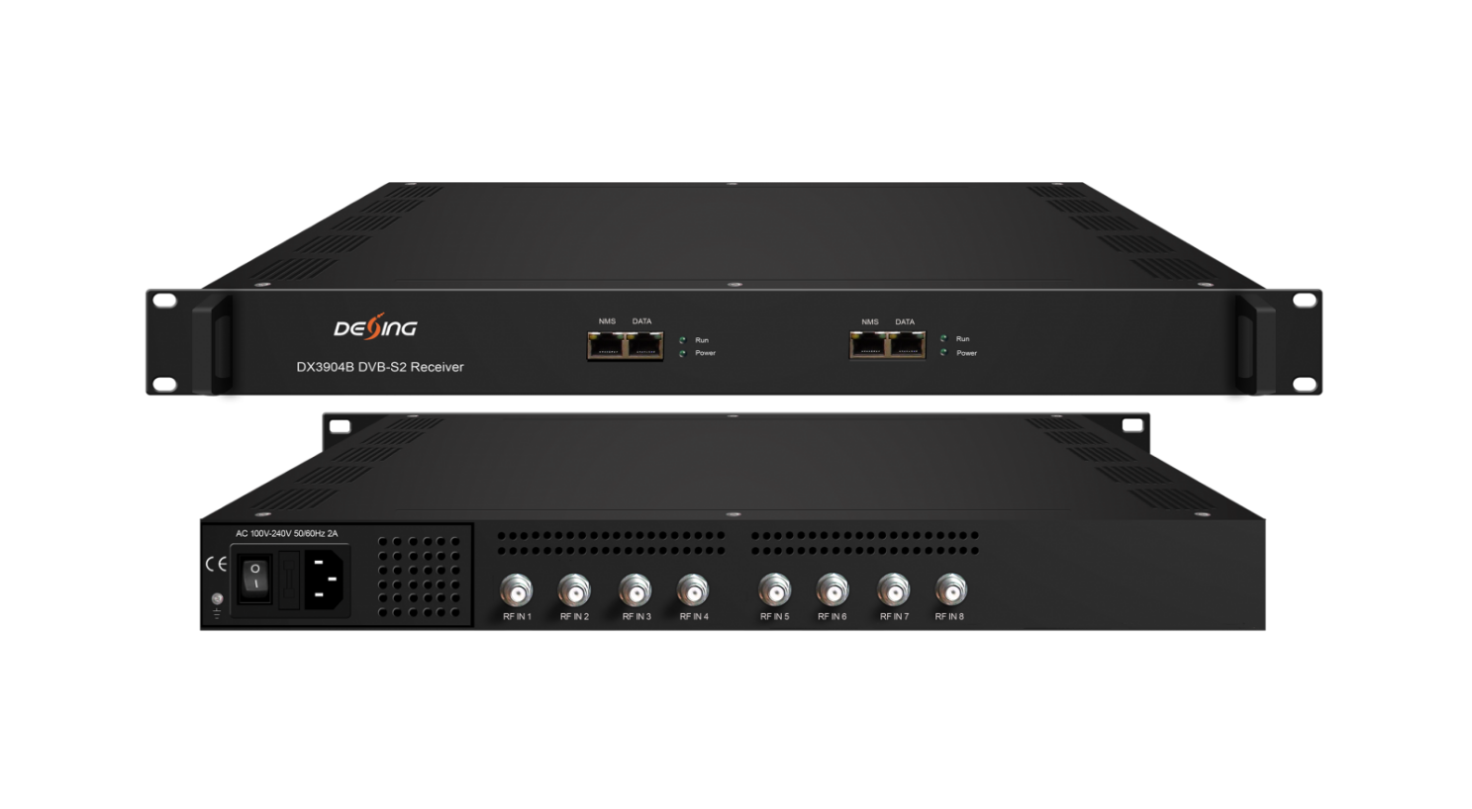
Product overview
The FMUSER FUQ-3904C is a professional receiver card supporting DVB-S/S2/S2X standards, featuring four tuner inputs and five MPTS outputs. It processes satellite signals through multiplexing and PID remapping. Managed via web-based NMS for remote control. Ideal for broadcast integration and satellite reception systems.
Key Features
Includes DiSEqC support for enhanced satellite dish functionality.
Inner Principle Chart (Per Card)
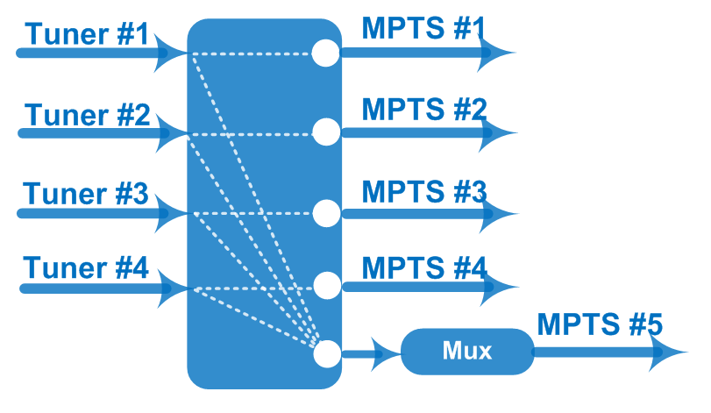
Specifications
Input / Output | 4 Tuner input, F Type  5 MPTS (4 MPTS out thru bypassing, 1 MPTS multiplexing) out over UDP/RTP thru Data port, 100/1000Mself-adaption, unicast/multicast
Mux | Max number of managing PID: 256 (for 1 MPTS out thru multiplexing)
Mux | Functions | PID remapping (automatically/ manually)
Mux | Functions | PID pass-through
Tuner Section | DVB-S | Input Frequency |  | 950-2150MHz
Tuner Section | DVB-S | Symbol Rate |  | 0.5~45 Msps
Tuner Section | DVB-S | Constellation |  | QPSK
Tuner Section | DVB-S | FEC |  | 1/2, 2/3, 3/4, 5/6, 7/8
Tuner Section | DVB-S2 | Input Frequency |  | 950-2150MHz
Tuner Section | DVB-S2 | Symbol Rate |  | QPSK/8PSK/16APSK: 0.5~45 Msps  32APSK:0.5~40 Msps
Tuner Section | DVB-S2 | Constellation |  | QPSK/8PSK/16APSK/32APSK
Tuner Section | DVB-S2 | FEC |  | QPSK: 1/2, 3/5, 2/3, 3/4, 4/5, 5/6, 8/9,9/10  8PSK: 3/5, 2/3, 3/4, 5/6, 8/9, 9/10  16APSK: 2/3, 3/4, 4/5, 5/6, 8/9, 9/10  32APSK: 3/4, 4/5, 5/6, 8/9
Tuner Section | DVB-S2 | Max input bitrate per tuner |  | ≤170 Mbps
Tuner Section | DVB-S2X | Symbol Rate |  | QPSK/8PSK/16APSK: 0.5~45 Msps;  8APSK/32APSK: 0.5~40 Msps
Tuner Section | DVB-S2X | Constellation |  | QPSK/8PSK/16APSK/8APSK/32APSK
Tuner Section | DVB-S2X | FEC |  | QPSK: 1/2, 3/5, 2/3, 3/4, 4/5, 5/6, 8/9, 9/10, 13/45, 9/20, 11/20  8PSK: 3/5, 2/3, 3/4, 5/6, 8/9, 9/10, 23/36, 25/36, 13/18  8APSK: 5/9-L, 26/45-L  16APSK: 2/3, 3/4, 4/5, 5/6, 8/9, 9/10,1/2-L, 8/15-L, 5/9-L, 26/45, 3/5, 3/5-L, 28/45, 23/36, 2/3-L, 25/36, 13/18, 7/9, 77/90  32APSK: 3/4, 4/5, 5/6, 8/9, 2/3-L, 32/45, 11/15, 7/9
Tuner Section | DVB-S2X | Max input bitrate per tuner |  | ≤170 Mbps
Tuner Section | Signal Strength | -65 ~ -25dBm
System | Web management:100M NMS port
System | Language: English and Chinese
System | Ethernet software upgrade
General | Dimensions |  | 482mm×328mm×44mm (WxLxH)
General | Weight |  | 3.5kg
General | Temperature |  | 0~45℃(operation), -20~80℃(storage)
General | Power supply |  | AC 110V±10%, 50/60Hz Or AC 220V±10%, 50/60Hz
General | Consumption |  | ≤40W

About Us
FMUSER is a company specializing in broadcasting and television transmission systems and integrating hotel IPTV systems. The company was established in 2009 and has served over 180 countries worldwide. More than 20,000 television stations, radio stations, and hotel clients from different.

Contact:Tomleequan Email：sales@fmuser.com whatsapp: +8613922702227

