FMUSER FUQ-3908 8 DVB-S-S2-S2X Tuner Input Receiver 8 MPTS or 512 SPTS Output F-Type 1G Ethernet DVB-S2X BISS Decryption PID Remapping Professional Broadcast IPTV
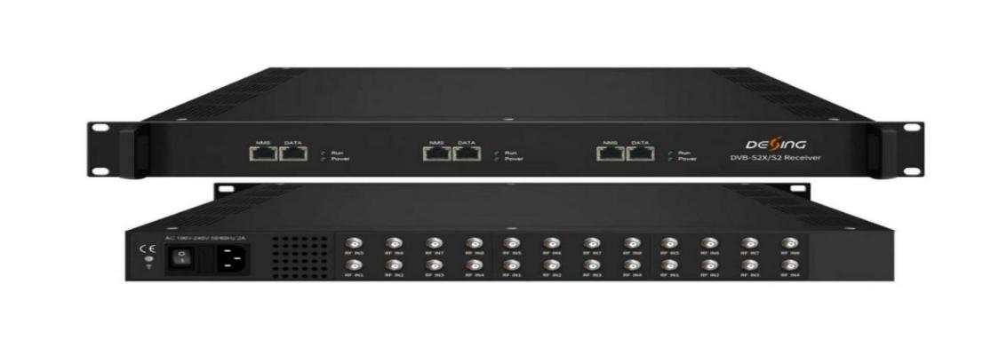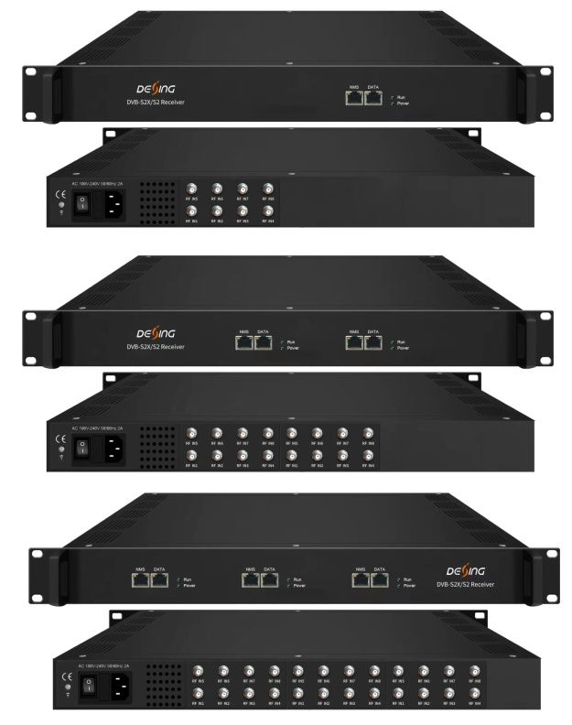
Product overview
The FMUSER FUQ-3908/FUQ-3928 is a professional DVB receiver with up to 24 tuner inputs for DVB-S/S2/S2X, DVB-C/T, and ISDB-T standards. It processes signals in Passthrough mode for direct MPTS output or Mux mode for switchable MPTS/SPTS over UDP/RTP. Managed via web-based NMS in an expandable 1U chassis, it is ideal for broadcast system integration and content distribution.
Key feature
Supports up to 24 tuners with optional 1U chassis, each featuring independent NMS and 1 GE Data port.
Delivers Passthrough mode for 8 MPTS outputs via UDP/RTP multicast/unicast.
Provides Mux mode with switchable 2 MPTS or 512 SPTS outputs, including PID remapping and Biss decryption.
Features web-based NMS for efficient control and monitoring of all functions.
Inner Principle Chart (Per Card/8 Input):
Version 1: Passthrough Mode
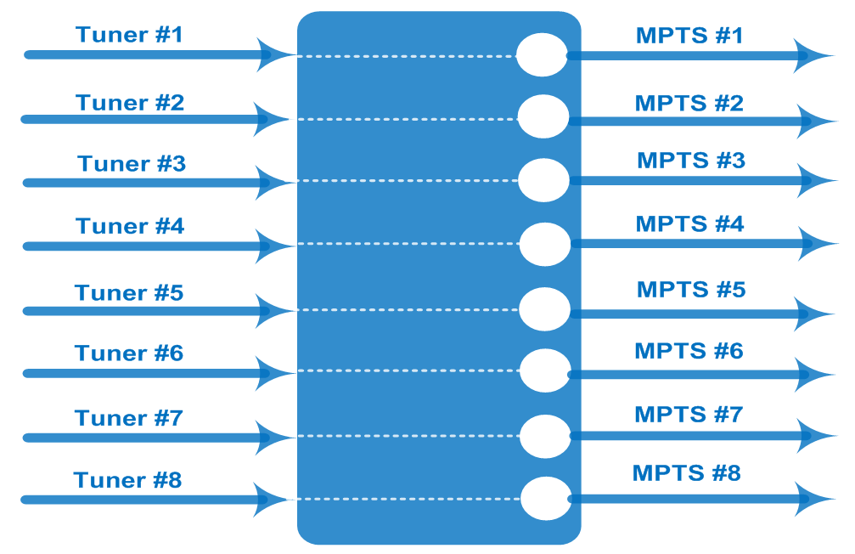

Version 2: Mux Mode (MPTS and SPTS output Switchable)
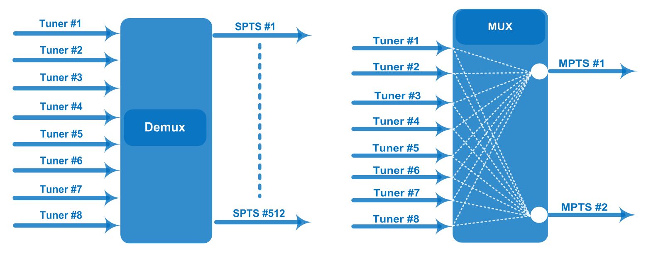
Specifications (Per Card/8 Input)

Input / Output | 8 Tuner input (DVB-S/S2/S2X or/and DVB-C/T/T2/ISDB-T), F Type  8 MPTS out thru bypassing over UDP/RTP thru Data port (Version 1)  100/1000Mself-adaption, unicast/multicast
Mux (Version 2) | Max number of managing PID: 256 (for 2 MPTS out thru multiplexing) or 512 SPTS out
Mux (Version 2) | Functions | PID remapping (automatically/ manually)
Mux (Version 2) | Functions | PID pass-through
Tuner Section | DVB-S | Input Frequency |  | 950-2150MHz
Tuner Section | DVB-S | Symbol Rate |  | 0.5~45 Msps
Tuner Section | DVB-S | Constellation |  | QPSK
Tuner Section | DVB-S | FEC |  | 1/2, 2/3, 3/4, 5/6, 7/8
Tuner Section | DVB-S2 | Input Frequency |  | 950-2150MHz
Tuner Section | DVB-S2 | Symbol Rate |  | QPSK/8PSK/16APSK: 0.5~45 Msps  32APSK:0.5~40 Msps
Tuner Section | DVB-S2 | Constellation |  | QPSK/8PSK/16APSK/32APSK
Tuner Section | DVB-S2 | FEC |  | QPSK: 1/2, 3/5, 2/3, 3/4, 4/5, 5/6, 8/9,9/10  8PSK: 3/5, 2/3, 3/4, 5/6, 8/9, 9/10  16APSK: 2/3, 3/4, 4/5, 5/6, 8/9, 9/10  32APSK: 3/4, 4/5, 5/6, 8/9
Tuner Section | DVB-S2 | Max input bitrate per tuner |  | ≤170 Mbps
Tuner Section | DVB-S2X | Symbol Rate |  | QPSK/8PSK/16APSK: 0.5~45 Msps;  8APSK/32APSK: 0.5~40 Msps
Tuner Section | DVB-S2X | Constellation |  | QPSK/8PSK/16APSK/8APSK/32APSK
Tuner Section | DVB-S2X | FEC |  | QPSK: 1/2, 3/5, 2/3, 3/4, 4/5, 5/6, 8/9, 9/10, 13/45, 9/20, 11/20  8PSK: 3/5, 2/3, 3/4, 5/6, 8/9, 9/10, 23/36, 25/36, 13/18  8APSK: 5/9-L, 26/45-L  16APSK: 2/3, 3/4, 4/5, 5/6, 8/9, 9/10,1/2-L, 8/15-L, 5/9-L, 26/45, 3/5, 3/5-L, 28/45, 23/36, 2/3-L, 25/36, 13/18, 7/9, 77/90  32APSK: 3/4, 4/5, 5/6, 8/9, 2/3-L, 32/45, 11/15, 7/9
Tuner Section | DVB-S2X | Max input bitrate per tuner |  | ≤170 Mbps
Tuner Section | DVB-S2X | Signal Strength |  | -65 ~ -25dBm
Tuner Section | DVB-C | Input Frequency |  | 60 ~890 MHz
Tuner Section | DVB-C | Standard |  | J.83A, J.83C | J.83B
Tuner Section | DVB-C | Constellation |  | 16/32/64/128/256 QAM | 64/256 QAM
Tuner Section | DVB-T/T2 | Input Frequency |  | 60 ~890 MHz
Tuner Section | DVB-T/T2 | Bandwidth |  | 6/7/8 M
Tuner Section | ISDB-T | Input Frequency |  | 60 ~890 MHz
System | Web management:100M NMS port
System | Language: English and Chinese
System | Ethernet software upgrade
General | Dimensions |  | 482mm×328mm×44mm (WxLxH)
General | Weight |  | 3.5kg
General | Temperature |  | 0~45℃(operation), -20~80℃(storage)
General | Power supply |  | AC 110V±10%, 50/60Hz Or AC 220V±10%, 50/60Hz
General | Consumption |  | ≤25W (1card inside)  ≤50W (2 cards inside)  ≤75W (3 cards inside)

Order Guide
DX3908-8 | 8 FTA DVB-S/S2/S2X Tuner Input, Version 1 or Version 2
DX3908-16 | 16 FTA DVB-S/S2/S2X Tuner Input, Version 1 or Version 2
DX3908-24 | 24 FTA DVB-S/S2/S2X Tuner Input, Version 1 or Version 2
DX3928-8 | 8 FTA DVB-C/T/ISDB-T Tuner Input, Version 1 or Version 2
DX3928-16 | 16 FTA DVB-C/T/ISDB-T Tuner Input, Version 1 or Version 2
DX3928-24 | 24 FTA DVB-C/T/ISDB-TTuner Input, Version 1 or Version 2

About Us
FMUSER is a company specializing in broadcasting and television transmission systems and integrating hotel IPTV systems. The company was established in 2009 and has served over 180 countries worldwide. More than 20,000 television stations, radio stations, and hotel clients from different.

Contact:Tomleequan Email：sales@fmuser.com whatsapp: +8613922702227

