FMUSER FUQ-400 DTV Head-end Processor 6 Module Slots ASI-IP-RF Interfaces UDP-RTP-RTSP Encoding-Decoding-Multiplexing Descrambling Modulation for CATV Systems

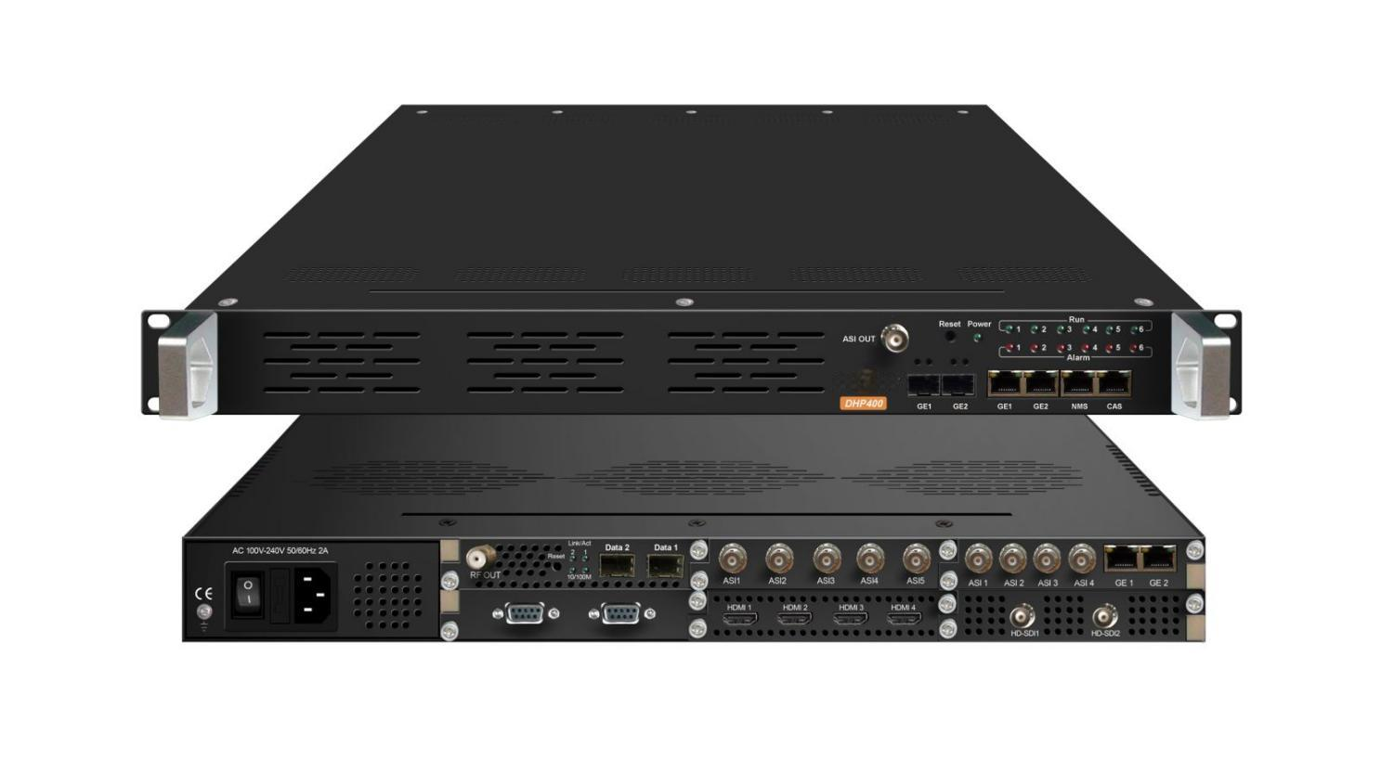products

Product overview
The FMUSER FUQ-400 is a head-end processor with encoding, decoding, transcoding, multiplexing, descrambling, and modulation functions. It processes signals through six independent module slots for flexible configurations. Housed in a compact 1U chassis, it supports ASI and GE output interfaces and web-based management. Ideal for modern CATV systems requiring scalable and reliable solutions.
Key Fetures
Flexible Module Configuration: Supports up to six independent modules for customizable functions like encoding and modulation.
High-Capacity Output Interfaces: Includes ASI and GE ports, enabling 512 SPTS via GE1 and 8 MPTS via GE2 with UDP/RTP support.
Web-Based Management: Allows easy updates and control through a user-friendly interface.
Redundant Power Supply: Offers optional hot or non-hot plugging for enhanced reliability.

Module Specifications
4 CVBS/SDI Encoding Module (DX214B)
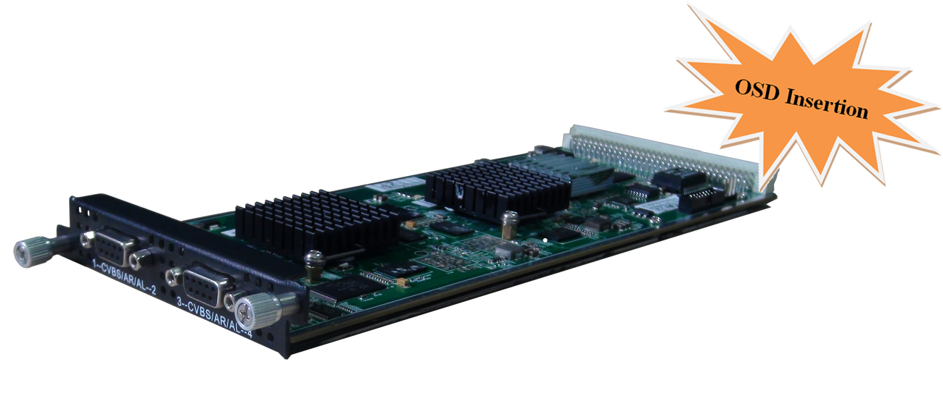
Module Specifications:
Input: 4 CVBS (DB9 to RCA) or 4 SDI (BNC)
Video Encoding:
Video format: MPEG-2, MPEG4 AVC/H.264
Image format: PAL, NTSC SD signal (Only for CVBS input)
Resolution:
Input: 720*576 @50i
Output: 720*576/352*288/320*240/320*180/176*144/160*120/160*90@50Hz
Input: 720*480 @60i
Output: 720*480/352*288/320*240/320*180/176*144/160*120/160*90@60Hz
Rate Control: CBR/VBR
GOP structure: IPPP, IBPBP, IBBPB, IBBBP
Video bitrate: 0.5~5Mbps
Audio Encoding:
Audio format: MPEG1 Audio Layer 2, LC-AAC, HE-AAC
Sampling rate: 48KHz
Bits per sample: 32-bit
Bit-rate: 48-384Kbps each channel
Support Logo, Caption, QR Code insertion

4 HDMI/SDI Encoding Module (DX224V)
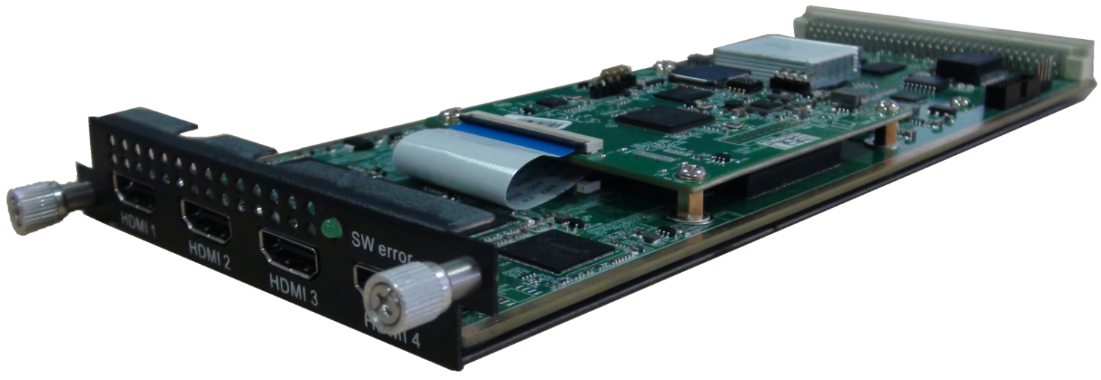

Module Specifications:
Input: 4×SDI/HDMI (1.4) input, HDCP 1.4
Video Encoding:
Video format: HEVC/H.265 & MPEG 4 AVC/H.264
Resolution:
HDMI:
3840×2160_30P, 3840×2160_29.97P;
(Encoding 2 CHs per module for H.265, and encoding 1 CH for H.264)
1920×1080_60P, 1920×1080_59.94P, 1920×1080_50P;
(Encoding 4 CHs per module for H.265, and encoding 2 CHs for H.264)
1280×720_60P, 1280×720_59.94P, 1280×720_50P
(Encoding 4 CHs per module for H.264 and H.265)
SDI:
1920×1080_60P, 1920×1080_59.94P, 1920×1080_50P;
(Encoding 4 CHs per module for H.265, and encoding 2 CHs for H.264)
1280×720_60P, 1280×720_59.94P, 1280×720_50P
(Encoding 4 CHs per module for H.264 and H.265)
Input: 1920×1080_60i, 1920×1080_59.94i, 1920×1080_50i
Output: 1920×1080_60P, 1920×1080_59.94P, 1920×1080_50P
(Encoding 4 CHs per module for H.265, and encoding 2 CHs for H.264)
Chroma: 4:2:0 Bit rate: 0.5Mbps~20Mbps (each channel)
Rate Control: CBR/VBR GOP structure: IBBP, IPPP
Audio Encoding:
Audio format: MPEG-1 Layer 2, LC-AAC, HE-AAC, HE-AAC V2, AC3 Passthrough
Sampling rate: 48KHz
Bit-rate (each channel):
48Kbps~384Kbps (MPEG-1 Layer 2 & LC-AAC)
24 Kbps~128 Kbps (HE-AAC)
18 Kbps~56 Kbps (HE-AAC V2)
Audio Gain: 0~255
4 HDMI Encoding Module (DX224H/HV) 
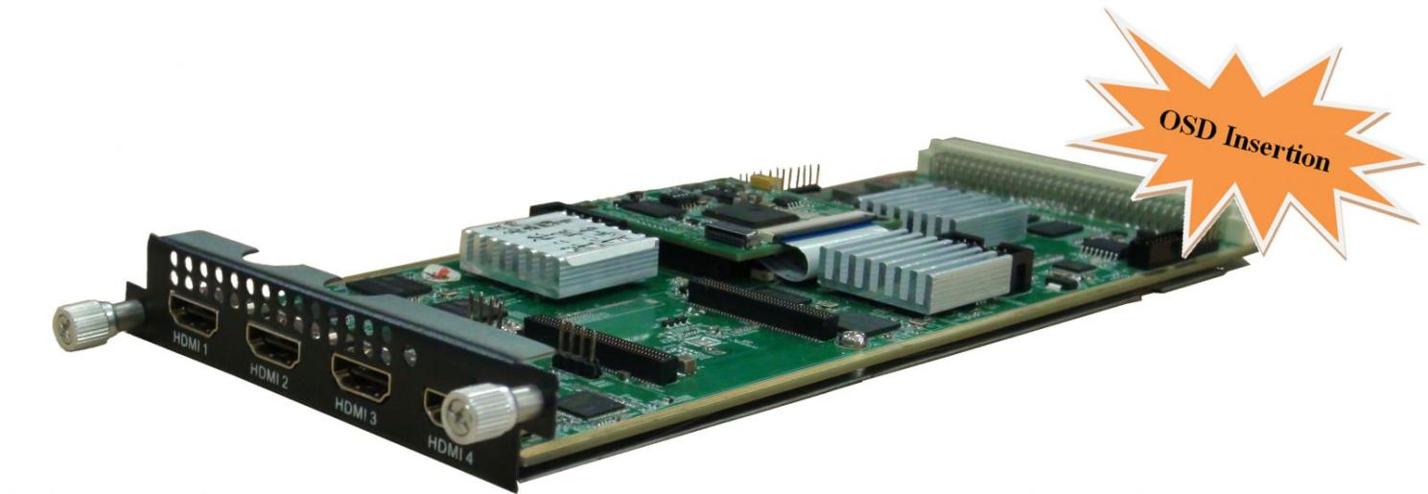
Module Specifications:
Input: 4×HDMI (1.4) input, HDCP 1.4
Video Encoding:
Video format: HEVC/H.265 & MPEG 4 AVC/H.264---DX224H
HEVC/H.265---DX224HV
Resolution:
1920×1080_60P, 1920×1080_59.94P, 1920×1080_50P;
1280×720_60P, 1280×720_59.94P, 1280×720_50P
Input: 1920×1080_60i, 1920×1080_59.94i, 1920×1080_50i
Output: 1920×1080_60P, 1920×1080_59.94P, 1920×1080_50P
Chroma: 4:2:0 Bit rate (each channel): 0.5Mbps~20Mbps (H.265)
4 Mbps~20Mbps (H.264)
Rate Control: CBR/VBR GOP structure: IBBP, IPPP
Audio Encoding:
Audio format: MPEG-1 Layer 2, LC-AAC, HE-AAC, HE-AAC V2, AC3 Passthrough
Sampling rate: 48KHz
Bit-rate (each channel):
48Kbps~384Kbps (MPEG-1 Layer 2 & LC-AAC)
24 Kbps~128 Kbps (HE-AAC)
18 Kbps~56 Kbps (HE-AAC V2)
Audio Gain: 0~255
Support Logo, QR Code insertion--Optional as per order

4 CVBS Encoding Module (DX214/214A)
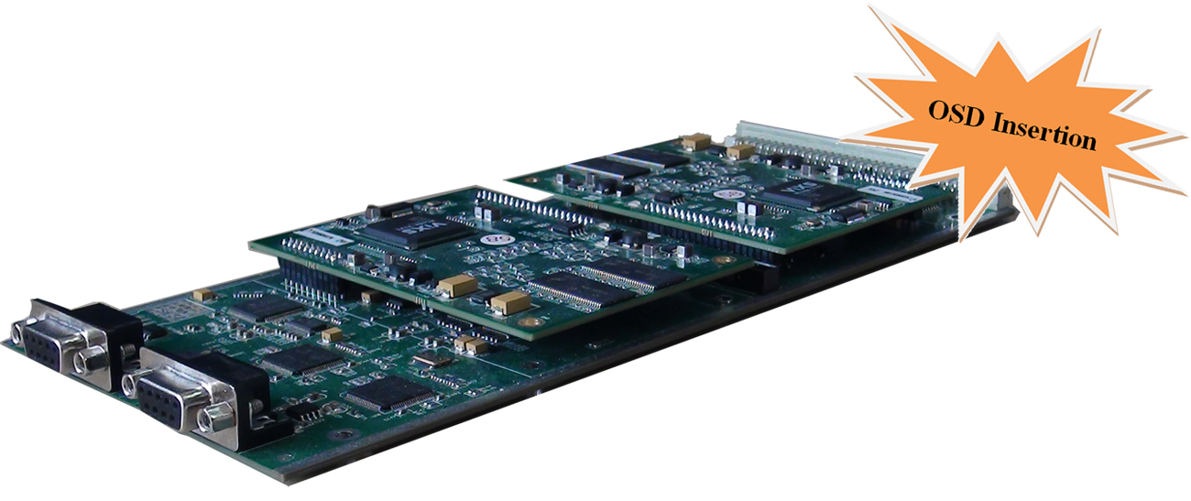
Module Specifications:
Input: 4 CVBS video, 4 Stereo Audio (DB9 to RCA)
Video Encoding:
Video format: MPEG-2 (4:2:0)
Image format: PAL, NTSC SD signal
Input resolution: 720×480_60i, 544×480_60i, 352×480_60i, 352×240_60i,
320×240_60i, 176×240_60i, 176×120_60i, 720×576_50i,
704×576_50i, 640×576_50i, 352×288_50i, 320×288_50i,
176×288_50i, 176×144_50i
GOP structure: IP, IBP, IBBP, IBBBP
Video bitrate: 0.5Mbps~8Mbps per channel
Support CC (closed caption)
Audio Encoding:
Audio format: MPEG-1 Layer 2, DD AC3 (2.0)
Sampling rate: 48KHz
Resolution: 24-bit
Audio bitrate:128/192/256/320/384kbps each channel
Support Logo, Caption, QR Code insertion (for DX214A only)
(Language Supported: 中文, English, اردو, for more languages please consult us…)

8 CVBS Encoding Module(DX218S)
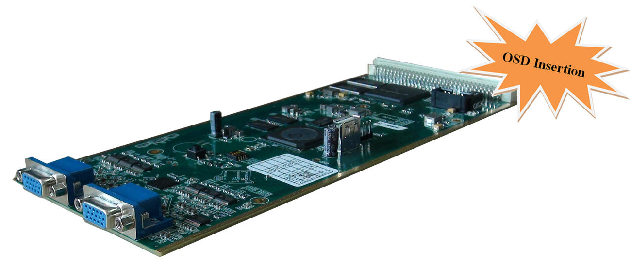
Module Specifications:
Input: 8 CVBS video, 8 Stereo Audio (DB15 to RCA)
Video Encoding:
Video format: MPEG4 AVC/H.264
Image format: PAL, NTSC SD signal
Resolution: 720×576i, 720×480i
Rate Control: CBR/VBR
GOP structure: IPP
Video bitrate: 1~7Mbps each channel
Audio Encoding:
Audio format: MPEG-1 Layer 2
Sampling rate: 48KHz
Resolution: 24-bit
Bit-rate: 64/128/192/224/256/320/384Kbps each channel
Support Logo, Caption, QR Code insertion
(Language Supported: 中文, English, اردو, for more languages please consult us…)

2 HDMI Encoding/Transcoding Module (DX202A)
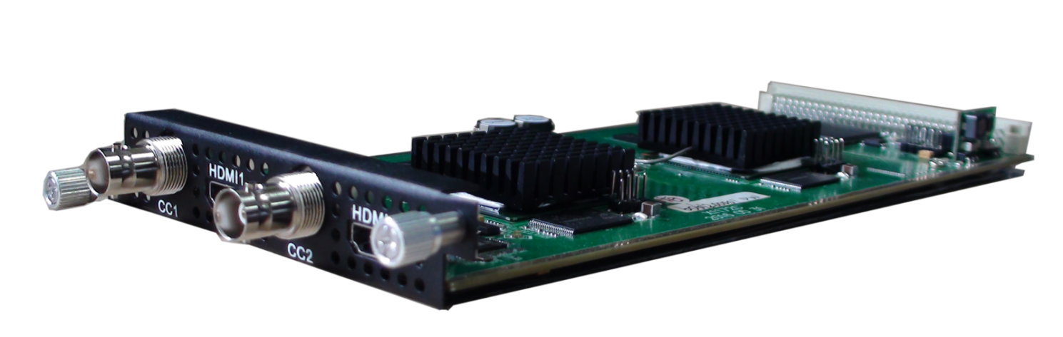
Module Specifications:
Input: 2*HDMI, 2*BNC for CC (Closed Caption) input and stream connector
Video Encoding:
Video format: MPEG2 & MPEG4 AVC/H.264
Input resolution:
1920*1080_60P, 1920*1080_50P, 1920*1080_60i, 1920*1080_50i, 1280*720_60p, 1280*720_50P, 720*480_60i, 720*576_50i
Rate control mode: CBR/VBR
Aspect ratio: 16:9, 4:3
Video bitrate: 0.8~19Mbps for MPEG-2 /H.264 encoding
Support CC (closed caption)
Audio Encoding:
Audio format: MPEG1 Layer II, MPEG2-AAC, MPEG4-AAC,
Dolby Digital AC3 (2.0) encoding (Optional); AC3 (2.0/5.1) passthrough
Sampling rate: 48KHz
Audio bitrate: 64Kbps-320kbps each channel
Video Tanscoding:
2*MPEG2 HD → 2*MPEG2/H.264 HD; 2*MPEG2 HD → 2*MPEG2/H.264 SD;
2* H.264 HD → 2*MPEG2/H.264 HD; 2* H.264 HD → 2*MPEG2/H.264 SD;
4 *MPEG2 SD → 4 *MPEG2/H.264 SD; 4* H.264 SD → 4 *MPEG2/H.264 SD
Audio Tanscoding:
MPEG-1 Layer 2, AC3 (Optional) and AAC any-to-any

2 HD-SDI Encoding/Transcoding Module (DX202A-D)
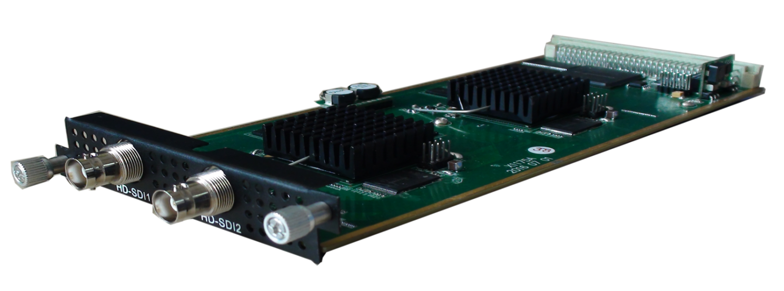

Module Specifications:
Input: 2*HD-SDI and stream connector
Video Encoding:
Video format: MPEG2 & MPEG4 AVC/H.264
Input resolution:
1920*1080_60P, 1920*1080_50P, 1920*1080_60i, 1920*1080_50i, 1280*720_60p, 1280*720_50P, 720*480_60i, 720*576_50i
Rate control mode: CBR/VBR
Aspect ratio: 16:9, 4:3
Video bitrate: 0.8~19Mbps for MPEG-2 /H.264 encoding;
Support CC (closed caption)
Audio Encoding:
Audio format:
MPEG1 Layer II, MPEG2-AAC, MPEG4-AAC,
Dolby Digital AC3 (2.0) encoding (Optional), AC3 (2.0/5.1) passthrough
Sampling rate: 48KHz
Audio bitrate: 64Kbps-320kbps each channel
Video Tanscoding:
2*MPEG2 HD → 2*MPEG2/H.264 HD; 2*MPEG2 HD → 2*MPEG2/H.264 SD;
2* H.264 HD → 2*MPEG2/H.264 HD; 2* H.264 HD → 2*MPEG2/H.264 SD;
4 *MPEG2 SD → 4 *MPEG2/H.264 SD; 4* H.264 SD → 4 *MPEG2/H.264 SD
Audio Tanscoding:
MPEG-1 Layer 2, AC3 (Optional) and AAC any-to-any

4 HDMI Encoding Module (DX224HS)
No Stock Available Currently. Please contact sales person for details.
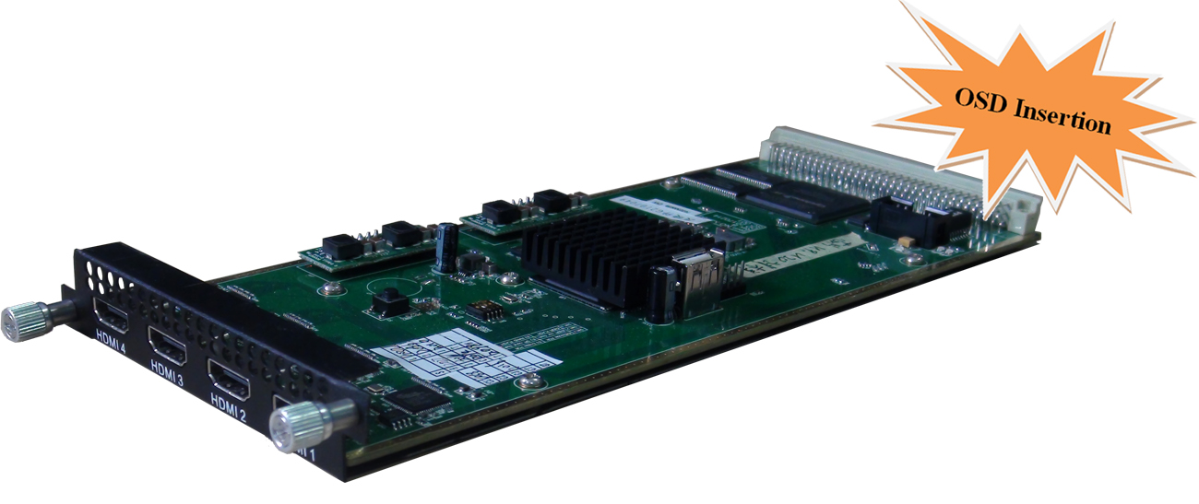
Module Specifications:
Input: 4*HDMI (1.4) input, HDCP 1.4
Video Encoding:
Video format: HEVC/ H.265, MPEG4 AVC/H.264
Input Resolution | Available Output Resolution
1920x1080P@60/59.94 | 1920x1080/1280x720/720*576/720*480P@60/50/30/25/24
1920x1080I@60/59.94 | 1920x1080/1280x720/720*576/720*480P@30/25/24
1920x1080P@50 | 1920x1080/1280x720/720*576/720*480P@50/30/25/24
1920x1080I@50 | 1920x1080/1280x720/720*576/720*480P@25/24
1280x720P@60/59.94 | 1280x720/720*576/720*480P@60/50/30/25/24
1280x720P@50 | 1280x720/720*576/720*480P@50/30/25/24
720*576I@50 | 720*576/720*480P@25/24
720*480I@60 | 720*480P@30/25/24
Chroma: 4:2:0
GOP structure: IP, IBBP, IBBBP
Video Bit-rate: 1Mbps~15Mbps per channel
Rate Control: CBR/VBR
Audio Encoding:
Audio format: MPEG-1 Layer 2, LC-AAC, HE-AAC, HE-AAC V2, AC3 Passthrough
Sampling rate: 48 KHz
Resolution: 24-bit
Audio Bit-rate (per channel):
48Kbps~384Kbps (MPEG-1 Layer 2 & LC-AAC)
24 Kbps~128 Kbps (HE-AAC)
18 Kbps~56 Kbps (HE-AAC V2)
Others: Support Logo, Caption, QR Code insertion

2 Tuner Descrambling Module (DX902A)
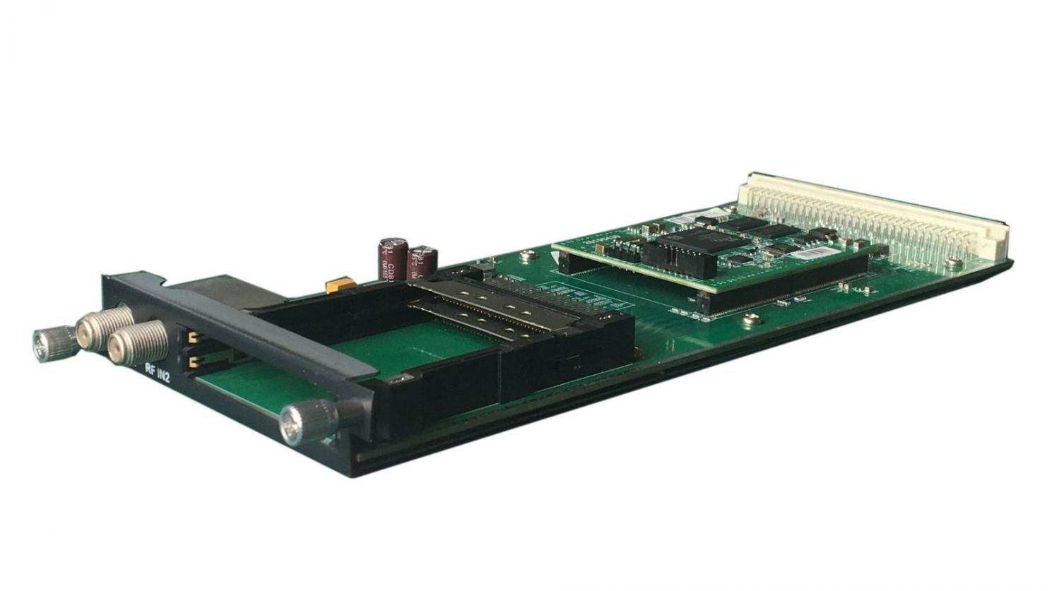

Module Specifications:
Stream in: 2 Tuner input, F Type
DVB-CI: 2 Independent common interface slots
Standard: DVB-S/S2/S2X
Tuner Section:
DVB-S Input Frequency: 950-2150MHz
Symbol Rate: QPSK 0.5~45 Msps
FEC Demodulation: 1/2, 2/3, 3/4, 5/6, 7/8

DVB-S2 Input Frequency: 950-2150MHz
Symbol rate: QPSK/8PSK/16APSK 0.5~45 Msps; 32APSK 0.5~40 Msps
FEC Demodulation: QPSK: 1/2, 3/5, 2/3, 3/4, 4/5, 5/6, 8/9, 9/10
8PSK: 3/5, 2/3, 3/4, 5/6, 8/9, 9/10
16APSK: 2/3, 3/4, 4/5, 5/6, 8/9, 9/10
32APSK: 3/4, 4/5, 5/6, 8/9

DVB-S2X Input Frequency: 950-2150MHz
Symbol rate: QPSK/8PSK/16APSK 0.5~45 Msps; 8APSK/32APSK: 0.5~40Msps
FEC Demodulation: QPSK: 1/2, 3/5, 2/3, 3/4, 4/5, 5/6, 8/9, 9/10, 13/45, 9/20, 11/20
8PSK: 3/5, 2/3, 3/4, 5/6, 8/9, 9/10, 23/36, 25/36, 13/18
8APSK: 5/9-L, 26/45-L
16APSK: 2/3, 3/4, 4/5, 5/6, 8/9, 9/10,1/2-L, 8/15-L, 5/9-L, 26/45, 3/5, 3/5-L, 28/45, 23/36, 2/3-L, 25/36, 13/18, 7/9, 77/90
32APSK: 3/4, 4/5, 5/6, 8/9, 2/3-L, 32/45, 11/15, 7/9

Signal Strength: -65~ -25dBm
Support Diseqc function
Multiplexing:
Maximum PID Remapping: 256 output pids
Function: PID remapping (automatically or manually), Accurate PCR adjusting, generate PSI/ SI table automatically
Descrambling:
CAM/CI Quantity: 2
BISS Mode: Mode 1, Mode E; up to 120Mbps (Optional as required)

2 Tuner Descrambling Module (DX912)
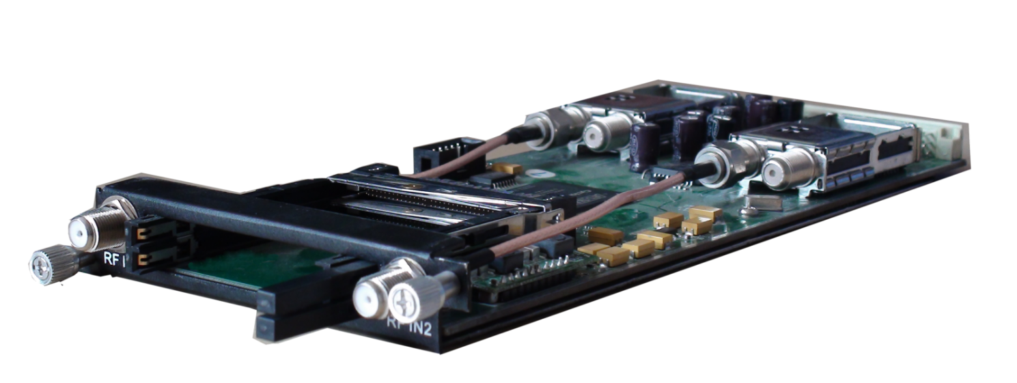
Module Specifications:
Stream in: 2 Tuner input, F Type
DVB-CI: 2 Independent common interface slots
Standard: DVB-C (J.83 A/C)/J.83B/ DVB-T/ISDB-T switchable

Standard: DVB-C (J.83 A/C); J.83B
Input Frequency: 60MHz~890MHz
Symbol rate: 1000~9000Ksps
Constellation: 16/32/64/128/256 QAM; 64/256 QAM for J.83B

Standard: DVB-T
Frequency In: 60MHz~890MHz
Bandwidth: 5/6/7/8M bandwidth
PLP Index: 0~255 (Optional)

Standard: ISDB-T
Input Frequency: 60-890MHz

Signal Strength: -65~ -25dBm
Multiplexing:
Maximum PID Remapping: 256 output pids
Function: PID remapping (automatically or manually), Accurate PCR adjusting, generate PSI/ SI table automatically
Descrambling:
CAM/CI Quantity: 2
BISS Mode: Mode 1, Mode E; up to 120Mbps (Optional as required)
4 FTA Tuner Module (DX904B)
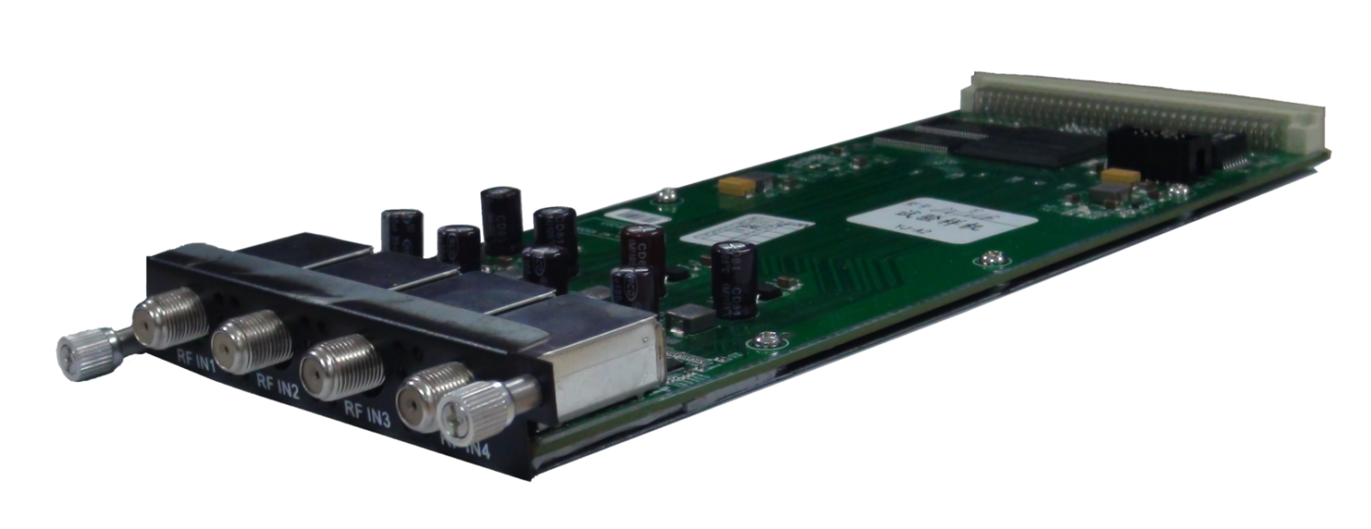
Module Specifications:
Stream in: 4 Tuner input, F Type
Stream out: 1 MPTS out over UDP, unicast/multicast
Standard: DVB-S/S2/S2X
Tuner Section
DVB-S Input Frequency: 950-2150MHz
Symbol Rate: QPSK 0.5~45 Msps
FEC Demodulation: 1/2, 2/3, 3/4, 5/6, 7/8

DVB-S2 Input Frequency: 950-2150MHz
Symbol rate: QPSK/8PSK/16APSK 0.5~45 Msps; 32APSK 0.5~40 Msps
FEC Demodulation: QPSK: 1/2, 3/5, 2/3, 3/4, 4/5, 5/6, 8/9, 9/10
8PSK: 3/5, 2/3, 3/4, 5/6, 8/9, 9/10
16APSK: 2/3, 3/4, 4/5, 5/6, 8/9, 9/10
32APSK: 3/4, 4/5, 5/6, 8/9

DVB-S2X Input Frequency: 950-2150MHz
Symbol rate: QPSK/8PSK/16APSK 0.5~45 Msps; 8APSK/32APSK: 0.5~40Msps
FEC Demodulation: QPSK: 1/2, 3/5, 2/3, 3/4, 4/5, 5/6, 8/9, 9/10, 13/45, 9/20, 11/20
8PSK: 3/5, 2/3, 3/4, 5/6, 8/9, 9/10, 23/36, 25/36, 13/18
8APSK: 5/9-L, 26/45-L
16APSK: 2/3, 3/4, 4/5, 5/6, 8/9, 9/10,1/2-L, 8/15-L, 5/9-L, 26/45, 3/5, 3/5-L, 28/45, 23/36, 2/3-L, 25/36, 13/18, 7/9, 77/90
32APSK: 3/4, 4/5, 5/6, 8/9, 2/3-L, 32/45, 11/15, 7/9
Signal Strength: -65 ~ -25dBm
Support Diseqc function

Multiplexing:
Max number of managing PID: 256
Function: PID remapping (automatically/ manually), Accurate PCR adjust, PID pass-through

4 FTA Tuner Module (DX924)
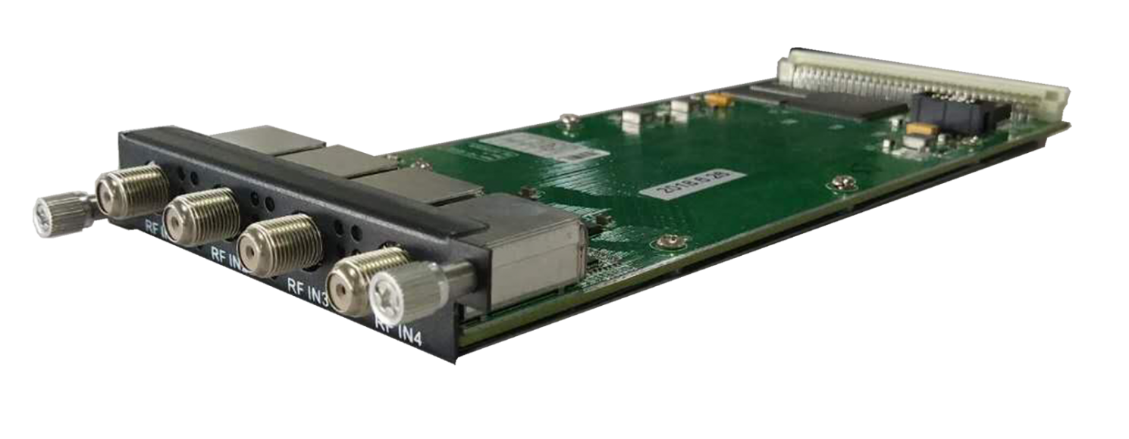
Module Specifications:
Stream in: 4 Tuner input, F Type
Standard: DX924: DVB-C(J.83 A/C)/J.83B/ DVB-T/ISDB-T switchable
Standard: DVB-C(J.83 A/C); J.83B
Input Frequency: 60MHz~890MHz
Symbol rate: 1000~9000Ksps
Constellation: 16/32/64/128/256 QAM; 64/256 QAM for J.83B
Standard: DVB-T
Frequency In: 60MHz~890MHz
Bandwidth: 5/6/7/8M bandwidth
PLP Index: 0~255(optional)
Standard: ISDB-T
Input Frequency: 60-890MHz
Multiplexing:
Max number of managing PID: 256
Function: PID remapping (automatically/ manually), Accurate PCR adjust, PID pass-through

4 ASI/IP Multiplexing Module (DX504)
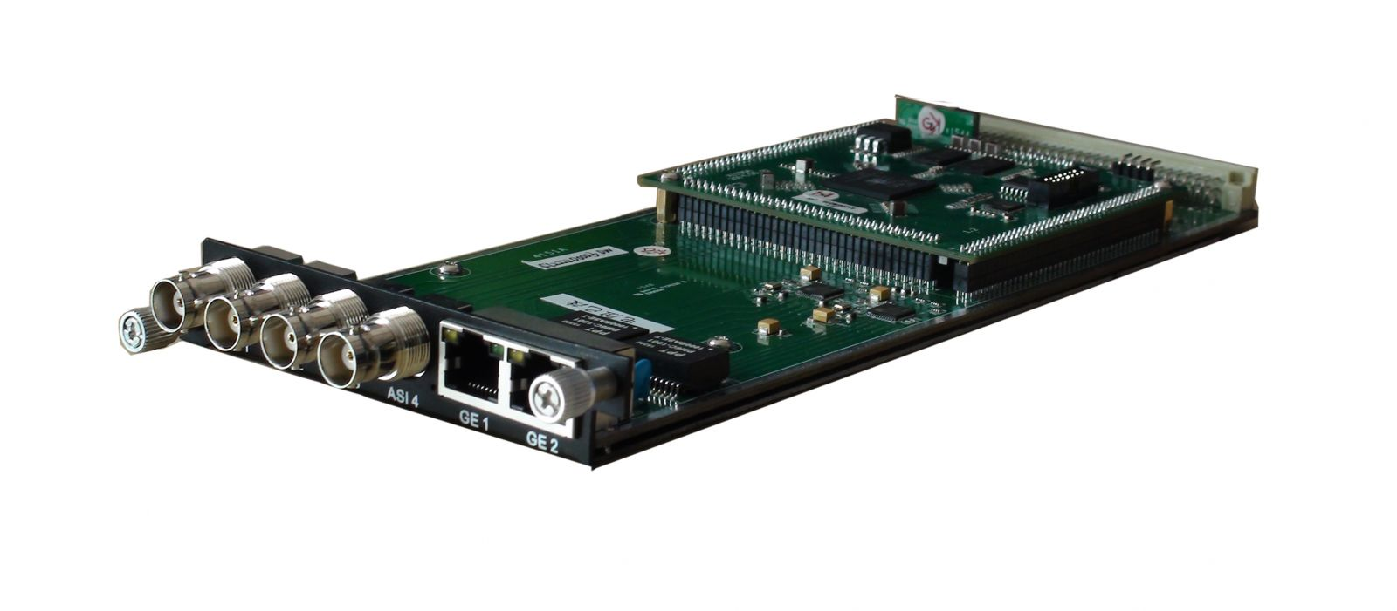
Module Specifications:
ASI inputs/outputs: 4 ASI bi-direction, BNC 75Ω
IP inputs/outputs: 2 Ethernet Port(100/1000M)
Stream connector input
Re-multiplexing: PID remapping, PCR correction, generate PSI/ SI table automatically
Stream In: maximum 4 ASI input, 256×2 IP input
Stream Out: maximum 4 ASI output, 4 IP output

4/8 CH EAS Multiplexing Module (DX504E/DX508E)
DX504E/DX508E Module Specifications:
ASI input: ASI1 input (SPTS), BNC 75Ω
IP input: 256 IP input thru 1 GE1 (100/1000M)
EAS Source: ASI1 or IP (the 256th IP) (ASI&IP should be SPTS, both can’t mux, source Bitrate≤10Mbps)
Re-multiplexing: PID remapping, PCR correction (only for IP), generate PSI/ SI table automatically
Stream Out: 4 IP output thru GE1, maximum 16 programs each channel--DX504E
Stream Out: 8 IP output thru GE1, maximum 8 programs each channel--DX508E

5 ASI Multiplexing Module (DX505)
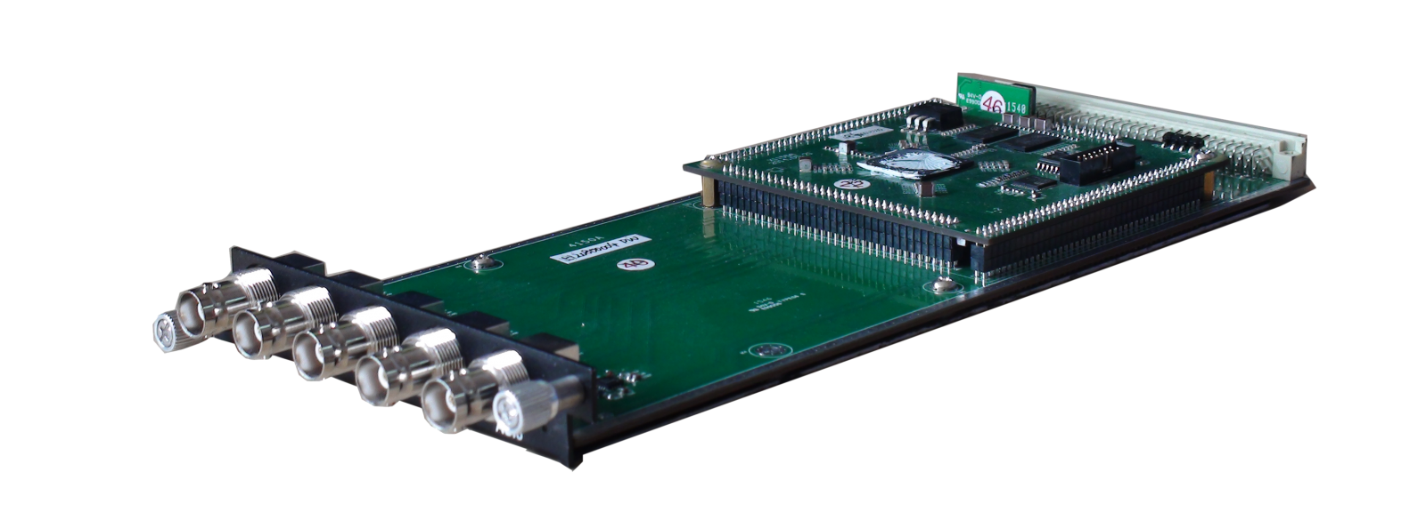
Module Specifications:
ASI inputs/outputs: 5 ASI bi-direction, BNC 75Ω
Stream connector input
Stream in: maximum 5 ASI input
Re-multiplexing: PID remapping, PCR correction, generate PSI/ SI table automatically
Stream out: maximum 5 ASI output

IP Multiplexing Module (DX506)
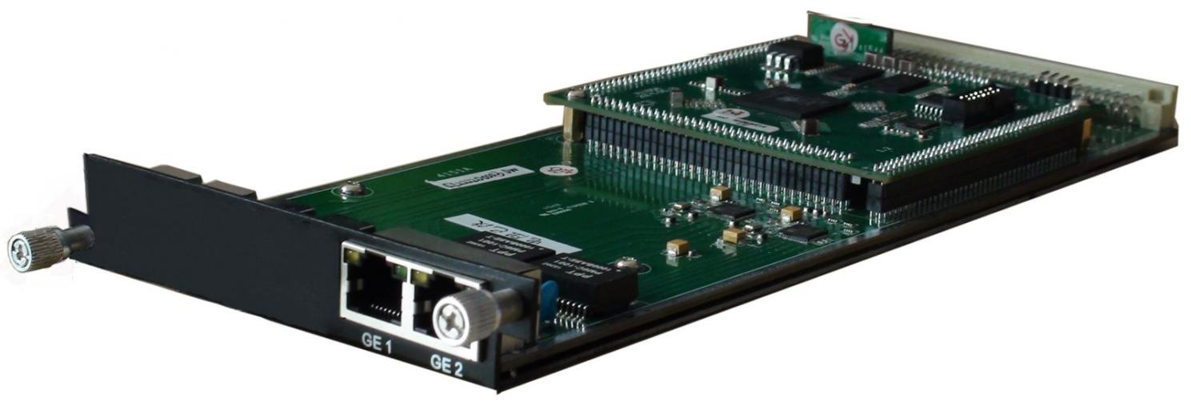
Module Specifications:
IP input: 512 SPTS or MPTS input over UDP, RTP, Unicast and Multicast thru GE1 Ethernet Port(100/1000M)
Re-multiplexing: PID remapping, PCR correction, generate PSI/ SI table automatically
Stream Out: 512 SPTS output over UDP, RTP, Unicast and Multicast thru GE2 Ethernet Port(100/1000M)

ASI/IP Mux-Scrambler Module (DX514)
Module Specifications:
ASI inputs/outputs: 4 ASI bi-direction, BNC 75Ω
IP inputs/outputs: 2 Ethernet Port (100/1000M)
Stream connector input
Re-multiplexing: PID remapping, PCR correction, generate PSI/ SI table automatically
Stream In: maximum 4 ASI input, IP input over UDP/RTP/
Stream Out: maximum 4 ASI output, 4 IP (MPTS) output over UDP/RTP/RTSP
Scrambling:
Maximum simulcrypt CA: 4
Standard: ETR289, ETSI 101 197, ETSI 103 197
Connection: Local/remote connection

ASI TS Switch Module (DX515)
Module Specifications:
Input: 3 ASI
Output: 2 ASI mirror out
TS packet: 188/204
Switch Mode: Manually/Auto
Support monitor program status (bitrate, continuous counting, synchronization status)
Support channel mode and program mode switching
Support to switch back to the main stream manually or automatically once the main stream recovers

16/32 QAM Modulating Module (DX316/DX332)
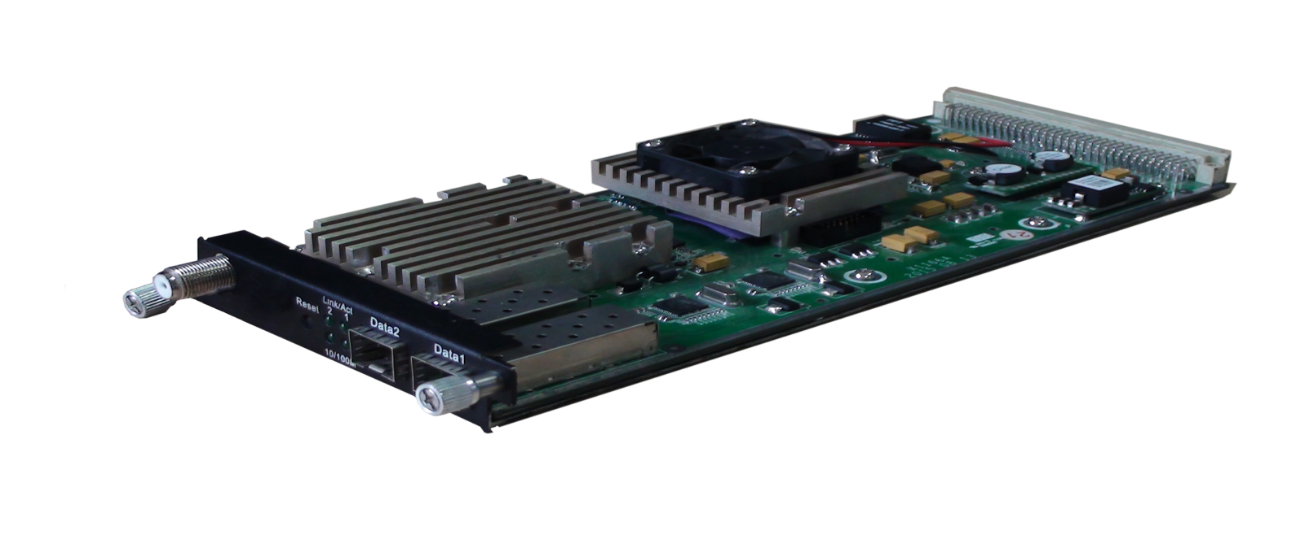
Module Specifications:
Data input: 512×2 IP input over UDP/RTP, 2 GE Ports (RJ45/SFP), Stream connector
Data output: 16 or 32 IP output over UDP/RTP/RTSP, unicast/multicast, 2 GE Ports (RJ45/SFP)
Trans Rate: Max 840Mbps/GE Port
RF output (F type): 16/32 channels of multiplexing, scrambling and modualtion.
Multiplexing:
Maximum PID Remapping: 180 output pids per channel for DX316, 256 output pids per channel for DX332
Function: PID remapping (automatically or manually), Accurate PCR adjusting, generate PSI/SI table automatically
Scrambling:
Maximum simulcrypt CA: 4
Standard: ETR289, ETSI 101 197, ETSI 103 197
Connection: Local/remote connection
Modulation:
Standard: EN300 429/ITU-T J.83A/B (DVB-C)
MER: ≥40dB
RF frequency: 50~960MHz, 1KHz step
RF output level: -20~+10dBm (87~117 dBµV), 0.1dB step for all carriers
Symbol Rate: 5.0Msps~7.0Msps, 1ksps stepping
Constellation: 16/32/64/128/256QAM
DX316 Output: 16 non-adjacent carrier outputs within 192M bandwidth
DX332 Output: 32 non-adjacent carrier outputs within 384M bandwidth

48 QAM Modulating Module (DX348D)
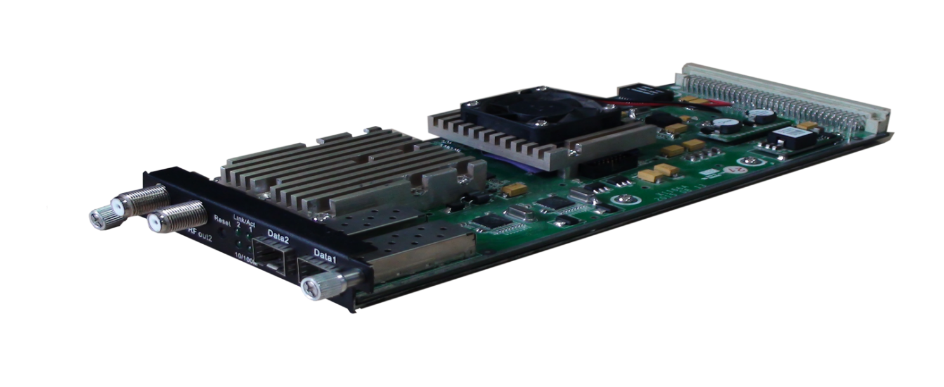
Module Specifications:
Data input: 1024 IP input over UDP/RTP, unicast/multicast, 2 GE Ports (RJ45/SFP), 512 IP input through stream connector
Data output: 48 IP output over UDP/RTP/RTSP, unicast/multicast, 2 GE Ports (RJ45/SFP), GE1 for IP #1-#24, GE2 for IP #25-#48
Trans Rate: Max 840Mbps/GE Port
RF output: 2 F type output ports for 48 non-adjacent carriers, 75Ω
Carrier 1~24 out thru RF1, 25~48 thru RF2, each RF supports 384M bandwidth
Multiplexing:
Maximum PID Remapping: 256 output PIDs per channel
Function: PID remapping (automatically or manually), Accurate PCR adjusting, generate PSI/SI table automatically
Scrambling:
Maximum simulcrypt CA: 6
Standard: ETR289, ETSI 101 197, ETSI 103 197
Connection: Local/remote connection
Modulation:
Standard: EN300 429/ITU-T J.83A/B/C MER: ≥40dB
RF frequency: 50~960MHz, 1KHz step
RF output level: -20~+10dBm (87~117 dBµV), 0.1dB step for all carriers
Symbol Rate: 3600~7000Ksps, 1ksps stepping
5057Ksps (J.83B, 64QAM), 5361Ksps (J.83B, 256QAM)
Constellation/Bandwidth: J.83A: 16/32/64/128/256QAM, 8M
J.83B/C: 64/256QAM, 6M

8 DVB-T/ATSC Modulating Module (DX308T/DX308AT)
Module Specifications:
Data input: Stream connector
256 IP input over UDP/RTP, 2GE Ports (RJ45/SFP) —— DX308T
256 IP input over UDP/RTP, 2GE Ports (RJ45/SFP) —— DX308AT
Data output: 8 IP output over UDP/RTP/RTSP, unicast/multicast, 2 GE Ports (RJ45/SFP)
Trans Rate: Max 840Mbps/GE Port
RF Output (F type): 8 non-adjacent carrier outputs within 192M bandwidth
Multiplexing:
Channel Number: 8 multiplexing channels
Maximum PID Remapping: 180 output pids per channel
Function: PID remapping (automatically or manually), Accurate PCR adjusting, generate PSI/ SI table automatically
Modulation: DX308T (8*DVB-T)
Standard: ETSI EN300 744 MER: ≥40dB
RF Frequency: 50~960MHz, 1KHz step
Constellation: QPSK/16QAM/64QAM
Bandwidth: 6/7/8 MHz
Trans mode: 2K/4K/8K FEC: 1/2, 2/3, 3/4, 5/6, 7/8
RF Output Level: -20~+10dBm (for all carriers), 0.5dB step
Modulation: DX308AT (8*ATSC)
Standard: ATSC A/53 MER: ≥40dB RF Frequency: 50~960MHz, 1KHz step
Constellation: 8VSB Bandwidth: 6MHz FEC: RS(208 188)+Trellis
RF Output Level: -20~+10dBm (for all carriers), 0.5dB step

6 ISDB-Tb Modulating Module (DX306I)
Module Specifications:
Data input: 32×6 IP input over UDP/RTP, 2 GE Ports (RJ45/SFP) and stream connector
Data output: 6 IP output over UDP/RTP/RTSP, unicast/multicast, 2 GE Ports (RJ45/SFP)
Trans Rate: Max 840Mbps/GE Port
RF output (F type): 6 channels of multiplexing and modualtion.
Multiplexing:
Maximum PID Remapping: 180 output pids per channel
Function: PID remapping (automatically or manually), Accurate PCR adjusting, generate PSI/ SI table automatically
Modulation:
Standard: ARIB STD-B31
Bandwidth: 6M
Constellation: QPSK, 16QAM, 64QAM
Guard Interval: 1/32, 1/16, 1/8, 1/4
Transmission Mode: 2K, 4K, 8K
Code rate: 1/2, 2/3, 3/4, 5/6, 7/8
MER: ≥40dB
RF frequency: 50~960MHz, 1KHz step
RF output level: -20dBm~+10dBm (87~117dBµV), 0.1dB stepping

2 HD-SDI Decoding Module (DX702)
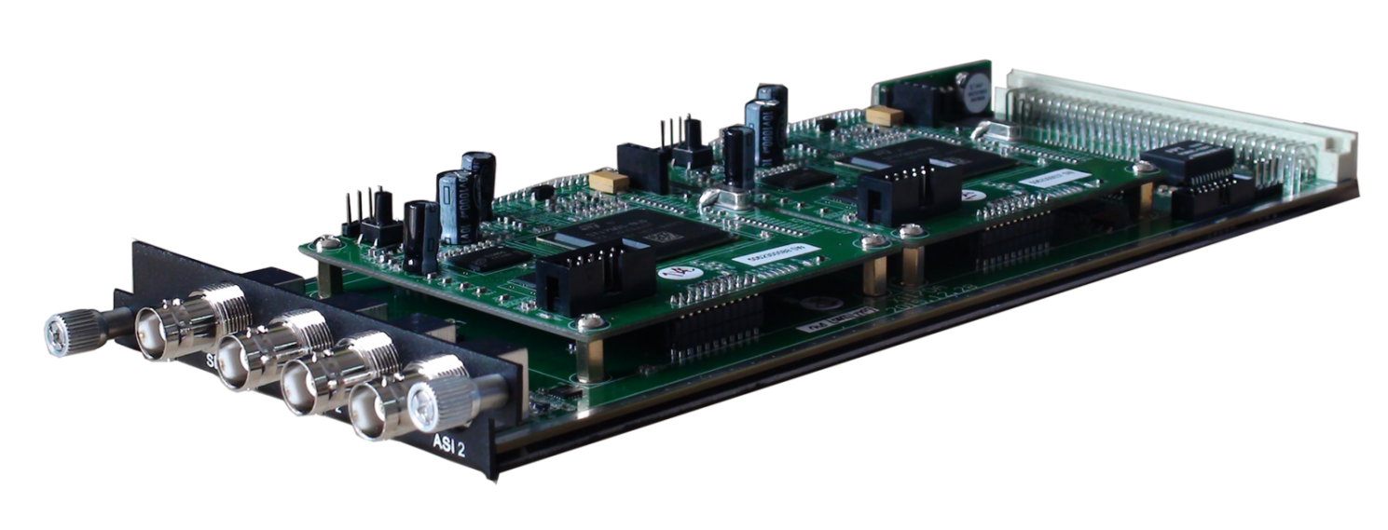
Module Specifications:
ASI input/output: 2 ASI bi-direction, BNC 75Ω
Stream Connector input
Decoding:
Video/Audio Out: 2 HD/SD SDI output
Video Format: MPEG-2, MPEG-4 AVC/H.264
Resolution: 480i,480p,576i,576p,720p@50/59.94/60,1080i@50/59.94/60
Chroma: 4:2:0
Audio Format: MPEG1 Layer2, LC-AAC, HE-AAC, AC3 (2.0/5.1), AC3 Passthrough,
Support Dual Audio Out
Support CC/Subtitle

4 HDMI Decoding Module (DX714)
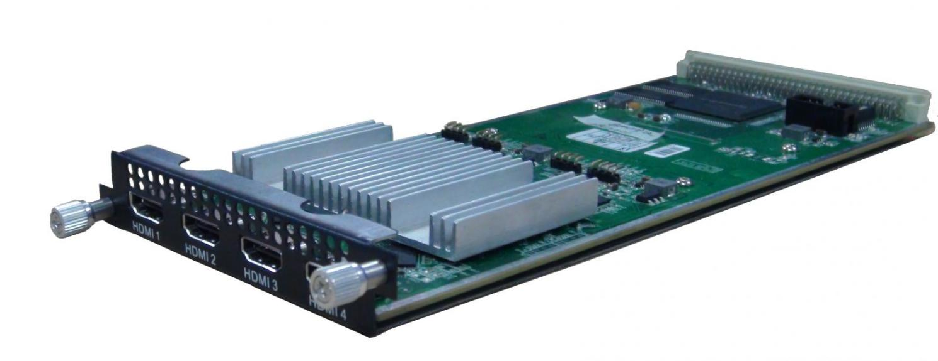
Module Specifications:
Input: 1 IP (MPTS/SPTS) input over UDP thru stream connector, Unicast/Multicast
Output: 4 HDMI output
Decoding:
Video/Audio Out: 4 HDMI output with 1 channel stereo audio embedded in each port
Video Format: MPEG-2, MPEG-4 AVC/H.264, HEVC/H.265, AVS, AVS+
Audio Format: MPEG 1 Layer 2, LC-AAC, HE-AAC, AC3 (2.0)
Resolution: 480i, 480p, 576i, 576p,1280×720_50p, 1280×720_60p, 1920×1080_50i, 1920×1080_50p 1920×1080_60i, 1920×1080_60p
Support manually upscale/downscale resolution

2 IP Transcoding Module (DX202)
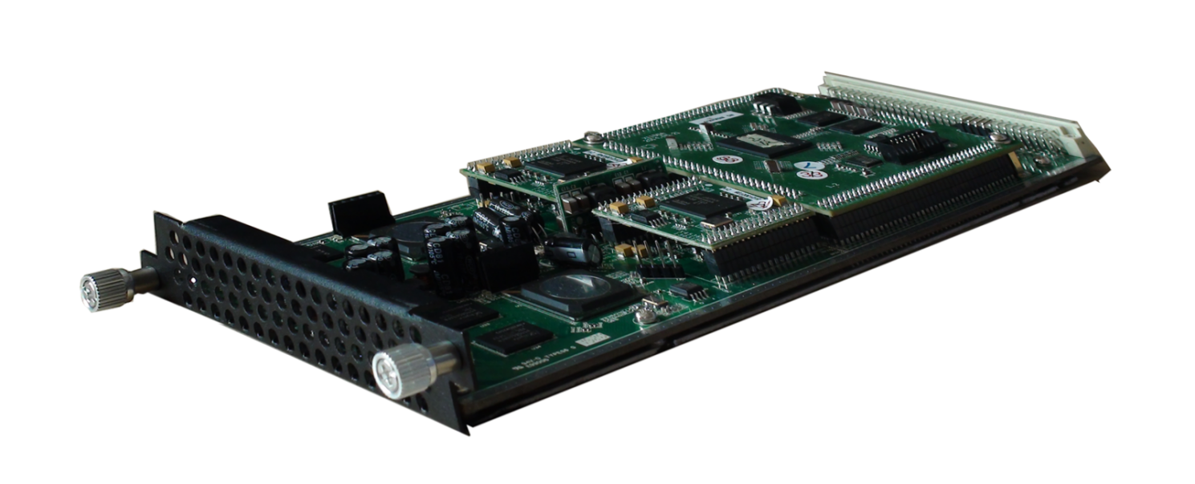

Module Specifications:
Input: Stream connector
Resolution: 480i, 576i, 720P@50, 720P@60, 1080i@50, 1080i@60, 1080P@50, 1080P@60
Video Tanscoding:
2*MPEG-2/ H.264/ AVS/AVS+ HD/SD → 2* H.264 HD/SD
Video Bit-rate: 1~19.5Mbps each channel
Rate Mode: CBR/VBR
GOP Struct: IBBP, IPPP, IBP
AudioTanscoding:
MPEG-1 Layer II, LC/HE-AAC, AC3, DRA→ MPEG-1 Layer II, LC/HE-AAC
Audio bitrate: 64/96/128/192/256/320/384Kbps
Audio Gain Control: 0-100

Equipment Specifications:

Base Unit Parameters
Dimension(W×L×H): 482mm×410mm×44mm
Environment: 0~45℃(work); -20~80℃(Storage）
Power requirements AC 110V± 10%, 50/60Hz, AC 220 ± 10%, 50/60Hz

Parameters Comparison:
 | DHP400 | DHP400A
IP Data Transport | One-way Transport:  GE1/GE2 support output maximum 8MPTS & 512SPTS | Bi-directional Transport:  GE1/ GE2 support IP data input and output
TS Processing Number | Support 1 TS (MPTS/SPTS) input from each module, and maximum bitrate is 350Mbps | Support maximum 512 TS (MPTS/SPTS) input from each module, and maximum bitrate is 350Mbps
Multiplexing | Support multiplexing function:  It can mux TSs from different modules to one TS and output through one module or GE1/GE2 port | Doesn’t support multiplexing function:  It can combine TSs from different modules and output these TSs through one module or GE1/GE2 port
Output Per Module | 1 MPTS after multiplexing | 1 or multiple MPTS/SPTS

About Us
FMUSER is a company specializing in broadcasting and television transmission systems and integrating hotel IPTV systems. The company was established in 2009 and has served over 180 countries worldwide. More than 20,000 television stations, radio stations, and hotel clients from different.

Contact:Tomleequan Email：sales@fmuser.com whatsapp: +8613922702227

