FMUSER FUQ-400B Modular Headend Processor 6-Slot Configurable ASI-IP I-O MPEG-2-H.264-H.265 DVB-ISDB Encoding Decoding Transcoding Multiplexing Modulating For CATV Systems

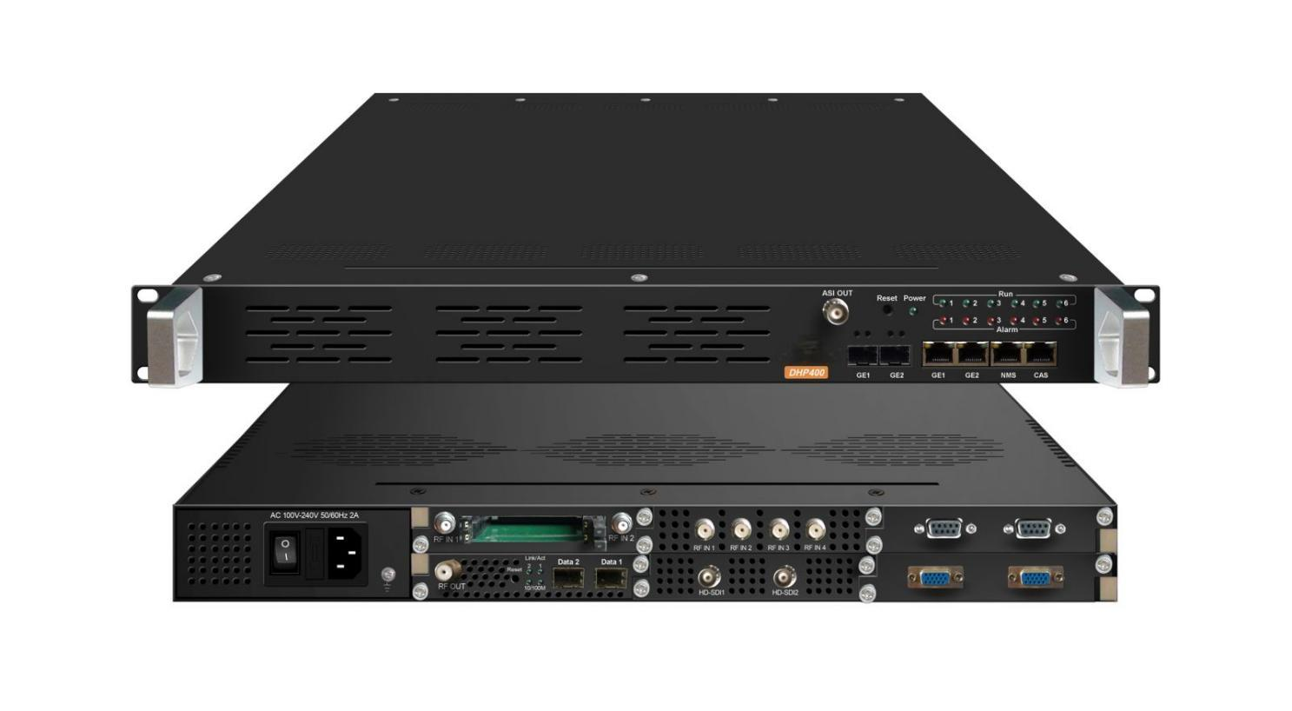products

Product overview
The FMUSER FUQ-400B is a modular head-end processor in a 1U chassis, supporting encoding, decoding, transcoding, multiplexing, descrambling, and modulating via six configurable slots. It handles signals through IP input/output via GE1 and GE2 ports and ASI output. Controlled via a web-based interface, it offers optional redundancy power supply. Ideal for CATV systems requiring flexible and cost-effective signal processing in head-end applications.
Key Fetures
Supports flexible module configuration with up to six slots for encoding, decoding, transcoding, multiplexing, descrambling, and modulating,
Features IP input/output through GE1 and GE2 ports and ASI output,
Offers redundancy power supply with hot or non-hot plugging options,
Enables web-based management for remote configuration and updates

Specifications
4 CVBS/SDI Encoding Module(DX214B)
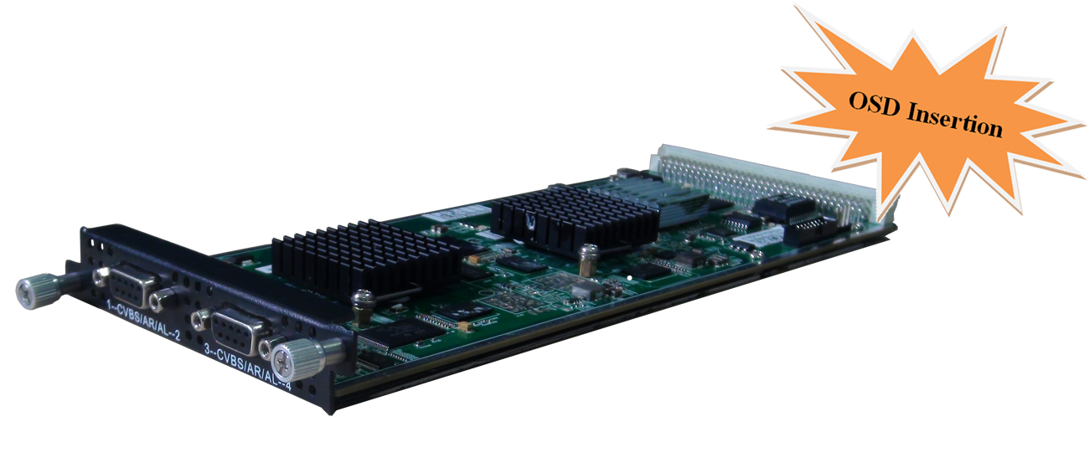
Module Specifications:
Input: 4 CVBS (DB9 to RCA) or 4 SDI (BNC)
Output: 1MPTS and 4 SPTS output over UDP/RTP, unicast and multicast
Video Encoding:
Video format: MPEG-2, MPEG4 AVC/H.264
Image format: PAL, NTSC SD signal (Only for CVBS input)
Resolution:
Input: 720*576 @50i
Output: 720*576/352*288/320*240/320*180/176*144/160*120/160*90@50Hz
Input: 720*480 @60i
Output: 720*480/352*288/320*240/320*180/176*144/160*120/160*90@60Hz
Rate Control: CBR/VBR
GOP structure: IPPP, IBPBP, IBBPB, IBBBP
Video bitrate: 0.5~5Mbps
Audio Encoding:
Audio format: MPEG1 Audio Layer 2, LC-AAC, HE-AAC
Sampling rate: 48KHz
Bits per sample: 32-bit
Bit-rate: 48-384Kbps each channel
Support Logo, Caption, QR Code insertion
4 HDMI/SDI Encoding Module (DX224V) 
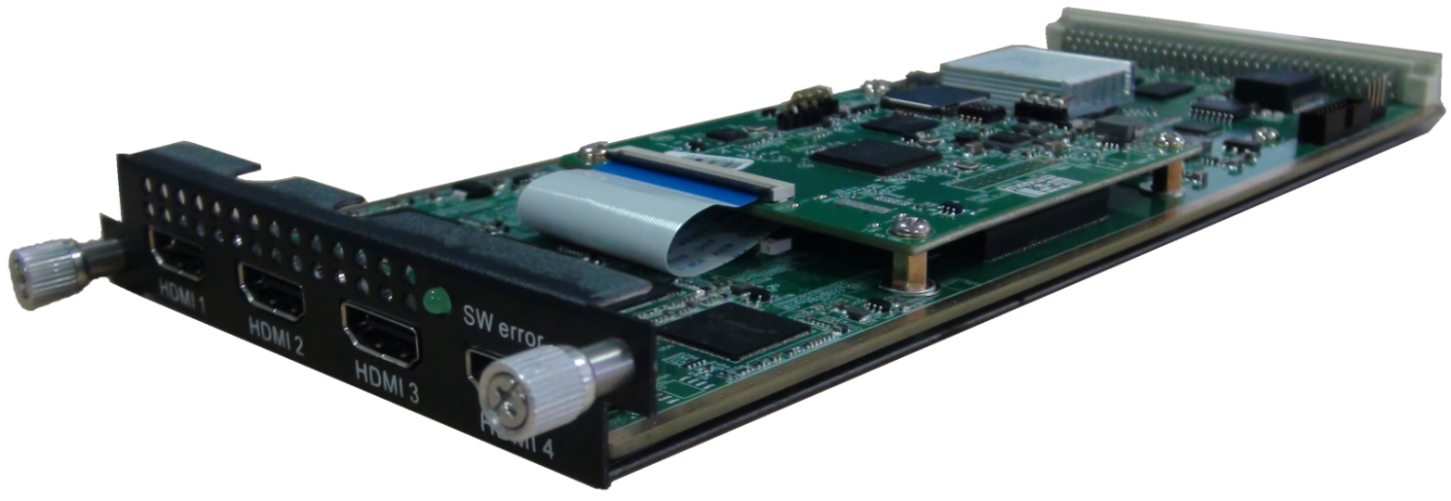

Module Specifications:
Input: 4×SDI/HDMI (1.4) input, HDCP 1.4
Output: 1 MPTS and maximum 4 SPTS output over UDP/RTP/RTSP
Video Encoding:
Video format: HEVC/H.265 & MPEG 4 AVC/H.264
Resolution:
HDMI:
3840×2160_30P, 3840×2160_29.97P;
(Encoding 2 CHs per module for H.265, and encoding 1 CH for H.264)
1920×1080_60P, 1920×1080_59.94P, 1920×1080_50P;
(Encoding 4 CHs per module for H.265, and encoding 2 CHs for H.264)
1280×720_60P, 1280×720_59.94P, 1280×720_50P
(Encoding 4 CHs per module for H.264 and H.265)
SDI:
1920×1080_60P, 1920×1080_59.94P, 1920×1080_50P;
(Encoding 4 CHs per module for H.265, and encoding 2 CHs for H.264)
1280×720_60P, 1280×720_59.94P, 1280×720_50P
(Encoding 4 CHs per module for H.264 and H.265)
Input: 1920×1080_60i, 1920×1080_59.94i, 1920×1080_50i
Output: 1920×1080_60P, 1920×1080_59.94P, 1920×1080_50P
(Encoding 4 CHs per module for H.265, and encoding 2 CHs for H.264)
Chroma: 4:2:0 Bit rate: 0.5Mbps~20Mbps (each channel)
Rate Control: CBR/VBR GOP structure: IBBP, IPPP
Audio Encoding:
Audio format: MPEG-1 Layer 2, LC-AAC, HE-AAC, HE-AAC V2, AC3 Passthrough
Sampling rate: 48KHz
Bit-rate (each channel):
48Kbps~384Kbps (MPEG-1 Layer 2 & LC-AAC)
24 Kbps~128 Kbps (HE-AAC)
18 Kbps~56 Kbps (HE-AAC V2)
Audio Gain: 0~255

4 HDMI Encoding Module(DX224H/HV)
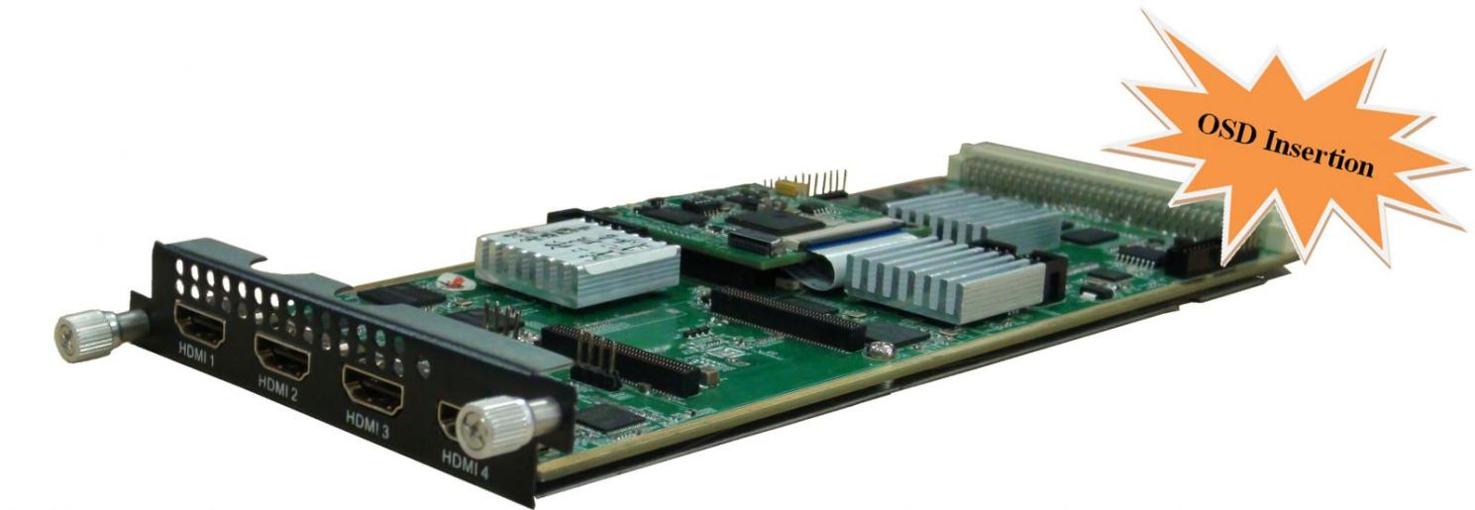
Module Specifications:
Input: 4×HDMI (1.4) input, HDCP 1.4
Output: 1 MPTS and 4 SPTS output over UDP/RTP/RTSP; IPv4, IPv6 output
Video Encoding:
Video format: HEVC/H.265 & MPEG 4 AVC/H.264---DX 224H
HEVC/H.265---DX224HV
Resolution:
1920×1080_60P, 1920×1080_59.94P, 1920×1080_50P;
1280×720_60P, 1280×720_59.94P, 1280×720_50P
Input: 1920×1080_60i, 1920×1080_59.94i, 1920×1080_50i
Output: 1920×1080_60P, 1920×1080_59.94P, 1920×1080_50P
Chroma: 4:2:0 Bit rate (each channel): 0.5Mbps~20Mbps (H.265)
4 Mbps~20Mbps (H.264)
Rate Control: CBR/VBR GOP structure: IBBP, IPPP
Audio Encoding:
Audio format: MPEG-1 Layer 2, LC-AAC, HE-AAC, HE-AAC V2, AC3 Passthrough
Sampling rate: 48KHz
Bit-rate (each channel):
48Kbps~384Kbps (MPEG-1 Layer 2 & LC-AAC)
24 Kbps~128 Kbps (HE-AAC)
18 Kbps~56 Kbps (HE-AAC V2)
Audio Gain: 0~255
Support Logo, QR Code insertion--Optional as per order

2 Tuner Descrambling Module (DX902A)
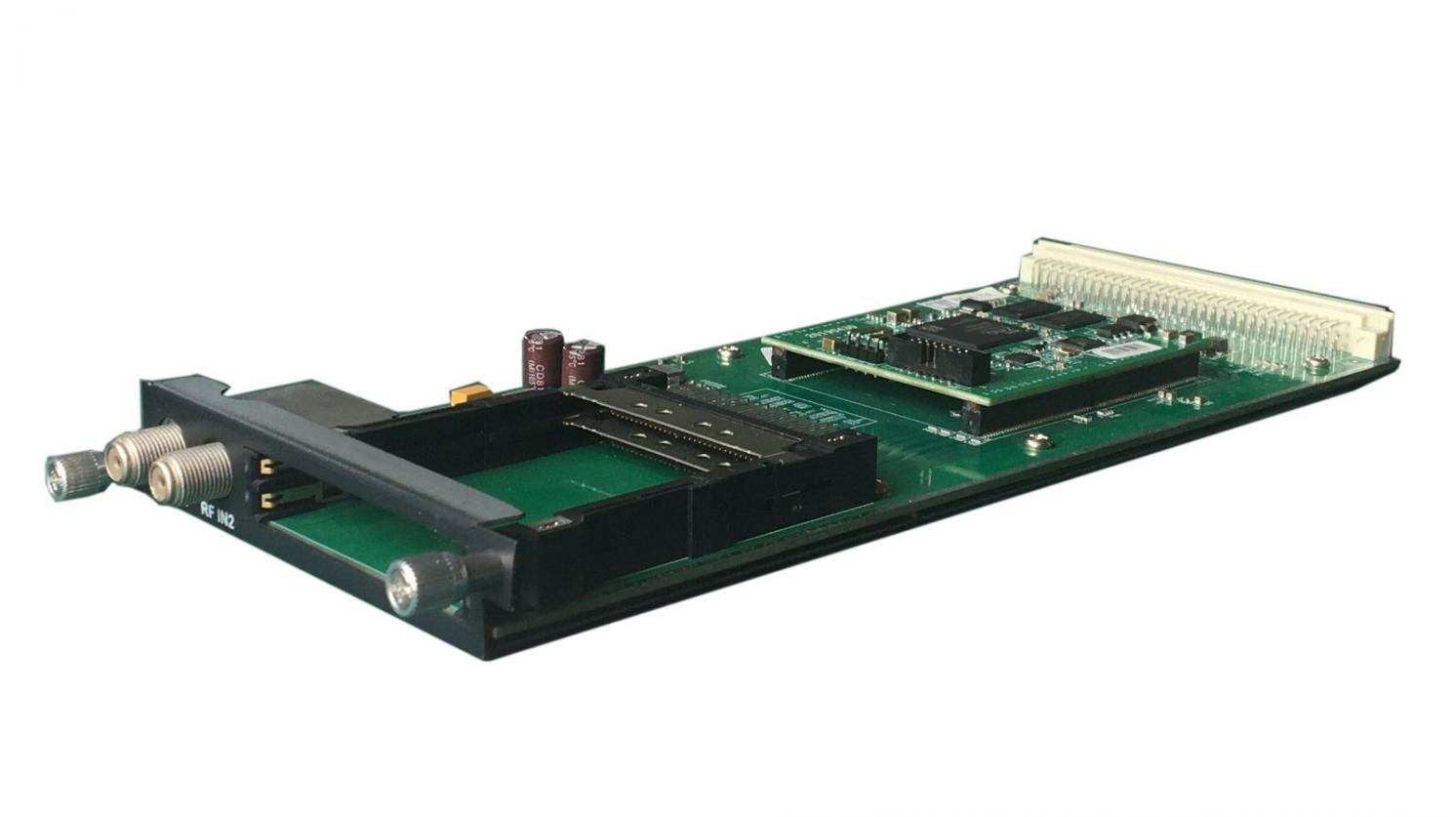
Module Specifications:
Stream in: 2 Tuner input, F Type
Stream out: 1 MPTS output output over UDP, Unicast/Multicast, SFP/RJ45
DVB-CI: 2 independent common interface slots
Standard: DVB-S/S2/S2X
DVB-S Input Frequency: 950-2150MHz
Symbol Rate: QPSK: 0.5~45 Msps
FEC Demodulation: 1/2, 2/3, 3/4, 5/6, 7/8

DVB-S2 Input Frequency: 950-2150MHz
Symbol rate: QPSK/8PSK/16APSK: 0.5~45 Msps; 32APSK:0.5~40 Msps
FEC Demodulation: QPSK: 1/2, 3/5, 2/3, 3/4, 4/5, 5/6, 8/9, 9/10
8PSK: 3/5, 2/3, 3/4, 5/6, 8/9, 9/10
16APSK: 2/3, 3/4, 4/5, 5/6, 8/9, 9/10
32APSK: 3/4, 4/5, 5/6, 8/9

DVB-S2X Input Frequency: 950-2150MHz
Symbol rate: QPSK/8PSK/16APSK: 0.5~45 Msps; 8APSK/32APSK: 0.5~40 Msps
FEC Demodulation: QPSK: 1/2, 3/5, 2/3, 3/4, 4/5, 5/6, 8/9, 9/10, 13/45, 9/20, 11/20
8PSK: 3/5, 2/3, 3/4, 5/6, 8/9, 9/10, 23/36, 25/36, 13/18
8APSK: 5/9-L, 26/45-L
16APSK: 2/3, 3/4, 4/5, 5/6, 8/9, 9/10,1/2-L, 8/15-L, 5/9-L, 26/45, 3/5, 3/5-L, 28/45, 23/36, 2/3-L, 25/36, 13/18, 7/9, 77/90
32APSK: 3/4, 4/5, 5/6, 8/9, 2/3-L, 32/45, 11/15, 7/9

Signal Strength: -65~ -25dBm
Support Diseqc function (For DX902A)
Multiplexing:
Maximum PID Remapping: 256 output pids
Function: PID remapping (automatically or manually), Accurate PCR adjusting, generate PSI/ SI table automatically
Descrambling:
CAM/CI Quantity: 2
BISS Mode: Mode 1, Mode E; up to 120Mbps (Optional as required)

2 Tuner Descrambling Module (DX912)
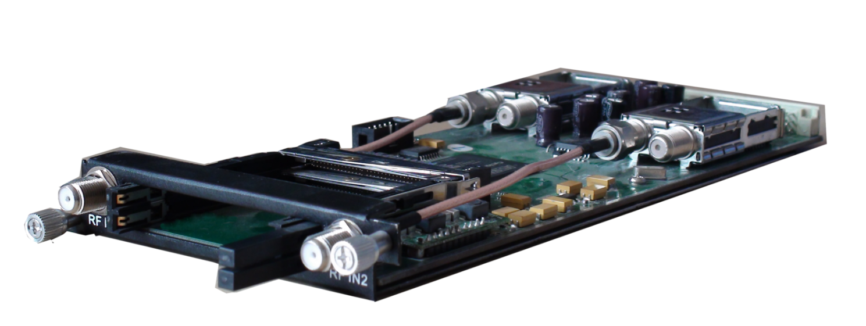
Module Specifications:
Stream in: 2 Tuner input, F Type
Stream out: 1 MPTS output over UDP, Unicast/Multicast, SFP/RJ45
DVB-CI: 2 Independent common interface slots
Standard: DVB-C (J.83 A/C)/J.83B/ DVB-T/(T)/ISDB-T switchable

Standard: DVB-C (J.83 A/C); J.83B
Input Frequency: 60MHz~890MHz
Symbol rate: 1000~9000Ksps
Constellation: 16/32/64/128/256 QAM; 64/256 QAM for J.83B

Standard: DVB-T/(T)
Frequency In: 60MHz~890MHz
Bandwidth: 5/6/7/8M bandwidth
PLP Index: 0~255 (for DVB-(T))

Standard: ISDB-T
Input Frequency: 60-890MHz
Signal Strength: -65~ -25dBm
Multiplexing:
Maximum PID Remapping: 256 output pids
Function: PID remapping (automatically or manually), Accurate PCR adjusting, generate PSI/ SI table automatically
Descrambling:
CAM/CI Quantity: 2
BISS Mode: Mode 1, Mode E; up to 120Mbps (Optional as required)

4 HDMI Decoding Module (DX714)
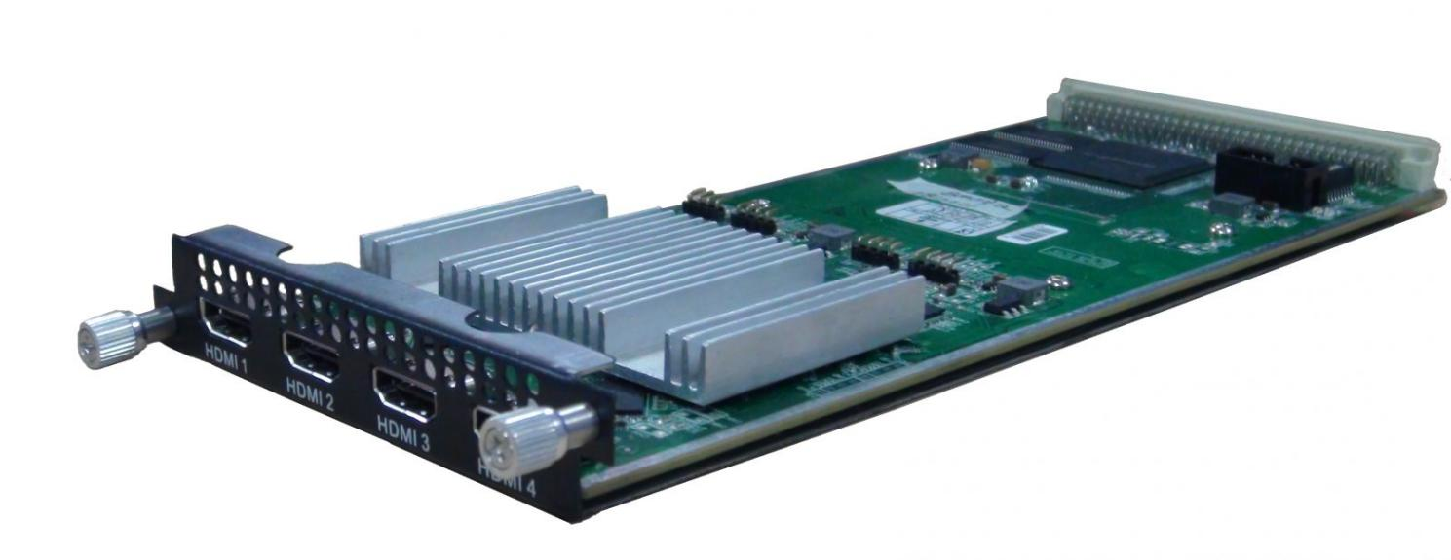
Module Specifications:
Input: 4 IP (MPTS/SPTS) input from data port over UDP&RTP, Unicast/Multicast
Output: 4 HDMI output
Decoding:
Video/Audio Out: 4 HDMI output with 1 channel stereo audio embedded in each port
Video Format: MPEG-2, MPEG-4 AVC/H.264, HEVC/H.265, AVS, AVS+
Audio Format: MPEG 1 Layer 2, LC-AAC, HE-AAC, AC3 (2.0)
Resolution: 480i, 480p, 576i, 576p,1280×720_50p, 1280×720_60p, 1920×1080_50i, 1920×1080_50p 1920×1080_60i, 1920×1080_60p
Support manually upscale/downscale resolution

4 CVBS Encoding Module(DX214/DX214A)
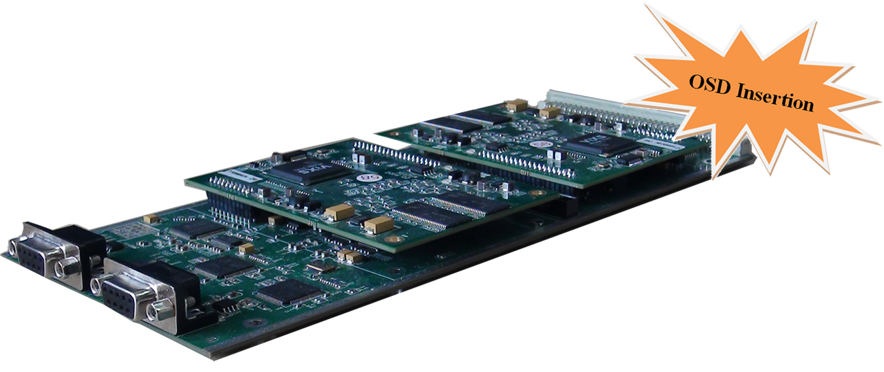
Module Specifications:
Input: 4 CVBS video, 4 Stereo Audio (DB9 to RCA)
Output: 1MPTS and 4 SPTS output over UDP/RTP, unicast and multicast, SFP/RJ45
Video Encoding:
Video format: MPEG-2 (4:2:0)
Image format: PAL, NTSC SD signal
Input resolution: 720×480_60i, 544×480_60i, 352×480_60i, 352×240_60i,
320×240_60i, 176×240_60i, 176×120_60i, 720×576_50i,
704×576_50i, 640×576_50i, 352×288_50i, 320×288_50i,
176×288_50i, 176×144_50i
GOP structure: IP, IBP, IBBP, IBBBP
Video bit rate: 0.5Mbps~8Mbps per channel
Support CC (closed caption)
Audio Encoding:
Audio format: MPEG-1 Layer 2, DD AC3 (2.0)
Sampling rate: 48KHz
Resolution: 24-bit
Audio bitrate:128/192/256/320/384kbps each channel
Support Logo, Caption, QR Code insertion (for DX214A only)

2 HDMI Encoding/Transcoding Module (DX202A)
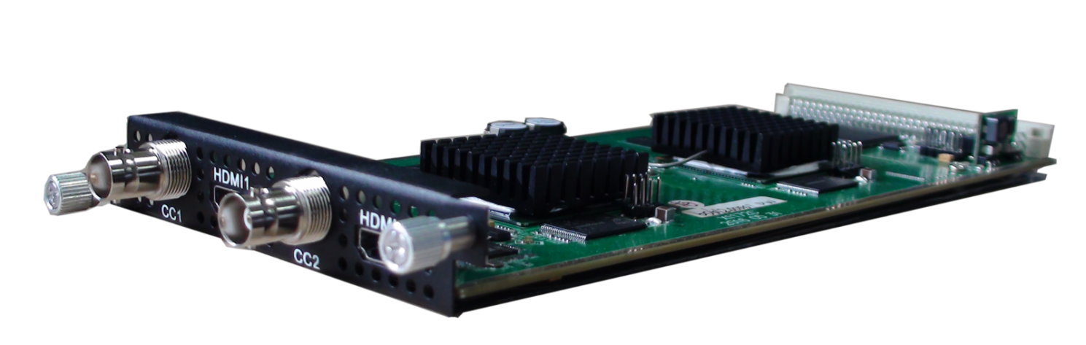
Module Specifications:
Input: 2*HDMI, 2*BNC for CC (Closed Caption) input
Output: 1*MPTS output over UDP, Unicast/Multicast
Video Encoding:
Video format: MPEG2 & MPEG4 AVC/H.264
Input resolution:
1920*1080_60P, 1920*1080_50P, 1920*1080_60i, 1920*1080_50i, 1280*720_60p, 1280*720_50P, 720*480_60i, 720*576_50i
Rate control mode: CBR/VBR
Aspect ratio: 16:9, 4:3
Video bitrate: 0.8~19Mbps for H.264 encoding
1~19.5Mbps for MPEG-2 encoding
Support CC (closed caption)
Audio Encoding:
Audio format: MPEG1 Layer II, MPEG2-AAC, MPEG4-AAC,
Dolby Digital AC3 (2.0) encoding (Optional); AC3 (2.0/5.1) passthrough
Sampling rate: 48KHz
Audio bitrate: 64Kbps-320kbps each channel
Video Tanscoding:
2*MPEG2 HD → 2*MPEG2/H.264 HD; 2*MPEG2 HD → 2*MPEG2/H.264 SD;
2* H.264 HD → 2*MPEG2/H.264 HD; 2* H.264 HD → 2*MPEG2/H.264 SD;
4 *MPEG2 SD → 4 *MPEG2/H.264 SD; 4* H.264 SD → 4 *MPEG2/H.264 SD
Audio Tanscoding:
MPEG-1 Layer 2, AC3 (Optional) and AAC any-to-any

2 SDI Encoding/Transcoding Module (DX202A-D)
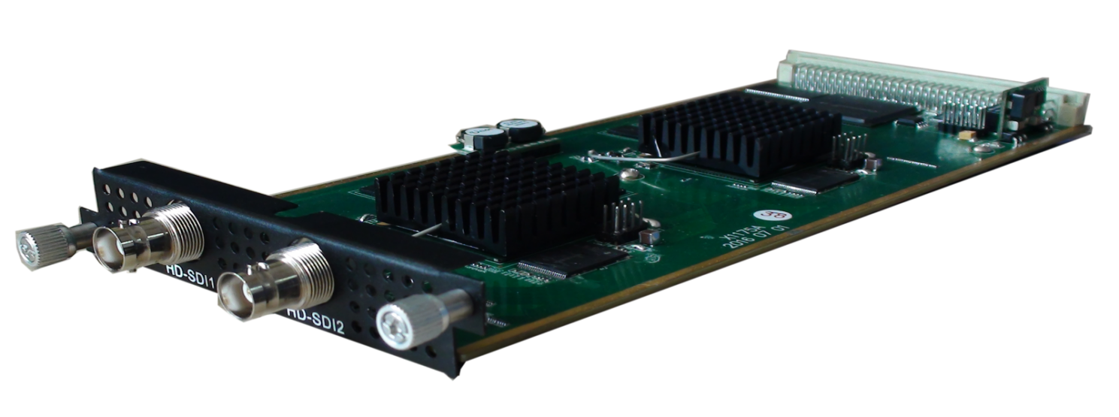
Module Specifications:
Input: 2*HD-SDI
Output: 1*MPTS output over UDP, Unicast/Multicast
Video Encoding:
Video format: MPEG2 & MPEG4 AVC/H.264
Input resolution:
1920*1080_60P, 1920*1080_50P, 1920*1080_60i, 1920*1080_50i, 1280*720_60p, 1280*720_50P, 720*480_60i, 720*576_50i
Rate control mode: CBR/VBR
Aspect ratio: 16:9, 4:3
Video bitrate: 0.8~19Mbps for H.264 encoding;
1~19.5Mbps for MPEG-2 encoding
Support CC (closed caption)
Audio Encoding:
Audio format:
MPEG1 Layer II, MPEG2-AAC, MPEG4-AAC,
Dolby Digital AC3 (2.0) encoding (Optional), AC3 (2.0/5.1) passthrough
Sampling rate: 48KHz
Audio bitrate: 64Kbps-320kbps each channel
Video Tanscoding:
2*MPEG2 HD → 2*MPEG2/H.264 HD; 2*MPEG2 HD → 2*MPEG2/H.264 SD;
2* H.264 HD → 2*MPEG2/H.264 HD; 2* H.264 HD → 2*MPEG2/H.264 SD;
4 *MPEG2 SD → 4 *MPEG2/H.264 SD; 4* H.264 SD → 4 *MPEG2/H.264 SD
Audio Tanscoding:
MPEG-1 Layer 2, AC3 (Optional) and AAC any-to-any

8 CVBS Encoding Module(DX218S)
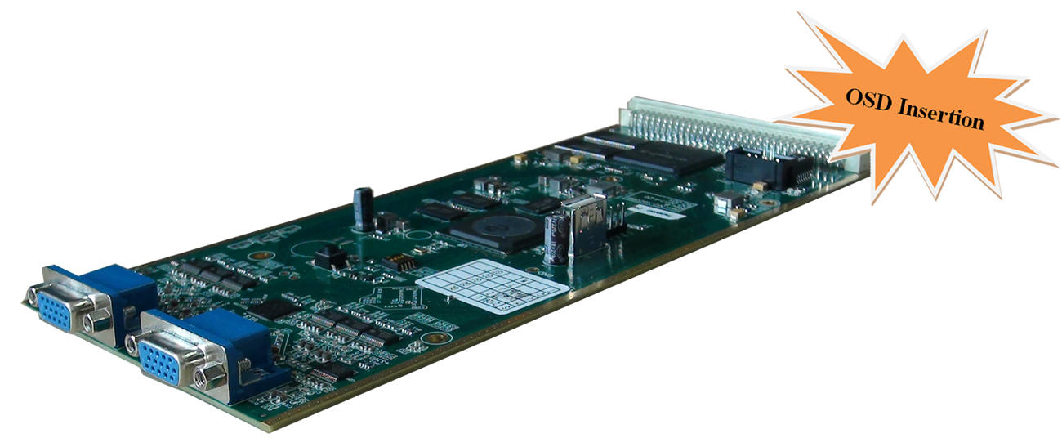
Module Specifications:
Input: 8 CVBS video, 8 Stereo Audio (DB15 to RCA)
Output: 1 MPTS and 8 SPTS output over UDP/RTP, unicast and multicast,
Video Encoding:
Video format: MPEG4 AVC/H.264
Image format: PAL, NTSC SD signal
Resolution: 720×576i, 720×480i
Rate Control: CBR/VBR
GOP structure: IPP
Video bitrate: 1~7Mbps each channel
Audio Encoding:
Audio format: MPEG-1 Layer 2
Sampling rate: 48KHz
Resolution: 24-bit
Bit-rate: 64/128/192/224/256/320/384Kbps each channel
Support Logo, Caption, QR Code insertion (Language Supported: 中文, English, اردو, for more languages please consult us…)

4 ASI/IP Multiplexing Module (DX504)
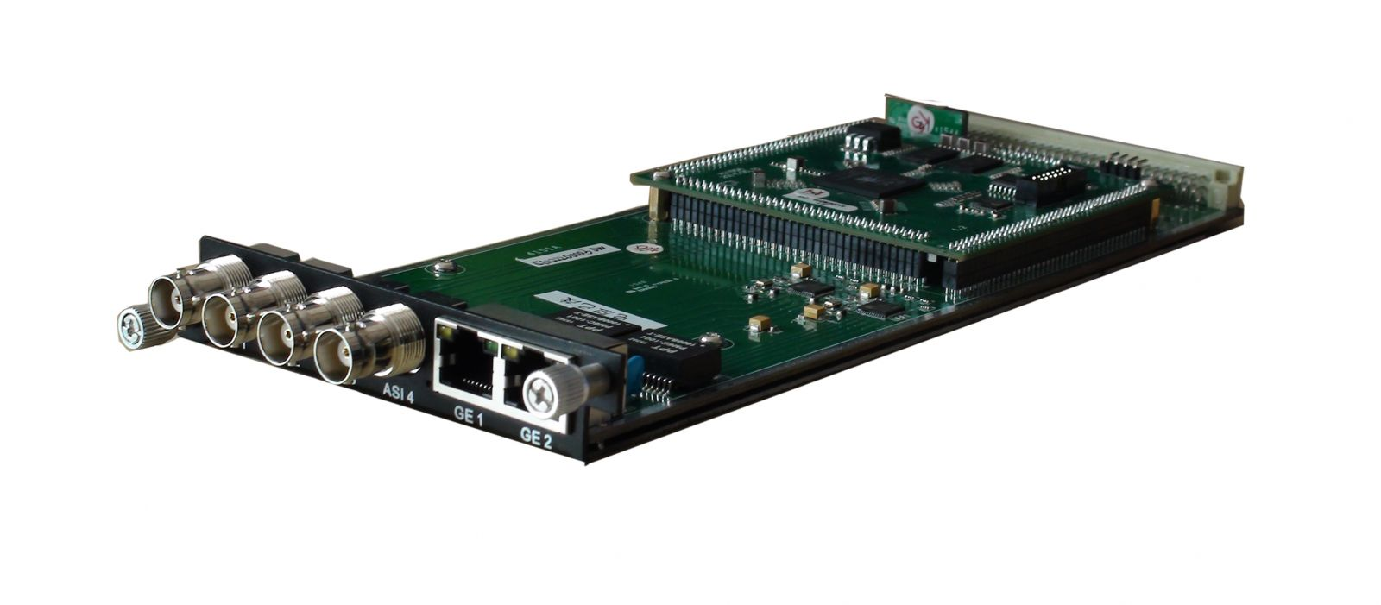
Module Specifications:
ASI inputs/outputs: 4 ASI bi-direction, BNC 75Ω
IP inputs/outputs: 2 Ethernet Port(100/1000M)
Stream connector input
Re-multiplexing: PID remapping, PCR correction, generate PSI/ SI table automatically
Stream In: maximum 4 ASI input, 256×2 IP input
Stream Out: maximum 4 ASI output, 4 IP output

4/8 CH EAS Multiplexing Module (DX504E/DX508E)
Module Specifications:
ASI input: 1 ASI input (SPTS), BNC 75Ω
IP input: 256 IP input thru 1 GE1 (100/1000M)
EAS Source: ASI or IP (the 256th IP) (ASI&IP should be SPTS, both can’t mux, source Bitrate≤10Mbps)
Re-multiplexing: PID remapping, PCR correction (only for IP), generate PSI/ SI table automatically
Stream Out: 4 IP output thru GE1, maximum 16 programs each channel--DX504E
Stream Out: 8 IP output thru GE1, maximum 8 programs each channel--DX508E

IP Adapter Module (DX514)
Module Specifications:
IP Ports: GE1/GE2 (100/1000M self- adaption)
IP Input: 10 IP input through GE1/GE2
IP Output: 10 IP output switch to other module
ASI Ports: 4 ASI bi-direction, BNC 75Ω
Select ASI port as input, IP output thru GE1/GE2 as mirror of ASI input
Select ASI port as output, ASI (1/2/3/4) output as mirror of IP in (IP 1/2/3/4)
Support PCR correction, IP De-jitter
Suggest match with DX902/DX912 module to descramble IP

IP Multiplexing Module (DX506)
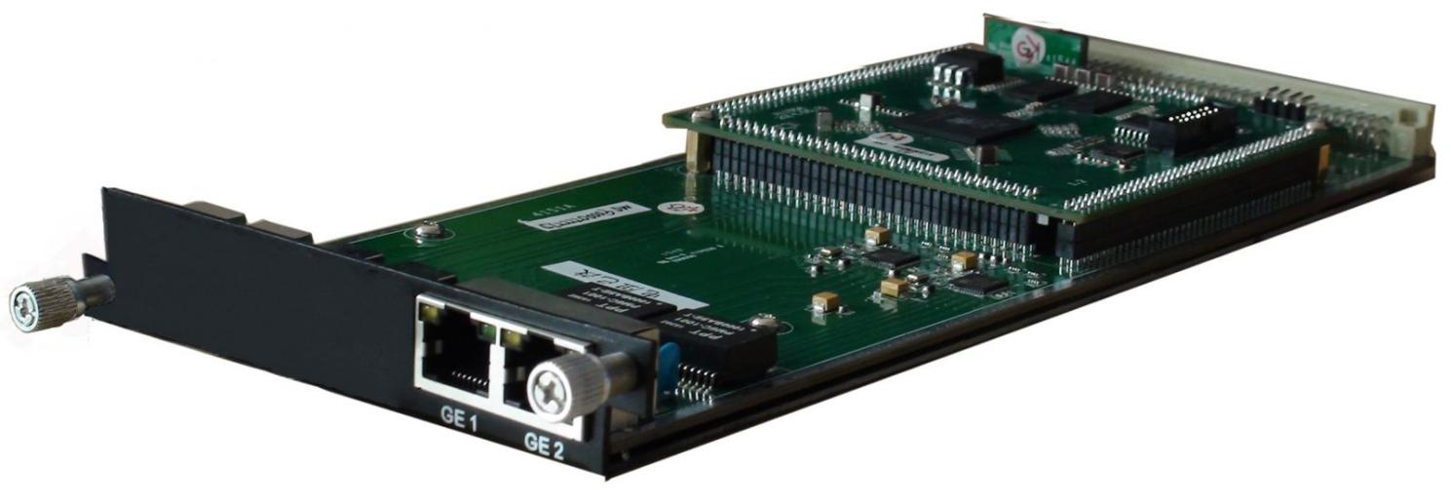

Module Specifications:
IP input: 512 SPTS or MPTS input over UDP, RTP, Unicast and Multicast thru GE1 Ethernet Port (100/1000M)
Re-multiplexing: PID remapping, PCR correction, generate PSI/ SI table automatically
IP Out: 512 SPTS output over UDP, RTP, Unicast and Multicast through GE2 Ethernet Port (100/1000M)

16/32 QAM Modulating Module (DX316/DX332)
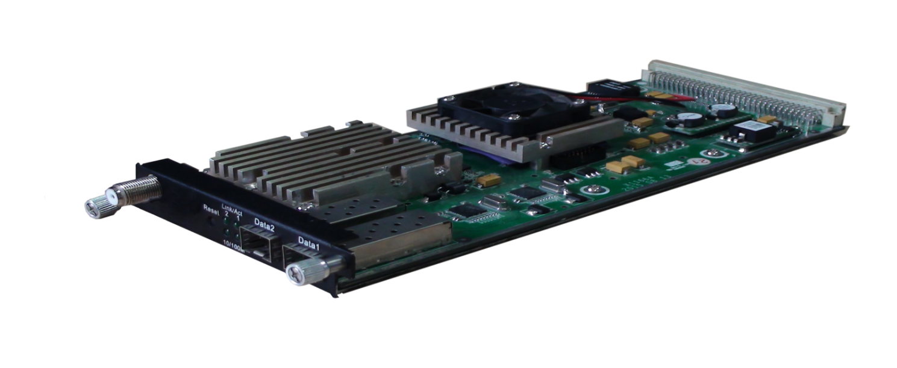
Module Specifications:
Data input: Max 512 IP input over UDP/RTP, 2 GE Ports (RJ45/SFP) (DX316)
Max 1024 IP input over UDP/RTP, 2 GE Ports (RJ45/SFP) (DX332)
128 IP input through front panel GE2 port or internal IP output
Data output: 16 or 32 IP output over UDP/RTP/RTSP, unicast/multicast, 2 GE Ports (RJ45/SFP)
Trans Rate: Max 840Mbps/GE Port
RF output (F type): 16/32 channels of multiplexing, scrambling and modualtion.
Multiplexing:
Maximum PID Remapping: 180 output pids per channel for DX316. 256 output pids per channel for DX332.
Function: PID remapping (automatically or manually), Accurate PCR adjusting, generate PSI/SI table automatically
Scrambling:
Maximum simulcrypt CA: 4
Standard: ETR289, ETSI 101 197, ETSI 103 197
Connection: Local/remote connection
Modulation:
Standard: EN300 429/ITU-T J.83A/B (DVB-C)
MER: ≥40dB
RF frequency: 50~960MHz, 1KHz step
RF output level: -20~+10dBm (87~117 dBµV), 0.1dB step for all carriers
Symbol Rate: 5.0Msps~7.0Msps, 1ksps step
Constellation: 16/32/64/128/256QAM
DX316 Output: 16 non-adjacent carrier outputs within 192M bandwidth
DX332 Output: 32 non-adjacent carrier outputs within 384M bandwidth

2 HD-SDI Decoding Module(DX702)
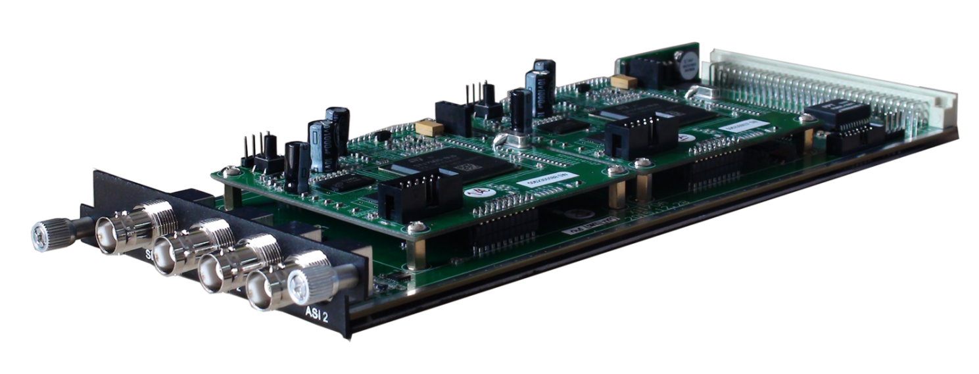
Module Specifications:
ASI input/output: 2 ASI bi-direction, BNC 75Ω
IP input: 2 IP input from data port
IP output: 1 MPTS output over UDP, Unicast/Multicast
Decoding:
Video/Audio Out: 2 HD/SD SDI output
Video Format: MPEG-2, MPEG-4 AVC/H.264
Resolution: 480i,480p,576i,576p,720p@50/59.94/60,1080i@50/59.94/60
Chroma: 4:2:0
Audio Format: MPEG1 Layer2, LC-AAC, HE-AAC, AC3 (2.0/5.1), AC3 Passthrough,
Support Dual Audio Out
Support CC/Subtitle

4 FTA Tuner Module (DX904B)
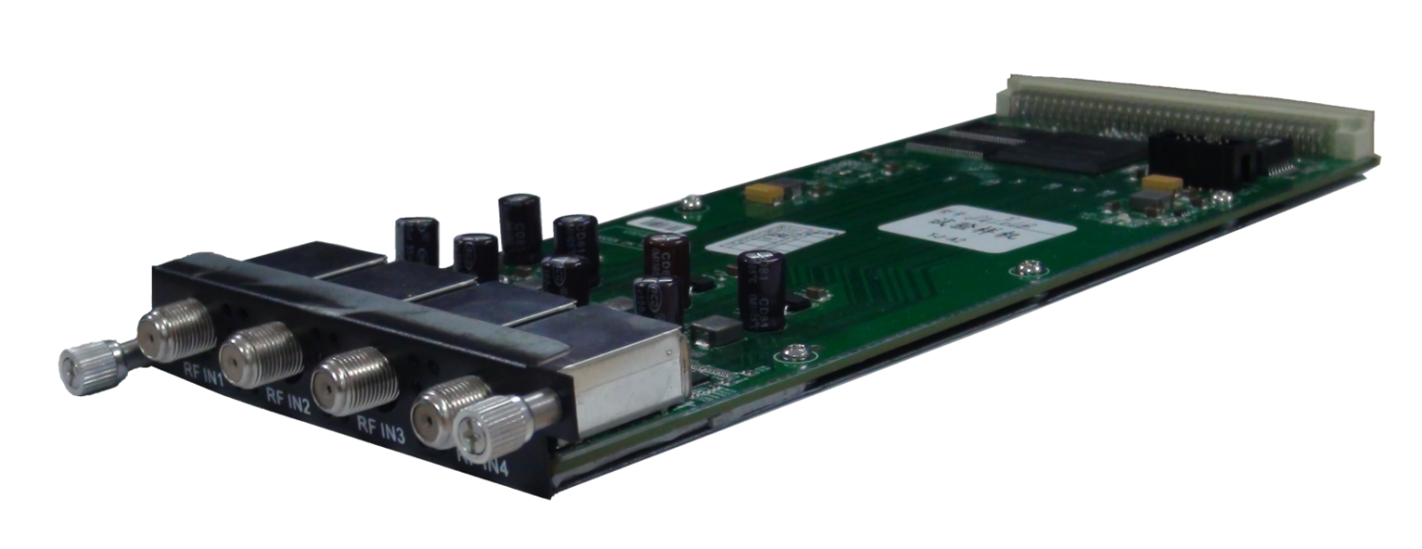
Module Specifications:
Stream in: 4 Tuner input, F Type
Stream out: 5 MPTS out over UDP, unicast/multicast
Standard: DVB-S/S2/S2X
Tuner Section
DVB-S
Input Frequency: 950-2150MHz
Symbol Rate: QPSK: 0.5~45 Msps
FEC Demodulation: 1/2, 2/3, 3/4, 5/6, 7/8
DVB-S2
Input Frequency: 950-2150MHz
Symbol rate: QPSK/8PSK/16APSK: 0.5~45 Msps;
32APSK: 0.5~40 Msps
FEC Demodulation: QPSK: 1/2, 3/5, 2/3, 3/4, 4/5, 5/6, 8/9, 9/10
8PSK: 3/5, 2/3, 3/4, 5/6, 8/9, 9/10
16APSK: 2/3, 3/4, 4/5, 5/6, 8/9, 9/10
32APSK: 3/4, 4/5, 5/6, 8/9

DVB-S2X
Input Frequency: 950-2150MHz
Symbol rate: QPSK/8PSK/16APSK: 0.5~45 Msps;
8APSK/32APSK: 0.5~40 Msps
FEC Demodulation:
QPSK: 1/2, 3/5, 2/3, 3/4, 4/5, 5/6, 8/9, 9/10, 13/45, 9/20, 11/20
8PSK: 3/5, 2/3, 3/4, 5/6, 8/9, 9/10, 23/36, 25/36, 13/18
8APSK: 5/9-L, 26/45-L
16APSK: 2/3, 3/4, 4/5, 5/6, 8/9, 9/10,1/2-L, 8/15-L, 5/9-L, 26/45, 3/5, 3/5-L, 28/45, 23/36, 2/3-L, 25/36, 13/18, 7/9, 77/90
32APSK: 3/4, 4/5, 5/6, 8/9, 2/3-L, 32/45, 11/15, 7/9
Signal Strength: -65 ~ -25dBm
Support Diseqc function

Multiplexing:
Max number of managing PID: 256
Function: PID remapping (automatically/ manually), Accurate PCR adjust, PID pass-through

Equipment Specifications:
Base Unit Parameters
Dimension(W×L×H): 482mm×410mm×44mm
Environment: 0~45℃(work); -20~80℃(Storage）
Power requirements AC 110V± 10%, 50/60Hz, AC 220 ± 10%, 50/60Hz

Parameters Comparison:
 | DHP400 | DHP400A
IP Data Transport | One-way Transport:  GE1/GE2 support output maximum 8MPTS & 512SPTS | Bi-directional Transport:  GE1/ GE2 support IP data input and output
TS Processing Number | Support 1 TS (MPTS/SPTS) input from each module, and maximum bitrate is 350Mbps | Support maximum 512 TS (MPTS/SPTS) input from each module, and maximum bitrate is 350Mbps
Multiplexing | Support multiplexing function:  It can multiplex TSs from different modules to one TS and output through one module or GE1/GE2 port | Doesn’t support multiplexing function:  It can combine TSs from different modules and output these TSs through one module or GE1/GE2 port
Output Per Module | 1 MPTS after multiplexing | 1 or multiple MPTS/SPTS

About Us
FMUSER is a company specializing in broadcasting and television transmission systems and integrating hotel IPTV systems. The company was established in 2009 and has served over 180 countries worldwide. More than 20,000 television stations, radio stations, and hotel clients from different.

Contact:Tomleequan Email：sales@fmuser.com whatsapp: +8613922702227

