FMUSER FUQ-4019J Decoder 8IP-1ASI Input to 8CVBS Output MPEG-2-H.264-AVS+ Video MPEG1 Layer 2-AC3 Audio Real-Time Monitoring Professional Broadcast Cable TV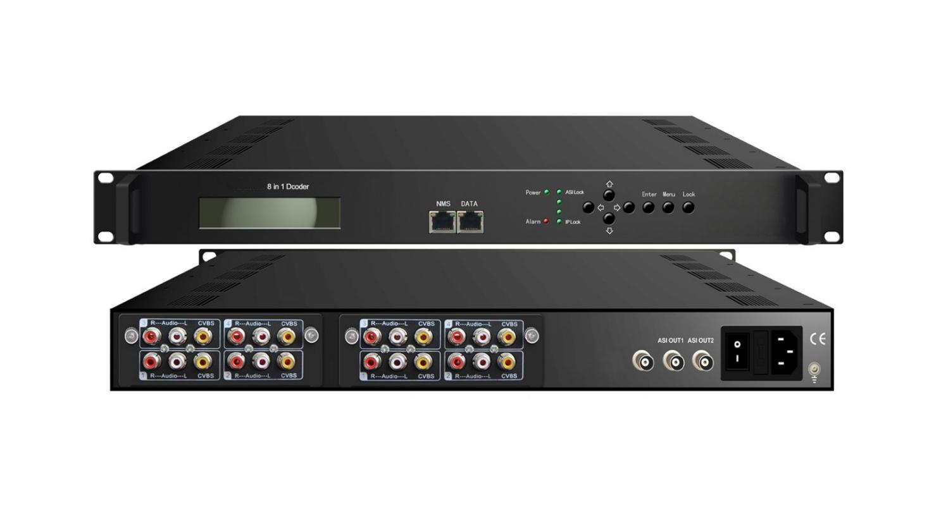8*IP + ASI input→ 8*CVBS output

Product Overview
The FMUSER FUQ-4214 is a 1U digital decoder supporting 8IP (UDP/RTP) and 1ASI inputs with 8CVBS analog outputs. It processes signals by decoding MPEG-2/H.264/AVS+ video and MPEG1 Layer 2/AC3 audio codecs. Featuring a pluggable module design and control via LCD and web-server, it is ideal for broadcast systems and cable TV distribution networks.
Key feature
Supports versatile inputs: 8IP (UDP/RTP) and 1ASI signals.
Provides high-density output: 8CVBS video and unbalanced stereo audio.
Features advanced codec decoding: MPEG-2/H.264/AVS+ video and MPEG1 Layer 2/AC3 audio.
Includes real-time bit rate monitoring for quality control.
Enables easy management via LCD and web-server.
Principle Chart
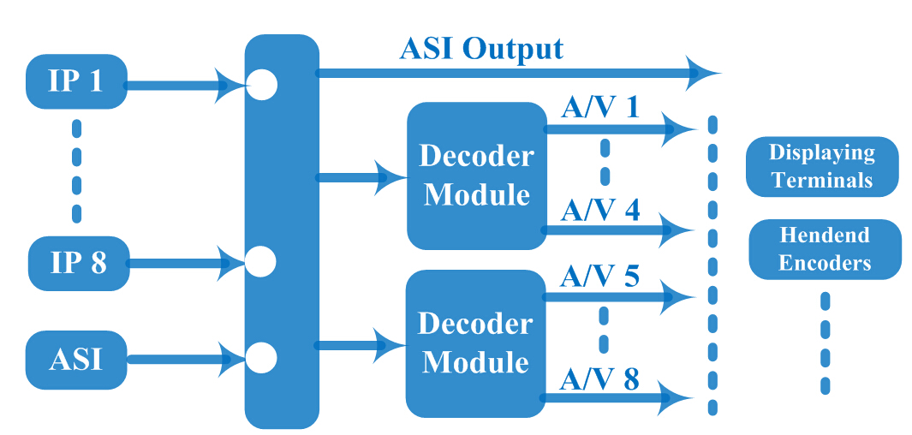

Specification
Input | 8*IP (MPTS/SPTS) (100Mbps Ethernet) (RJ45)
Input | IP Protocol |  | UDP and RTP (Unicast/multicast)
Input | 1* ASI (BNC)
Decode | Video Format |  | MPEG-2/H.264/AVS+
Decode | Interface |  | 8* CVBS（RCA）
Decode | Video Resolution |  | 576i@25fps, 480i@29.97fps
Decode | Audio Format |  | MPEG-1 Layer 2, AC3 (2.0)
Decode | Interface |  | 8*Unbalanced stereo (RCA)
General |  | Operation | LCD display/Control button; Web-server
 |  | Language | Chinese/English
 |  | Dimension (LxWxH) | 44 mm×482 mm×410mm
 |  | Environment | 0~45℃(Work)；-20~80℃(Storage)
 |  | Power Supply | 220VAC±10%，50Hz
 |  | Consumption | <25W

About Us
FMUSER is a company specializing in broadcasting and television transmission systems and integrating hotel IPTV systems. The company was established in 2009 and has served over 180 countries worldwide. More than 20,000 television stations, radio stations, and hotel clients from different.

Contact:Tomleequan Email：sales@fmuser.com whatsapp: +8613922702227

