FMUSER FUQ-41013K TransModulator 2-In 2-Out DVB-S-S2-S2X to DVB-T Dual Tuners CAM Slots EN300744 Advanced Signal Processing Broadcast Systems 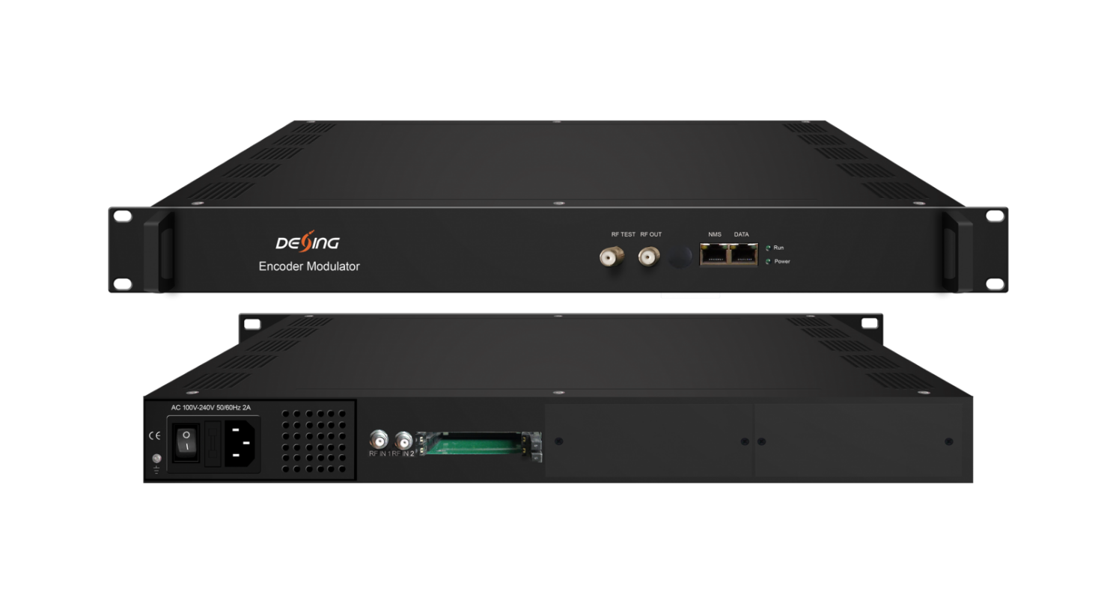
Product overview
The FMUSER FUQ-41013K TransModulator converts satellite signals to terrestrial formats with dual DVB-S/S2/S2X tuners and 2 CAM slots. It processes signals through 2 groups multiplexing and 2 groups DVB-T modulating, including PCR adjusting and PID remapping. Managed via web-based NMS for remote control, it suits broadcasters in TV transmission and terrestrial network deployments.
Key feature
Features dual DVB-S/S2/S2X tuners with 2 CAM slots for secure reception.
Supports 2 groups multiplexing and 2 groups DVB-T modulating for flexible output.
Includes accurate PCR adjusting, PID remapping, PSI/SI editing, and A/V PID filtering.
Enables web-based NMS for remote monitoring and upgrades.
Principle Chart
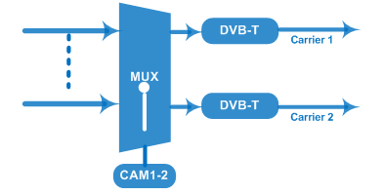

Tech Specifications
Input | 2 DVB-S/S2/S2X Tuners
Tuner Section | DVB-S/S2/S2X Tuner | DVB-S | Input Frequency | 950~2150MHz
Tuner Section | DVB-S/S2/S2X Tuner | DVB-S | Symbol rate | 0.5~45Msps
Tuner Section | DVB-S/S2/S2X Tuner | DVB-S | Signal Strength | - 65- -25dBm
Tuner Section | DVB-S/S2/S2X Tuner | DVB-S | FEC | 1/2, 2/3, 3/4, 5/6, 7/8
Tuner Section | DVB-S/S2/S2X Tuner | DVB-S | Constellation | QPSK
Tuner Section | DVB-S/S2/S2X Tuner | DVB-S | Max input bitrate | ≤129 Mbps
Tuner Section | DVB-S/S2/S2X Tuner | DVB-S2 | Input Frequency | 950~2150MHz
Tuner Section | DVB-S/S2/S2X Tuner | DVB-S2 | Symbol rate | QPSK/8PSK /16APSK: 0.5~45 Msps  32APSK: 0.5~40Msps;
Tuner Section | DVB-S/S2/S2X Tuner | DVB-S2 | FEC | QPSK: 1/2, 3/5, 2/3, 3/4, 4/5, 5/6, 8/9, 9/10  8PSK: 3/5, 2/3, 3/4, 5/6, 8/9, 9/10  16APSK: 2/3, 3/4, 4/5, 5/6, 8/9, 9/10  32APSK: 3/4, 4/5, 5/6, 8/9, 9/10
Tuner Section | DVB-S/S2/S2X Tuner | DVB-S2 | Constellation | QPSK, 8PSK, 16APSK, 32APSK
Tuner Section | DVB-S/S2/S2X Tuner | DVB-S2 | Max input bitrate | ≤129 Mbps
Tuner Section | DVB-S/S2/S2X Tuner | DVB-S2X | Input Frequency | 950~2150MHz
Tuner Section | DVB-S/S2/S2X Tuner | DVB-S2X | Symbol rate | QPSK/8PSK /16APSK: 0.5~45 Msps  8APSK: 0.5~40Msps  32APSK: 0.5~40Msps
Tuner Section | DVB-S/S2/S2X Tuner | DVB-S2X | FEC | QPSK: 1/2, 3/5, 2/3, 3/4, 4/5, 5/6, 8/9, 9/10, 13/45, 9/20, 11/20  8PSK: 3/5, 2/3, 3/4, 5/6, 8/9, 9/10  8APSK: 5/9-L, 26/45-L  16APSK: 2/3, 3/4, 4/5, 5/6, 8/9, 9/10, 1/2-L, 8/15-L, 5/9-L, 26/45, 3/5, 3/5-L, 28/45, 23/36, 2/3-L, 25/36, 13/18, 7/9, 77/90  32APSK: 3/4, 4/5, 5/6, 8/9, 2/3-L, 32/45, 11/15, 7/9
Tuner Section | DVB-S/S2/S2X Tuner | DVB-S2X | Constellation | QPSK, 8PSK, 8APSK, 16APSK, 32APSK
Tuner Section | DVB-S/S2/S2X Tuner | DVB-S2X | Max input bitrate | ≤129 Mbps
Descrambling | CAM/CI |  | 2 sets
Multiplexing | Maximum PID Remapping |  | 256 per input channel
Multiplexing | Function |  | A/V PID filtering
Multiplexing |  |  | PID Remapping
Multiplexing |  |  | Accurate PCR adjusting
Multiplexing |  |  | Generate PSI/SI table automatically
Modulation | DVB-T |  | Standard | EN300744
Modulation |  |  | FFT mode | 2K
Modulation |  |  | Bandwidth | 6M, 7M, 8M
Modulation |  |  | Constellation | QPSK, 16QAM, 64QAM
Modulation |  |  | Guard Interval | 1/4, 1/8, 1/16, 1/32
Modulation |  |  | Code Rate | 1/2, 2/3, 3/4, 5/6, 7/8
Modulation |  |  | MER | ≥42 dB
Modulation |  |  | RF frequency | 50~960MHz, 1KHz step
Modulation |  |  | RF out | 2*DVB-T non-adjacent carriers combined output
Modulation |  |  | RF output level | -28~ -3 dBm (79~104 dbµV), 0.1db step
System | Web-based NMS support
System | Ethernet software upgrading
General | Temperature |  | 0~45℃(Operation) ; -20~80℃(Storage)
General | Power |  | AC 100V±1050/60Hz; AC 220V±10%, 50/60HZ

About Us
FMUSER is a company specializing in broadcasting and television transmission systems and integrating hotel IPTV systems. The company was established in 2009 and has served over 180 countries worldwide. More than 20,000 television stations, radio stations, and hotel clients from different.

Contact:Tomleequan Email：sales@fmuser.com whatsapp: +8613922702227

