FMUSER FUQ-41015 Quad Decoder 4 ASI Input 4 ASI Loop-Out 4 CVBS Stereo Audio MPEG-2 PAL-NTSC Auto Switch Broadcast Transmission
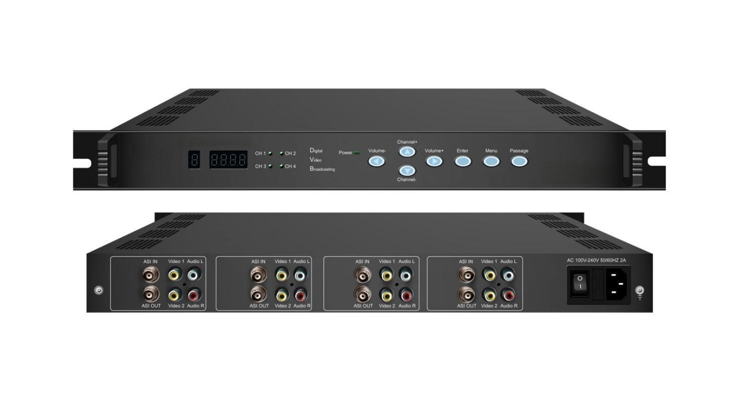Product overview
The FUQ-41015 Quad Decoder decodes MPEG2 TS signals with 4 ASI inputs and outputs 4 separate A/V signals, including ASI loop outputs. It processes signals by decoding them into audio and video formats. Housed in a compact 1U rack unit, it features modular design for reduced space and power consumption. Ideal for broadcast systems, it ensures efficient and user-friendly operation and maintenance.
Key feature
Integrated four independent decoders in a 1U chassis
Supports 4 ASI inputs, 4 A/V outputs, and 4 ASI loop outputs
Features an intuitive user interface for easy operation
Automatically switches between PAL and NTSC video standards
Includes auto-save function to retain channel settings
Technical Specifications
Signal Input |  | 4×ASI (BNC interface)
Decoding Standard |  | MPEG-2
Video OUT |  | 4×CVBS (RCA interface)
Audio OUT |  | 4×Stereo Audio (L/R)
ASI Loop OUT |  | 4×BNC interface
Miscellaneous | Management | LED /Control Buttons
Miscellaneous | Dimension | 44mm×482mm×410mm
Miscellaneous | Temperature | 0~45℃(Operating), -20~80℃(Storage)
Miscellaneous | Power | AC 90~220V, 50/60Hz, 25W

Principle Chart

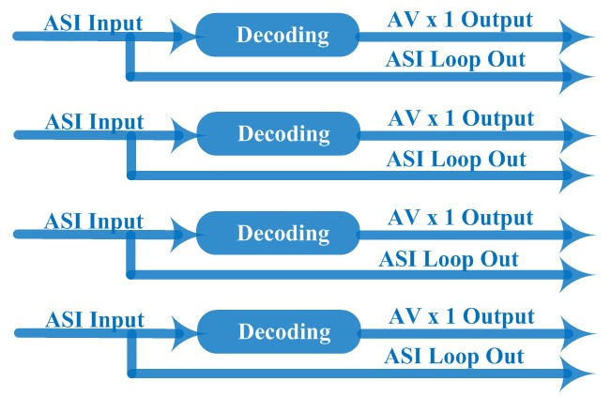

About Us
FMUSER is a company specializing in broadcasting and television transmission systems and integrating hotel IPTV systems. The company was established in 2009 and has served over 180 countries worldwide. More than 20,000 television stations, radio stations, and hotel clients from different.

Contact:Tomleequan Email：sales@fmuser.com whatsapp: +8613922702227

